Contents

Contents 1

I. Infosec Governance 3

Section One: Overview 3

DOMAIN DEFINITION 3

Learning Objectives 3

TASK STATEMENTS (9) 3

KNOWLEDGE STATEMENTS (19) 3

Section Two: Content 3

1.0 INTRODUCTION 3

1.1 INFOSEC GOVERNANCE OVERVIEW 3

1.1.1 Importance of Infosec Governance 4

1.1.2 Outcomes of Infosec Governance 4

1.2 EFFECTIVE INFOSEC GOVERNANCE 4

1.2.1 Business Goals & Objectives 4

1.2.2 Risk Capacity, Risk Appetite (Acceptable Risk) 4

1.2.3 Infosec Governance Scope & Charter 5

1.2.4 Governance, Risk Management, Compliance 5

1.2.5 Business Model for Infosec (BMIS) 5

Four elements of the model 5

Six dynamic Interconnections 5

1.2.6 Assurance Process 5

Integration 5

Convergence 5

1.3 ROLES & RESPONSIBILITIES 5

Skills 6

Culture 6

1.3.1 Board of Directors 6

1.3.2 Senior Management 6

1.3.3 Business Process Owners 6

1.3.4 Steering Committee 6

1.3.5 Chief Infosec Officer 6

1.4 RISK MANAGEMENT ROLES & RESPONSIBILITIES 6

1.4.1 Key Roles 6

1.4.2 Infosec Roles & Responsibilities 6

Obtain Senior Management’s commitment 6

Develop and Present Business Case 7

Establish reporting & communication channels 7

1.5 GOVERNANCE of 3RD-PARTY RELATIONSHIPS 7

1.6 INFOSEC GOVERNANCE METRICS 7

1.6.1 Effective Security Metrics 8

1.6.2 Metrics on Governance Implementation 8

1.6.3 Metrics on Strategic Alignment 8

1.6.4 Metrics on Risk Management 8

1.6.5 Metrics on Value Delivery 9

1.6.6 Metrics on Resource Management 9

1.6.7 Metrics on Performance 9

1.6.8 Integrate (Converge) Assurance Process 9

1.7 INFOSEC STRATEGY OVERVIEW 9

1.7.1 Develop Infosec Strategy 9

1.7.2 Common Pitfalls 10

1.8 INFOSEC STRATEGY OBJECTIVES 10

1.8.1 The Goal 10

1.8.2 Define Objectives 10

Business Linkages 10

1.8.3 The Desired State 10

COBIT 10

Capability Maturity Model Integration (CMMI) 11

Balanced Scorecard 11

Architectural Approaches 11

ISO/IEC 27000 Series 11

Other Approaches 12

1.8.4 Risk Objectives 12

1.9 DETERMINE CURRENT STATE OF SECURITY 12

1.9.1 Current Risk 12

Business Impact Analysis 12

1.10 INFOSEC STRATEGY DEVELOPMENT 12

1.10.1 Elements of Strategy 12

Road Map 12

1.10.2 Strategy Resources & Constraints 12

Enablers 12

Resources 12

Constraints 13

1.11 RESOURCES FOR INFOSEC STRATEGY 13

1.11.1 Policies & Standards 13

Policies 13

Standards 13

Procedures 13

Guidelines 13

1.11.2 Enterprise Infosec Architecture (EISA) 13

Alternative Enterprise Architecture Frameworks 13

1.11.3 Controls 14

IT Controls 14

Non-IT Controls 14

Countermeasures 14

Layered Defenses 14

1.11.4 Technologies 14

1.11.5 PERSONNEL 14

1.11.6 Organizational Structure 14

Centralized & Decentralized Approaches to Coordinate Infosec 14

1.11.7 Employee Roles & Responsibilities 14

1.11.8 Skills 14

1.11.9 Awareness & Education 14

1.11.10 Audits 14

1.11.11 Compliance Enforcement 14

1.11.12 Threat Assessment 14

1.11.13 Vulnerability Assessment 15

1.11.14 Risk Assessment & Management 15

1.11.15 Insurance 15

1.11.16 Business Impact Analysis (BIA) 15

1.11.17 Resource Dependency Analysis 15

1.11.18 Outsourced Services 15

1.11.19 Other Support & Assurance Providers 15

1.12 STRATEGY CONSTRAINTS 15

1.12.1 Legal & Regulatory Requirements 15

Requirements for Content & Retention of Business Records 15

E-discovery 15

1.12.2 Physical 15

1.12.3 Ethics 15

1.12.4 Culture 15

1.12.5 Organizational Structure 15

1.12.6 Costs 15

1.12.7 Personnel 16

1.12.8 Resources 16

1.12.9 Capabilities 16

1.12.10 Time 16

1.12.11 Risk Acceptance & Tolerance 16

1.13 ACTION PLAN to IMPLEMENT STRATEGY 16

1.13.1 Gap Analysis: Basis for Action Plan 16

1.13.2 Policy Development 16

1.13.3 Standards Development 16

1.13.4 Training & Awareness 16

1.13.5 Action Plan Metrics 16

Key Goal Indicators 16

Critical Success Factors 17

Key Performance Indicators 17

General Metrics Considerations 17

1.13.6 Action Plan Intermediate Goals 17

1.14 INFOSEC PROGRAM OBJECTIVES 17

CHAPTER 1 PRACTICE 17

In Practice 17

Knowledge Check: Roles & Responsibilities 17

Knowledge Check: Metrics 17

Case Study 18

II. Information Risk Management 19

Section 1 Overview 19

DOMAIN DEFINITION 19

Learning Objectives 19

TASK STATEMENTS (9) 19

KNOWLEDGE STATEMENTS (19) 19

Section 2 Content 19

2.0 INTRODUCTION 19

2.1 RISK MANAGEMENT OVERVIEW 19

2.1.1 Importance of Risk Management 20

2.1.2 Outcomes of Risk Management 20

2.2 RISK MANAGEMENT STRATEGY 20

2.2.1 Risk Communication, Awareness, Consulting 20

2.2.2 Risk Awareness 20

2.3 EFFECTIVE INFORMATION RISK MANAGEMENT 20

2.3.1 Develop Risk Management Program 20

Establish Context & Purpose 21

Define Scope & Charter 21

Define Authority, Structure, Reporting 21

Asset Identification, Classification, Ownership 21

Determine Objectives 21

Determine Methodologies 21

Designate Program Development Team 21

2.3.2 Roles & Responsibilities 21

2.4 INFORMATION RISK MANAGEMENT CONCEPTS 21

2.4.1 Concepts 21

2.4.2 Technologies 21

2.5 IMPLEMENT RISK MANAGEMENT 21

2.5.1 Risk Management Process 21

2.5.2 Define Risk Management Framework 22

2.5.3 Define External Environment 22

2.5.4 Define Internal Environment 22

2.5.5 Determine Risk Management Context 22

2.5.6 Gap Analysis 22

2.5.7 Other Organizational Support 22

2.6 RISK ASSESSMENT & ANALYSIS METHODOLOGIES 22

2.7 RISK ASSESSMENT 23

2.7.1 Identify & Value Info Asset 23

2.7.2 Strategies to Value Info Asset 23

2.7.3 Methodologies to Value Info Asset 23

2.7.4 Risk Assessment & Management Approaches 23

2.7.5 NIST Risk Assessment Methodology 24

2.7.6 ISO/IEC Process Steps 24

2.7.7 Aggregated & Cascading Risk 24

2.7.8Other Risk Assessment Approaches 24

Factor Analysis of Information Risk (FAIR) 24

Probabilistic Risk Assessment 24

2.7.9 Identification of Risk 24

2.7.10 Threats 25

Internal Threats 25

External Threats 25

Advanced Persistent Threat 26

Emerging Threats 26

2.7.11 Vulnerabilities 26

2.7.12 Risk, Likelihood, Impact 26

2.7.13 Risk Register 27

2.7.14 Risk Analysis 28

Qualitative Analysis 28

Semiquantitative Analysis 28

Quantitative Analysis 28

ALE & SLE 28

Value at Risk 28

OCTAVE 28

Other Risk Analysis Methods 29

2.7.15 Evaluation of Risk 29

2.7.16 Risk Ranking 29

2.7.17 Risk Ownership & Accountability 29

2.7.18 Risk Treatment (Response) Options 29

Terminate Activity 29

Transfer Risk 29

Mitigate Risk 29

Accept Risk 29

Risk Acceptance Framework 29

2.7.19 Residual Risk 29

2.7.20 Impact 30

2.7.21 Controls 30

2.7.22 Legal & Regulatory Requirements 30

2.7.23 Costs & Benefits 30

2.7.24 Events affecting Security Baselines 30

2.8 INFORMATION ASSET CLASSIFICATION 30

2.8.1 Determine assets criticality & Impact of adverse events 30

2.8.2 Impact Assessment & Analysis 31

2.9 OPERATIONAL RISK MANAGEMENT 31

2.9.1 Recovery Time Objectives (RTO) 31

2.9.2 Relation (RTO, BCP) and Contingency Planning 31

2.9.3 Recovery Point Objectives (RPO) 31

2.9.4 Service Delivery Objectives (SDO) 31

2.9.5 Maximum Tolerable Outage (MTO) 31

2.9.6 Allowable Interruption Window (AIW) 32

2.10 THIRD-PARTY SERVICE PROVIDERS 32

2.10.1 Outsourcing Challenges 32

2.11 INTEGRATE RISK MANAGEMENT WITH LIFE CYCLE PROCESSES 32

2.11.1 Risk Management for IT SDLC 32

2.11.2 Life Cycle-Based Risk Management Principles & Practices 33

2.12 SECURITY CONTROL BASELINES 33

2.13 RISK MONITORING & COMMUNICATION 33

2.13.1 Risk Monitoring 33

2.13.2 Key Risk Indicators 33

2.13.3 Report significant changes in Risk 33

2.14 TRAINING & AWARENESS 33

2.15 DOCUMENTATION 34

CHAPTER 2 PRACTICE 34

Knowledge Check: Semiquantitative Analysis 34

Knowledge Check: Cost-benefit Analysis 34

Case Study 34

III. Infosec Program Development and Management 36

Section One: Overview 36

DOMAIN DEFINITION 36

Learning Objectives 36

TASK STATEMENTS (10) 36

KNOWLEDGE STATEMENTS (16) 36

Section Two: Content 36

3.0 INTRODUCTION 36

3.1 INFOSEC PROGRAM MANAGEMENT OVERVIEW 36

Infosec Management Trends 36

Essential Elements of an Infosec Program 36

3.1.1 Importance of Infosec Program 36

3.1.2 Infosec Program Management Outcomes 37

Strategic Alignment 37

Risk Management 37

Value Delivery 37

Resource Management 37

Performance Measurement 37

Assurance Process Integration 37

3.2 INFOSEC PROGRAM OBJECTIVES 37

3.2.1 Define Objectives 37

3.3 INFOSEC PROGRAM CONCEPTS 37

3.3.1 Concepts 38

3.3.2 Technology Resources 38

3.4 SCOPE & CHARTER OF INFOSEC PROGRAM 38

3.5 INFOSEC MANAGEMENT FRAMEWORK 38

3.5.1 COBIT 5 38

3.5.2 ISO/IEC 27001:2013 39

3.6 INFOSEC FRAMEWORK COMPONENTS 39

3.6.1 Technical Components 39

3.6.2 Operational Components 39

3.6.3 Management Components 39

3.6.4 Administrative Components 39

3.6.5 Educational & Informational Components 40

3.7 DEFINE INFOSEC PROGRAM ROAD MAP 40

3.7.1 Elements of Road Map 40

3.7.2 Develop Infosec Program Road Map 40

3.7.3 Gap Analysis: Basis for Action Plan 40

3.8 INFOSEC INFRASTRUCTURE & ARCHITECTURE 40

3.8.1 Enterprise Infosec Architecture 40

Enterprise Architecture Domains 41

3.8.2 Objectives of Infosec Architectures 41

Provide a Framework and Road Map 41

Simplicity and Clarity through Layering and Modularization 41

Business Focus beyond Technical Domain 41

Architecture and Control Objectives 41

3.9 ARCHITECTURE IMPLEMENTATION 41

3.10 PROGRAM MANAGEMENT & ADMINISTRATIVE ACTIVITIES 41

Program Administration 42

3.10.1 Personnel, Roles, Skills, Culture 42

Roles 42

Skills 42

Culture 42

3.10.2 Security Awareness Training & Education 42

3.10.3 Policy for Rules of Use & Acceptable Use 42

3.10.4 Ethics 42

3.10.5 Documentation 42

3.10.6 Program Development & Project Management 43

3.10.7 Risk Management 43

3.10.8 Business Case Development 43

3.10.9 Program Budgeting 43

Elements of an Infosec Program Budget 43

3.10.10 Infosec Problem Management Practices 43

3.10.11 Vendor Management 43

3.10.12 Program Management Evaluation 43

Program Objectives 43

Compliance Requirements 44

Program Management 44

Security Operations Management 44

Technical Security Management 44

Resource Levels 44

3.10.13 PLAN-DO-CHECK-ACT 44

3.10.14 Legal & Regulatory Requirements 44

3.10.15 Physical & Environmental Factors 45

3.10.16 Culture & Regional Variances 45

3.10.17 Logistics 45

3.11 PROGRAM SERVICES & OPERATIONAL ACTIVITIES 45

3.11.1 Infosec Liaison Responsibilities 45

Physical/Corporate Security 45

IT Audit 45

Information Technology 45

Business Unit Managers 45

Human Resources 45

Legal Department 45

Employees 45

Procurement 45

Compliance 45

Privacy 45

Training 45

Quality Assurance 45

Insurance 45

Third-party Management 45

Project Management Office 45

3.11.2 Cross-Organizational Responsibilities 46

3.11.3 Incident Response 46

3.11.4 Security Reviews & Audits 46

Audits 46

Auditors 46

3.11.5 Manage Security Technology 46

Technology Competencies 46

3.11.6 Due Diligence 47

Manage & Control Access to Information Resources 47

Vulnerability Reporting Sources 47

3.11.7 Compliance Monitoring & Enforcement 47

Policy Compliance 47

Standards Compliance 47

Resolution of Non-compliance Issues 47

Compliance Enforcement 47

3.11.8 Assess Risk & Impact 47

Vulnerability Assessment 47

Threat Assessment 47

Risk Assessment and Business Impact Analysis (BIA) 47

Resource Dependency Assessment 48

3.11.9 Outsourcing & Service Providers 48

Outsourcing Contracts 48

Third-party Access 48

3.11.10 Cloud Computing 48

Advantages 49

Security Considerations 49

Evaluation of Cloud Service Providers 49

3.11.11 Integration with IT Processes 50

Integration 50

System Development Life Cycle Processes 50

Change Management 50

Configuration Management 50

Release Management 50

3.12 CONTROLS & COUNTERMEASURES 50

3.12.1 Control Categories 50

3.12.2 Control Design Considerations 51

Controls as Resources to implement Strategy 51

3.12.3 Control Strength 51

3.12.4 Control Methods 51

3.12.5 Control Recommendations 51

3.12.6 Countermeasures 52

3.12.7 Physical & Environmental Controls 52

3.12.8 Control Technology Categories 52

Native Control Technologies 52

Supplemental Control Technologies 52

Management Support Technologies 52

3.12.9 Technical Control Components & Architecture 52

Analysis of Controls 52

3.12.10 Control Testing & Modification 52

3.12.11 Baseline Controls 53

3.13 SECURITY PROGRAM METRICS & MONITORING 53

3.13.1 Metrics Development 53

Strategic 53

Management 53

Operational 53

3.13.2 Monitoring Approaches 53

Monitor Security Activities in Infrastructure & Business Applications 53

Determine Success of Infosec Investments 54

3.13.3 Measure Infosec Management Performance 54

3.13.4 Measure Infosec Risk & Loss 54

3.13.5 Measure Support of Org. Objectives 54

3.13.6 Measure Compliance 54

3.13.7 Measure Operational Productivity 54

3.13.8 Measure Security Cost-Effectiveness 54

3.13.9 Measure Organizational Awareness 54

3.13.10 Measure Effectiveness of Technical Security Architecture 54

3.13.11 Measure Effectiveness of Management Framework & Resources 55

3.13.12 Measure Operational Performance 55

3.13.13 Monitoring & Communication 55

3.14 COMMON INFOSEC PROGRAM CHALLENGES 55

Management Support 55

Funding 55

Staffing 56

CHAPTER 3 PRACTICE 56

In Practice 56

Knowledge Check: Outsourcing Contracts & Cloud Computing 56

Knowledge Check: Control Categories 56

Case Study 56

IV. InfoSec Incident Management 58

Section One: Overview 58

DOMAIN DEFINITION 58

Learning Objectives 58

TASK STATEMENTS (10) 58

KNOWLEDGE STATEMENTS (18) 58

Section Two: Content 58

4.0 INTRODUCTION 58

4.1 INCIDENT MANAGEMENT OVERVIEW 58

4.2 INCIDENT RESPONSE PROCEDURES 59

4.2.1 Importance of Incident Management 59

4.2.2 Outcomes of Incident Management 59

4.2.3 Role of Infosec in Incident Management 59

4.2.4 Incident Response Concepts 59

4.2.5 Incident Management Systems 59

4.3 INCIDENT MANAGEMENT ORGANIZATION 59

4.3.1 Responsibilities 59

4.3.2 Senior Management Commitment 60

4.4 INCIDENT MANAGEMENT RESOURCES 60

4.4.1 Policies & Standards 60

4.4.2 Incident Response Technology Concepts 60

4.4.3 Personnel 60

Incident Response Team Organization 60

4.4.4 Roles & Responsibilities 60

4.4.5 Skills 60

4.4.6 Awareness & Education 61

4.4.7 Audits 61

4.4.8 Outsourced Security Providers 61

4.5 INCIDENT MANAGEMENT OBJECTIVES 61

4.5.1 Strategic Alignment 61

4.5.2 Risk Management 61

4.5.3 Assurance Process Integration 61

4.5.4 Value Delivery 61

4.5.5 Resource Management 61

4.6 IM METRICS AND INDICATORS 61

4.6.1 Performance Measurement 62

4.7 INCIDENT MANAGEMENT PROCEDURES 62

4.7.1 IM Detailed Plan of Action 62

4.8 CURRENT STATE OF IR CAPABILITY 62

4.8.1 History of Incidents 62

4.8.2 Threats 62

4.8.3 Vulnerabilities 62

4.9 DEVELOP INCIDENT RESPONSE PLAN (IRP) 63

4.9.1 Elements of Incident Response Plan 63

4.9.2 Gap Analysis Basis for IR Plan 63

4.9.3 Business Impact Analysis (BIA) 63

Elements of a Business Impact Analysis 63

Benefits of Conducting a Business Impact Analysis 64

4.9.4 IM Escalation Process 64

4.9.5 Service Desk Processes to Identify Security Incidents 64

4.9.6 Incident Management & Response Teams 64

4.9.7 Organize, Train, Equip Response Staff 64

4.9.8 Incident Notification Process 64

4.9.9 Challenges with Developing IM Plan 64

4.10 BC & DR PROCEDURES 65

4.10.1 Recovery Plan & Business Recovery Processes 65

4.10.2 Recovery Operations 65

4.10.3 Recovery Strategies 65

4.10.4 Addressing Threats 65

4.10.5 Recovery Sites 65

4.10.6 Basis for Recovery Site Selections 65

4.10.7 Implement Response & Recovery Strategy 66

4.10.8 Response & Recovery Plan 66

4.10.9 Integrate IR with Business Continuity 66

Risk Acceptance and Tolerance 66

Business Impact Analysis 66

Recovery Time Objectives 66

Recovery Point Objectives 66

Service Delivery Objectives 66

Maximum Tolerable Outage 66

4.10.10 Notification Requirements 66

4.10.11 Supplies 66

4.10.12 Communication Networks 66

4.10.13 Methods to Provide Network Services Continuity 66

4.10.14 High-Availability Considerations 67

4.10.15 Insurance 67

4.10.16 Update Recovery Plans 67

4.11 TESTING INCIDENT RESPONSE, BUSINESS CONTINUITY, DISASTER RECOVERY PLANS 68

4.11.1 Testing Response & Recovery Plans 68

4.11.2 Test I/F & Business Applications 68

4.11.3 Types of Tests 68

4.11.4 Test Results 68

4.11.5 Recovery Test Metrics 68

4.12 EXECUTE RESPONSE & RECOVERY PLANS 68

4.12.1 Ensure Execution as Required 68

4.13 POSTINCIDENT ACTIVITIES & INVESTIGATION 68

4.13.1 Identify Causes & Corrective Actions 68

4.13.2 Document Events 68

4.13.3 Establish Procedures 68

4.13.4 Requirements for Evidence 69

4.13.5 Legal Aspects of Forensic Evidence 69

CHAPTER 4 PRACTICE 69

Knowledge Check: Gap Analysis 69

Knowledge Check: Incident Response Parameters 69

Case Study1 69

Case Study 2 70

# I. Infosec Governance

## Section One: Overview

### DOMAIN DEFINITION

Establish & maintain an infosec governance framework and supporting processes to ensure that the infosec strategy is aligned with organizational goals and objectives.

#### Learning Objectives

•Understand purpose of **infosec governance**, what it consists of and how to accomplish it

•Understand purpose of **infosec strategy**, its objectives, reasons, steps to develop one

•Understand meaning, content, creation and use of **policies**, **standards**, **procedures** and **guidelines** and how they relate to each other

•Develop **business cases** and gain commitment from senior leadership

•Define **governance metrics** requirements, selection and creation

### TASK STATEMENTS (9)

T1.1 Establish & maintain an **infosec strategy** in alignment with organizational goals and objectives to guide the establishment and ongoing management of infosec program.

T1.2 Establish & maintain an **infosec governance framework** to guide activities that support the infosec strategy.

T1.3 Integrate **infosec governance** into **corporate governance** to ensure that organizational goals and objectives are supported by the infosec

T1.4 Establish and maintain **infosec policies** to guide the development of standards, procedures and guidelines in alignment with enterprise goals and objectives.

T1.5 Develop **business cases** to support investments in infosec.

T1.6 Identify **internal and external influences** to the organization (e.g., emerging technologies, social media, business environment, risk tolerance, regulatory requirements, third-party considerations, threat landscape).

T1.7 Gain ongoing **commitment** from senior leadership and other stakeholders to support the successful implementation of the infosec strategy.

T1.8 Define, communicate and monitor **infosec responsibilities** throughout the organization (e.g., data owners, data custodians, end users, privileged or high-risk users) and lines of authority.

T1.9 Establish, monitor, evaluate and report key **infosec metrics** to provide management with accurate and meaningful information regarding effectiveness of infosec strategy.

### KNOWLEDGE STATEMENTS (19)

K1.1 Knowledge of techniques used to develop an infosec strategy (e.g., SWOT [strengths, weaknesses, opportunities, threats] analysis, gap analysis, threat research)

K1.2 Knowledge of the relationship of infosec to business goals, objectives, functions, processes and practices

K1.3 Knowledge of available infosec governance frameworks

K1.4 Knowledge of globally recognized standards, frameworks and industry best practices related to infosec governance and strategy development

K1.5 Knowledge of fundamental concepts of governance and how they relate to infosec

K1.6 Knowledge of methods to assess, plan, design, implement governance framework

K1.7 Knowledge of methods to integrate infosec governance into corporate governance

K1.8 Knowledge of contributing factors and parameters (e.g., organizational structure and culture, tone at the top, regulations) for infosec policy development

K1.9 Knowledge of content in, and techniques to develop business cases

K1.10 Knowledge of strategic budgetary planning and reporting methods

K1.11 Knowledge of internal and external influences (e.g., emerging technologies, social media, business environment, risk tolerance, regulatory requirements, 3rd-party considerations, threat landscape) and how they impact infosec strategy

K1.12 Knowledge of key information needed to obtain commitment from senior leadership and support from other stakeholders (e.g., how infosec supports organizational goals and objectives, criteria for determining successful implementation, business impact)

K1.13 Knowledge of methods and considerations for communicating with senior leadership and other stakeholders (e.g., organizational culture, channels of communication, highlighting essential aspects of infosec)

K1.14 Knowledge of roles and responsibilities of the infosec manager

K 1.15 Knowledge of organizational structures, lines of authority and escalation points

K1.16 Knowledge of infosec responsibilities of staff across the organization (e.g., data owners, end users, privileged or high-risk users)

K1.17 Knowledge of processes to monitor performance of infosec responsibilities

K1.18 Knowledge of methods to establish new, or utilize existing, reporting and communication channels throughout an organization

K1.19 Knowledge of methods to select, implement and interpret infosec metrics (**key goal indicators [KGIs]**, **key performance indicators [KPIs]**, **key risk indicators [KRIs])**

## Section Two: Content

### 1.0 INTRODUCTION

**Infosec strategy** documents direction & goals for infosec program. Provides basis to implement effective **infosec governance**. **Governance** = rules that run organization, including policies, standards and procedures to set direction and control org. activities.

Step 1 Infosec governance**:** (senior management) determines **infosec program outcomes** (stated in terms of risk management and levels of acceptable risk). Step 2: (infosec) meets with senior management and business leaders. Step 3: (infosec) develops requirements for security program. Sets series of specific objectives to satisfy the requirements.

**Develop strategy**: **develop objectives** or **desired state** based on outcomes (set by senior management) and available frameworks. Determine outcomes and levels of acceptable risk to set **control objectives**. Next, determine steps to move from current to desired state by using **gap analysis**. This becomes basis of strategy. Create **road map** to identify specifics to achieve objectives. Identify **resources** and **controls** (technologies, standards, processes) to navigate road map and implement strategy. Identify constraints (skills, funding, laws and regulations).

Integrate infosec governance into enterprise governance. Ensure org. goals supported by infosec program. **Governance framework** = outline or skeleton of interlinked items that support approach or objective as stated in the strategy. Example of governance frameworks: **COBIT 5** and **ISO/IEC 27000**. High-level architecture can also be framework. Use same framework for corporate and infosec governance to facilitate integration.

**Security policies** designed to mitigate risk. Developed in response to actual or perceived threat. **Policies** state management intent and direction at high level (both policies and infosec strategy need to support strategic objectives). **Standards** set boundaries for people, processes, procedures, technologies to maintain compliance with policies and support organization’s goals and objectives. Several standards for each policy, *depending on classification levels of asset related to standard*. Standards combined with **controls** (technical, physical, administrative) to create **security baselines**.

Baseline security, control objectives, acceptable risk, risk appetite, residual risk are inter-related. **Control objectives** fall within boundaries of **acceptable risk**. **Risk mitigation** keeps organization within level of acceptable risk and achieves control objectives. **Residual risk levels** set the **security baselines**. See details in chapters 2 and 3).

**Infosec projects** support **infosec strategy**. **Business case** captures business reasoning for project/task; identify needs & business purpose to implement governance processes; include technologies & cost benefit (value proposition); include all factors that can materially affect project’s success; must *persuasively encompass benefits, costs and risk*. **Benefits** be tangible, supportable and relevant. **Total cost of ownership (TCO)** and **risk** to represent full life cycle of project.

Strategy be *living document*.Objectives, approaches and methods change to conditions. High-level objectives rarely change significantly. Approaches, methods and technologies may evolve as conditions warrant. *Internal metrics* and *ongoing monitoring* help keep aware of changes. *Risk,* *impact assessments, number of security incidents*: good indicator of changes. *Threats*, *vulnerabilities*, *exposures* change because of *internal* and *external factors*. **Internal factors**: changes in technology, personnel, business activities and financial capacity to absorb loss. **External factors**: changing markets, emerging threats, new technologies, increasing sophistication of attackers and new regulations.

Have ongoing support from senior management, business owners and department heads (funding, staffing and compliance). Organization’s **culture** = reflection of senior management. Senior management’s lack of support reflects in organization; evidenced by org. perception of and relationship to infosec and risk management. Lack of commitment and support from senior management cascades down and result in little support from business owners and department heads.

Gain support by **educating** senior management. Develop persuasive business cases. Commitment from strong governmental regulation, frequent audits and costly sanctions, support and commitment. Security is as strong as weakest link. Everyone has responsibilities related to infosec or risk management. **Define** those responsibilities. Inform employees of those responsibilities. **Monitor** compliance regularly.

Develop **infosec metrics** to increase oversight, performance accountability and workload. Metrics be considered at 3 levels: operational, management and strategic. Determine what information is needed at organizational levels to make informed decisions. This information becomes **basis** for effective infosec metrics. Determine what is meaningful to recipients. Then monitor, evaluate, communicate metrics timely basis.

### 1.1 INFOSEC GOVERNANCE OVERVIEW

**Information** = “*data endowed with meaning and purpose*.” *2015 Ernst and Young Global Infosec Survey* findings: •12% organizations believe infosec meets needs of organization. •67% still making improvements. •69% that infosec budget should increase by 50% to be able to protect in line with risk tolerance set by management. **Infosec failures** = failure of *governance.* Cannot be solved by technology alone.

Needs for adequate protection of information resources be raised at board level. Address complexity, relevance, criticality of infosec and governance mandate be addressed and supported at highest levels. Senior management and board of directors be held accountable for infosec governance ⇨ Must provide leadership, organizational structures, oversight, resources and processes to ensure infosec governance integral and transparent part of enterprise governance.

Information be treated with same care, caution and prudence as other essential asset. *IT systems, content, information* and *knowledge* be protected, regardless how handled, processed, transported or stored. Aware of needs to stay competitive, gains from deploying more information resources ⇨ Increasing dependence on information and supporting systems, increasing host of threats, scores of new/ existing laws and regulations ⇨ (demand for compliance and higher levels of accountability).

#### 1.1.1 Importance of Infosec Governance

**Benefits of effective infosec governance**:

•Address increasing potential for civil or legal liability inuring to organization and senior management, resulting from *information inaccuracy* or *absence of due care in its protection* or *inadequate regulatory compliance*

•Provide assurance of policy compliance

•Increase predictability & reduce uncertainty of business operations by lowering risk to definable & acceptable levels

•Provide structure & framework to optimize allocations of limited security resources

•Provide assurance that critical decisions not based on faulty information

•Provide foundation for efficient and effective risk management, process improvement, rapid incident response & continuity management

•Provide greater confidence in interactions with trading partners

•Improve trust in customer relationships

•Protect organization reputation

•Enable new and better ways to process electronic transactions

•Provide accountability for safeguarding information during critical business activities, (e.g., mergers & acquisitions, business process recovery, regulatory response)

•Effective management of infosec resources

#### 1.1.2 Outcomes of Infosec Governance

*Infosec governance* assures senior management that its *direction* and *intent* reflect in *org. security posture* by using *structured approach* to implement security program.

Infosec governance’s objective: develop, implement and manage security program that achieves **6 basic outcomes**:

➊ **Strategic alignment**: Align infosec with business strategy to support org. objectives:

•**Security requirements** driven by enterprise requirements to *guide* on “*what must be done”* and *measure* “*when it has been achieved*”

•**Security solutions** fit for enterprise processes. Take into account *culture, governance style, technology and structure of organization*

•**Investment** aligned with *org. strategy* & *operations* + t*hreat, vulnerability, risk profile*

➋ **Risk management:** Execute measures to mitigate risk, reduce potential impacts on information resources to acceptable level such as:

•Collective understanding of organization’s **threat, vulnerability and risk profile**

•Understand **risk exposure & potential consequences of compromise**

•Aware of **risk management priorities** based on potential consequences

•**Risk mitigation** sufficient to achieve acceptable consequences from **residual risk**

•**Risk acceptance/deference** based on potential consequences of **residual risk**

➌**Value delivery:** Optimize security investments in support of business objectives such as:

•**Standard set of security practices** (i.e., *baseline security requirements* following adequate and sufficient practices proportionate to risk and potential impact)

•Maintain i**nfosec overheads** at minimum level and effective security program

•Prioritize & distribute **effort** to areas of high **probability, impact, business benefit**

•Institutionalize and commoditize standards-based **cost-effective solutions**

•**Complete solutions** cover: organization, process, technology (end-to-end business)

•**Continuous improvement culture** (security is an ongoing process not an event)

➍**Resource optimization:** Efficient and effective use of infosec knowledge/infrastructure:

•Ensure **knowledge** captured and available

•**Document** security processes and practices

•Develop **security architecture(s)** to define/ utilize infrastructure resources efficiently

➎**Performance measurement:** Monitor/report to ensure objectives achieved, including:

•Defined, agreed-upon, meaningful set of **metrics** that align with strategic objectives/ provide information for decisions at strategic, management, operational levels

•**Measurement process** helps identify shortcomings, feedback on progress

•**Independent assurance** from external assessments and audits

•Criteria to **separate most useful metrics** from others that can be measured

➏ **Assurance process integration**: Integrate assurance factors for end-to-end operation:

•Determine all organizational **assurance functions**

•Develop formal **relationships** with other assurance functions

•**Coordinate** all assurance functions for cost-effective security

•Ensure **roles & responsibilities** in assurance *overlap and leave no gaps* in protection

•Employ **system approach** to infosec planning, deployment, metrics and management

### 1.2 EFFECTIVE INFOSEC GOVERNANCE

**Infosec governance** = *responsibility of Board of directors and senior management*. Be *integral* and *transparent* part of enterprise governance. *Complement/ encompass IT governance framework*. **Senior management** responsible of responding to destructive infosec issues. **Boards of directors** required to integrate infosec with processes in place to govern other critical organizational resources (*monitoring* & *reporting* on governance effectiveness and compliance). Developers of *Business Model for Infosec (BMIS* **)** (see section 1.2.5), “*It is no longer enough to communicate to the world of stakeholders why we [the organization] exist and what constitutes success, we must also communicate how we are going to protect our existence.*” Infosec governance to address **legal and regulatory requirements.** Become **mandatory** due care.

#### 1.2.1 Business Goals & Objectives

**Corporate governance** = Responsibilities & practices by Board & Senior management. Goals: provide strategic direction, ensure objectives are achieved, ascertain risk appropriately managed, verify enterprise’s resources used responsibly. **Strategy** = plan to achieve objective. Business strategic direction defined by **objectives** set in strategy. Infosecto support***business strategy*** *and activities to achieve objectives*.

**Infosec governance** = subset of corporate governance. Provides *strategic direction* for security activities; ensures *objectives* are achieved. Ensures that **infosec risk** *managed* and **information resources** used effectively and efficiently.

Components of **infosec governance framework**:

➊Comprehensive **security strategy** intrinsically linked with business objectives

➋Governing **security policies** to express *management intent* and address aspects of *strategy, controls* and *regulation*

➌Complete set of **standards for each policy** to ensure that *people, procedures, practices* and *technologies* comply with *policy requirements* + **set *security baselines***

➍Effective **security organizational structure** with sufficient *authority* and adequate *resources*, *void of conflicts of interest*

➎**Workflows & structures** that define *responsibilities,* *accountability* for governance

➏**Metrics** and **monitoring processes** to ensure compliance, provide feedback on control effectiveness, provide basis for management decisions.

**Figure 1.1** shows IT and infosec governance relationship and development process sequence. Once strategy developed, infosec informs IT strategy to protect information assets/ align IT development and management processes with infosec requirements.

###### Figure 1.1 Relationship of Governance Elements

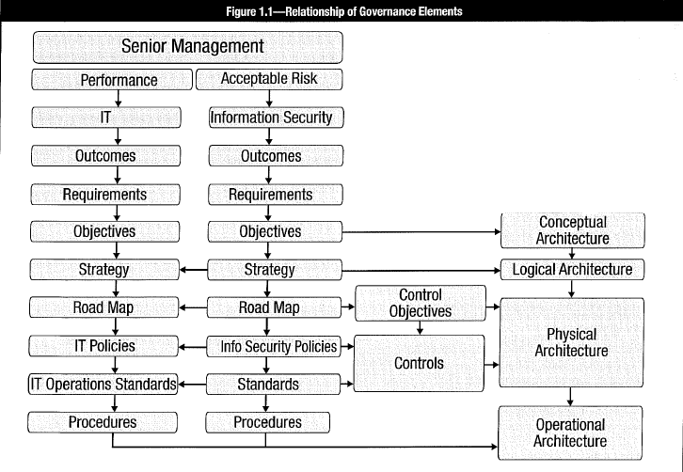

#### 1.2.2 Risk Capacity, Risk Appetite (Acceptable Risk)

**Risk capacity** = Amount of loss an enterprise can tolerate without its continued existence being called into question.

**Risk appetite** = Amount of risk that an entity is willing to accept in pursuit of its mission.

**Acceptable risk** or **risk appetite** (and related assessing *criteria*) determines aspects of strategy: control objectives, control implementation, baseline security, cost-benefit calculations, risk management options, severity criteria, incident response capabilities, insurance requirements and feasibility assessments, etc.

**Risk appetite** translated in ***standards*** & ***policies*** to contain ***risk level*** within ***boundaries*** set by risk appetite. **Boundaries** be regularly *adjusted* or *confirmed*. Within boundaries, *formal and explicit process* to affirm that risk requires NO additional response.

**Risk acceptance** NOT exceed **risk appetite**, NOT exceed **risk capacity**.

**Risk tolerance levels** = Deviations from risk appetite. Not desirable but sufficiently below risk capacity that acceptance of risk still possible. Define risk tolerance with *IT process metrics* or *adherence to defined IT procedures and policies* (=translation of IT goals). Define risk tolerance *at enterprise level;* *reflect in* senior management *policies*. *Exceptions* can be tolerated at lower levels as long as overall exposure not exceed risk appetite.

#### 1.2.3 Infosec Governance Scope & Charter

**Infosec** deals with **all aspects of information**, in *any medium* (e.g., written, spoken, electronic), regardless of how created, viewed, transported, stored or destroyed. **IT security** (by contrast) concerned with information within boundaries of technology domain, usually in custodial capacity (IT not owner of most of information in its systems; rather owns machinery that processes it). Information in IT’s *care, control and custody* ⇨ IT custodian for data owners. **Cybersecurity** = ***both*** information and IT security: malware, ransomware, advanced persistent threats (APTs), phishing in all forms, other threats related to cyberspace.

#### 1.2.4 Governance, Risk Management, Compliance

**Governance, risk management and compliance (GRC)** recognizes necessity for convergence (assurance process integration). See 1.2.6 Assurance Process Integration-Convergence. GRC includes: internal audit, compliance programs (e.g., US Sarbanes-Oxley Act), ERM, operational risk, incident management and others.

•**Governance** = responsibility of senior management and board of directors. Creates mechanisms to ensure personnel follow established processes and policies.

•**Risk management** = process to manage risk to acceptable levels within acceptable tolerances; identify potential risk and associated impacts; prioritize mitigation based on business objectives; develops/deploys internal controls to manage & mitigate risk.

•**Compliance** = process to record and monitor policies, procedures, controls. Ensure that policies and standards are adequately adhered to.

GRC initial response to US SOX Act. Became approach to ERM. Usually focused on financial, IT & legal areas. *Financial GRC* ensures proper operation of financial processes and compliance with regulatory requirements. *IT GRC* ensures proper operation and policy compliance of IT processes. *Legal GRC* focuses on regulatory compliance.

#### 1.2.5 Business Model for Infosec (BMIS)

**BMIS model** uses *systems thinking* to clarify complex relationships within enterprise. *Elements* and *dynamic interconnections* establish boundaries of infosec program. Model how program functions and reacts to internal & external change. Provides *context for frameworks* such as COBIT.

**System** is viewed holistically (not merely a sum of its parts). Holistic approach examines system as complete functioning unit. One part helps understand other parts of system. (“the whole is more than the sum of its parts”). **Systems theory** = *complex network of events, relationships, reactions, consequences, technologies, processes and people that interact in unseen and unexpected ways*.

BMIS viewed as flexible, 3-dimensional, pyramid-shaped structure made up of **4 elements** linked by **6 dynamic interconnections**. The interconnections act as *tensions*, exerting a *push/pull force* in reaction to *changes*, allowing the model to adapt.

###### Figure 1.2 Business Model for Information Security (BMIS)

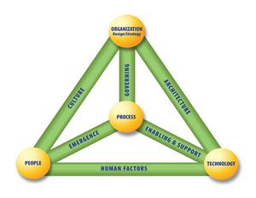

##### Four elements of the model

➊**Organization, design and strategy:**

•**Organization** = network of people, assets and processes interacting with each other in defined roles and working toward a common goal.

•Enterprise’s **strategy** specifies business *goals,* *objectives* to be achieved, values and missions. Sets *basic direction*. Adaptive to external & internal factors. **Resources** = material to design strategy (can be people, equipment, know-how, etc.):

•**Design** defines how to implement strategy. *Processes*, *culture* and *architecture* important in determining design.

➋**People:** *Human resources* and related *security issues*. Defines who implements (through design) parts of strategy. Take into account *values*, *behaviors* and *biases*.

•**Internally**, Work with HR and Legal departments to address issues such as:

-**Recruitment strategies** (access, background checks, interviews, roles, responsibilities)

-**Employment** (office location, access to tools & data, training & awareness, movement within enterprise)

-**Termination** (reasons for leaving, timing of exit, roles & responsibilities, access to systems, access to other employees)

•**Externally** within security posture: customers, suppliers, media, stakeholders.

➌**Process:** *Formal* & *informal* mechanisms (large/ small, simple/ complex) to get things done. Identify, measure, manage and control (risk, availability, integrity, confidentiality). Ensure accountability. Derive from strategy. Implement operational part. Processes must:

•Meet *business requirements* and align with *policy*

•Consider *emergence* and be *adaptable to changing requirements*

•Be well *documented* and *communicated* to appropriate human resources

•Be *reviewed periodically* to ensure efficiency and effectiveness

➍**Technology:** Composed of (tools, applications, infrastructure). *Has own dynamic risk*. Core part of infrastructure and a critical component to accomplish its mission.

•Technology *NOT be viewed as infosec solution*.

•Technology impacted by users and organizational culture. Some mistrust technology; not learned to use it; feel it slows them down. Be aware that, as with physical and administrative controls, people will try to *sidestep t*echnical controls.

##### Six dynamic Interconnections

➊**Governance:** Steer enterprise. Demand strategic leadership. Set limits for operation. Implemented within processes to monitor performance, describe activities and achieve compliance. Adapt to emergent conditions. Ensure objectives determined. Ascertains risk managed appropriately. Verify resources used responsibly.

➋**Culture:** Pattern of behaviors, beliefs, assumptions, attitudes and ways to do. Emergent and learned. Create sense of comfort.

•Influences what information to consider, how interpreted, and what to be done with it.

•Many levels: *national* (legislation/regulation, political, traditional), *organizational* (policies, hierarchical style, expectations), *social* (family, etiquette). Created from both external and internal factors; influenced by and influences organizational patterns.

➌**Enablement & support:** Connects technology to process element.

•Make processes *usable* and *easy* ⇨ (Helps people comply with technical security measures, policies, procedures). *Transparency* helps acceptance of security controls if security not inhibit user’s ability to work effectively.

•Actions affecting technology and processes occur in “enablement and support”. Policies, standards, guidelines to support business needs by reducing conflicts of interest, remaining flexible to support changes, being acceptable and easy for people to follow.

➍**Emergence** (surfacing, developing, growing, evolving): Patterns with *no* obvious cause and outcomes *impossible* to predict and control. Place to introduce solutions such as feedback loops; alignment with process improvement. Consider emergent issues in system design life cycle, change control and risk management.

➎**Human factors:** Represents interaction & gap between technology and people. Critical *to* infosec program. Internal threats (data leakage, data theft and misuse of data) occurs within this dynamic interconnection. Arise due inexperience, cultural experiences, differing generational perspectives. Train human resources on pertinent skills.

➏**Architecture:** *Comprehensive* and *formal* encapsulation of people, processes, policies and technology comprising enterprise’s security practices.

•Robust business information architecture essential to understand need for security; to design security architecture.

•Defense in depth ensured within *architecture dynamic interconnection*. Describe how security controls positioned; how they relate to overall enterprise architecture. Facilitate security capabilities across lines of businesses in consistent & cost-effective manner. Enable enterprises be proactive with security investment decisions.

#### 1.2.6 Assurance Process

##### Integration

Assurance processes often fragmented and segmented in silos with different reporting structures. Tend to use different terminology. Reflect different understandings of processes and outcomes. Assurance silos include: risk management, change management, internal & external audit, privacy offices, insurance, human resources (HR), legal, etc. can Mitigate tendency for security gaps to exist among various assurance functions. Evaluate business processes from start to finish (along with their controls), regardless of particular assurance process. **GRC** (see section 1.2.4): recent effort to address integration issues among major functions of governance, risk management and compliance. **BMIS** (see section 1.2.5): ISACA effort to develop integrated approach to infosec using a systems approach. **ISO/IEC 27001:2013** (see section 3.5.2): requirements to establish, implement, operate, monitor, review, maintain and improve documented **infosec management system (ISMS)** within context of organization’s overall business risk.

##### Convergence

Security-related activities divided into: physical security, IT security, risk management, privacy, compliance and infosec. Not conducive to achieve optimal results. CISOs often elevated to CSOs. Physical security fairly routine, more easily integrated into infosec. Expect integration of many security activities centered around infosec.

### 1.3 ROLES & RESPONSIBILITIES

Clearly define responsibilities and communicate throughout enterprise on recurring basis.

**Role** = designation assigned to individual by virtue of a job function or other label. **Responsibility** = description of procedures/ functions related to role. Roles important to infosec because *responsibilities* and *access* *rights* assigned based on performing function rather than on individual people.

**RACI (responsible, accountable, consulted, informed)** charts define roles. **Figure 1.3** shows typical organizational roles and related governance activities (R: responsible, A: accountable, C: consulted, I: informed).

###### Figure 1.3 Sample RACI chart

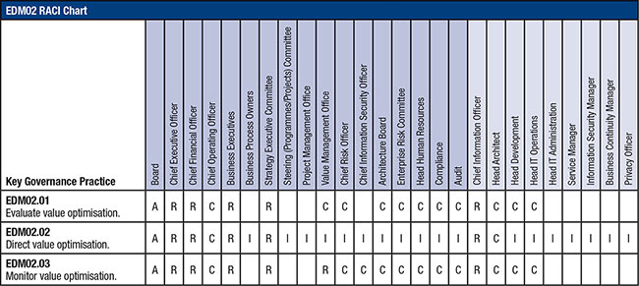

##### Skills

Skills be considered when developing RACI charts. Skills = training, expertise and experience. Ensure proficiencies mapped to competencies required for program implementation. Specific skills acquired through training or external resources (consultants more cost-effective). Establish formal employment agreements to reference responsibilities to consider when screening for employment.

##### Culture

Culture represents organizational behavior, methods for navigating and influencing organization’s formal and informal structures to get the work done, attitudes, norms, level of teamwork, existence or lack of turf issues, and geographic dispersion. Impacted by individual backgrounds, work ethics, values, past experiences, individual filters/blind spots and perceptions of life that individuals bring to workplace. Every organization has culture (whether purposely designed or emerged over time as reflection of leadership).

Recognize logical and analytical activities; Skills: build relationships, foster teamwork and influence organizational attitudes toward positive security culture).

Build security-aware culture. Each person, no matter what level or role, be able to articulate how infosec relates to their role. Infosec to plan communications, participate in committees and projects, and provide individual attention to end users’ or managers’ needs. Be able to answer “*What is in it for me?*” or “*Why should I care?*”

**Indicators of successful security culture**: Infosec brought into projects at appropriate times, end users knowing how to identify and report incidents, organization’s ability to identify security manager, people knowing their role in protecting information assets, and integrating information security into daily practices.

#### 1.3.1 Board of Directors

Board members be aware of information assets, risk to assets and criticality to ongoing business operations. *PWC Global State of Infosec Survey 2016:* 45% say board participates in security strategy. Report to Board high-level results of *risk assessments* and *business impact analysis (BIA);* validate/ratify key assets and protection levels & priorities (appropriate to standard of due care?)

Security expectations be met at all levels. Noncompliance penalties be defined, communicated and enforced from board level down. Ongoing obligation to provide oversight of infosec activities due directors’ legal & ethical responsibility to exercise due care in protecting key assets (include confidential and critical information).

Other concern: ***liability***. Insurance requires directors to exercise *good faith effort* in exercising due care to discharge duties. Neglection may void insurance protection.

US SOX Act mandates company listed on US stock exchange maintain **audit committee** (comprised of Board members) with required level of experience and demonstrable competence. Committee’s responsibilities: ongoing monitoring of ***internal controls*** that affect reliability of financial statements. *Financial controls* technical and procedural; technical portion in-scope of infosec.

Institutional investors understand long-term org. prospects impacted by governance. Corporate rating now includes ***governance rating*** or ***metric***. Weight & relevance of scores driven by impacts and consequences of loss of critical and sensitive information.

Bottom line: Board of directors subject to increasing degree of liability and regulatory intervention. *PWC Global State of Infosec Survey 2016*: “*Cyber security is now a persistent business risk. It is no longer an issue that concerns only information technology and security professionals, the impact has extended to the C-suites and boardroom.*”

#### 1.3.2 Senior Management

Senior management responsible to ensure org. functions, resources and infrastructure available and utilized to fulfill Board’s infosec-related directives, regulatory compliance and other demands. While IT faced with performance pressures, security must deal with *risk* and *regulatory issues* ⇨ Tension between IT & security ⇨ Senior management promotes cooperation, arbitrates differences, is clear about priorities ⇨ Maintain balance among performance, cost and security.

#### 1.3.3 Business Process Owners

Align infosec activities with business objectives. Determine cost-effectiveness of infosec program in achieving predictable level of assurance and acceptable level of impact.

#### 1.3.4 Steering Committee

Steering committee comprised of senior representatives of affected groups. Achieve consensus on priorities & tradeoffs. Effective communications channel. Basis to ensure alignment with business objectives. Instrumental to modify behavior toward culture more conducive to good security. Topics, agendas, decisions for security steering committee:

•Security strategy & integration efforts (e.g., to integrate security with business activities)

•Actions and progress relative to business support of infosec functions and vice versa

•Emerging risk, business security practices and compliance issues

Infosec manager ensure that roles, responsibilities, scope and activities of infosec steering committee clearly defined to prevent poor productivity/distractions from priorities of committee. Important: materials be distributed, reviews encouraged and solution discussions held in advance of full committee meeting. Use subcommittees and individual action assignments for this type of management strategy.

#### 1.3.5 Chief Infosec Officer

Chief infosec officer (CISO) maybe chief information officer (CIO), chief security officer (CSO), chief financial officer (CFO) or chief executive officer (CEO). Authority required to make decisions and responsibility to take action be held by C-level officer or senior manager. Legal responsibility extends up command structure and ultimately resides with senior management and board of directors. *PWC Global State of Infosec Survey 2016*: 54% have CISO in charge of security program; reported to CEO, followed by CIO, board and chief technology officer (CTO) ⇨ CISO is fundamentally a ***regulatory role*** (CIO focuses on performance). Main concern: inadequate budget to execute security program and provide adequate attention to end users’ or managers’ needs.

### 1.4 RISK MANAGEMENT ROLES & RESPONSIBILITIES

#### 1.4.1 Key Roles

*US National Institute of Standards and Technology (NIST) Special Publication 800-30 Revision 1: Guide for Conducting Risk Assessments*

•**Governing boards & senior management**: Senior management under standard of due care and responsibility for mission accomplishment. Ensures necessary resources effectively applied. Assess/ incorporate results of risk assessment activity in decision-making process. Support/be involved - assesses & mitigates IT-related mission risk.

•**Chief risk officer:** Charged with ERM (may include infosec). Includes all non-information risk (operational risk, environmental risk and credit risk).

•**Chief information officer:** Responsible for IT planning, budgeting and performance.

•**Chief Infosec officer (CISO)**: Performs most of functions of infosec manager. Holds officer status. Greater authority. Includes more strategic and management elements.

•**Infosec manager**: Responsible for org. security programs, including information risk management. Leading role to introduce appropriate, structured methodology to identify, evaluate and minimize risk to information resources.

•**System & information owners**: Responsible to ensure proper controls in place to address confidentiality, integrity and availability of IT systems and data. Responsible for changes to their IT systems. Responsible for policy compliance and enforcement. Have to approve and sign off on changes. Involved in governing policies and standards (e.g., system enhancement, major changes to SW/HW, and compliance requirements). Must understand role in risk management process, objectives and requirements.

•**Business & functional managers**: Responsible for business operations and IT procurement process. Active role in risk management process. Have authority and responsibility to make trade-off decisions essential to mission accomplishment. Involvement in risk management achieves security for IT systems ⇨ Provide mission effectiveness with acceptable expenditure of resources.

•**IT security practitioners** (network, system, application, DB administrators; computer specialists; security analysts; security consultants): Implement security requirements in systems. Changes to environment (network connectivity, infrastructure, org. policies, standards, procedures, new technologies)? Support/use risk management process to identify and assess new potential risk; implement new security controls as needed.

•**Security awareness trainers (security/subject matter** **professionals):** Critical to mitigate risk and protect IT resources: use IT systems and data according to org policies, guidelines and rules of behavior ⇨ Need security awareness training + processes & requirements for secure operations. IT security trainers or security/subject matter professionals must understand org. risk management objectives and processes.

#### 1.4.2 Infosec Roles & Responsibilities

##### Obtain Senior Management’s commitment

After infosec has developed security strategy with input from business and data owners, senior management approves strategy to ensure support and resources. Need infosec to first educate senior managers on high-level aspects of infosec before submitting strategy for review ⇨ presentation to describe aspects of security strategy; educate in areas of regulatory compliance and organization’s dependence on information assets; document risk and potential impacts; inform on potential for compromise and consequences. True value of securing information systems become *apparent only when they fail*

Recommendations to address management’s possible questions on what actions would constitute an appropriate level of support:

•Clear approval & support for formal security strategies and policies

•Monitor & measure org. performance in implementing security policies

•Support security awareness and training for all staff throughout organization

•Adequate resources & sufficient authority to implement/maintain security activities

•Treat infosec as critical business issue. Create security-positive environment

•Demonstrate to 3rd parties that org. deals with infosec in professional manner

•Provide high-level oversight & control

•Periodically review infosec effectiveness

•Set example by adhering to organization’s security policies and practices

•Address infosec issues at board/senior management meetings.

Support for infosec programs may be limited for financial or other reasons. Infosec to recognize constraints ⇨ Prioritize and maximize effects of available resources. Work with management to develop additional resources.

##### Develop & Present Business Case

**Business case** provides information to decide whether project should proceed. Essential consideration: *value proposition* or *cost-benefit analysis*. Business case normally derived from **feasibility study** (part of project initiation/planning; early study of problem; assess if solution is practical, meets requirements within budgets and schedule requirements).

**Six elements of feasibility study**:

➊**Project scope** defines business problem and opportunity to be addressed

➋**Current analysis** defines and establishes understanding of system, SW product, infosec control, etc. Based on this analysis, determine that current system or SW is working correctly, modifications needed, or upgrade/replacement required. Identify strengths & weaknesses of current system or SW product.

➌**Requirements** are defined based on stakeholder needs & constraints. SW requirements ≠ systems requirements. Examples of needs & constraints to define requirements: •Business, contractual and regulatory processes •End-user functional needs •Technical/ physical attributes that define operational & engineering parameters

➍**Approach** = recommended system and SW to satisfy requirements. Identify alternatives and rationale to select proposed solution. Consider “build versus buy” decisions.

➎**Evaluation** based on previously completed elements within feasibility study. Address cost effectiveness of selected approach selected or the value proposition. Include:

•Estimated total cost of project (along with alternates as cost comparison) comprising:

+Estimate of employee hours required to complete +Material & facility costs +Vendors and 3rd-party contractors costs +Project schedule start & end dates +Cost & evaluation summary encompassing cost-benefit analysis, return on investment (ROI), etc.

➏**Formal review of feasibility study** with all stakeholders. Validates completeness & accuracy of feasibility study. Renders decision to approve/reject project or ask for corrections before making a final decision. If approved, all key stakeholders sign the document. Rationale for rejection be explained and attached to document as part of a lessons learned for use in future project studies.

Develop options to compare costs and business benefits of various options. Sufficient detail to justify. Answer question, “Why should this project be undertaken?” Business case be key element of decision process *throughout life cycle of project*. If business case rendered invalid (increased costs or reduced benefits), consider whether project should proceed. Provide decision points in project ( “*stage gates*” or “*kill points*”) to review and re-validate business case (and re-approve if necessary).

Facilitate acceptance by applying common business case aspects:

•**Align security objectives with business objectives**: Enable senior management to understand and apply security policies & procedures

•**Identify potential consequences if failing** security objectives & regulatory compliance

•**Identify budget items** for senior management to quantify costs of security program

•**Use commonly accepted project risk/benefit or financial models** (TCO, ROI)

•**Define monitoring & auditing measures** to include in security program.

All employees must understand and abide by security policies, standards and procedures. Gain acceptance by showing management clearly comply with org. security policies

##### Establish reporting & communication channels

Presentation to senior management and business owner’s contents:

•Status of implementation of system based on approved strategy

•Overall BIA result comparison (prior to and after implementation)

•Statistics of detected and prevented threats (to demonstrate value)

•Identify weakest security links in org. and potential consequences of compromise

•Performance measurement data analysis supported with external assessment/audit

•Address ongoing alignment for critical business objectives, operation processes or corporate environments

•Require approval for renewed plans, as well as related budget items

Four groups requiring different communication channels:

➊**Senior management**

-Attend business strategy meetings to get updated business strategies and objectives.

-Periodic one-to-one meetings to understand business objectives from its perspective.

➋**Business process owners**

-Join operation review meetings to realize challenges & requirements of daily operations and dependencies.

-Monthly one-to-one meetings to gain continued support in implementation of infosec governance and address current individual security-related issues.

➌**Other management**

-Inform line managers, supervisors, department heads on security & risk management-related functions, incl. ensure security requirement awareness and policy compliance.

➍**Employees**

-Offer timely training & education programs.

-Initiate centralized on-board training program for new hires.

-Distribute education material on updated strategies and policies.

-Instruct personnel to access intranet or email-based notifications for periodic reminders or ad hoc adaptations.

-Support senior management/business process owners by assigning infosec governance coordinator to functional unit for accurate/timely feedback of daily practices.

###### Figure 1.4 Relationship Security Governance Outcomes - Management Responsibilities

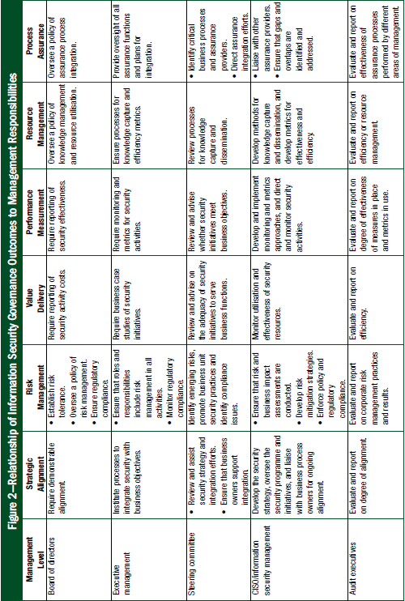

### 1.5 GOVERNANCE of 3RD-PARTY RELATIONSHIPS

Third-parties include: •Service providers •Outsourced operations •Trading partners •Merged or acquired organizations

Challenges: •Cultural differences ⇨ not acceptable approaches to security and behavior •Technology incompatibilities between organizations, process differences that do not integrate well or inadequate levels of baseline security •Areas of concern: incident response, business continuity and disaster recovery capabilities.

Infosec to assess impacts of possible security failures of 3rd party. Understand and plan to manage potential failures within acceptable range.

Document responsibilities of infosec manager to address risk and impacts of 3rd-party relationships. Develop policies, standards and procedures to establish involvement of infosec prior to creation of 3rd-party relationship ⇨ determine risk so management can decide whether acceptable or to be mitigated. Formalize engagement model between infosec and 3rd parties to establish & manage third-party relationships.

### 1.6 INFOSEC GOVERNANCE METRICS

**Metric** = quantifiable entity to measure achievement of process goal. **Security** = protection from (or absence of) danger. **Security metrics** inform about degree of safety relative to reference point. Distinguish managing technical IT security infrastructure at operational level against overall management of infosec program.

**Technical metrics** useful for tactical operational management of technical security systems (*i.e., intrusion detection systems [IDSs], proxy servers, firewalls, etc*.) Indicate that infrastructure is operating soundly; technical vulnerabilities identified and addressed.

However, technical metrics NOT informative on: strategic management/governance; strategic alignment with organizational objectives; how well risk is managed; policy compliance; progress in objectives for acceptable levels of impact; progress of infosec program in achieving desired outcomes. NO answers to following questions:

•How secure is organization?

•How much security is enough?

•How do we know when we have achieved an adequate level of security?

•What are the most cost-effective security solutions?

•How do we determine the degree of risk?

•How well can risk be predicted?

•Is the security program achieving its objectives?

•What impact is lack of security having on productivity?

•What impact would a catastrophic security breach have?

•What impact will security solutions have on productivity?

Address with metrics on management requirements to make decisions about organization’s safety. Need full audits and comprehensive risk assessments to provide this breadth of perspective. But audits and risk assessment only provide *history* or snapshot: NOT a day-to-day guide for security management.

#### 1.6.1 Effective Security Metrics

Fundamental purpose of metrics, measures & monitoring: decision support. Metrics info be relevant to roles & responsibilities. *Anything that results in change can be measured*.

**Criteria for good metrics (SMART)**:

•**Specific:** Based on clearly understood goal; clear and concise

•**Measurable:** Able to be measured; quantifiable (objective), not subjective

•**Attainable:** Realistic; based on important goals and values

•**Relevant:** Directly related to a specific activity or goal

•**Timely:** Grounded in a specific time frame

Other considerations (Brotby, Krag; InfoSec Management Metrics, Auerbach, USA, 2009):

•**Accurate:** Reasonable degree of accuracy.

•**Cost-effective:** Measurements not too expensive to acquire or maintain.

•**Repeatable:** Measure be acquired reliably over time.

•**Predictive:** Measurements be indicative of outcomes.

•**Actionable:** Clear to recipient what action must be taken.

Standard security metrics: downtime due to viruses or Trojans, number of penetrations of systems, impacts and losses, recovery times, number of vulnerabilities uncovered with network scans, and percentage of servers patched. These measures are indicative of aspects of security, useful to IT operations, BUT no information about how secure organization is; probably not meet aforementioned criteria.

Some major efforts to develop useful metrics:

•**ISO/IEC 27004:2009 Information technology**: **Security techniques: Infosec management: Measurement**: Part of ISO/IEC 27XXX series of security standards that includes *ISO/IEC 27001:2013 Infosec management* and *ISO/IEC 27002:2013 Information technology: Security techniques: Code of practice for infosec controls*. ISO/IEC 27004 “*provides guidance on the development and use of measures and measurement in order to assess the effectiveness of an implemented infosec management system and controls or groups of controls as specified in ISO/IEC 27001*.” Not widely accepted; many deficiencies; currently rewritten to address issues raised by infosec community.

•**COBIT 5**: (based on *balanced scorecard*) Approx. 150 metrics for each of 17 enterprise goals. *COBIT 5: Enabling Processes* states, “*These metrics are samples and every enterprise should carefully review the list, decide on relevant and achievable metrics of its own environment, and design its own scorecard system*.” But lack of guidance on development and implementation; what is relevant and achievable? development of scorecard?

•**Center for Internet Security (CIS)**: *The CIS Security Metrics (2010)* offers comprehensive approach to develop and implement infosec metrics. Includes 28 metrics definitions with a number of possible metrics for 7 major business functions (on consensus of 150 industry professionals).

•**NIST Special Publication 800-55 Revision 1: Performance Measurement Guide for Infosec**: Aligned with security controls in **NIST SP 800-53**. Comprehensive approach to selection, development and implementation of a metrics. Aimed to support *Federal Information Security Modernization Act (FISMA)* - high-level policy document for US federal agencies with value for the commercial environment.

*Operational risk* & *security* NOT measured in absolute but: *probabilities*, *exposures*, *attributes*, *effects,* *consequences*: **value at risk (VAR)[1]**, **return on security investment (ROSI)[2]** and **annual loss expectancy (ALE)[3]** (see section 2.7.14 Analysis Of Risk). These speculative numbers are basis to allocate/justify resources for security activities.

Maximum impacts of potential adverse events as measure of security? Measure security by consequences and impacts is similar to gauging how tall a tree is by how loud a noise it makes when it falls. Adverse events need to occur to determine if security is working. Absence of adverse events provides no information on state of security (may mean that defenses worked, no one attacked or vulnerability not discovered). Simulated attacks with penetration testing can provide some measure of effectiveness of defenses. But unless statistically relevant % of all possible attacks, no prediction can be made about state of security and organization’s ability to resist attack.

Certainty about security:

1. Some organizations attacked more frequently and suffer greater losses than others.

2. Strong correlation between good security management & practices and fewer incidents & losses.

*Good metrics be based on attributes, costs and subsequent outcomes of security program.* **Figure 1.5** presents components of infosec governance program. Demonstrates that actual course of governance and ability to measure/report performance is required.

###### Figure 1.5 NIST SP 800-55 Components of Security Metrics

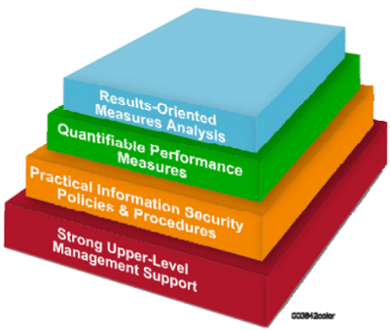

**Fallacy of assumption that (risk, threat, impact) can be determined by measuring just technical vulnerabilities** (without considering potential threats, exposure, impacts). Example: Use vulnerability scans as indication of overall security. Impossible to eliminate all or most vulnerabilities ⇨ Risk could NOT be avoided. Effective metrics can be designed if clear infosec objectives have been developed. *Metrics = any measure of results of infosec program progressing toward defined objectives* (serving as reference point). Different metrics required for information at *strategic*, *tactical* and *operational* levels. *Strategic metrics* oriented toward high-level outcomes and business objectives.

#### 1.6.2 Metrics on Governance Implementation

Relevant metrics for implementation of governance program. Performance of overall security program too far downstream to provide timely information on implementation. **Key goal indicators (KGIs)** and **key performance indicators (KPIs)** useful information about achievement of process or service goals; can determine whether organizational milestones & objectives are met. **Standard project measurement** can also serve as metrics (achieve specific milestones/objectives, budget/ time line conformance).

#### 1.6.3 Metrics on Strategic Alignment

Cost-effectiveness of security program tied to how well it supports business objectives at what cost. Organizational objectives be used as reference point (other gauge, including best practices, be overkill, inadequate or misdirected). Adequate & sufficient practices proportionate to requirements ⇨ more cost-effective than best practices, and received better by cost-conscious management.

Best overall indicator that security activities in alignment with business objectives = development of security strategy that defines security objectives in business terms; and ensures that objectives are directly articulated from planning to implementation of policies, standards, procedures, processes and technology. Litmus test: reverse order evaluation of specific control being able to be tracked to specific business requirement. Any control that cannot be tracked back to a specific business requirement is suspect and should be analyzed for relevancy and possible elimination.

**Indicators of alignment** include:

•Extent to which security program demonstrably enables specific business activities

•Business activities NOT undertaken or delayed due inadequate capability to manage risk

•Responsive security organization to business requirements (from business owner input)

•Organizational and security objectives be defined and clearly understood by all involved in security and related assurance activities. Measured by *awareness testing*

•Percentage of security program activities mapped to organizational objectives and validated by senior management

•Security steering committee consists of key executives with charter to ensure ongoing alignment of security activities and business strategy.

#### 1.6.4 Metrics on Risk Management

**Risk management** = ultimate objective of all infosec activities and organizational assurance efforts. Risk management effectiveness NOT directly measured. Instead, *indicators correlate to successful approach*. Successful risk management program *efficiently*, *effectively* and *consistently* meets expectations & attains defined objectives (assuming that expectations & objectives of risk management defined).

**Indicators of appropriate risk management**:

•Defined organizational risk appetite and tolerance that are relevant to organization

•Completeness of security strategy and program to achieve acceptable levels of risk

•Number of defined mitigation objectives for identified significant risk

•Processes to manage or reduce adverse impacts

•Coverage of critical systems by systematic, continuous risk management processes

•Trends of risk assessment indicating progress toward defined goals

•Trends in impacts

•Results from tested incident response and business continuity/disaster recovery plans

•Completeness of asset inventory, valuation and assignment of ownership

•Percentage of BIAs of all critical or sensitive systems

•Extent of complete and functioning asset classification process

•Ratio of security incidents from known risk compared to unidentified risk.

**Key metric**: adverse impacts of infosec incidents experienced by organization and extent to which they do (or not) exceed criteria for acceptable risk and impact. Effective security program shows *trend in reduced incident frequency and impact*. **Quantitative measures** include *trend analyses of impacts over time in financial terms*.

#### 1.6.5 Metrics on Value Delivery

**Value delivery** when security investments optimized in support of objectives. Function of strategic alignment of security strategy & business objectives (e.g., when a business case be convincingly made for all security activities). *Optimal investment levels* when strategic goals for security achieved and acceptable risk posture attained at lowest cost.

**Key indicators (KGIs & KPIs)**:

•Security activities achieving strategic objectives cost-effectively

•Cost of security proportional to asset value

•Security resources allocated by degree of risk & potential impact

•Protection costs aggregated as function of revenues/ asset valuation

•Controls based on control objectives (defined, achieved, fully utilized)

•Adequate & appropriate number of controls to achieve acceptable risk & impact levels

•Control cost-effectiveness determined by periodic testing

•Policies requiring controls be re-evaluated for cost, compliance, effectiveness

•Use of controls (controls rarely used not cost-effective).

•Controls achieving acceptable risk & impact levels (fewer effective controls more cost-effective than many less effective controls).

•Effectiveness of controls determined by testing. Marginal controls not cost-effective

#### 1.6.6 Metrics on Resource Management

**Infosec resource management** describes processes to plan, allocate and control infosec resources (people, processes and technologies). Knowledge be captured, disseminated and available when needed. Providing multiple solutions to same problem is inefficient and indicates a lack of resource management. Controls and processes be standardized, when possible, to reduce administrative and training costs. Problems and solutions be well documented, referenced and available.

**Indicators of effective resource management** include:

•Infrequent problem solution rediscovery

•Effective knowledge capture and dissemination

•Extent to which security-related processes are standardized

•Clearly defined roles & responsibilities for infosec functions

•Infosec incorporated into every project plan

•Percentage of information assets & related threats addressed by security activities

•Proper org. location, level of authority, number of personnel for infosec function

•Resource utilization levels

•Staff productivity

•Per-seat cost of security services

#### 1.6.7 Metrics on Performance

Critical to design metrics that indicate performance of security machinery. Information needed to make decisions to guide security activities of organization.

**Indicators of effective performance measurement:**

•Time to detect & report security-related incidents

•Number & frequency of subsequently discovered unreported incidents

•Benchmarking comparable organizations for costs & effectiveness

•Ability to determine effectiveness/efficiency of controls

•Clear indications that security objectives are met

•Absence of unexpected/undetected security events

•Knowledge of evolving & impending threats

•Effective means to determine organizational vulnerabilities

•Methods to track evolving risk

•Consistency of log review practices

•Results of business continuity planning (BCP)/disaster recovery (DR) tests

•Extent to which key controls are monitored

•Percentage of metrics achieving defined criteria (meta-metrics)

#### 1.6.8 Metrics on Integration (Convergence) of Assurance Process

Include effort to integrate assurance functions ⇨ Increase security effectiveness and efficiency; reduce duplicated efforts and gaps in protection; ensure that processes operate as intended from end to end, minimizing hidden risk.

**KGIs** include:

•No gaps in information asset protection

•Elimination of unnecessary security overlaps

•Seamless integration of assurance activities

•Well-defined roles & responsibilities

•Assurance providers understand relationship to other assurance functions

•All assurance functions are identified & considered in strategy

•Effective communication & cooperation between assurance functions

The BMIS approach (see section 1.2.5) brings various elements and stakeholders in the problem set to work closely together. Major objective: understand how organizations can bring together diverse elements and get them to orient on common objectives.

### 1.7 INFOSEC STRATEGY OVERVIEW

**Strategy** derives from military: *plan to achieve an objective*. Two elements to develop a plan to achieve objective: ➊well-defined objectives; ➋understanding of current conditions. Strategy requires *knowing where you are* and *where you need to go*, then *analyze gap to determine what needs to be accomplished to bridge the gap*.

###### Figure 1.6 Participants involved in developing security strategy

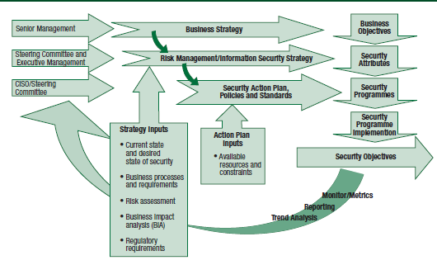

Figure 1.6 shows the participants in developing a security strategy, their relationships and alignment with business objectives. “*Business Strategy*” provides basis for road map to achieve “*Business Objectives*”; and input into “*Risk Management*” and “*Information Security Strategy*”. Balance inputs by comparing desired state to existing state of security. Consider business processes, key organizational risks (e.g., regulatory requirements), risk analysis and associated impact analysis to determine protection levels & priorities. Constant constraint = organization’s *risk appetite* & *capacity* (see section 1.2.2).

Strategy & action plans to contain provisions for monitoring + metrics to determine level of success ⇨ Provides feedback to CISO and steering committee to allow mid-course correction and ensure security initiatives are on track to meet defined objectives.

#### 1.7.1 Develop Infosec Strategy

Many elements to consider when developing infosec strategy as in figure 1.7 and 1.8.

###### Figure 1.7 Prevalent Standards and Frameworks

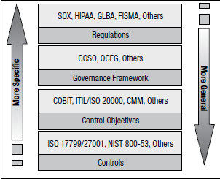

###### Figure 1.8 SABSA Security Architecture

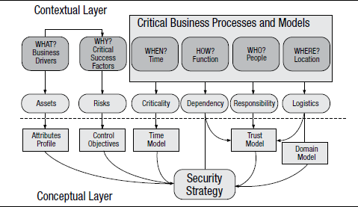

In addition, be aware of common failures of strategic plans to avoid pitfalls.

#### 1.7.2 Common Pitfalls

**Failures with root causes explained by behavioral economics**:

•**Overconfidence**: Excessive confidence in ability to make accurate estimates. Reluctant to estimate wide ranges of possible outcomes. Prefer being *precisely wrong*, than *vaguely right*. Tend to be overconfident of own abilities.

•**Optimism**: Be optimistic in forecasts. Combination of overconfidence and optimism ⇨ disastrous impact on strategies based on unrealistically precise/optimistic estimates

•**Anchoring**: Subsequent estimate of unrelated subject involving numbers will “anchor” on previous number. Serious consequences in developing strategies when future outcomes anchored in past experiences.

•**Status quo bias**: Strong tendency toward sticking with known approaches even if inadequate or ineffective. Concern over loss generally stronger than possible gain. “**Endowment effect**” similar bias: people prefer to keep what they own/know; owning something makes it more valuable to the owner.

•**Mental accounting**: “*inclination to categorize & treat money differently depending on where come from, where kept, and how spent.*” Mental accounting common even with conservative/rational, corporations. Examples: •Be less concerned with expenses against restructuring charge than those against profit & loss statement •Impose cost caps on a core business while spending freely on a start-up •Create new categories of spending such as “revenue investment” or “strategic investment”

•**Herding instinct**: Fundamentally human to conform & seek others’ validation (“faddism” in security, sudden interests in ID management/ intrusion detection, “*idea whose time has come*”, herding instinct behind thought leaders: “*the only thing worse than making a huge strategic mistake is being the only person in the industry to make it.*”

•**False consensus**: Tendency to overestimate the extent that others share their views, beliefs and experiences. When developing strategies, *false consensus* leads to minimizing important threats/weaknesses in the plans and to persist with doomed strategies.

**More common causes of flawed decision** (from C. F. Camerer and G. Loewenstein):

•**Confirmation bias**: Seek opinions and facts that support one’s own beliefs

•**Selective recall**: Remember only facts & experiences that reinforce current assumptions

•**Biased assimilation**: Accept only facts that support current position or perspective

•**Biased evaluation**: Accept evidence that supports own hypotheses. Challenge/ reject contradictory evidence. Critics charged with hostile motives or competence impugned.

•**Groupthink**: Pressure for agreement in team-based cultures.

### 1.8 INFOSEC STRATEGY OBJECTIVES

Define objectives for developing infosec strategy. Develop metrics to measure achievement. **Six outcomes of security governance** to provide high-level guidance:

➊Strategic alignment

➋Effective risk management

➌Value delivery

➍Resource optimization

➎Performance measurement

➏Integration of assurance processes

#### 1.8.1 The Goal

**What is the goal**? Trivial question (goal of infosec = protect org. information assets). But most fail to define with any specificity, because: ➊Must know Information assets with precision ➋Must define *which* assets need *how much* protection *against what*.

**Challenges**: Scant knowledge of what info exists: no process to purge useless, outdated, dangerous info, data, unused applications; no comprehensive catalog/ index of info/ processes to define what is (not) important, who owns it ⇨ Everything gets saved assuming that storage cheaper than data classification, ownership assignment and identification of users ⇨ Difficult to devise *data protection plan* (little sense to expend resources to protect useless or dangerous data[4] or unused applications).

Information be classified by *criticality* and *sensitivity* or *business value*. **Classification:** basis to apply *protective measures in proportion to business value* (otherwise, it is **wasteful** to expend substantial resources to protect them).

Assign **value to information** to **prioritize** budget-constrained protection efforts and determine **levels of protection**. Difficult to be precise. Alternatives: *cost of creating or replacing it* (e.g. knowledge or trade secrets difficult to replace and may be priceless). Create **rough levels of value** (0-5, 0=no value and 5=critical). **Zero-value information**: applications with no owner, no use for a period of time; be archived for a specified period then destroyed). Alternatively, **business dependency evaluation** used as **indication of value:** define critical business processes, then what information and physical assets are used in the process. The contribution these resources make to revenue measures level of criticality of information resources.

**Sensitivity:** (subjective call). Disclose sensitive info? Many ramifications. Data owner best to determine: consequences of “*data leakage*”; *classification level for data* (basis to protect efforts & access control) ⇨ Use 3 (or 4) sensitivity/criticality classifications: confidential, internal use and public.

Policies, standards and processes be developed to mandate classification moving forward and prevent problem from getting worse. **Over-classification** serious problem for classification implementation. Organizations with blame culture: data owners may err on side of caution by marking data more sensitive/critical than warranted, negating benefits of classification. Practical solution: IT operates on chargeback system and IT services cost to business units ⇨ Additional charges for higher classifications.

Another essential part: ensure assets have **owner** and defined **accountability**. Create RACI charts as discussed in section 1.3 Roles and Responsibilities.

**Conditions for cost-effective security strategy**:

•Define **business requirements** for infosec

•Determine **objectives** of infosec that will satisfy the requirements

•**Locate** & **identify** information assets and resources

•**Evaluate** information assets and resources

•**Classify** information assets per **criticality** and **sensitivity**

•Implement process to ensure that all assets have a defined **owner**.

#### 1.8.2 Define Objectives

Why **long-term objectives** for **desired state of security**? Avoid *ad hoc tactical* solutions ⇨ Non-integrated systems difficult to manage, costly, impossible to secure.

InfoSec **objectives** stated in terms of **risk**, **goals** aimed to support business **activities**. **Notes**: Risk mitigation (virus, malware protection) = protection = support org. health but NOT considered business enabler]. Review: business plans, change management, audit reports, steering committee discussions ⇨ Uncover opportunities for InfoSec to support/enable business by reducing risk, losses, operational disruptions.

Example: Implement *public key infrastructure (PKI)* for high-value transactions between trusted trading partners or customers. Deploy *virtual private networks (VPNs)* to provide sales with secure remote connectivity, protection for sensitive information ⇨ *Infosec enables activities otherwise too risky to undertake*.

##### Business Linkages

Ensure **direct linkages** between (strategic objectives, business activities & goals). Develop & analyze **business linkages** to *uncover InfoSec issues* at operational level ⇨ Improve *value of InfoSec* by making business processes more robust, reducing errors and improving productivity. Include representatives of major departments and business units in *InfoSec steering* to realize benefits from improved business linkages.

Understand & consider all info streams critical to operations. Anything affects *integrity* or *availability* of info is a problem. Start with *objectives* of specific business line. Analyze elements of a product line. Look at pieces of info that is handled & processed. Investigate *process history* for *past failures*.

Example: Manufacture breakfast cereal. Raw materials come into plant just-in-time via railcar. Grains dumped into hoppers that feed various processing machinery. Finished cereals packaged and moved to warehouse continuously and automatically in hours. Process relies on *information flows* subject to failure of *availability,* *confidentiality* or *integrity*. Breakdown or disruption in supply chain (e.g., *ordering*, *tracking*, *payments*) causes disruption in manufacturing. All automated processing activities in plant are tied to data processing and information flows. Interruption or data corruption cause failure of process (stop manufacturing or deliver defective product).

Procedural changes/entry validation can address entry errors. Periodic self-test or instrumentation redundancy can address instrumentation failures. Control access can prevent unauthorized access. Failures due to human error? Reduce errors with additional controls OR redundancy (more automated processes). Data entry errors? Improve by range checking OR technical processes to correct instrumentation failure.

#### 1.8.3 The Desired State

“**Desired State**” = complete snapshot of relevant conditions at point in future. For robust picture, include: principles, policies and frameworks; processes; organizational structures; culture, ethics and behavior; information; services, infrastructure and applications; and people, skills and competencies. Impossible to define *state of security* in purely quantitative terms ⇨ define *qualitatively* in terms of attributes, characteristics and outcomes. Qualitative elements (e.g. desired outcomes) be defined precisely to provide guidance to strategy development. Example: desired outcome = specific regulatory compliance? Technical and process requirements become apparent.

##### COBIT

COBIT 5 provides framework for governance & IT management; addresses: IT security, governance, risk and InfoSec; can be framework to determine desired state for infosec. ***COBIT 5 for Information Security*** builds on COBIT 5 framework; provides detailed & practical guidance for infosec; based on 5 key principles for governance & management of IT and information assets.

###### Figure 1.9 COBIT 5 Principles

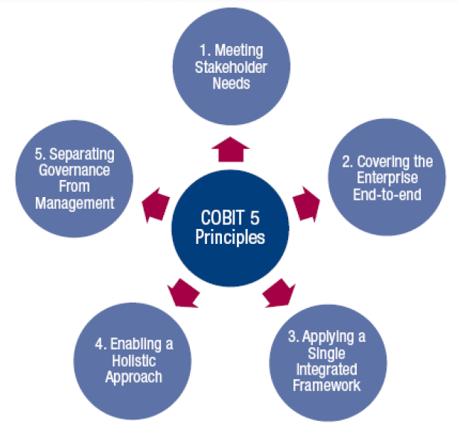

•**Principle 1: Meet Stakeholder Needs**: Enterprises exist to create value for stakeholders by maintaining balance between realize benefits and optimize risk and use of resources.

•**Principle 2: Cover Enterprise End-to-end**: Integrates IT governance with enterprise:

*Covers all functions & processes within enterprise. Not only “IT function”. Treats information and technologies as assets.

-Considers IT-related governance & management *enablers* be *enterprise-wide* and *end-to-end* (i.e., *inclusive of everything and everyone*: *internal and external*: relevant to governance and management of enterprise information and related IT).

•**Principle 3: Apply Single, Integrated Framework**: At a high level, COBIT 5 aligns with other relevant standards and frameworks such as the ISO 27000 series.

•**Principle 4: Enable Holistic Approach**: Consider interacting components. 7 categories of **enablers** (anything that helps achieve objectives): ➊Principles, policies & frameworks ➋Processes ➌Organizational structures ➍Culture, ethics & behavior ➎Information ➏Services, infrastructure & applications ➐People, skills and competencies

•**Principle 5: Separate Governance from Management**: Clear distinction between governance and management. **Governance**: •Ensures stakeholder needs, conditions & options are evaluated to determine balanced, agreed-on enterprise objectives •Set direction through prioritization & decision making •Monitor performance & compliance against direction & objectives. **Management**: Plans, builds, runs & monitors activities in alignment with direction set by governance body to achieve enterprise objectives.

###### COBIT 5 PAM

**COBIT 5 Process Assessment Model (PAM)** = (conforms to ISO/IEC 15504-2 requirements for a PAM). Tool to assess current state & define future desired InfoSec state. Can be used to assess capability of each COBIT 5 process (0 to 5 level of maturity). [*Process dimension* uses COBIT 5 as **process reference model** (composed of **37 processes** describe **life cycle for governance & management**. See figure 1.10).

###### Figure 1.10 Overview of COBIT Process Assessment Model (PAM)

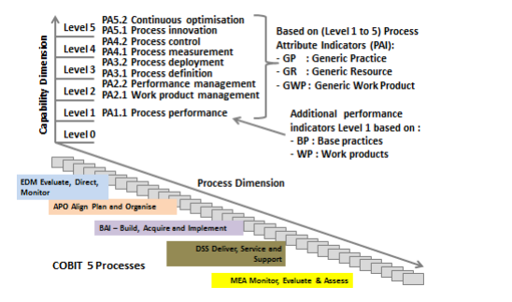

##### Capability Maturity Model Integration (CMMI)

**Capability Maturity Model Integration (CMMI)** = Capability improvement framework to guide to elevate performance. Helps organizations benchmark their capabilities, build maturity by comparing operations to good practices and identifying performance gaps. 5 maturity levels; each level builds on previous for continuous improvement. Use CMMI to build capability to achieve increased quality, better customer satisfaction, improved employee retention and improved profitability.

###### Figure 1.11 Characteristics of Maturity Levels

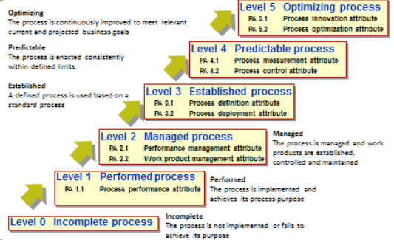

##### Balanced Scorecard

**Balanced scorecard** = management system (not only measurement system). Helps clarify vision and strategy; translate them into action. Provides feedback around both internal business processes and external outcomes in order to continuously improve strategic performance and results. Transforms strategic planning into nerve center of an enterprise. Develop metrics, collect and analyze data relative to each of 4 perspectives:

•Learning and growth •Business process •Customer •Financial

###### Figure 1.12 Dimensions of Balance Scorecard

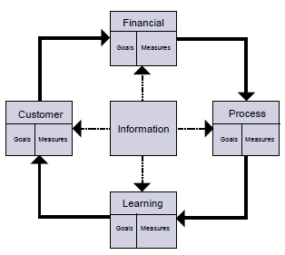

##### Architectural Approaches

**Enterprise infosec architecture** (**EISA**) = Subset of enterprise architecture. **Architecture framework** = foundational structure (set of structures) to develop different architectures, incl. *business process architecture*. Referred as *contextual architecture* and more traditional *conceptual*, *logical*, *physical*, *functional* and *operational* architectures.

Architectural approaches with linkages to business: *COBIT 5*, *the Open Group Architecture Framework (TOGAF)*, *Zachman Enterprise Architecture Framework*, *Extended Enterprise Architecture Framework (E2AF)*. Help define desired state of security. Describe method to design target or desired state of enterprise in terms of set of building blocks. Target architecture referred as *reference architecture*. Serves to set longer-term objectives for technical, systems and process design.

##### ISO/IEC 27000 Series

**14 areas of ISO/IEC 27001:2013** **standard** = framework to gauge comprehensiveness. Organizational policies & standards be tracked to each element of standard. Standard to certify and assess. **27002:2013** = Code of Practice that supports implementation.

**14 security control clauses of ISO/IEC 27001:2013**:

•A.5: Infosec policies

•A.6: Organization of infosec

•A.7: Human resource security (controls before, during, after employment)

•A.8: Asset management

•A.9: Access control

•A.10: Cryptography

•A.11: Physical and environmental security

•A.12: Operations security

•A.13: Communications security

•A.14: System acquisition, development and maintenance

•A.15: Supplier relationships

•A.16: Infosec incident management

•A.17: Infosec aspects of business continuity management

•A.18: Compliance with internal (policies) and external (laws)

Whereas ISO/IEC 27001:2013 Annex A refers to **114 “controls”:** sections in ISO/IEC 27002:2013, many of which propose multiple security controls. ISO/IEC 27002:2013 not mandate specific controls; users to select and implement controls that suit them, using a risk assessment process. ISO/IEC standard treated as *generic controls checklist*.

##### Other Approaches

Other ISO standards on quality (**ISO 9001:2015**). Six Sigma approach to quality and business management. Publications from NIST & Infosec Forum (ISF), and US Federal Infosec Modernization Act (FISMA).

#### 1.8.4 Risk Objectives

**Input to define desired state**: Approach to risk, risk appetite, risk tolerance.

**Acceptable risk** devolves into: control objectives, risk mitigation measures, criteria to evaluate risk for acceptability. **Control objectives** determine type, nature and extent of controls and countermeasures to manage risk. **Determination of acceptable** **risk**:Does InfoSec meet objectives & level of resources deployed? Risk = complex subject, many known and unknown variables (See chapter 2). *Operational risk management* always trade-off: risk associated with a course of action vs. risk of not doing. Mitigate one risk increases/creates other risks in response. Risk always carries *cost* (controlled or not). **Risk cost** can be expressed as **ALE** (potential loss x likelihood of occurrence) to show optimal level of control. Figure 1.13 shows optimal level of control = balance of cost of controls against cost of losses.

###### Figure 1.13 Relationship among risk, control measures and cost of controls.

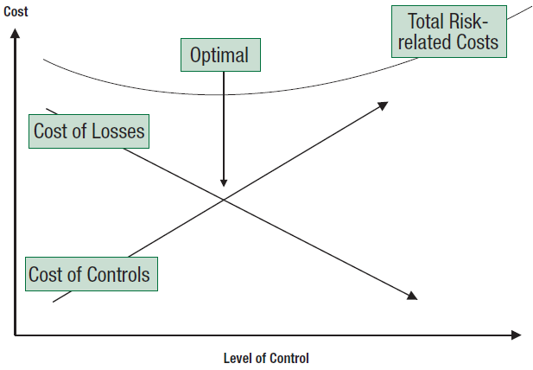

**Quantify risk acceptability** by using *business continuity approach* to develop *recovery time objectives (RTOs)*. **RTO** = informal business determination of time during which critical systems be inoperative without business consequences = Approx. costs to achieve recovery. Too high? Iterate process to arrive at acceptable *recovery time* at acceptable cost. This may be considered the ***acceptable risk***. Alternatively, approx. acceptable risk with ***business interruption insurance*, *amount of deductible* and *cost*** (i.e., annual premiums). Example: Insurance= US$1M, deductible = $10,000 at annual cost of $50,000. Hence, reasonable to spend $50,000 in control activities to reduce $1M risk to acceptable risk level (residual risk) of $10,000.

**Lower level of acceptable risk can be more costly**. Approach to achieve desired state by treating undesirable risk can reduce costs. Technical controls (e.g., firewalls, intrusion detection systems [IDSs]): only one dimension to consider. Physical, process and procedural controls can be more effective and less costly. Process risk poses greatest hazard: poor management or faulty processes cannot be adequately compensated. Once objectives defined, architect solutions to min. costs and complexity.

### 1.9 DETERMINE CURRENT STATE OF SECURITY

Evaluate current-state of infosec by using same methodologies to determine strategy objectives, i.e. same combination of methodologies (COBIT, CMMI, balanced scorecard to define desired state and current state ⇨ Provide apple-to-apple comparison, basis for gap analysis and metrics on progress toward meeting the objectives.

#### 1.9.1 Current Risk

*Current state of risk* be assessed with comprehensive *risk assessment*. Full risk assessment = threat, vulnerability and impact analyses. Address risk in different ways: alter risky behavior, develop countermeasures to threats, reduce vulnerabilities or develop controls ⇨ Provide basis to determine most cost-effective strategy.

Inventory, test and evaluate existing controls to determine whether meet desired state objectives for risk mitigation ⇨ Basis to decide whether controls sufficient; need be strengthened, modified or replaced; or additional controls added. Additional periodic assessments to provide metrics to determine progress.

Approaches to assess risk: *COBIT 5 for Risk*, *NIST SP 800-30*, *ISO/IEC 27005* and *Operationally Critical Threat, Asset, and Vulnerability Evaluation"' (OCTAVE)*.

##### Business Impact Analysis

Thorough BIA of critical systems and processes to round out current-state picture. Impact analysis provides information to develop effective strategy, input for asset classification based on business value. Strategy to address difference between *acceptable levels* and *current level of potential impacts*.

### 1.10 INFOSEC STRATEGY DEVELOPMENT

**Road map** = specific steps to implement the strategy. (Infosec objectives, available processes, methods, tools, techniques) = means to construct security strategy. **Good security strategy** addresses & mitigates risk with acceptable level of compliance to legal, contractual and statutory requirements; provides demonstrable support for business objectives and maximize value to stakeholders: addresses how to embed good security practices into every business process and area of the business.

Controls **NOT** only means to implement security. Re-engineering process can reduce/ eliminate risk without need for controls; mitigate potential impacts by architectural modifications rather than controls. (Sometimes, mitigating risk can reduce business opportunities, be counterproductive) ⇨ Balance between security and operational efficiency/ effectiveness ⇨ Performing cost-benefit analysis of proposed control activities. Primary operational goal: maximize success of business processes and minimize impediments to those processes.

#### 1.10.1 Elements of Strategy

What in security strategy? Define start & destination. What resources be available, what constraints (resources = mechanisms to achieve strategy, bound by constraints)?

##### Road Map

**Road map** includes: people, processes, technologies, other resources. Map routes & steps to navigate to objectives. Same stages as when developing security architecture (see 1.11.2 Enterprise InfoSec Architectures): structured approach to define business drivers, resource relationships and process flows; consider contextual & conceptual elements such as business drivers and consequences.

**Achieve desired state**: long-term goal with series of projects & initiatives. Break down into short-term projects to accomplish in reasonable time period given resource constraints and budget cycles. Chart entire road map. Expect objectives be modified over time (except attain maturity level, reengineer high-risk processes, achieve control objectives). Short-term projects aligned with long-range objectives provide: checkpoints & opportunities for midcourse corrections; metrics to validate the overall strategy.

Example: Long-term objective = data classification according to sensitivity & criticality ⇨ Strategy: (1) target completion of 25% per fiscal year using various tactical approaches; (2) create policies & standards to preclude practices giving rise to problem (so it does not get worse while the remediation process is underway).

#### 1.10.2 Strategy Resources & Constraints

##### Enablers

COBIT 5 **enablers** = factors that individually and collectively influence whether something will work (i.e., governance & management of infosec, enterprise IT). Enablers driven by ***goals cascade*** (i.e., higher-level goals define what enablers should achieve). Enablers are both ***resources*** and ***constraints*** (be considered from both perspectives).

###### Figure 1.14 COBIT 5 Enterprise Enablers

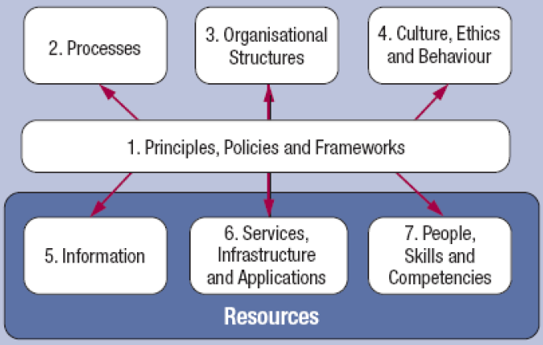

COBIT 7 categories of enablers (figure 1.14):

➊**Principles, policies, frameworks** translate desired behavior into practical guidance for day-to-day management.

➋**Processes** = set of practices & activities to achieve objectives and produce outputs in support of achieving overall goals.

➌**Organizational structures** key decision-making entities in enterprise.

➍**Culture, ethics, behavior of individuals & enterprise**: success factor in governance & management activities.

➎**Information**: pervasive in organization. Includes information produced & used by enterprise. Keeps organization running & governed. At operational level, information is key product of enterprise itself.

➏**Services, infrastructure, applications** include infrastructure, technology and applications that provide information technology processing and services.

➐**People, skills, competencies** required for successful completion of all activities and for making correct decisions and taking corrective actions.

##### Resources

**Resources** to be enumerated. Maximize utilization of existing assets & capabilities. Consider available mechanisms, processes & systems in optimal mix:

•Policies •Standards •Procedures •Guidelines •Architectures •**Controls** (physical, technical, procedural) •Countermeasures •Layered defenses •Technologies •Personnel security •Organizational structure •Roles & responsibilities •Skills •Training •Awareness & education •Audits •Compliance enforcement •Threat assessment •Vulnerability assessment •BIA •Risk analysis •Resource dependency analysis •3rd-party service providers •Other org. support & assurance providers •Facilities •Environmental security

##### Constraints

Some constraints (e.g., ethics, culture) are dealt with in developing desired state. Others arise consequent to the developing of road map and action plan.

•**Legal**: Laws and regulatory requirements

•**Physical**: Capacity, space, environmental constraints

•**Ethics**: Appropriate, reasonable and customary

•**Culture**: Both inside and outside the organization

•**Costs**: Time, money

•**Personnel**: Resistance to change, resentment against new constraints

•**Organizational structure**: How decisions are made and by whom, turf protection

•**Resources**: Capital, technology, people

•**Capabilities**: Knowledge, training, skills, expertise

•**Time**: Window of opportunity, mandated compliance

•**Risk appetite**: Threats, vulnerabilities, impacts

### 1.11 RESOURCES FOR INFOSEC STRATEGY

#### 1.11.1 Policies & Standards

**Policies** and **standards** are respectively tools of **governance** and **management. Procedures** and **guidelines** are purview of **operations**.

##### Policies

**Policies** = high-level statements of management intent, expectations and direction. Considered as “*constitution*” of security governance. Must be aligned with and support strategic security objectives. Static in mature organization. Example of policy statement on access control: Resources be controlled to effectively preclude unauthorized access.

##### Standards

**Standards** = metrics, boundaries or process to determine whether procedures, processes or systems meet policy requirements. **Metrics** to determine whether procedure complies with standard. **Boundaries** set in terms of allowable limits on processes, people and technologies. Standard to provide parameters/boundaries to unambiguously determine a procedure or practice. Standards to provide only *necessary limits* to ensure security while maximizing procedural options. Standards to change as requirements and technologies change. Multiple standards may exist for each policy, depending security domain or classification level ⇨ password standard (password composition requirements, minimum & maximum password length, frequency of password changes, rules for reuse) more restrictive when accessing high-security domains.

##### Procedures

**Procedures** = responsibility of operations. Be clear & unambiguous. Include necessary steps to accomplish specific tasks. Define expected outcomes, displays and required conditions precedent to execution. Contain steps when unexpected results occur. Use words “*must*” and “*shall*” for mandatory task. Use “*should*” for non-mandatory preferred action. Use “*may*” or “*can*” for discretionary action (only where necessary, since discretionary dilute message).

##### Guidelines

**Guidelines** also responsibility of operations. Contain information helpful to execute procedures. Include clarification of policies & standards, dependencies, suggestions & examples, clarifying narrative, background information, and tools that can be used.

#### 1.11.2 Enterprise Infosec Architecture (EISA)

**EISA** powerful development, implementation & integration tool to develop/implement strategy. Effective if integrated in **enterprise architecture (EA)** (controls implemented & integrated throughout org. infrastructure, processes & technologies. See InfoSec architecture in 3.8 Infosec Infrastructure and Architecture. Some approaches are similar. For example, Zachman framework (who, what, why, where, when, how) matrix is shared by SABSA and E2AF as shown in figure 1.15.

**Framework** details [org., roles, entities, relationships] that (should) exist to perform business processes. Provides rigorous *taxonomy* to identify what processes a business performs; and info about how processes are executed & secured. End product: set of artifacts to describe what/how business operates and what security controls are required.

**COBIT 5** provides extensive resources & tools to achieve these objectives. Moves from IT-centric approach to a holistic architectural framework. Consolidates & integrates *COBIT 4.1*, *Val IT 2.0* and *Risk IT* frameworks. Draws from ISACA’s *IT Assurance Framework* (ITAF) and *BMIS*. Aligns with: ITIL, ISO, PMBOK, PRINCE2 and TOGAF.

Drivers to develop COBIT 5 for InfoSec:

•Need to describe InfoSec in an enterprise context: •Full end-to-end business and IT functional responsibilities •All aspects for effective governance & management of InfoSec (e.g., organizational structures, policies and culture) •Relationship & link of InfoSec to enterprise objectives

•Ever-increasing need for enterprise to: •Maintain info risk at acceptable level •Protect info against unauthorized disclosure, unauthorized modifications, intrusions •Ensure services & systems continuously available to internal & external stakeholders •Comply with relevant laws & regulations; contractual requirements; internal policies on info & systems security & protection; transparency on level of compliance •Achieve all of the above while containing cost of IT services and technology protection.

###### Figure 1.15 SABSA Security Architecture Matrix

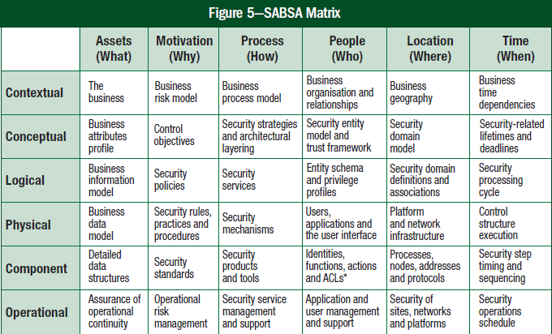

**TOGAF** (figure 1.16) is an EA and preferred approach to ensure effective integration, addresses security as component of overall design. Addresses 4 areas of specialization called ***architecture domains***:

•**Business architecture** defines business strategy, governance, organization and key business processes of the organization

•**Applications architecture** provides blueprint for application systems to be deployed, interactions among application systems, and relationships to core business processes with frameworks for services to be exposed as business functions for integration

•**Data architecture** describes structure of organization’s logical and physical data assets and associated data management resources

•**Technical architecture** or **technology architecture** describes HW, SW and network infrastructure to support deployment of core, mission-critical applications.

###### Figure 1.16 Structure of the TOGAF Document

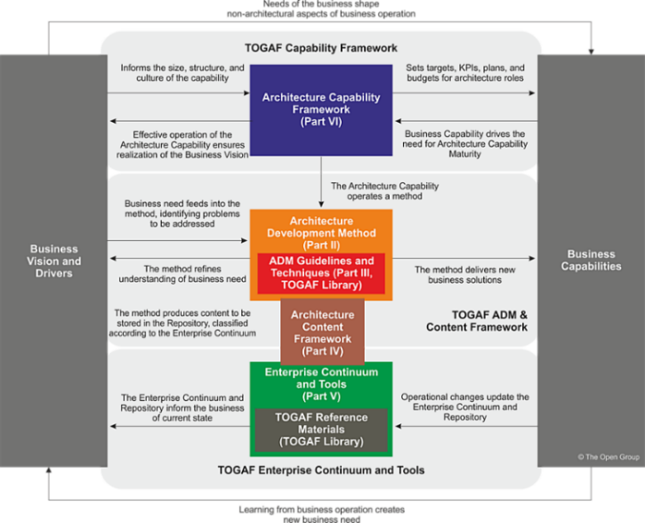

##### Alternative Enterprise Architecture Frameworks

•**AGATE** French Delegation Generate pour l’Armement Atelier de Gestion de l’Architecture des systemes d’information et de communication

•Integrated Architecture Framework of Capgemini

•Interoperable Delivery (of European government services to public) Administrations, Business and Citizens (**IDABC**)

•Method for an Integrated Knowledge Environment (**MIKE2.0**); includes enterprise architecture framework: Strategic Architecture for the Federated Enterprise (**SAFE**)

•Model-driven Architecture (**MDA**) of the Object Management Group

•**NIFI** Enterprise Architecture Framework

•**OBASHI** business and IT methodology and framework

•Open Security Architecture

•**SAP Enterprise Architecture Framework**, an extension of TOGAF

•Service-Oriented Modeling Framework (**SOMF**)

•United Kingdom Ministry of Defence Architecture Framework (**MODAF**)

•United States Department of Defense Architectural Framework (**DoDAF**)

•United States Office of Management and Budget Federal Enterprise Architecture (**FEA**)

#### 1.11.3 Controls

Controls can be physical, technical or procedural. Choose controls based on: effectiveness, cost, restriction to business activities, and optimal form of control. Discussion of controls, usage, implementation and enforcement is in section 2.7.21 Controls.

##### IT Controls

COBIT focuses on IT controls (majority of controls) besides procedural & administrative controls. COBIT defines control objectives as “*a statement of the desired result or purpose to be achieved by implementing control procedures in a particular IT activity*.”

##### Non-IT Controls

For non-IT-related information processes: secure marking, handling, storage of physical information + handling, preventing social engineering + environmental controls (secure systems not being stolen).

##### Countermeasures

Countermeasures = protection measures to directly reduce vulnerability or threat. Considered ***targeted controls***. Consider from strategic perspective. Passive or active. More effective and less constricting than general controls. Example: Make most sensitive info accessible only from separate subnet, not externally available; change to inherently more secure operating system; prevent unsecured systems from connecting to network.

##### Layered Defenses

**Layering defenses** (**defense in depth**) Failure of one layer not cause failure of next layer. Number of layers = function (asset *sensitivity* & *criticality*, *reliability* of defenses, *degree of exposure*). Example: firewall + education of “human firewall” + segmented network.

#### 1.11.4 Technologies

Technology cannot compensate for management, cultural or operational deficiencies. Figure 1.17 shows that effective defenses is combination of *policies, standards, procedures and technology*. Technologies with security mechanisms are discussed in Chapter 3.

###### Figure 1.17 Defense in depth by Function

|  |  |
| --- | --- |
| **Defense against System Compromise** | **Policies, Standard, Procedures, Technology** |
| **Prevention** | Authentication  Authorization  Encryption  Firewalls  Data labeling/handling/retention  Management  Physical security  Intrusion prevention  Virus scanning  Personnel security  Awareness and training |
| **Containment** | Authorization  Data privacy  Firewalls/security domains  Network segmentation  Physical security |
| **Detection/notification** | Monitoring  Measurements/metrics  Auditing/logging  Honeypots  Intrusion detection  Virus detection |
| **Reaction** | Incident response  Policy/procedure change  Additional security mechanisms  New/better controls |
| **Evidence collection/**  **event tracking** | Auditing/logging  Management/monitoring  Nonrepudiation  Forensics |
| **Recovery/restoration** | Backups/restoration  Failover/remote sites  Business continuity/disaster recovery planning |

#### 1.11.5 PERSONNEL

**Personnel security**: **preventive** means to security. Costly & damaging compromises from insider activities (intentional or unintentional) ⇨ First line of defense: ensure integrity & trustworthiness of new/existing personnel ⇨ Limited background checks. Extensive checks may be constrained by privacy and other laws. Extent and nature of background investigations be relevant and proportional to sensitivity and criticality of position.

Develop controls to prevent employment of undesirable personnel. Provide ongoing intelligence indicative of emerging or potential problems with existing staff. Develop methods to track, investigate incidents of theft. Develop investigation and background-checking policy and standards (reviewed by legal and HR).

#### 1.11.6 Organizational Structure

**Flexible & evolving structure** good to develop security strategy (in constrained structures, infosec strategy may be perceived as threat to autonomy or authority).

Infosec not report to CIO but C-level, reports to COO, CEO or board of directors because: ➊Infosec requirements outside scope and focus of CIO. ➋Inherent conflict of interest: infosec primarily regulatory, while CIO focused on IT cost & performance. Infosec often perceived as constraint on IT operations. ➌To be effective, infosec be aligned with business not technology.

##### Centralized & Decentralized Approaches to Coordinate Infosec

Centralized & standardized security: Multinational companies to consider local legal requirements. Example of distributed approach: Grow through acquisitions and operate as independent entities rather than single company ⇨ Separate IT groups with different SW/HW, different security orgs with separate approaches, policies and procedures. Benefits to create single set of enterprise-wide security policies and then deal with local differences through local standards and procedures. **Decentralized security process** **Advantages**: security administrators closer to users and understand local issues better. Can respond quickly to requests for changes to access rights or security incidents. **Disadvantages**: Quality of service vary by location, based on level of training, work load.

Regardless of centralized or decentralized approach, responsibilities and objectives of security will not change. They still must:

•Be closely aligned with the business objectives

•Be sponsored and approved by senior management

•Have monitoring in place

•Have reporting and crisis management in place

•Have organizational continuance procedures

•Have risk management in place

•Have appropriate security awareness and training programs

#### 1.11.7 Employee Roles & Responsibilities

Strategy to coordinate HR to define security roles & responsibilities (section 1.3 Roles & Responsibilities). Incorporate them in employee job descriptions. Include security-related measurements to employee’s annual job performance and objectives.

#### 1.11.8 Skills

Choose strategy that uses skills already available is more cost-effective option. Develop skills inventory. Develop skills or outsource. Proficiency testing to determine if skills available or can be achieved through training.

#### 1.11.9 Awareness & Education

Training, education and awareness are vital because security is weakest at end-user level. Develop methods and processes to make policies, standards and procedures easier to follow, implement and monitor. Recurring security awareness program reinforces importance of InfoSec and now required by law in some jurisdictions. Overqualified individuals are costly to acquire and maintain and, failing to be challenged, are often dissatisfied with the position ⇨ Employee turnover, unproductive attitudes or substandard performance. More cost-effective to train new or existing security personnel. *Effective training targets specific systems, processes and policies; organization’s unique and specific way of doing business and its unique security context*.

#### 1.11.10 Audits

Audits (internal & external) determine infosec **deficiencies** from controls & compliance standpoint. **Internal audits** performed by internal audit department, report to CRO/ audit committee of board of directors. Focus on policy compliance of people, processes and technology. **External audits** conducted by finance department. Ensure that security department has access to audit information. Regulatory oversight ⇨ required to file audit/other reports with regulatory agencies. Many reports have infosec implications with useful intelligence and monitoring information for infosec. Example: under compliance provisions of US SOX, the financial controls of public companies are required to be tested annually within 90 days of reporting to the US Securities and Exchange Commission (SEC).

#### 1.11.11 Compliance Enforcement

Develop procedures to handle security violations. Get senior management buy-in and backing for procedures, especially in area of enforcement. Most effective approach to compliance in organization where openness and trust are valued and promoted by management? **Self-report** and **voluntary compliance**. Requires processes be thought out, clearly communicated and cooperatively implemented. **Prioritize** on compliance requirements: focus on areas of **greatest risk and impact**.

#### 1.11.12 Threat Assessment

**Threat assessment** part of **risk assessment** and important element for **strategic consideration**. Risk treatment options to consider most cost-effective approach to address risk. Facilitate separate analysis of **threat** & **vulnerability**, **exposure** & **impact**. **Threat profile** be developed by: ➊**Strategy** to develop: consider *viable threats regardless whether vulnerability exist* ⇨ proactive approach (not all vulnerabilities can be known, new ones introduced continuously). ➋**Policy**: threats are *constant* (e.g., fire, flood, earthquake, malware, theft, fraud, attacks, mistakes), whereas vulnerabilities *change frequently* as result of changes in business, processes, technology and personnel. Review existing policies for relevance and address new threats. See section 2.7.10 Threats.

#### 1.11.13 Vulnerability Assessment

**Technical vulnerability assessments** using automated scans are common but of limited value for security strategy development. **Comprehensive vulnerability assessments** to include physical elements (procedures, practices, technologies, facilities, service level agreements, legal and contractual requirement). Processes and facilities: most vulnerable but least frequently assessed ⇨ Developing strategy = opportunities to address many vulnerabilities in prudent, proactive approach. See section 2.7.11 Vulnerabilities.

#### 1.11.14 Risk Assessment & Management

(In addition to threat & vulnerability assessments) **Identify & assess overall risk**. ➊Determine viable threats to information resources: physical & environmental threats (e.g., flood, fire, earthquake, pandemic), technology threats (malicious software, system failure, internal and external attacks). ➋(**Risk identification**) Consider *likelihood* that threats materialize + *probable magnitude*. ➌Determine extent of org. weaknesses and exposure to threats. Combination of *frequency*, *magnitude* and extent of org. *vulnerability* determines level of risk. Calculate **resulting probable ALE** (frequency, magnitude and exposure) ⇨ decide on acceptability. Frequency of occurrence and probable magnitude of threats derivable from past. **Frequency** is important, even if magnitude moderate. See section 2.7.4 Risk Assessment and Management Approaches.

#### 1.11.15 Insurance

Strategy resources include the option of addressing some risk with insurance. Generally, the types of risk suitable for insuring are rare, high-impact events such as floods, hurricanes, fire, embezzlement or liability lawsuits. The most common types of insurance that can be considered include first-party, third-party and fidelity bonds. First-party insurance covers the organization in the event of damage from most sources and can include business interruption, direct loss and recovery costs. Third-party insurance deals with potential liability to third parties and generally includes defense against lawsuits and covers damages up to predetermined limits. Fidelity insurance or bonding involves protection against employee or agent theft or embezzlement.

#### 1.11.16 Business Impact Analysis (BIA)

Business impact = **bottom line of risk**. **BIA** = exercise to determine consequences of losing support of resource; part of risk assessment process. Consequences reduced to **financial impacts** (risk with no appreciable impact is not important). BIA important component of strategy to address potential adverse. BIA be considered as requirement to determine criticality and sensitivity of systems and information ⇨ Basis for information classification and business continuity. See section 2.8.2 Impact Assessment and Analysis.

#### 1.11.17 Resource Dependency Analysis

**Business dependency analysis** similar to **resource dependency analysis**, but less granular and includes elements to consider in BCP (staples and paper clips). *Resource dependency* similar to **disaster recovery planning (DRP)**: consider systems, HW and SW to perform organizational functions. Resource dependency provides perspective on criticality of information resources; be used instead of impact analysis to consider resources critical to business operations. Analysis to determine resources (systems, SW, connectivity) and dependencies (input processes, data repositories).

#### 1.11.18 Outsourced Services

Outsourcing present risk difficult to quantify and mitigate. Both resources and skills of outsourced functions are lost to organization (itself presents risk). Providers operate on different standards; difficult to control. Security strategy to ensure outsourced security services not a critical single point of failure; or there is viable backup plan in the event of service provider failure. **Cloud services** presents new and obscure risks (see section 3.11.10 Cloud Computing). Risk from outsourcing can materialize from **mergers and acquisitions** (differences in culture, systems, technology and operations).

#### 1.11.19 Other Support & Assurance Providers

Consider support and assurance service providers within organization (legal, compliance, audit, procurement, insurance, disaster recovery, physical security, training, project office, HR, change management or quality assurance) as part of infosec resources. These assurance functions not well integrated. Strategic considerations to ensure these functions operate seamlessly to prevent gaps that may lead to security compromises. Reduce or eliminate duplication of efforts. Prevent groups working at cross-purposes (i.e., prevent assurance activities of one group from undermining by activities of another).

### 1.12 STRATEGY CONSTRAINTS

Constraints set boundaries for options available to infosec manager.

#### 1.12.1 Legal & Regulatory Requirements

Consider legal and regulatory issues affecting infosec: privacy; intellectual property; and contractual, civil and criminal law. Different regions may be governed by conflicting legislation (in area of privacy legislation, different cultures place different degrees of importance on privacy) ⇨ Establish different security strategies for each regional division, or base policy on most restrictive requirements.

Boundaries and constraints from legal and regulatory issues with **internet**, **global transmissions** and **trans-border data flows** (e.g., privacy, tax laws and tariffs, data import/export restrictions, restrictions on cryptography, warranties, patents, copyrights, trade secrets, national security). **Regulatory compliance** be treated another **risk**; extent of compliance = a business decision with input (risk and potential impact).

**Personnel safety**: priority and subject of regulations in many jurisdictions.

##### Requirements for Content & Retention of Business Records

Two main aspects:

•Business requirements for business records

•Legal and regulatory requirements for records

**Business requirements** may exceed legal & regulatory requirements due nature of business (business needs to access data +10-20 years old - customer records, patient records and engineering information).

**Rule**: retention strategy and policy must at a minimum meet legal requirements in applicable jurisdiction and industry. Regulatory requirements on legal, medical and tax records. SOX regulations: mandatory retention requirements for various types & categories of information, regardless storage medium. Requirements of **lawful preservation order:** retain specific data when required ⇨ archived information be **indexed** sufficiently to be located and retrieved.

##### E-discovery

**Civil and criminal actions** rely on evidence from email/ other electronic communications in response to production request or subpoena ⇨ Information be archived, classified and cataloged ⇨ Consider **retention policy** that limits length of time to retain kinds of information (email) within *bounds of legal requirements*. Best option: **policy** to require destruction of data NOT required be retained by law or for specific business reasons.

#### 1.12.2 Physical

**Physical & environmental** influences/constraints: capacity, space, environmental hazards, availability of infrastructure (data center placed in basement known to flood periodically). Include considerations: environmental hazards & adequate infrastructure capacity; physical requirements for recovery from disaster; personnel & resource safety.

#### 1.12.3 Ethics

The perception an organization’s customers and the public at large have of the organization’s ethical behavior can have a major impact on the organization and affect its value. These perceptions are often influenced by location and culture, and an effective strategy will include ethical considerations in the areas of its operations.

#### 1.12.4 Culture

Internal culture of the organization must be taken into account in developing a security strategy. The culture in which the organization operates must also be considered. A strategy that is at odds with cultural norms may encounter resistance and may make successful implementation difficult.

#### 1.12.5 Organizational Structure

Organizational structure will have a significant impact on how a governance strategy can be devised and implemented. Often, various assurance functions exist in silos that have different reporting structures and authority. Cooperation among these functions is important and typically requires senior management buy-in and involvement.

#### 1.12.6 Costs

**Security projects primary drivers**: control of risk or compliance with regulations.

Consider cost-effective way to consume resources (people, time, money). Justify spending based on a project’s value (cost-benefit or other financial analysis).

**Traditional (speculative approach)**: Determine **ROI** by comparing cost of mitigating/ preventing controls against **ALE**, which is value to avoid risk = *potential losses* incurred multiply by probability of occurrence(see Section 2.7.14). Many believe that ROI NOT good approach to justify security programs. Especially true for regulatory compliance programs (SOX enhanced penalties = long sentences in federal prisons and large fines for senior executives).

**Alternative estimate of ROI**: calculate savings in time and cost thanks to technological advances, (single sign-on, user access provisioning technologies and procedures).

#### 1.12.7 Personnel

Expect resistance to significant changes; possible resentment against new constraints.

#### 1.12.8 Resources

Consider available budgets; TCO of new/additional technologies; manpower requirements of design, implementation, operation, maintenance and eventual decommissioning. TCO be developed for full life cycle of technologies, processes and personnel.

#### 1.12.9 Capabilities

Resources available to implement strategy include known capabilities of organization, including expertise and skills. Rely on demonstrated capabilities to succeed.

#### 1.12.10 Time

Time = compliance deadlines to support strategic operations (e.g., merger); windows of opportunity for particular business activities that mandate specific timelines.

#### 1.12.11 Risk Acceptance & Tolerance

**Level of acceptable risk and risk tolerance**: Develop **RTO**s for critical systems by performing a BIA; shorter the times, the greater the cost and the lower the risk appetite. Relationship of cost of downtime compared to cost of recovery ⇨ quantifiable basis to determine acceptable risk. If organization has business continuity insurance, **deductible** (amount of loss before insurance pays a claim) = good quantifiable indication of acceptable risk. *Cost of protection should never exceed benefit derived.*

### 1.13 ACTION PLAN to IMPLEMENT STRATEGY

Implementing information strategy requires many projects or initiatives. Analyze gaps between current and desired state for each defined metric. Identify requirements & priorities for plan or road map to achieve objectives and close gaps.

#### 1.13.1 Gap Analysis: Basis for Action Plan

**Gap analysis** for (components of strategy) maturity levels, objective for each control in control universe, each risk & impact in risk register. Identify steps to move from current to desired state to achieve defined objectives. **Frequency**: (min) annually. **Goals**: provide performance & goal metrics + info for midcourse correction. **Approach**: work backward from endpoint to current state; determine intermediate steps to accomplish objectives. **Methodology**: CMMI or other methods. Areas to assess:

•Security strategy with senior management acceptance and support

•Security strategy intrinsically linked with business objectives

•Security policies complete and consistent with strategy

•Complete standards for relevant, consistently maintained policies

•Complete and accurate procedures for key operations

•Clear assignment of roles and responsibilities

•Organizational structure for infosec authority without inherent conflicts of interest

•Information assets identified and classified per criticality and sensitivity

•Effective controls to design, implement and maintain

•Effective security metrics and monitoring processes

•Effective compliance and enforcement processes

•Tested and functional incident & emergency response capabilities

•Tested business continuity/disaster recovery plan

•Appropriate security approvals in change management processes

•Risk properly identified, evaluated, communicated and managed

•Adequate security awareness and training of all users

•Develop & deliver activities to positively influence security culture and behavior of staff

•Regulatory and legal issues understood and addressed

•Address security issues with third-party service providers

•Timely resolution of noncompliance issues and other variances

#### 1.13.2 Policy Development

Develop **supporting policies** to articulate **strategy**. The completed strategy provides basis to create/ modify existing policies. Policies *be directly traceable* to strategy elements (if NOT, either strategy incomplete or policy incorrect). **Strategy** = statement of intent, expectations and direction of management. Policies in turn, be consistent with and support intent & direction of strategy.

Example: Objective is ISO/IEC 27001:2013 compliance in 3 years? Strategy to consider elements to address first, what resources to allocate, how elements of standard can be accomplished, etc. Each relevant 14 domains and major subsections must be subject of one or more policies (in practice, about two dozen specific policies).

Each policy has many supporting **standards** divided by **security domains** (standards for a high-security domain more stringent than standards for a low-security domain). Other standards may need be developed for different business units (depending on activities and regulatory requirements).

**Road map** shows steps, sequence, dependencies and milestones. **Action plan** = project plan to implement **strategy** following **road map**.

**Policies**: constitution/primary elements of governance, **standards**: law. *Policies capture intent, expectations and direction of management*. Be properly created, accepted and validated by board and senior management and broadly communicated throughout organization. **Sub-policies** may be created to address unique situations (e.g., a separate part of organization performs highly classified military work. Policies for specific security requirements for classified military work may exist as a separate set).

When security policies developed PRIOR to security strategy. Policy development may not followed above approach; ad hoc in formats. Policies written to include standards and procedures in lengthy, detailed documents. On other hand, effective practices be developed but not reflected in policies ⇨ Use existing practices as basis for policy and standards development ⇨ Minimize organizational disruptions, communications of new policies, and resistance to new or unfamiliar constraints.

**Attributes of good policies**:

•Security policies = articulation of infosec strategy. Capture intent, expectations and direction of management.

•Each policy states only one general security mandate.

•Policies be clear and easily understood by all affected parties.

•Policies rarely be more than a few sentences long.

•No reason to have more than two dozen policies.

#### 1.13.3 Standards Development

**Standards** = powerful security management tools. Permissible bounds for procedures and practices of technology and systems, people and events. **Law** to constitution of policy. Provide *measuring stick* for **policy compliance** and sound basis for **audits**. Govern creation of **procedures** and **guidelines**. Set **security baselines**, reflect **acceptable risk** and **control objectives**, and criteria to **evaluate acceptable risk**.

Standards = predominant tool to implement effective security governance. Owned by InfoSec. Provide only *necessary and meaningful boundaries* without unnecessary restrictions. Help to interpret policies, must reflect intent of policy. Be unambiguous, consistent, and precise as to scope and audience. Consistent format, content and required approvals. Be disseminated to those governed by them and those impacted.

Define **review** and **modification** processes; **exception processes** (for standards not readily attainable for technological or other reasons). Develop process to implement mitigating controls for out-of-compliance situations.

#### 1.13.4 Training & Awareness

Consider ongoing program of security awareness and training. Train all impacted personnel so they can see connection between policies and standards and daily tasks. Tailor information to individual groups to ensure relevance. Presented in terms that are clear and understood by intended audience. Ensure staff be appropriately trained and understand: objectives of strategy (**KGIs**); processes to use; and performance metrics for various activities (**KPIs**), and critical success factors (**CSFs**) to achieve KGIs. See section 3.10.2 Security Awareness Training and Education.

#### 1.13.5 Action Plan Metrics

Action plans to implement strategy require *methods to monitor and measure* progress & achievement of milestones. Progress and costs be monitored on ongoing basis to determine conformance with plan and allow for midcourse corrections. Near-term goals require resources and plan of action for achievement.

Common approaches to monitor & measure progress: *balanced scorecard*; CMMI (current state and objectives). COBIT 5 *Process Assessment Model (PAM)* (see COBIT) basis for ongoing gap analysis to determine progress toward achieving the goals. Each plan of action benefits from developing appropriate set of **KPIs**, defining **CSFs** and **KGIs**.

**Plan of action** to achieve SOX[5] compliance: •Detailed analysis by legal to determine regulatory requirements for affected business •Knowledge of current state of compliance •Definition by management of required state of compliance.

##### Key Goal Indicators

Define clear objectives, achieve consensus on goals.

**Key goals** for SOX projects: •Achieve Sarbanes-Oxley controls testing compliance mandates •Complete independent controls testing compliance validation and attestation •Prepare required statement of control effectiveness

##### Critical Success Factors

Steps to achieve Sarbanes-Oxley compliance: •Identify, categorize, define controls

•Define tests to determine effectiveness •Commit resources to accomplish testing

Hundreds (or more) of controls may be developed over a period of time. They are ad hoc, may not subject to formal processes ⇨ Identify control processes, procedures, structures and technologies to develop appropriate testing regime. Determine necessary resources and testing procedures to accomplish required tests.

##### Key Performance Indicators

Indicators of key (critical) performance factors to achieve objectives: •Plans to test control effectiveness •Progress in testing of controls effectiveness •Results of testing control effectiveness

Develop testing plans *consistent with defined goals* and *encompassing* ***CSFs***.

##### General Metrics Considerations

Ensure what is measured is relevant. Metrics serve only one purpose: provide information necessary for making decisions ⇨ Critical to understand what decisions be made and who makes them; then supply that information accurately and timely. Different metrics more useful for different parts of organization ⇨ Determine in collaboration with business process owners and management.

Three (3) categories of metrics: strategic, tactical and operational. Senior management more interested in information of a strategic nature (e.g., significant emerging risks that may impact achievement of business objectives). Typically wants a summary of information important from a management perspective.

**Information that excludes detailed technical data**:

•Progress according to plan and budget

•Significant changes in risk and possible impacts to business objectives

•Results of disaster recovery testing

•Audit results

•Regulatory compliance status

**Tactical information**:

•Policy compliance metrics

•Significant process, system or changes affecting risk profile

•Patch management status

•Exceptions and variances to policy or standards

**Technical security data**:

•Vulnerability scan results

•Server configuration standards compliance

•IDS monitoring results

•Firewall log analysis

Information of little value: IT vulnerabilities from automated scans without knowing whether threat exists, extent of exposure or whether there is potential impact ⇨ Sheer volume of data difficult to see the big picture ⇨ Develop processes to distill technical data into information for effective management. Improve monitoring by careful analysis of available metrics to determine relevancy. Example of useful information: amount of time to recover critical services after major incident.

**Considerations for metrics design and monitoring activities**:

•What is important to manage information security operations?

•IT security management requirements

•Needs of business process owners

•What senior management wants to know?

#### 1.13.6 Action Plan Intermediate Goals

Based on BIA of business-critical resources and state of security (determined by CMMI gap analysis), prioritization of remedial activities are straightforward. Objectives of security strategy to achieve CMMI level 4 (Quantitatively Managed) compliance or certification? Example of a near-term action (or tactical) plan (next 12 months):

•Each business unit to identify current applications in use

•25% of stored information be reviewed to determine ownership, criticality and sensitivity

•Each business unit completes BIA for information resources to identify critical resources

•Business units must achieve regulatory compliance

•All security roles and responsibilities must be defined

•A process will be developed to ensure business process linkages

•A comprehensive risk assessment must be performed for each business unit

•All users must be educated on an acceptable use policy

•All policies be reviewed and revised for consistency with strategic security objectives

•Standards must exist for all policies

**Near-term goals & milestones** required for action plans. **Long-term desired state** be clearly defined to maximize potential synergies and ensure short/intermediate-term action plans ultimately aligned with end goals.

### 1.14 INFOSEC PROGRAM OBJECTIVES

Implement **strategy** with **action plan** results in **infosec program** (= essentially project plan to implement/establish ongoing management of parts of strategy). **Objective** of infosec program = *protect interests of those relying on (information & processes, systems & communications that handle, store, deliver the information) from harm resulting from failures of (availability, confidentiality and integrity)*.

The security objective is met when:

•Information available and usable when required (**availability**)

•The systems that provide information can appropriately resist attacks (**availability**).

•Information read or disclosed to only those with right to know (**confidentiality**).

•Information protected against unauthorized modification (**integrity**).

•Business transactions, information exchanges within enterprise or with partners, can be trusted (**authenticity** and **nonrepudiation**).

Priority and significance of availability, confidentiality, integrity, authenticity and nonrepudiation vary with data within information system and business context. **Integrity** important relative to management information due to impact on critical strategy-related decisions. **Confidentiality** most important based on regulatory or legal requirements regarding personal, financial or medical information or to protect trade secrets.

Above concepts apply equally to *electronic systems* as well as *physical systems*. **Confidentiality** is as much at risk from social engineering or “dumpster diving” as from a successful external attack. **Integrity** can be compromised as easily from forged physical inputs to the system as from electronic compromise.

Consider that many significant losses occur from insiders as well as from external attacks. ⇨ Controls to detect anomalies and ensure integrity of systems EQUALLY concerned with nontechnical attacks by insiders.

### CHAPTER 1 PRACTICE

#### In Practice

Identify an IT-related goals in your organization. Next, consider the IT-related goals in the context of the enterprise’s goals. How does the IT-related goal serve to support the enterprise’s overall goals? If it does not, what could be done to change the goal so it better aligns with the organization? Use the information provided in this chapter to guide your recommendations.

#### Knowledge Check: Roles & Responsibilities

Complete the following RACI chart, noting who is responsible, accountable, consulted or informed for the tasks listed in the left-hand column. Some tasks may not include all four of the RACI components, and all personnel may not be involved in all tasks. If they are available, refer to similar RACI charts or responsibility charts used by your organization.

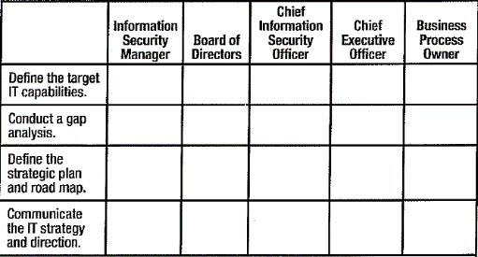

**Answers:**

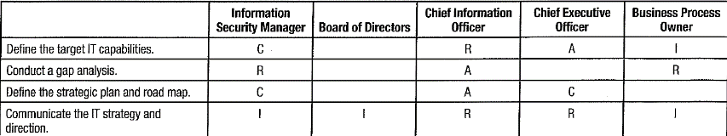

#### Knowledge Check: Metrics

Consider the following information security metrics and answer the questions below:

A. Number of info security policy violations reported quarterly

B. Number of info security incidents that result in a disruption to key business activities

C. Percentage of systems that are patched within the required time period

D. Percentage of incidents that are responded to within the required time period

E. Maturity level of organization’s information security activities

**Questions:**

1. Which of the above metrics are SMART?

2. Which of the above metrics could be considered strategic?

3. Which of the above metrics are related to performance management?

4. How could the metrics that are not SMART be rewritten to be SMART?

**Answers:**

1. Which of the above metrics are SMART? Answer: A and B

2. Which of the above metrics could be considered strategic? Answer: B, C and D

3. Which of the above metrics are related to performance management? Answer: A, C, D, E

4. How could the metrics that are not SMART be rewritten to be SMART?

Suggested revisions:

C. Percentage of critical business systems patched within 7 days from patch release

D. Percentage of network incidents responded to in time allowed over a 3-month period

E. Number of information security activities that are at CMMI level 3 (Defined) or above

#### Case Study

The CISO of a large manufacturing company with three years ‘experience began to realize that the information security function was having less influence and information risk recommendations were increasingly being ignored by the organization’s business units. Despite continuing efforts to communicate with managers from the various corporate departments and business units and a positively regarded security training and awareness program, she was having little success in getting management buy-in for implementing needed controls.

The decreasing importance of information security became apparent when she was not invited to a series of meetings concerning significant changes in company operations. During subsequent budget meetings, several executives (including the CEO) said they were unsure of the value that information security contributes to the company and suggested the budget might be better allocated elsewhere. In addition, the CISO has noticed that she has not been invited to a board meeting to present updates regarding the information security program in more than a year.

The company is publicly held and has been in operation for nearly 90 years. It has been profitable for all but a few years of its existence, although profits were down during the recent worldwide recession. The company has approximately 9,000 employees and a few hundred long-term contractors. It makes a wide variety of small hand and power tools and is known internationally for the wide variety of high-quality products it makes. The CEO is also the chairman of the board of directors and appoints people to the board on the basis of their willingness to give approval for his initiatives with little delay. Consequently, the board provides little oversight and guidance to the business, and although the audit committee of the board is increasingly concerned about the unmitigated risks the organization faces, il has little influence on the CEO. Due to the CEO’s meager appreciation for information security, the CISO is worried that her job is at risk unless she can improve management’s perception of the value of information security.

An additional complication is the recent recession, which saw a drop in the sales of manufactured goods. Competitors were selling goods below cost to reduce inventories and increase cash flow. As a result, the CEO has seen this increase in competition and reduction in profits as further justification to reduce expenses not directly correlated with revenue production.

Business units are the backbone of this company. Except for sharing the machinery and equipment used in manufacturing, each is a fiercely independent silo with the mission of being as profitable as possible. Business unit managers are highly valued and are placed at a fairly senior level in the organizational chart; all of them report to the COO. Each business unit often faces short deadlines to beat the competition to market with new products. As a result, business unit administrators must carefully plan their use of machinery and equipment within each plant because several business units often need machinery and equipment at the same time. Additionally, the machinery and equipment must be available on a 24/7 basis. All machinery and equipment are controlled by process automation software on computers that run in control rooms. This software is highly distributed to the point that any kind of network disruption or outage is likely to adversely affect production.

The CISO has come to realize that the information security practice set up three years ago is not adequate to deal with current ever-growing threats. Although she made efforts to adjust the program according to changes that occurred within the organization, it is clear that some areas were not sufficiently considered. One of these areas is information security metrics relevant to management’s concerns. Presently, the following types of metrics are used to measure the success of the information security program:

•Percentage of Windows systems that run antivirus software that is updated daily

•Percentage of incoming network traffic evaluated by a firewall on an exterior gateway

•Percentage of network traffic that is monitored by an IDS

**Answers:**

**Question 1**: The following aspects could help the CISO improve her standing in org:

•**Obtain management commitment**: in this situation would help the CISO explain the

importance of information security to the organization and help her to influence the board of directors to consider information security in its decisions.

•**Business case development**: One key tool in obtaining management commitment. It provides the information required for an organization to decide whether a project should proceed. The business case can be used to prove the worth of IT and information security initiatives in the organization and provide concrete justification for the costs.

•**Information security strategy development**: Can help to ensure strategic alignment, value delivery and resource optimization to the business. It will help to define the direction of information security in terms of the business, thus ensuring that it has proven benefit to the organization.

•**Information security program metrics**: Can be used to justify that the program is meeting its defined goals and providing value to the business.

**Question 2**: Information security can help this business reach its goals by implementing controls that provide assurance to achieve enterprise’s aforementioned goals and ensure that security objectives are aligned with organizational goals and business strategy.

**Question 3**: The current set of information security metrics does not tie well to business’s goals. The metrics are not very meaningful in the context of how infosec supports the business strategy; they simply measure arbitrary factors that may not accurately portray the information security function. This set of metrics seems to be based on discussions with the CEO, who, as it has been seen, does not have a sufficient understanding of the information security function and how it can align to meet business objectives.

# II. Information Risk Management

## Section 1 Overview

### DOMAIN DEFINITION

Manage information risk to an acceptable level based on risk appetite to meet organizational goals and objectives.

#### Learning Objectives

•Understands importance of risk management as tool to meet business needs and develop security management program to support these needs

•Understands ways to identify, rank and respond to risk in a way that is appropriate as defined by organizational directives

•Assesses appropriateness and effectiveness of InfoSec controls

•Reports on InfoSec risk effectively

### TASK STATEMENTS (9)

T2.1 Establish and/or maintain process for information asset classification to ensure that measures to protect assets are proportional to business value.

T2.2 Identify legal, regulatory, organizational and other requirements to manage the risk of noncompliance to acceptable levels.

T2.3 Ensure that risk assessments, vulnerability assessments and threat analyses are conducted consistently, and at appropriate times, to identify and assess risk to the organization’s information.

T2.4 Identify, recommend, implement appropriate risk treatment/response options to manage risk to levels based on organizational risk appetite.

T2.5 Determine whether InfoSec controls are appropriate and effectively manage risk to an acceptable level.

T2.6 Facilitate the integration of info risk management into business & IT processes (e.g., systems development, procurement, project management) to enable a consistent and comprehensive information risk management program across the organization.

T2.7 Monitor for internal and external factors (e.g., threat landscape, cybersecurity, geopolitical, regulatory change) that may require reassessment of risk to ensure that changes to existing or new risk scenarios are identified and managed appropriately.

T2.8 Report noncompliance and other changes in information risk to facilitate the risk management decision-making process.

T2.9 Ensure that InfoSec risk is reported to senior management to support an understanding of potential impact on the organizational goals and objectives

### KNOWLEDGE STATEMENTS (19)

K2.1 Knowledge of methods to establish an information asset classification model consistent with business objectives

K2.2 Knowledge of considerations for assigning ownership of information assets and risk

K2.3 Knowledge of methods to identify and evaluate the impact of internal or external events on information assets and the business

K2.4 Knowledge of methods used to monitor internal or external risk factors

K2.5 Knowledge of information asset valuation methodologies

K2.6 Knowledge of legal, regulatory, organizational, other requirements related to InfoSec

K2.7 Knowledge of reputable, reliable and timely sources of information regarding emerging InfoSec threats and vulnerabilities

K2.8 Knowledge of events that may require risk reassessments and changes to InfoSec program elements

K2.9 Knowledge of information threats, vulnerabilities and exposures (including cybersecurity) and their evolving nature

K2.10 Knowledge of risk assessment and analysis methodologies

K2.11 Knowledge methods to prioritize risk scenarios & risk treatment/response options

K2.12 Knowledge risk reporting requirements (frequency, audience, content)

K2.13 Knowledge of risk treatment/response options (avoid, mitigate, accept or transfer) and methods to apply them

K2.14 Knowledge control baselines/standards and relationships to risk assessments

K2.15 Knowledge of InfoSec controls and the methods to analyze their effectiveness

K2.16 Knowledge of gap analysis techniques as related to InfoSec

K2.17 Knowledge techniques to integrate InfoSec risk management into business and IT

K2.18 Knowledge of compliance reporting requirements and processes

K2.19 Knowledge of cost/benefit analysis to assess risk treatment options

## Section 2 Content

### 2.0 INTRODUCTION

**Risk ≡** Combination of probability (or likelihood) of event & its consequences. **Probability of an event** ≡ likelihood that given threat will exploit exposed vulnerability. No consequences or impact? No risk ⇨ Greater consequences or impact, greater risk. **Exposure** (aka **attack surface**.) ≡ Extent to which vulnerability exposed to threat; affects risk (extent of exposure affects probability of compromise (less exposure ⇨ less likelihood/ frequency of compromise ⇨reduce risk)); affected by: extent/effectiveness of controls; device location within network (server on perimeter most exposed to attack). **Risk exposure = (probability of risk occurring) X (total loss of risk occurrence)**

**Classifying assets** according to business value (greater value ⇨ greater potential impact ⇨ greater risk). **Business value** = combination of *criticality* & *sensitivity* ⇨ function of damage resulting from unauthorized disclosure (e.g., strategic plans, customer lists) ⇨ Achieve cost-effective management of info risk *by allocating protection resources proportional business value*. **Task**: develop ***classification schema*** to optimize allocation + criteria to classify. ***Basis for classification levels****: impact if asset compromised*.

**InfoSec knowledge**: *explicit constraints* (legal & regulatory requirements by jurisdictions; internal policies, standards, procedures); *non-explicit constraints* (local/org culture & perceptions of ethical behavior resulting in reputational damage/loss of customer & public trust). **InfoSec responsibilities**: use risk identification, analysis & evaluation to identify all info-related risk and potential impacts. Develop response options so management can make informed decisions on acceptable risk management approaches.

**Structured, consistent process for risk assessment**: **Step 1:** Understand threat landscape. **Step 2:** Determine vulnerabilities susceptible to compromise. Assess technical/ physical weaknesses/ exposure of vulnerabilities to threats. Identify risk and assess existing controls effectiveness in mitigating risk. **Step 3:** Analyze/ evaluate identified risk against criteria for acceptability. **Step 4:** Evaluate options for treatment (or response). [Choices available: accept/ transfer/ avoid-mitigate risk (cease activity creating risk)]. Consider costs and consequences of options (cost of mitigating controls, control risk (fail or inadequate) of risk reduction). **Step 5:** Control effectiveness changes over time as risk changes ⇨ periodically *test & assess* controls effectiveness against control objectives in simulated/real conditions (e.g., penetration testing).

**Understand & analyze organization’s processes** (physical/ procedural activities + IT processes) to determine risk to InfoSec. Business units responsible of remediation ⇨ **InfoSec role** **investigatory, monitoring & facilitative**: Understand what information used and developed; which is sensitive or critical; How handled, stored and processed; what media forms; and where located ⇨ suggest appropriate remediation options.

**Monitor changing risk landscape** for new threats, new regulations, new attack modalities and evolving vulnerabilities. Review public sources of information on external threats. Monitor internal changes through change control process/ by metrics/ reporting/ audits or direct observation. Assess risk on regular or event-driven basis (e.g. after incident or security event).

**Report changes in risk** to inform decision-making process. Assess risk associated with regulatory compliance: stay current with regulatory enforcement actions and resulting sanctions. *Determine*: level of compliance, timetable to achieve, budgetary requirements. *Report to management*: likelihood and impact related to risk. *Likelihood* (or probability) determined by risk analysis and *Impact* by BIA.

### 2.1 RISK MANAGEMENT OVERVIEW

**Risk management**: Balance (realize opportunities vs. minimize vulnerabilities& loss). Ensure threats exploiting vulnerabilities have impact within *acceptable limits* at *acceptable cost*. **Risk management** different from managing risk (risk mitigation or risk response) ⇨ Risk not materially/adversely impact process 🞦 Acceptable level of assurance 🞦 Predictability to desired outcomes. [Org decides level of risk to achieve financial and organizational results (higher level of strategic risk, higher returns)]. **Risk management** operates at strategic, management & operational levels. Needs business experience & decision making. Risk management decisions have *financial implications/changes across organization* ⇨ needs management to support, understand & agree with results of program. {Mean differently to different people: business manager assumes threats seldom occur/ not convinced of ROI for security measures. Auditor views risk management as loss prevention. Insurance manager as cost-effective risk financing].

**Risk assessment** needs to understand ***risk universe*** (risk program irrelevant if not *understand* nature & extent of risk plus impact on org activities). **3 phases**: ➊***Risk identification***: risk scenarios and possible outcomes based on assessment of threat landscape and vulnerability (logical, physical, exposures); then determine probable compromises and possible consequences. ➋***Risk analysis***: use various techniques to perform BIAs to develop understanding of potential impacts. ➌***Risk evaluation*** uses results of analysis to determine if risk falls within acceptable range or it must be mitigated. Next: ***Risk response***: risk mitigation, acceptance, avoidance or transfer.

**Risk function structure** (centralized or decentralized). Mature organizations manage risk through *enterprise risk management (ERM)* group OR separate IT risk department under ERM group. InfoSec management, business resiliency, incident management programs integrated into technology risk management framework.

**Security strategy prerequisites**: *risk management, BIA, asset inventory & risk analysis*. InfoSec governance program (chapter 1) includes *risk management* (balance risk exposure vs. mitigation costs + implement controls & countermeasures).

**Controls** (part of risk management framework) incorporates: *policies, standards, procedures, practices & organizational structures*. **Design**: assure business objectives achieved; undesired events prevented/detected/addressed. **Framework**: encompass people-processes-technology; physical-technical-contractual-procedural aspects; strategic-tactical-administrative-operational components of organization.

**Countermeasures** (considered ***targeted control***) include process to counter specific threats. Examples: modify architecture, reengineer processes, reduce/eliminate internal threats to technical vulnerabilities, create awareness program (target social engineering, promote early recognition and report security incidents).

#### 2.1.1 Risk Management Importance

**Manage risk**: Is InfoSec function. Provides rationale & justification for all InfoSec activities. Manage risk to *confidentiality*, *integrity,* *availability* of information.

**Effective risk management**: main objective of governance (section 1.1.2 Outcomes of InfoSec Governance); key to manage regulatory requirements; provides *level of assurance* for business activities (by managing risk to acceptable/appropriate levels); determines cost/impact & mitigation measures (by identifying & analyzing risks of business activities. *Effectiveness* of RM depends on its integration with org. culture and extent RM becomes everyone’s responsibility. Influences to RM process design & implementation:

•Culture (risk averse/aggressive) •Mission & objectives •Organizational structure •Ability to absorb losses • Products & services • Management & operation processes •Specific organizational practices •Physical, environmental, regulatory conditions

#### 2.1.2 Risk Management Outcomes

Risk management reduces adverse impact by addressing threats, mitigating exposure and reducing vulnerability/impact; provides *level of predictability* that supports org. ability to operate effectively & profitably. And provide:

•Understand organization’s threat, vulnerability, risk profiles

•Understand risk exposure & potential consequences of compromise

•Aware of risk management priorities based on potential consequences

•Risk mitigation strategy to achieve acceptable consequences from residual risk

•Acceptance/deference based on potential consequences of residual risk

•Measurable evidence that risk resources used appropriately & cost-effectively

### 2.2 RISK MANAGEMENT STRATEGY

**Risk management strategy** ≡ Plan to achieve RM objectives (achieve acceptable level of risk resulting in acceptable level of disruption). Determines optimal approach to align processes, technology and behavior. Account for all credible risks, full range of options, effective processes to identify/monitor risks and metrics. Promote robustness in defenses and resilience to recover from any conceivable mishap.

**Acceptable level of risk** determines **control objectives**, which become main objectives of strategy. Based on: •Ability to absorb loss •Management’s risk appetite •Costs to achieve acceptable risk levels •Risk-benefit ratios.

**Information risk strategy**: •Integrated with other org. risk management activities ⇨ prevent gaps in protection/ duplication of efforts/ ensure risk management activities not working at cross-purposes •Consistent & integrated into security governance strategy •Based on org. objectives & business strategy

**Execution of plans** to achieve risk management objectives determined by *internal* and *external* factors. ***Internal factors***: organizational maturity, history, culture, structure and acceptable risk. ***External factors***: industry sector, legal and regulatory requirements

#### 2.2.1 Risk Communication, Awareness, Consulting

**Communication** to all stakeholders. Focus on consultation & development of common understanding of objectives & requirements of program. See Figure 2.1 for a template.

#### 2.2.2 Risk Awareness

**Risk awareness**: Tool to *create culture*, *shape ethics*, *influence org. behavior.* Acknowledge risk integral part of business. NOT avoid/ eliminate risk. Rather:

•Risk well understood & known.

•Information risk issues identifiable.

•Employees recognize org. risk can affect them personally.

•Enterprise recognizes & uses means to manage risk.

**Risk & security awareness program**

**Objectives**: Help mitigate areas of org. risk. Achieve cost-effective improvement in risk & security. **Purposes**: Communicate risk & security info, periodically test to measure awareness, provide channel for staff to report risk & security issues. Develop team approach for everybody to identify/ report risk and defend systems & networks (each member help identify vulnerabilities, suspicious activity & possible attacks ⇨ faster response & better risk containment).

**Content**: Educate org. *risks*, *risk factors* & *types of risk*. Tailor program to needs of individual groups. Ensure staff can identify & understand risk. Educate in procedures & policy; risk & impact (so staff understand painful steps but necessary for risk mitigation & security controls). Periodically change risk awareness messages & means of delivery. Do NOT disclose ongoing investigations (unless already closed)/vulnerabilities. Use examples from other orgs.

**To test awareness levels**: use *standardized* approach (short computer or paper-based quizzes). Test periodically to get *metrics* for awareness trends & training effectiveness. **Indicators *for* additional training** from: tracking help desk activity, operational errors, security events and audits.

**Awareness program for management**

**Target**: Managers responsible to oversee staff actions and to direct compliance with policies, procedures & practices. **Content**: Highlight need for management’s supervisory role to protect systems & applications. Highlight liability, need for compliance, due care & due diligence, and need to create tone & culture of org. through policy & good practice. Remind senior managers that they *own* the risk and bear *responsibility* to determine risk acceptance levels.

###### Figure 2.1 Template for risk communication

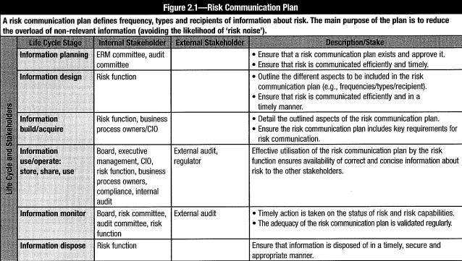

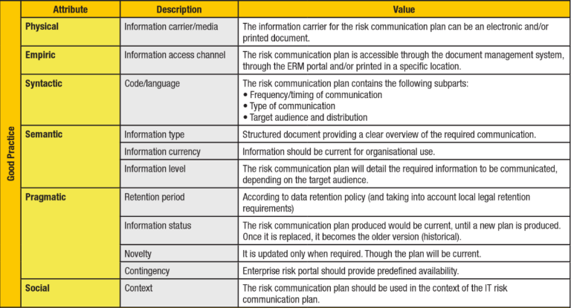

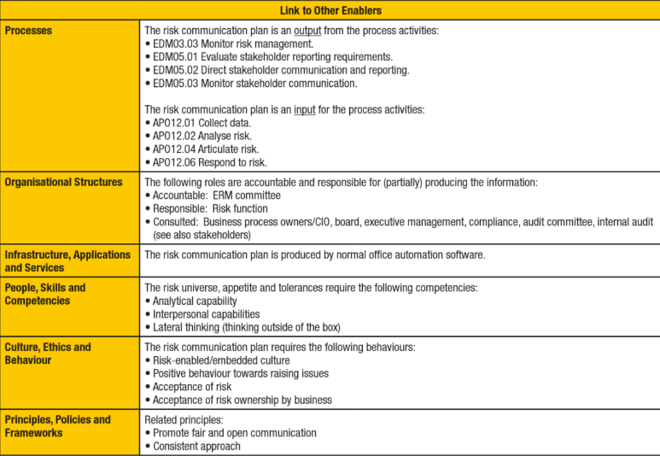

### 2.3 EFFECTIVE INFORMATION RISK MANAGEMENT

**Effective information risk management**: Supported by all org. members. Org. culture includes sound InfoSec practices. Has senior management support & commitment. Risk has *owner* with clear *accountability*. Personnel is aware of org. risk, understand their responsibilities and is trained in control procedures. Controls compliance is monitored, tested and enforced on a continuing basis. **Risk management activities** (legal, facilities, physical security, HR, audit, privacy and compliance) are integrated. [See *assurance process integration* (one of 6 governance outcomes in chapter 1). Integration of risk management, (governance & compliance) promoted by **Open Compliance and Ethics Group (OCEG)**].

#### 2.3.1 Develop Risk Management Program

To develop risk management program, initially establish:

•Context & purpose of program

•Scope & charter

•Authority, structure & reporting relationships

•Asset identification, classification & ownership

•Risk management objectives

•Methodology to be used

•Implementation team

##### Establish Context & Purpose

Determine ***purpose*** *to create info RM program*, identify *desired* ***outcomes*** and define***objectives*** (without context & scope, program will be too broad, responsibilities spread across several departments). **Integrate** & **divide responsibilities** if many risk management functions already exist. (*Integration* max cost-effectiveness, min gaps in protection & reduces chances to work at cross-purposes or be subverted by inadequate efforts elsewhere in organization).

***Set RM context***: define internal & external environment; org. structure & lines of authority; process, project or activity; scope; goals & objectives; **risk appetite** (acceptable level of risk), **risk tolerance** (acceptable level of deviation from acceptable risk level)\

##### Define Scope & Charter

Develop **RM RACI chart** (see section 1.3 Roles and Responsibilities): define scope of responsibility & authority ⇨ Prevent gaps, improve consistency of RM efforts & reduce duplication of effort. (Relationship between InfoSec and (physical security, operational risk, IT and business management) can be contentious).

##### Define Authority, Structure, Reporting

Define **authority** to take actions and make decisions (severe consequences due to lack of clarity as to who has authority to make decisions and take certain actions). **Reporting, authority, structure** impact on ability to manage risk (because different parts of org control different/conflicting parts of RM. Fractured RM structure further degrades if reporting goes to different decision makers).

##### Asset Identification, Classification, Ownership

Complete & accurate ***information asset register*** is required to scope & prioritize RM efforts. Locate, classify all instances of information assets in terms of *business value* or *sensitivity* and *criticality* (see 2.8 Information Asset Classification). Assign *owner* with specific *responsibilities* to manage risk ⇨ Help promote *accountability* for policy compliance and risk management requirements. Establish *policies* to require asset/risk ownership; process to assign ownership when acquire, transfer or create.

##### Determine Objectives

Set clear objectives and priorities (time & resource limitations). Set **priorities** for program and risk (some types of risk cannot be addressed & must be accepted; some can wait; and some need be addressed immediately). Before being prioritized, risk must be *identified*, its *likelihood/ impact* determined through risk analysis & impact assessment. Set priorities by starting with types of risk with high likelihood of materializing and high impact.

##### Determine Methodologies

Standard approaches to assess, analyze & mitigate risk should be used. If not established or inadequate, evaluate available choices to implement.

##### Designate Program Development Team

Once scope of risk management activities defined & objectives clarified, designate team responsible to develop & implement program. Success requires integration of risk management at all levels of organization. Operations staff and board members assist risk management committee to identify risk, determine acceptable risk levels, develop *loss-control* & intervention strategies, and determine authority & responsibility. Program needs be aligned with strategy & direction of business.

#### 2.3.2 Roles & Responsibilities

InfoSec responsible to *develop, collaborate and manage information risk management program to achieve acceptable level of risk by meeting control objectives*. Strive for most cost-effective solutions. Work with other risk management teams and assurance activities to promote integration of activities and provide effective/coordinated level of business process assurance. Effective integration prevents: gaps in protection/inconsistent risk management; reduces: duplication of efforts & work at cross-purposes.

### 2.4 INFORMATION RISK MANAGEMENT CONCEPTS

Concepts fundamental to security and risk management include: *technical, strategic, tactical, administrative* and *operational elements*.

#### 2.4.1 Concepts

•Acceptable interruption window (AIW) •Business impact analysis (BIA) •Controls •Countermeasures •Criticality •Exposure •Frequency •Impacts •Info asset classification •Key risk indicators (KRIs) •Max tolerable outage (MTO) •Proximity •Recovery time objectives (RTOs) •Recovery point objectives (RPOs) •Redundancy •Resource valuation •Risk •Risk analysis •Risk appetite •Risk assessment •Risk evaluation •Risk identification •Risk metrics/trends •Risk reporting •Risk tolerance •Risk treatment & response •Sensitivity •Service delivery objectives (SDOs) •Threats •Velocity •Volatility •Vulnerabilities

Other risk management aspects:

•Business continuity/disaster recovery •Business process reengineering •Enterprise & security architectures •IT and InfoSec governance •Policies, standards & procedures •Project management timelines & complexity •Service level agreements (SLAs) •System robustness & resilience •Systems life cycle management

#### 2.4.2 Technologies

InfoSec technologies and technical concepts:

•Antispam devices •Antivirus/malware, incl. spyware/adware •Application security measures •Cloud services, deployment, risk •Encryption, public key infrastructure (PKI) •Environmental controls •Intrusion detection/ prevention •Logical access controls •Network access controls •Network & Internet protocols •Physical security measures •Platform security •Routers, firewalls & components (bridges, gateways) •Telecom & voice-over-Internet protocol (VoIP) •Wireless security & protocols •Virtualization

In addition, **personnel** and **facilities security** need be considered as a part of risk management. Be aware/factor in personnel issues & security controls plus environmental & facilities controls as part of risk assessment & management activities.

### 2.5 IMPLEMENT RISK MANAGEMENT

To plan, identify org. risk management activities. Integrate or leverage within InfoSec context these functions: *risk management* function (related to physical risk); *credit risk*; *HR and privacy officers*; and *compliance functions* (audit). Ensure mechanisms to communicate with other risk management & assurance functions. Ensure risk management NOT bypassed or subverted. Prevent *duplication* of effort. Minimize *gaps* in assurance functions.

#### 2.5.1 Risk Management Process

Risk management = series of processes with end-to-end requirements to identify, analyze, evaluate and maintain risk at acceptable levels. Weigh policy alternatives in consultation with parties. Consider risk assessment & other factors. Select prevention & control options with acceptable costs and impacts on org. ability to operate. Risk management processes:

•**Establish scope & boundaries**: Global (internal/external) parameters for performance.

•**Identify info assets & valuation**: Determine assets at risk & impacts of compromise

•**Perform risk assessment**: Risk identification, analysis, evaluation, including: •Identify threats, vulnerabilities & exposures •Analyze level of risk & potential impact •Evaluate whether risk meets criteria for acceptance

•**Determine risk treatment/response**: Select strategies to deal with identified risk that exceeds acceptable level. Risk treatment strategies: avoid (by cessation of risky activities); mitigate (by developing/implementing controls); transfer risk to 3rd party (inside or outside org.); and accept (if no cost-effective way to mitigate, little exposure/impact, not feasible to address it effectively).

•**Accept residual risk**: Management decision & approval to accept remaining risk after treatment (risk accepted after evaluation shows it within acceptable limits; or if no effective treatment option available)

•**Communicate & monitor risk**: Exchange & share information. Review effectiveness of risk management process. Communication to decision makers and stakeholders inside/ outside organization. Ensure scope, boundaries, risk and action plans relevant & updated. See ***risk response workflow*** in figure 2.2 and 2.7.4 Risk Assessment & Management Approaches. Note: Concepts of avoid, reduce, share and accept are similar in meaning to: •Terminate the activity (avoid). •Reduce the risk (mitigate). •Transfer the risk (share). •Retain the risk (accept).

###### Figure 2.2 Risk Response Workflow

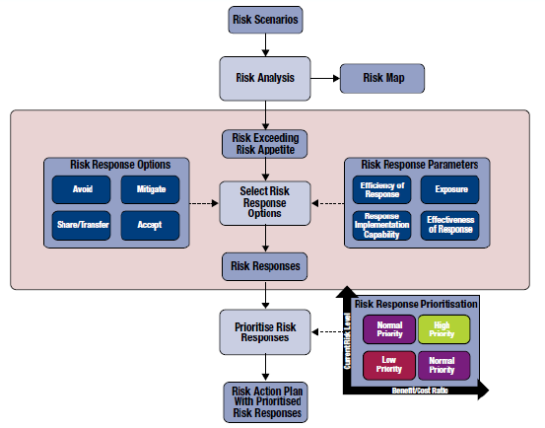

Develop systematic, analytical & continuous risk management process as shown in figure 2.3 as a formal process. Determine correct/appropriate level of security dependent on risk that org. faces, potential impact, and org. ability to accept/mitigate risk.

###### Figure 2.3 Continuous Risk Management Steps

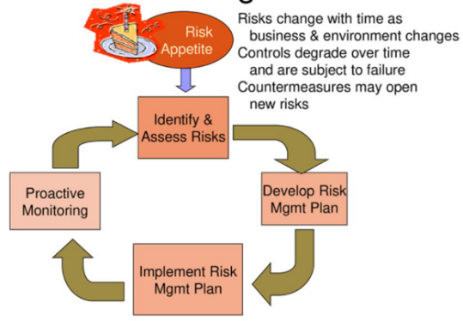

Set up regular, formal process to assess risk at organizational, system & application levels, including business processes (logical & physical). Ensure measurements (metrics) in place. Assess effectiveness of security measures/controls against control objectives and security baselines. Explore & recommend continuous manual/automated techniques to monitor risk. Focuses security activities on issues with greatest likelihood, impact & significance. Avoid over-generalization by applying risk factors across industries/regions. Consider challenges from organizational, technological and business/operational change. Monitor changes with change management processes. Risk management = continuous & dynamic process to address changing threats and vulnerabilities timely. Develop processes to monitor status of security controls & countermeasures. Controls degrade over time; subject to failure ⇨ Mandate ongoing control monitoring & periodic testing.

#### 2.5.2 Define Risk Management Framework

Use reference model. Adapt it to circumstances. Reference model reflects the desired state discussed in chapter 1 (snapshot of future state that meets risk management objectives). Examples of standards to provide guidance on IT and security risk management:

•COBIT 5 •ISO 31000:2009 Risk management: Principles and guidelines •IEC 31010:2009 Risk management: Risk assessment techniques •National Institute of Standards and Technology (NIST) Special Publication 800-39 Managing InfoSec Risk: Organization, Mission and Information System View •HB 158-2010 Delivering assurance based on ISO 31000:2009: Risk management: Principles and guidelines •ISO/IEC 27005:2011 Information technology>: Security> techniques: InfoSec risk management.

Standards have similar risk management requirements:

•**Policy**: (for risk management) including: objectives & commitment to risk management. Policy be relevant to org. strategic context, goals, objectives & nature of its business. Management ensures that policy understood; standards developed, implemented & maintained at all levels in organization.

•**Planning & resourcing**: Define & document responsibility, authority, accountability, interrelationships of personnel who perform and verify work (see section 1.3 Roles and Responsibilities). Identify resource requirements. Facilitate implementation of risk management programs by assigning trained personnel to manage/verify work activities.

•**Implementation program**: Define steps to implement risk management system.

•**Management review**: Executive ensure periodic review of risk management system to ensure stability & effectiveness. Records of reviews be maintained.

•**Risk management process**: Apply risk management at strategic & tactical levels: products/services, business/IT processes, projects, decisions, applications & platforms. Prioritize individual risk treatment according to business objectives, risk appetite and regulatory environment for given industry.

•**Risk management documentation**: Keep for each stage of the process records that satisfy independent audit. Establish framework for risk management; parameters within which risk be managed, incl. criteria for acceptable risk & control objectives.

Consequently, **scope** for rest of risk management process also set. Includes: definition of basic assumptions for org. external & internal environment and objectives of risk management process and activities. Definition of scope & framework are fundamental to establish of risk management BUT independent from structure of management process, methods & tools for implementation. To define a framework, it is important to:

•Understand org. background & risk (core processes, valuable assets, competitive areas)

•Evaluate existing risk management activities & criteria for acceptable risk levels

•Develop structure & process to develop management initiatives and control objectives.

This approach is useful to:

•Clarify & gain common understanding of organizational objectives

•Identify environment in which these objectives are set

•Specify scope & objectives for risk management, applicable restrictions, or specific conditions and outcomes

•Develop set of criteria against which risk is measured

•Define set of key elements to structure risk identification & assessment process.

Integrate risk management program with org. management system. Adapt various elements (policies, org. processes, accountability, resources, communication) to its needs. Review existing management practices/processes (with elements of risk management) OR formal risk management process for specific types of risk/circumstances). Assess to determine whether they meet current control objectives, mitigation and other requirements (efficiency, user acceptance, cultural compatibility, regulatory).

#### 2.5.3 Define External Environment

Define external environment (specify environment in which org. operates):

•Local market, business, competitive, financial & political environments

•Law and regulatory environment

•Social and cultural conditions

•External stakeholders

Evaluate both *perceptions* & *values* of stakeholders; external threats; and opportunities.

#### 2.5.4 Define Internal Environment

Key areas to evaluate organization’s internal environment:

•Key business drivers (market indicators, competitive advances & product attractiveness)

•Organization’s strengths, weaknesses, opportunities and threats

•Internal stakeholders

•Organization structure and culture

•Assets in terms of resources (i.e., people, systems, processes, capital)

•Goals, objectives, and strategies already in place to achieve them

#### 2.5.5 Determine Risk Management Context

**Risk Management context** = scope of activities + environment (org. structure & culture) in which risk management operates. Balance costs & benefits. Determine risk management context involves defining:

•Range of organization, processes/activities to be assessed

•Full scope of risk management activities

•Roles & responsibilities in organization participating in risk management process

•Organizational culture in terms of risk averseness/aggressiveness.

Determine and agreed upon criteria to evaluate risk. Decision over *risk treatment* based on operational, technical, financial, regulatory, legal, social or environmental criteria. Criteria are in line with scope & qualitative analysis of internal policies & procedures; and support its goals & objectives. Important criteria to be considered are:

•**Impact**: Kinds of consequences to consider

•**Likelihood**: Probability of compromise

•**Rules** to determine whether risk level is such that treatment activities are required

Change criteria during later phases of risk management process, based on result of changing circumstances/ consequence of risk assessment and evaluation process.

#### 2.5.6 Gap Analysis

**Gap analysis** determines gap between *existing controls* and *control objectives*. Define **control objectives** based on acceptable risk, consequent to developing InfoSec governance & strategy (chapter 1). Control objectives lead to controls that achieve acceptable risk, which serve to set **InfoSec baseline**. Control objectives may change due changes in risk management activities (exposures, business objectives & regulations), creating gap between control and its objectives. Periodically analyze gap between controls and objectives as part of *controls testing for effectiveness*. Control effectiveness fails to meet control objective/achieve acceptable risk? Controls be modified, redesigned or supplemented with new control activities. See 3.12 Controls and Countermeasures.

#### 2.5.7 Other Organizational Support

Many subscription services to integrate into InfoSec program leverage expertise of service providers without being responsible for any part of security program. They are:

•**Good practices** published by organizations: ISACA, SANS Institute and ISC2.

•**Security networking roundtables**: Gather InfoSec professionals from similar industries to discuss topics of common interest. Consider restricting attendance to vendor-sponsored forums so as to not feel pressure to purchase.

•**Security news organizations**: Daily or weekly news (e.g., Computer World, SANS, Tech Target, CIO Magazine).

•**Security-related studies**: PwC, EY, Verizon, Symantec and PONEMON provide annual studies regarding variety of security-related matters.

•**Security training organizations:** Classes on technical topics in InfoSec e.g. vulnerability analysis, platform security configuration strategies.

•**Vulnerability alerting services**: Allow InfoSec to maintain list of technologies in use at their organization and receive news on vulnerabilities found in any technology on the list.

### 2.6 RISK ASSESSMENT & ANALYSIS METHODOLOGIES

Risk assessment includes: *identification*, *analysis* and *evaluation* (figure 2.4), using COBIT 5 approach, which aligns with ISO/IEC 27005:2011.

###### Figure 2.4 InfoSec Risk Management Process

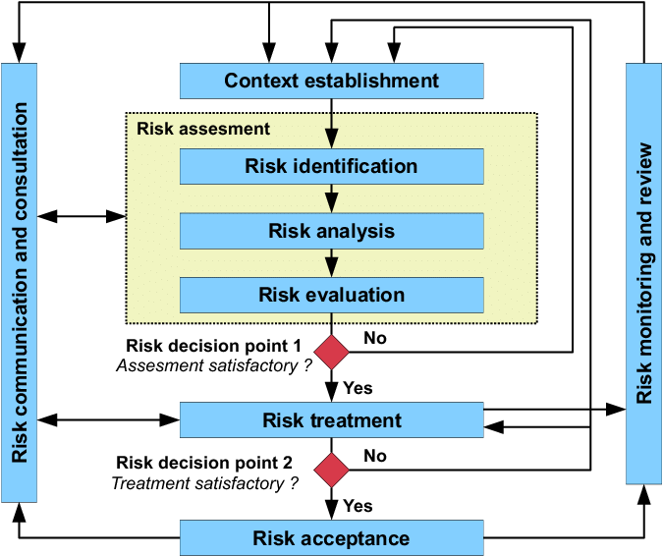

**Risk assessment**:(**Purposes**) Identify significant risks and provide *risk rating* of critical assets & processes. (**Approach)**: Develop **risk scenarios**. Perform **BIA**[6] & **asset classification** to determine (*business value* = *criticality &* *sensitivity*)*.* Identify appropriate & cost-effective countermeasures/controls to mitigate risk. **3 phases**:

➊**Risk identification** uses risk scenarios to determine range & nature of org. risk

➋**Risk analysis** combines info on *vulnerability* (from assessment) & *threat* (from other sources) to determine *risk* in terms of *frequency* & *magnitude*. Analysis includes statistical computations (VAR, ALE or ROSI[7]) for insight into *risk distribution* (max. risk, probable risk and potential consequences [impact]).

➌**Risk evaluation** compares results of risk analysis against criteria for *acceptability*, *impact*, *likelihood* and need for treatment. Decision over risk treatment based on *operational*, *technical*, *financial*, *regulatory*, *legal*, *social* or *environmental* criteria (in line with *scope* & *qualitative* analysis of org. *internal policies* & *procedures;* *goals* & *objectives*).

### 2.7 RISK ASSESSMENT

**Locate & identify, analyze then value assets**. **Rationales**: •Accurate *inventory of assets*: to determine *vulnerabilities to loss* that *(viable) threats* can exploit. •Asset’s *relative business value*: because *impact of losing asset (consequences)* determines *risk* & basis for *classification*. If asset is *valuable* and have *vulnerabilities* subject to *threats*, then there is *risk* (vulnerabilities without threats pose no risk). *Risk* exists if there is *likelihood of impact* and *consequences* [risk = likelihood x consequences]). The greater the *value* and the greater the number & degree of *vulnerabilities* coupled with more viable *threats*, the greater the *risk of loss*. Figure 2.5 is example of approach to risk assessment.

###### Figure 2.5 Risk Analysis Framework

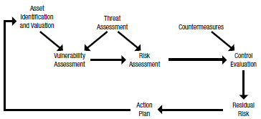

#### 2.7.1 Identify & Value Info Asset

Valuation relates values in common financial form. **Value HW** based on replacement costs. **Value of information** = Total range of potential losses & other impacts = Cost to recreate/restore it OR based on contribution to revenues OR related to consequential costs/ possible regulatory sanctions from exposure OR loss of trade secrets. (**Regulatory sanctions**: impact/consequences of breach of *personally identifiable information (PII)*; lawsuits from individuals suffering identity theft losses. **Reputational damage** resulting in loss of share value). **Marketing materials** NO intrinsic value BUT *unintended liabilities* (Inaccurate representations of products/services lead to wrong investor decisions can result in legal actions). **Categories of information assets to value and protect**:

•Proprietary info & processes of all types (incl. info damaging organization) •Current financial records & future projections •Acquisition or merger plans •Strategic marketing plans •Trade secrets •Patent-related information •PII

#### 2.7.2 Strategies to Value Info Asset

**Loss scenarios** is basis for effective resource valuation. Classify info into **matrix with loss scenario** to make problem more manageable & understandable (see Figure 2.6). Approach to prioritize efforts is *more critical* than valuation accuracy. **Sufficient for planning**: *Values within same order of magnitude as actual loss* (should it occur). Base valuation on media reports that document loss scenarios and loss amounts.

###### Figure 2.6 Matrix of Loss Scenarios

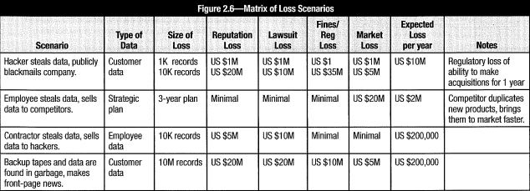

#### 2.7.3 Methodologies to Value Info Asset

**Variables** of asset valuation methodologies: (level of technical complexity, level of potential direct/consequential financial loss).

**Quantitative valuation** more precise but complex (analyze actual & downstream impacts) and not always available. **Monetary value** (purchase price, replacement cost or book value). Alternative approach if asset (in)directly generates revenue: **Net present value (NPV)** plus **value-add** or other intangible values. Example: e-commerce server costs US $50,000, but generates millions in revenue ⇨ Compute value in terms of revenue generation or financial impact for unanticipated downtime.

**Qualitative** **valuation** to make independent decision based on *business knowledge*, *executive directives*, *historical perspectives*, *business goals* & *environmental factors;* value on subjective scale (low, medium, high). **Intangible assets** (categorized as “*goodwill*”): difficult to quantify intellectual property (trade secrets, patents & copyrights, knowledge management, brand reputation, corporate culture, customer loyalty & trust, and innovation). Publicly traded company: **intangible assets** = difference (tangible assets, company’s market capitalization).

Be aware of **changes** in organization. Alter valuation methodologies to meet changes. Quantitative data outdated? Use qualitative data to augment quantitative data.

###### Figure 2.7 NIST Risk Assessment Methodology

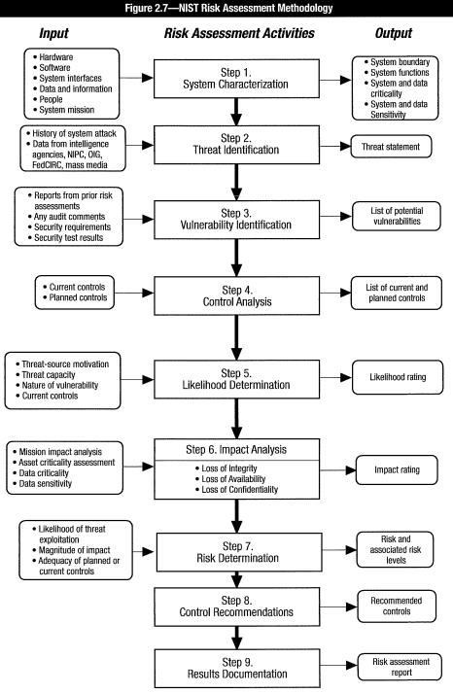

#### 2.7.4 Risk Assessment & Management Approaches

Standard RM models & assessment: *COBIT*, *OCTAVE*, *NIST 800-39*, *HB 158-2010*, *ISO/IEC 31000*, *ITIL,* *CRAMM*; *factor analysis of information risk (FAIR)*, *risk factor analysis* and *VAR*. Common approaches are shown in Figure 2.2 Risk response workflow.

**COBIT 5 approach**: **Risk scenarios** ⇨ 3 steps of **risk assessment:** *identify* then *analyze* *risk* then *evaluate* risk (to determine whether risk exceeds acceptable levels ⇨ **Risk response** (**risk treatment**) conditioned by criteria in risk response parameters ⇨ **Prioritize risk response (treatment)**based on cost-benefit & risk-level analysis (high cost-benefit & high likelihood-high impact = highest priority) ⇨ **Action plan**

#### 2.7.5 NIST Risk Assessment Methodology

Nine (9) primary steps in risk assessment methodology (Figure 2.7):

•Step 1: System (or general domain) characterization

•Step 2: Threat identification

•Step 3: Vulnerability identification

•Step 4: Control analysis

•Step 5: Likelihood determination

•Step 6: Impact analysis

•Step 7: Risk determination

•Step 8: Control recommendations

•Step 9: Results documentation

#### 2.7.6 ISO/IEC Process Steps

Figure 2.8shows ISO/IEC 27005 process steps for risk assessment & relation to COBIT 5.

###### Figure 2.8 ISO/IEC 27006 Process Steps Covered by COBIT 5 for Risk

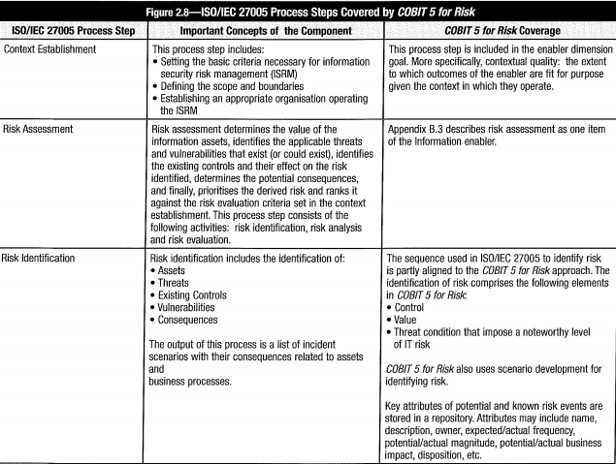

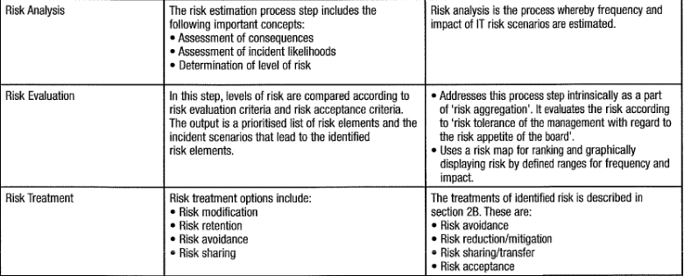

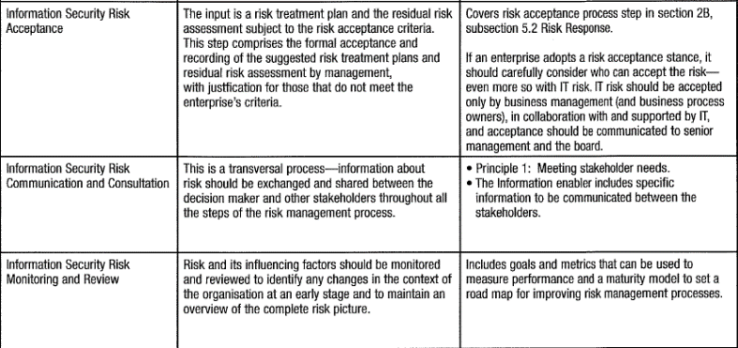

#### 2.7.7 Aggregated & Cascading Risk

**Aggregated risk** exists when *risk (individually acceptable) has catastrophic impact collectively*: threat affects many minor vulnerabilities that, in the aggregate, have a significant impact; OR many threats simultaneously affect many minor vulnerabilities, resulting in large aggregate risk.

**Cascading risk** manifests when one failure leads to chain reaction, resulting into unacceptable impacts. (IT and operations have closely coupled dependencies. Any particular failures or combinations of failures will affect dependent systems).

#### 2.7.8Other Risk Assessment Approaches

##### Factor Analysis of Information Risk (FAIR)

FAIR offers a reasoned, detailed analysis process. It is designed as a complement to other assessment approaches to increase accuracy.

###### Figure 2.9 Factor Analysis of Information Risk (FAIR)

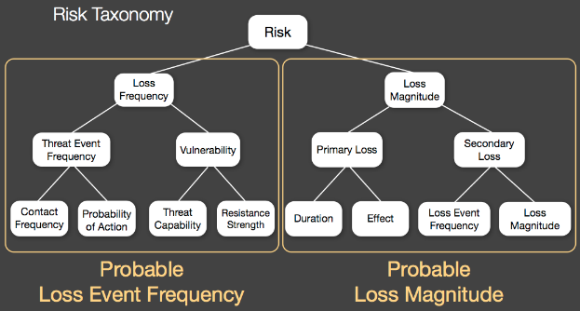

FAIR provides a reasoned and logical framework for the following:

•**Taxonomy** of factors making up information risk. Taxonomy provides foundational understanding of info risk plus set of standard definitions for necessary terms.

•**Method to measure** factors driving risk (threat event frequency, vulnerability and loss).

•**Computational engine** that derives risk by mathematically simulating relationships among the measured factors.

•**Simulation model** to apply taxonomy, measurement method, computational engine to build & analyze risk scenarios of virtually any size or complexity.

Four primary components of risk taxonomy to identify threat agent characteristics:

➊Frequency with which threat agents come into contact with organization or assets

➋Probability that threat agents will act against organization or assets

➌Probability of threat agent actions being successful in overcoming protective controls

➍Probable nature (type and severity) of impact to assets

##### Probabilistic Risk Assessment

**Probabilistic risk assessment (PRA)** = systematic & comprehensive methodology to evaluate risk associated with every life cycle aspect of complex engineered technological entity (from concept definition through design, construction, operation, and removal from service). Developed for NASA and nuclear power industry, approach is complex and time-consuming Basically, the approach looks to answer 3 questions:

➊What can go wrong? ➋How likely is it? ➌What are the consequences?

Answers based on deconstruction of all elements at risk in set of circumstances. Then systematically identify, model and quantify scenarios that lead to adverse consequences based on probability/statistical theory, reliability engineering, decision theory, and other information. Elements to assess chain of events: HW/SW failure, human actions, control failures and other possible interactions that can lead to serious consequences.

#### 2.7.9 Identification of Risk

**Risk identification** = Determine type & nature of viable threats and org. vulnerabilities subject to those threats. **Identified risk** = vulnerabilities on all assets (with service providers, outsourcers, employees, contractors, etc.) possibly exploited by identified threats. **Viable threats** (real & potential; subject to some control). **Vulnerabilities:** commonly known technical weaknesses; obscure/unmonitored processes, procedures or outsourced services (e.g., staff unawareness, exposed info via overheard conversations).

Identify risk through group effort to develop **risk scenarios** & **what-ifs**. Evaluate each vulnerability in terms of *viable threats* and *impact*. Create *list of identified risk* to analyze, determine likelihood & extent of potential impacts. Significant vulnerabilities not subject to identified threat? Add to analysis list as possible threat in the future. The main focus areas when developing risk scenarios are shown in figure 2.10. Prudent approach: consider what can go wrong eventually will. Process itself is subject to error, but reduces odds of successful attacks. Use technical methods to identify/ track risk and record risk analysis. Define resource requirements. Establish budget & timetable (chapter 3 Infosec Program Development and Management). Generate comprehensive list of sources of threats, vulnerabilities, exposures and risk; list of events impacting org. ability to achieve its objectives (events prevent, degrade, delay or help achieve objectives).

**Risk characteristics**:

•**Origin**: Threat agents (hostile/not properly trained employees, competitors, govt.)

•**Activity, event, incident (i.e., threat)**: Unauthorized dissemination of confidential data, competitor deployment of new marketing policy, new/revised data protection regulations, extensive power failure.

•**Consequences, results (impact)**: Service unavailability, loss or increase of market share/profits, increase in regulation, increase or decrease in competitiveness, penalties

•**Specific reason for occurrence**: System design error, human intervention, prediction or failure to predict competitor activity

•**Protective mechanisms, exposure & controls** (with estimate of effectiveness): Access control & detection systems, policies, security training, market research & surveillance

•**Time & place of occurrence**: Flood in computer room during extreme conditions.

###### Figure 2.10 Main areas to focus on to develop risk scenarios

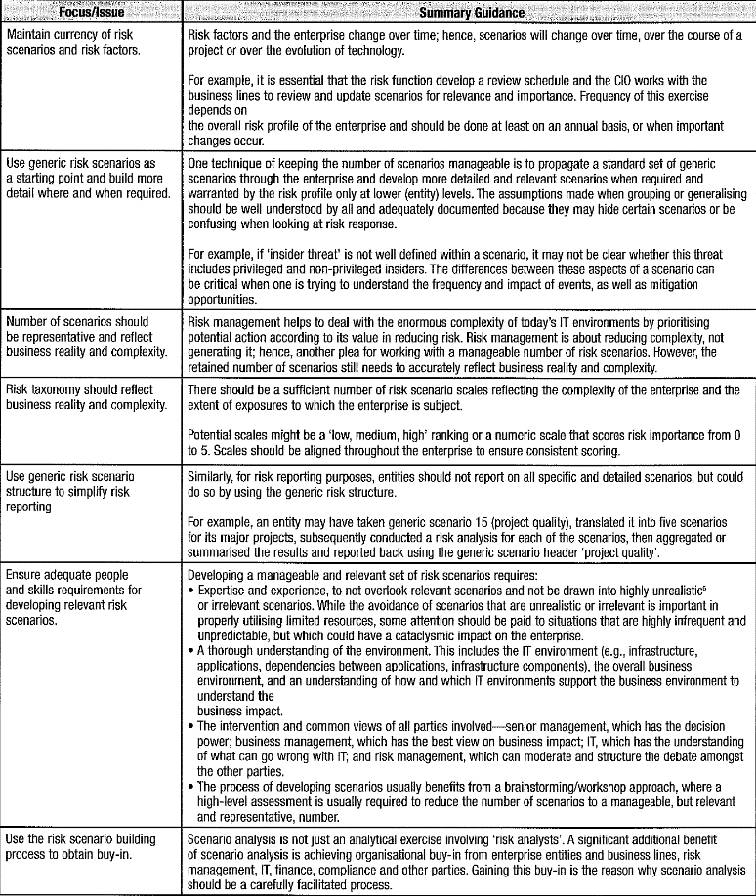

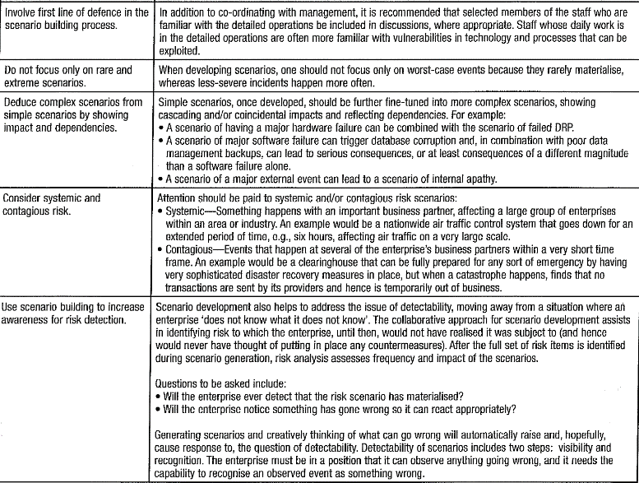

Methods, tools, techniques to identify risk & occurrence:

•**Team-based brainstorming** (workshops to build commitment, different experiences)

•**Structured techniques** (flowcharting, system design review, systems analysis, hazard & operability studies, operational modeling)

•**What-if** & **scenario analysis** for un-clearly defined situations (identify strategic risk & processes with a more general structure) as shown in figure 2.11

•**Threats** (internal/external) mapped to (identified/suspected) vulnerabilities

###### Figure 2.11 Risk Scenario Approaches

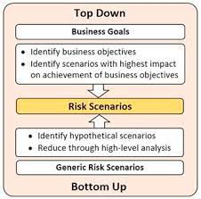

**Risk scenarios development:** describe potential risk event & document factors/areas affected by risk event. **Risk events** = (system failure, loss of key personnel, theft, network outages, power failures, natural disasters or situation affecting business operations & mission). Relate each risk scenario to *business objective* or *impact*. Focus on real & relevant potential risk events. Examples: develop risk scenario based on change in market for products, change in government/leadership, or supply chain failure. Figure 2.12 shows an example of many inputs to develop risk scenarios.

###### Figure 2.12 Risk Scenario Structure

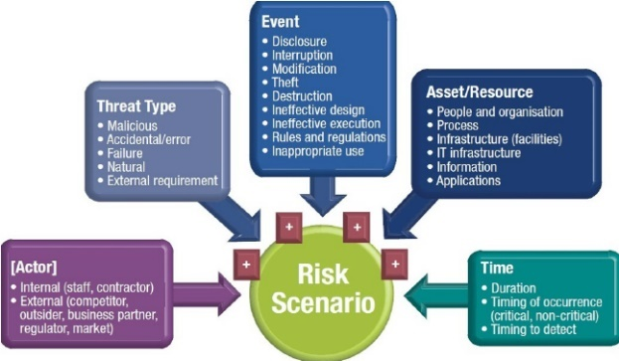

#### 2.7.10 Threats

***Threats*** (+circumstances/events) to potentially cause harm by exploiting vulnerabilities: can be external/internal, intentional/unintentional; caused by natural events, political, economic or competitive factors. Always exist. Beyond direct control of risk practitioner or asset owner. Not all conceivable threats need be considered. However, identify types of threats that may compromise systems. Categories of threats:

•Physical •Natural events •Loss of services •Disturbance due radiation •Compromise of information •Compromise of functions •Technical failures •Unauthorized actions

Document all threats applicable to systems & processes. Examine cause of past failures, audit reports, media reports, info from national ***computer emergency response teams (CERTs****)*, data from security vendors & communication with internal groups. Threats result from accidental actions, intentional/deliberate actions or natural events; originate from internal/external sources. Attacks may leverage combination of both internal & external sources. Threats directed by individual agents? Beware that threat agents are imaginative, creative, determined to explore new methods and avenues of attack. **Unidentified threat** = org. is unprepared and vulnerable. Sources for info on threats:

•Assessments •Audits •Business continuity plans •Finance •Government publications •Human resources •Insurance companies •Management •Media •Product vendors •Security companies •Service providers •Threat monitoring agencies •Users

##### Internal Threats

*Need-to-know* & *least privilege* is **imperfect** solution (*any system has trusted insiders*).

**Steps to address personnel threats**: (*Hiring process*) review qualifications & attitude of prospective employees (info on job applications, claimed education, certification, experience; review of references; background checks) may be worthwhile to the extent permitted by law. (*At hiring time*), require employee to sign nondisclosure agreement, org. ethics and policies). (*Throughout employment*) Awareness sessions & regular management reviews to remind employees of org. policies and responsibilities. Interact with employees to understand frustrations, complaints or issues. (*During times of strike, layoffs, mergers, relocation, reorganization*) employee likely a risk. Employee recently demoted/bypassed for promotion may pose risk. (*At end of employment*) Employee return all org. assets, ID badges, equipment (e.g., laptops, mobile phones, access cards) and uniforms. Remove systems, network, facility access immediately prior to employee’s departure.

##### External Threats

External threats:

•Criminal acts •Data corruption •Disease (epidemic) •Espionage •Facility flaws (freezing pipe/pipe burst) •Fire •Flooding •Hardware flaws •Industrial accidents •Lost assets •Mechanical failures •Power surge/utility failure •Sabotage •Seismic activity •Severe storms •Software errors •Supply chain interruption •Terrorism •Theft

Natural events: flood, storm, earthquake or tornado. Use governmental data and weather monitoring services to identify threats associated with natural events. External personnel threat: hacker, a thief or an advanced persistent threat (APT) [**APT** = *advanced, highly skilled attackers determined (persistent) in their attempts to exploit systems & networks*}. Most breaches result from targets of opportunity, not determined attacks. Verizon annual reports: organizations breached because discovered to be easy targets.

##### Advanced Persistent Threat

APTs pose significant risk to orgs of virtually all types globally. Figure 2.13 shows the typical sources of APT. Due to the required sophistication, expertise, time and costs involved, these efforts normally mounted only against high-value targets

###### Figure 2.13 Sources of APT

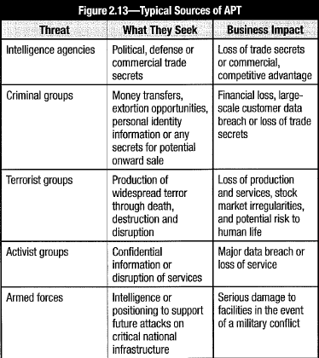

NIST publication 800-39 defined APT: *Adversary that possesses sophisticated levels of expertise and significant resources which allow it to create opportunities to achieve its objectives using multiple attack vectors (e.g., cyber, physical and deception). These objectives typically include establishing and extending footholds within the IT infrastructure of the targeted organizations for purposes of exfiltrating information, undermining or impeding critical aspects of a mission, program or organization; or positioning itself to carry out these objectives in the future. The advanced persistent threat: (i) pursues its objectives repeatedly over an extended period of time; (ii) adapts to defenders’ efforts to resist it; and (iii) is determined to maintain the level of interaction needed to execute its objectives*.

Typical APT attacks life cycle:

•**Initial compromise**: Attackers use social engineering & spear phishing via email, using zero-day viruses. Plant malware on web site that victimized employees likely to visit.

•**Establish foothold**: Attackers plant remote admin. software in victim’s network and create network back doors/ tunnels to allow stealth access to network infrastructure.

•**Escalate privileges**: APTs use exploits & password cracking to acquire administrator privileges over victim’s computer. Possibly expand to Windows domain admin. accounts.

•**Internal reconnaissance**: Attackers collect information on surrounding infrastructure, trust relationships and Windows domain structure.

•**Move laterally**: They expand control to other workstations, servers and infrastructure elements and perform data harvesting on them.

•**Maintain presence**: APTs ensure continued control over access channels & credentials.

•**Complete mission**: Attackers exfiltrate stolen data from the victim’s network.

##### Emerging Threats

Indications of emerging threats: unusual activity on system, repeated alarms, slow system/ network performance, new/excessive activity in logs. Evidence of emergent threats in logs BUT not noticed or acted on. *Lack of effective monitoring* leads to breach. Technologies built with emphasis on function and purpose without consideration for security = source of vulnerabilities/ be threat agent. Be alert to emergence of new technologies, particularly if promise cost savings/competitive advantage (e.g. Bring your own device (BYOD).

#### 2.7.11 Vulnerabilities

“**Vulnerability**” (aka “**weakness**”) NOT binary, *varying degrees* (control condition ⇨ *high (or lower) degree of vulnerability* + *extent of exposure* (probability of compromise).

**To identify, validate, classify vulnerabilities**: Conduct regular vulnerability assessments & penetration tests. **To assess vulnerabilities**: ➊Analyze process, procedural weaknesses, logical ones. ➋Estimate (quantitative/qualitative) vulnerability degree with (testing or SME estimates) & report estimates imprecision. Use ranges/distributions (for max, min, likely values). **About weak control**: Understand other controls (may mitigate overall exposure). Identify weaknesses with automated scan ⇨ lead indicators of compromise. Process & performance vulnerabilities more difficult to ascertain. *Effective assessment considers process, procedural and physical vulnerabilities in addition to technology weaknesses*.

Vulnerabilities numerous causes: no process for configuration control, poor personnel morale, technical issues, human factors. Categories of vulnerabilities:

•Network vulnerabilities •Physical access •Applications & web-facing services •Utilities •Supply chain • Processes •Equipment •Cloud computing •Internet of things

Audits, security reviews, vulnerability scans, penetration can identify vulnerabilities:

•Defective software •Improperly configured HW/SW •Inadequate compliance enforcement •Poor network design •Uncontrolled/defective processes •Inadequate governance/management •Insufficient staff •Lack knowledge to support users/ops •Lack security functionality •Lack proper maintenance •Poor passwords choice •Transmission unprotected communications •Lack redundancy •Poor management communications

*NIST “Special Publication 800-30 Revision 1 Guide to Conducting Risk Assessments*” lists vulnerabilities & “*predisposing conditions*” leading to rapid/unpredictable emergence of new vulnerabilities. Other sources: •National Vulnerability Database (*nvd.nist.gov*) •Common Weakness Enumeration (*nvd.nist.gov*) •Harmonized Threat & Risk Assessment (*www.cse-cst.gc.ca*) •Contingency Planning & Management (*contingencyplanning.com*) •Open Web Application Security Project (OWASP) at *www.owasp.org*

#### 2.7.12 Risk, Likelihood, Impact

**Risk definition**: “probability of an event and its consequences” ⇨ ***risk = threats x vulnerabilities x consequences***. (Traditional assessment: threats x vulnerabilities = risk (more threats, greater vulnerability, more risk). ISO 73:2009 (controversial) risk definition: “*combination of probability of event and its consequence”* (consequence can be compromise or positive event (opportunity)). Logical categories of risk areas (figure 2.14) helps focus on risk management strategies & decisions; and risk treatment approaches.

###### Figure 2.14 Operational Risk Categories

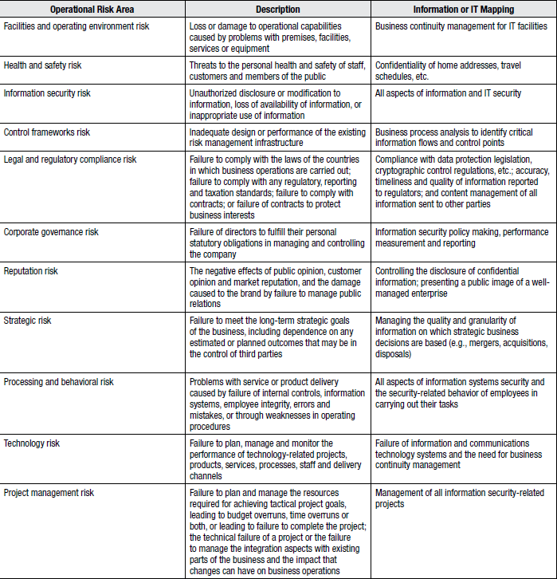

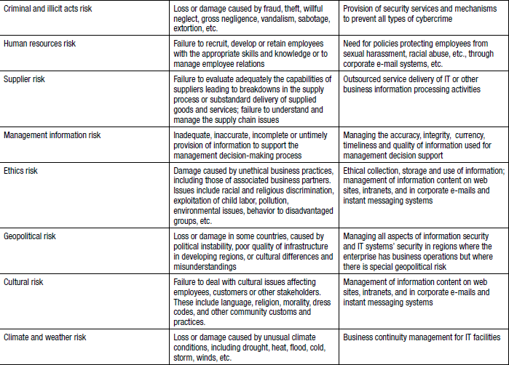

**Likelihood (probability)** = measure of frequency that event may occur. *Probability* derived from likelihood that *threat* will exploit *vulnerability*. No consequences? Risk nonexistent. Use likelihood to *calculate level of risk based on no events, combined with potential impact in given time period*. *Likelihood* (or frequency) combined with *magnitude* (of impact) determines **ALE**. The greater frequency, the greater likelihood, the greater risk. To determine *likelihood,* consider the following factors:

•**Volatility**: Probability of risk may depend on volatility of situation (When conditions vary, risk is greater increasing unpredictability, requiring higher estimation of risk.

•**Velocity**: A consideration of extent of prior warning of event + amount of time between event occurrence & subsequent impact.

•**Proximity**: Indicate time between event and impact (greater velocity, closer proximity).

•**Interdependency**: Do not consider risk in isolation, but in org. context & in relationship to other assets & functions. Materialization of risk types affect org. differently (whether risk events occur concurrently/ sequentially).

•**Motivation**: Attacker’s motivation affects chances of success. Nature of motivation affects type of assets (nation states target differently from criminals seek financial gain).

•**Skill**: Level of skill of attackers determine type & value of assets attacked (high-value assets attract more skilled attackers).

•**Visibility**: High-visibility targets likely be attacked.

Allocate protection resources for the greatest benefit. Majority of risks NOT from technology BUT from management & personnel problem. Address threats directly. (e.g., employees and former employees, service providers, consultants, suppliers)? *access controls*, *need-to-know*, *network segmentation*, *termination procedures,* *good monitoring*.

**Level of acceptable risk** = Senior management decision. Approaches to determine level of acceptable risk in section 1.8.4 Risk Objectives (cost of protection proportional to value of asset and not exceeding value of asset being protected). With most remedial activities, a *point of diminishing returns* at which costs of additional controls rise faster than benefits derived. **Factors affect acceptable risk**: •Culture (risk-averse/ risk-aggressive) •Ability to absorb losses (risk capacity) •Effects & costs of mitigation •Extent & kind of potential impacts •Legal & contractual requirements.

#### 2.7.13 Risk Register

###### Figure 2.15 Risk Profile

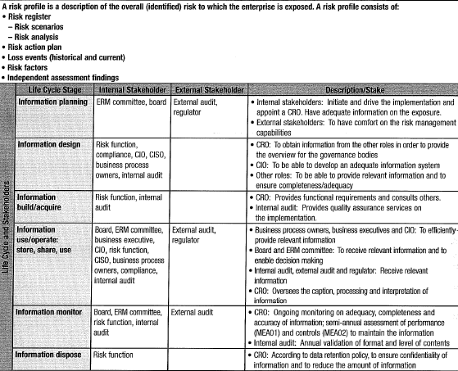

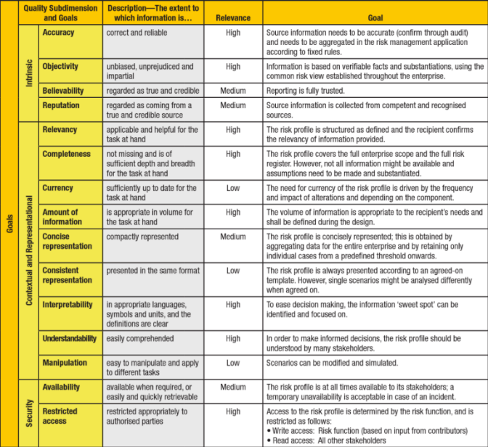

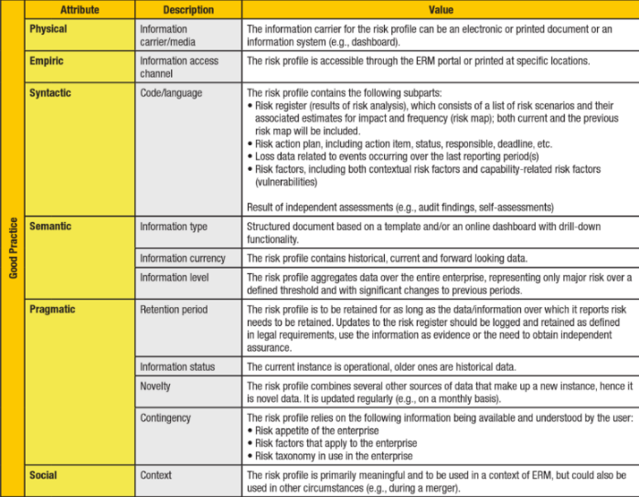

**Risk register**: central repository for infosec risks. Includes: *threats, vulnerabilities, exposures* and *assets;* *asset owner*, *risk owner* and *stakeholders*. Is part of **risk profile** (provide overview of org. risks). Figure 2.15 shows COBIT 5 risk profile. Figure 2.16 shows a template for risk register (part of risk profile).

###### Figure 2.16 Risk Register

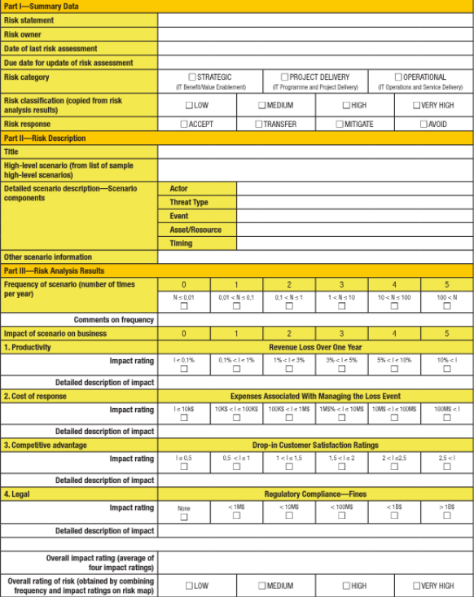

#### 2.7.14 Risk Analysis

**Risk analysis** = phase where identified *risk* & its *nature* are assessed/understood and consequences of compromise determined. Also determines effectiveness of existing controls and mitigating effects. Risk analysis involves:

•Examine risk sources (threats & vulnerabilities) determined in risk identification

•Extent to which assets have exposure to potential threats and effect on likelihood

•Potential negative consequences (impact) if assets successfully attacked

•Likelihood that those consequences may occur and factors that affect them

•Assess existing controls/processes (controls from standards; controls/practices selected from risk register; from previous risk treatment activities).

Estimate level of risk with statistical analysis; calculations of *impact* (require BIA) & *likelihood*. Formulas/methods that combine impact and likelihood be consistent with criteria defined in risk management context (event may have multiple consequences and affect different objectives ⇨ consequences & likelihood need be combined to calculate level of risk). Information to estimate impact & likelihood usually comes from:

•Past experience or data and records (e.g., incident reporting)

•Reliable practices, international standards or guidelines

•Market research on other organizations and analysis

•Experiments and prototypes

•Economic, engineering or other models

•Specialist and expert advice

Risk analysis techniques include:

•Interviews with experts in the area of interest and questionnaires

•Use of existing models and simulations

•Statistical and other analysis

##### Qualitative Analysis

In **qualitative analysis**, magnitude & likelihood of potential consequences are described in detail. Adjust *scales* to suit circumstances. Use of qualitative analysis:

•As initial assessment to identify risk (subject of further, detailed analysis)

•Where nontangible aspects of risk need be considered (reputation, culture, image)

•Where lack of information, data or resources for acceptable quantitative approach

Qualitative analysis can be accomplished by using a 5 by 5 matrix, as in figure 2.17.

###### Figure 2.17 Semiquantitative Impact Matrix

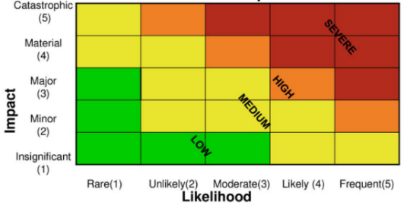

##### Semiquantitative Analysis

½ -quantitative analysis objective: assign values to scales. Values indicative, NOT real NOT accurate representation of actual magnitude of impact/likelihood ⇨ Use numbers in formula that recognizes limitations/assumptions). May lead to *inconsistencies* (numbers possibly NOT reflect analogies among risks, particularly when consequences/ likelihood extreme) ⇨ Select values to be indicative & sufficient to prioritize risk above another risk. Have common understanding of values and terms employed. Common definitions:

**Impact values**:

•**Insignificant (value = 1)**: No meaningful impact •**Minor (value = 2)**: Impact on small part of business only (or < US$1 million impact) •**Major (value = 3)**: Impact on org.’s brand (or > US $ million impact) •**Material (value = 4)**: Impact > US$200 million and requires external reporting •**Catastrophic (value = 5)**: Failure/downsizing of org.

**Likelihood values**:

•**Rare (value = 1)** •**Unlikely (value = 2)**: Not seen within last 5 years •**Moderate (value = 3)**: Seen within last 5 years but not last year •**Likely (value = 4)**: Seen within last year •**Frequent (value = 5)**: Happens on regular basis

**Risk probability and consequences**:

•**Risk = Impact x Likelihood**

Example: Risk = 4 (material) x 3 (moderate) = 12.

##### Quantitative Analysis

Numerical values assigned to *impact* and *likelihood*. Analysis quality depends on *accuracy* of values & *validity* of statistical models. Determine *impact* by evaluating results of an event/ by extrapolation from experiments/ past data. Consequences expressed in terms of:

•Monetary •Technical •Operational •Human impact criteria. Specification of risk level not unique. Impact & likelihood combined differently, according to type of risk, scope and objective of risk management process.

##### ALE & SLE

**Single Loss Expectancy (SLE)** = **asset value** (**AV**) * **exposure factor** **(EF)**

**Annualized Loss Expectancy (SLE)** = **SLE** * **annualized rate of occurrence (ARO)**

**SLE = AV * EF**; **ALE = SLE x ARO**

**EF** = Probability of event and its likely magnitude (= *Percentage of asset loss caused by identified threat*). Greater value (with greater probability & greater magnitude, greater potential risk of loss)

**ARO** = Estimated frequency of threat on *single asset*. High risk assoc. to threat, high ARO

**ALE** adds **ARO** (⇨ *multiple* occurrences result greater potential losses). **ALE** = *annual expected financial loss* to *an asset*, resulting from *one specific threat*.

Example: Insurance data suggest fire likely to occur once in 25 years. Annualized rate of occurrence ARO: 1/25 = 0.04. EF (percentage of loss that a realized threat could have on a specific asset when specific threat matches up with a specific vulnerability) = proportion of asset’s value likely be destroyed by particular risk, expressed as a percentage.

##### Value at Risk

**Value at risk (VAR)** useful, beneficial and suitable to infosec management. Computation *based on historical data of probability distribution of loss for given period of time at certainty factor (95% or 99%)*. Monte Carlo simulations generate probability distribution from ,000 iterations with random variables based on historical information.

##### OCTAVE

**Operationally Critical Threat Asset and Vulnerability Evaluation** (**OCTAVE**): approach to risk assessment and ranking to help understand, assess and address infosec risk. Methodology process-driven. Intended to help organizations:

•Develop qualitative risk evaluation criteria based on operational risk tolerances

•Identify assets critical to mission of organization

•Identify vulnerabilities and threats to critical assets

•Determine & evaluate potential consequences if threats are realized

•Initiate corrective actions to mitigate risk & create practice-based protection strategy

OCTAVE focuses on critical assets and the risk using comprehensive, systematic, context-driven and self-directed evaluation approach. Characteristics of OCTAVE:

•Identifies critical information assets

•Focuses risk analysis activities on these critical assets

•Considers relationships among critical assets; threats to assets; and vulnerabilities (both organizational and technological) that can expose assets to threats

•Evaluates risk in operational context (how critical assets used to conduct business; how they are at risk due to security threats & vulnerabilities)

•Creates practice-based protection strategy for improvement & risk mitigation plans to reduce risk to organization’s critical assets.

The OCTAVE process is based on 3 phases:

•**Phase 1: Build asset-based threat profiles (organizational evaluation)**: Determine critical assets and what is done to protect them. Identify security requirements for each critical asset. Establish org. vulnerabilities and threat profile for each critical asset.

•**Phase 2: Identify infrastructure vulnerabilities (technological evaluation)**: Identify network access paths and classes of IT components related to each critical asset. Determine extent to which each class of component is resistant to network attacks. Establish technological vulnerabilities that expose critical assets.

•**Phase 3: Develop security strategy & mitigation plans (strategy & plan development)**: Establish risk to critical assets based on analysis of information gathered. Decide what to do about the risk. Create protection strategy and mitigation plans. Determine next steps to implement and gain approval on outcome of entire process.

##### Other Risk Analysis Methods

Some other common approaches:

•**Bayesian analysis**: Method of statistical inference. Use *prior distribution data* to determine probability of result. Technique effectiveness & accuracy rely on accuracy of prior distribution data.

•**Bow tie analysis**: Provides diagram to communicate risk assessment results by displaying links among possible causes, controls & consequences. Cause of event depicted in the middle of diagram (“knot” of bow tie) and triggers, controls, mitigation strategies and consequences branch off of “knot.”

•**Delphi method**: Uses expert opinion (using 2 or more rounds of questionnaires). After each round of questioning, summarize results, communicated to experts by facilitator. Collaborative technique used to build a consensus among the experts.

•**Event tree analysis**: Forward-looking, bottom-up model to uses inductive reasoning to assess probability of different events resulting in possible outcomes.

•**Fault tree analysis**: Start with an event. Examine possible means for event to occur (top down). Display results in logical tree diagram (can be used to generate ways to reduce or eliminate potential causes of the event).

•**Markov analysis**: Used to analyze systems that can exist in multiple states. Assumes that future events are independent of past events.

•**Monte-Carlo analysis**: Used to establish aggregate variation in a system resulting from variations in the system, for a number of inputs, where each input has a defined distribution and the inputs are related to the output via defined relationships. Used for specific model where interactions of various inputs can be mathematically defined. Inputs can be based upon distribution types according to nature of uncertainty. For risk assessment, triangular distributions or beta distributions are commonly used.

#### 2.7.15 Evaluation of Risk

**During risk evaluation phase**: decisions concerning *risk treatment*, *treatment priorities* based with allowances for *margin of error* (considerable if reliable data unavailable). If risk meets acceptable risk criteria, treatment option = ***acceptance***. If risk exceeds acceptable level and not within tolerance variance, treatment = ***mitigation*** (options: modification, addition of controls, business process reengineering to make process less risky). *System redesign* to reduce technical risk (eliminate system failure) or ***risk transfer*** (or *sharing*). No cost-effective options to mitigate excessive risk? ***Accept risk*** if benefits are high. Select *risk transfer* for *low likelihood* & *high impact* risk. Risk mitigated through use of controls? consider *control risk* (probability control will fail or inadequate).

Consider org. objectives, stakeholder views, scope & objective of risk management process itself and probable margins of error. Make decisions based on risk level and ***thresholds*** specified in terms of:

•Consequences (e.g., impacts) •Likelihood of events •Cumulative (aggregated) impact of simultaneous events •Effect of cascading risk (domino effect) in closely coupled systems •Cost of treatment •Ability to absorb losses

#### 2.7.16 Risk Ranking

Uses results of risk assessment to rank risk to direct response effort. **Risk ranking** derived from combination of: recognition of threats, characteristics & capabilities of threat source, severity of vulnerability, likelihood of attack success (considering effectiveness of controls), control risk, impact of successful attack.

#### 2.7.17 Risk Ownership & Accountability

Risk requires **ownership** & **accountability**. Identify a manager or senior official as risk owner: *accountable* to accept risk based on org. risk appetite; has budget, authority & mandate to select *risk response*. **Accountability** extends to approving controls for mitigation (types of controls examined in chapter 3); create *direct link*: all risk addressed through appropriate treatment, all controls justified by risk. Owner also owns any controls associated with that risk; accountable to ensure monitoring of effectiveness. Prepare standard reports on status of risk, occurring incidents, level of risk faced and tested effectiveness of controls.

#### 2.7.18 Risk Treatment (Response) Options

Four strategic choices when facing risks:

➊**Avoid** risk by terminating activity that gives rise to it.

➋**Transfer** risk to another party (usually results from a transfer of impact).

➌**Mitigate** risk with appropriate control measures or mechanisms.

➍**Accept** the risk.

Another alternative: ignore risk (*dangerou*s, underestimation of likelihood & magnitude, disastrous consequences). Accept risk (understand probability & consequences; find them acceptable under the circumstances).

##### Terminate Activity

Activities can be modified or processes reengineered to mitigate/manage risk to acceptable levels. Analysis of the activity can conclude that it is not worth the risk. Note that even service terminated, liability remains as long as product/service is being used.

##### Transfer Risk

Transfer risk with **insurance purchase**; some risk transferred to insurance in exchange for premium payments (reflect insurance’s assessment of degree of risk). Risk *actually not transferred*; rather, *impact reduced* (insurance covers costs). Transfer to insurance when *probability of incident is low, but impact is high*.

Transfer risk by **outsourcing IT**, provided *indemnification clauses* are in contracts. In transferring *operational risk*, 3rd-party agreements/contracts to specifically address *liability* & *responsibilities* of both parties in **indemnification clauses** (part of outsourced service agreement to provide a level of protection against harmful incidents).

While some financial impacts associated can be transferred,  **legal responsibility** for consequences of compromise **cannot** be transferred.

##### Mitigate Risk

Mitigate risk: implement/ improve security controls; institute countermeasures; modify/ eliminate risky processes. *Preventive* controls address risk or reduce exposure. Risk can be reduced by countermeasures reducing or eliminating a threat. Reduce impact through *compensating* or *corrective controls* (incl. contractual, procedural, technical processes).

##### Accept Risk

Condition to accept risk: (mitigating cost > asset benefit/value) OR (NOT feasible to mitigate risk) OR (potential impact low). NOT all impacts can be reduced to financial terms. Other considerations than finance: customer trust & confidence; legal liability/ breach of regulatory requirements. Ensure risk management procedure to enable accurate & appropriate documentation for business manager to decide to accept risk. Risk acceptance be regularly reviewed to ensure rationale still valid within business context.

##### Risk Acceptance Framework

###### Figure 2.18 Risk Acceptance Framework

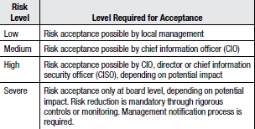

A risk acceptance framework to set criteria for acceptance of risk + level at which management acceptance is executed in figure 2.18.

#### 2.7.19 Residual Risk

**Inherent risk**: risk prior to mitigation. **Residual risk:** remaining risk after *countermeasures* and *controls* implemented. Risk NEVER eliminated; residual risk ALWAYS remains. Reducing risk INEVITABLY introduces another risk (of lesser nature). Example: dual control introduces risk that 2 individuals collude. Objective: Ensure (residual risk = org. criteria for acceptable risk and risk tolerance). **Risk tolerance:** allowable deviation from **acceptable risk** (as percentage or range +/- 10%). Acceptable residual risk: outcome of meeting control objectives; equivalent to defined security baselines for organization. Report of residual risk through risk assessment identifies areas to further mitigate risk. Acceptable risk levels risk established in infosec strategy (chapter 1). Strategy not developed? Determine acceptable risk levels, in terms of *allowable potential impacts*. Residual risk above acceptable level? Treat with additional mitigation through more stringent controls. Risk below acceptable level? Determine whether countermeasures/ control excessive; whether cost savings can be achieved. Considerations for final acceptance of residual risk:

•Regulatory compliance

•Organizational policy

•Sensitivity & criticality of relevant assets

•Acceptable levels of potential impacts

•Uncertainty inherent in risk assessment approach

•Cost & effectiveness of implementation

Consider *full life cycle cost*, including cost to implement/operate specific measures or mechanisms balanced against risk & potential impacts being addressed.

#### 2.7.20 Impact

**Impact**: result of vulnerability exploited by threat causing loss. Threats & vulnerabilities not causing impact are *irrelevant* and not considered as risk. Impact *quantified* as *direct financial loss* in short term or *ultimate (indirect) financial loss* in long term. Examples:

•Direct loss of money (cash or credit)

•Criminal or civil liability

•Loss of reputation/goodwill/image

•Reduction of share value

•Conflict of interests to staff, customers, shareholders

•Breach of confidence/privacy

•Loss of business opportunity/competition

•Loss of market share

•Reduction in operational efficiency/performance

•Interruption of business activity

•Noncompliance with laws & regulations resulting in penalties

Impact calculations can be qualitative or quantitative. Quantitative impacts: range of possible financial impacts. Qualitative impact: loss of reputation/market share. Determine impacts by performing **business impact assessment** (and semi-quantitative analysis with industry statistics) to determine **criticality** and **sensitivity** of assets; include RTO, RPO, MTO, SDOs and AIW. BIA: basis for access authorizations and **business continuity planning (BCP)**; prioritizes risk management; (coupled with asset valuations) basis for levels & types of protection and business case for controls.

#### 2.7.21 Controls

**Controls**: technology, process, practice, policy, standard or procedure to regulate activity to mitigate or reduce risk. Can be administrative, technical, management or legal nature (section 3.12 Controls and Countermeasures). Use excessive number of controls to address same risk is wasteful and *reduces productivity*. Ensure that *controls NOT subject to SAME risk.* Effective & accurate risk assessments? Conduct from beginning to end of processes ⇨ Facilitate understanding if upstream controls minimize/eliminate risk that may preclude need for subsequent controls; determine control *redundancy* or *duplication*.

#### 2.7.22 Legal & Regulatory Requirements

Consider **Legal & regulatory requirements** in terms of *risk* and *impact* to determine level of *compliance* & *priority*. Evaluate first **regulations** to determine extent of requirements, current level of compliance, risk level to organization, level of *enforcement,* org. relative position to peers. Evaluate impact (financial & reputational) of *full-partial-non* compliance.

#### 2.7.23 Costs & Benefits

Consider costs & benefits of controls/countermeasures. (Costs > benefits of mitigation)? Accept risk. “Cost of control never exceeds expected benefit” = proportionality principle in ***generally accepted security systems principles (GASSP)*** or ***generally accepted infosec principles (GAISP).*** *Cost-benefit analysis* provides *monetary* impact view of risk ⇨ Make smart choices on risk mitigation costs vs. losses (risk exposure). Caution: Loss metrics due infosec crime understated/not established (annual Computer Security Institute (CSI) Computer Crime and Security Survey).

3 common measurements of potential losses: ➊employee productivity impacts, ➋revenue losses and ➌direct cost loss events. Example: E-commerce web site produces US$ 1M of revenue each day. Denial of service (DoS) attack for ½ day creates $500,000 loss (can force customers delay purchases or go to a competitor). Consider direct loss (productivity & revenue losses) indirect loss (customer trust, employees additional work hours/protection efforts).

Consider **total cost of ownership (TCO)** for full life cycle of control/countermeasure:

•Acquisition costs

•Deployment & implementation costs

•Recurring maintenance costs

•Testing & assessment costs

•Compliance monitoring & enforcement

•Inconvenience to users

•Reduced throughput of controlled processes

•Training in new procedures/technologies

•End-of-life decommissioning

#### 2.7.24 Events affecting Security Baselines

**Baseline security** = minimum security level across enterprise. Baselines different for assets of different classification levels (higher classification, higher & more restrictive baseline). Example: higher-classification assets require two-factor authentication; lower classifications only ID and passwords. Baseline security *changes* with change in risk or impact equation; determined by *collective ability of controls* to protect; controlled by  *least restrictive aspect of collective standards;* be reflected in *control objectives*. Increase/modify baseline security by changing standards & controls – consequent to risk reassessment & analysis of security incident attributed to control failure/lack of control.

### 2.8 INFORMATION ASSET CLASSIFICATION

**Information asset classification** helps determine **sensitivity** & **criticality** (aka **business value**) of information assets. **Criticality** *determined by impact result from loss of asset* ( how important asset is to business). **Sensitivity** *based on potential damage resulting from unauthorized disclosure*. Basis to *protection efforts*, *business continuity planning* & *user access control*. Comprehensive classification not possible due to resource constraints? (less effective option) **business dependency assessment,** based on information resources that critical business functions utilize.

Start classification process by ensuring *information asset inventory* complete & *location of asset* identified. (step also necessary in *risk identification phase* of a *risk assessment*). **Identification process** determines *location of data*, *data owners*, *data users* and *data custodians*; what data housed by *external service providers* (media vaulting, archival firms, mailing list processors, mail processors, couriers or info transporters, data centers providing hosting functions, payroll services or health insurance administration).

Ascertain with business information **classification** based on *business value*, levels of *sensitivity* & *criticality*. Ensure business & IT stakeholders have reviewed & approved *established guidelines for access control levels*. Keep number of levels to a minimum.

Benefit of asset classification: reduce *risk of under protection* + *cost of overprotection* by tying security to business objectives. Questions for information asset classification model:

•How many classification levels are suitable for organization?

•How will information be located?

•What process is used to determine classification?

•How will classified information be identified?

•How will it be marked?

•How will it be handled?

•How will it be transported?

•How will confidential information be stored and archived?

•What life cycle of the information (create, update, retrieve, archive, dispose)?

•What processes associated with stages in information asset life cycle?

•How will it be retained according to policy or law?

•How will it be safely destroyed at end of retention period?

•Who has ownership of information?

•Who has access rights?

•Who has authority for determining access to the data?

•What approvals are needed for access?

Important: Not just apply classification label, but identify *security measures* to consistently apply to each level: high level, more restrictive security mechanism to provide greater level of protection. Sensitivity & criticality require different security mechanisms and processes.

#### 2.8.1 Determine assets criticality & Impact of adverse events

**BIA** = process to identify *impact of adverse events* (use methods in COBIT, NIST, OCTAVE). Focus on impact of loss of assets *rather than* on adverse event (too many adverse events to practically/ cost-effectively to list them all). **Step 1**: break org. structure into business units or departments (figure 2.19). Rate units by importance/value (related to revenue, critical functions). (In figure 2.19, Business Unit B is rated 1 since it is the most important).

###### Figure 2.19 Top Layer of Business Risk Structure



**Step 2**: Identify critical organizational functions. Define what tasks important to unit in achieving goals. Can be two-level structure within critical function layer to represent complex operations. Numerically rate business functions to prioritize risk remediation efforts. Once functions identified, basic structure of organization mapped (figure 2.20). Recognize that structure focused *only on operational elements*, not technologies, applications or data. Progressive drill-down structure looks similar to BIA ⇨ Provide management level view of risk and where it resides in organization.

###### Figure 2.20 Critical Function Layer of Business Risk Structure

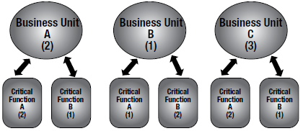

**Step 3**: In figure 2.21, assets & resources are *containers of risk* (vulnerabilities in assets exploitable by threats? There is risk). Numerically rate assets, like business units & critical functions (because assets support critical business functions).

###### Figure 2.21 Aligning Assets to the Critical Function Layer

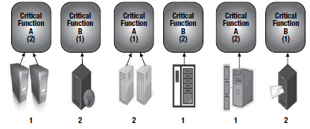

Risk in figure 2.22 = composite of vulnerabilities that threat can exploit to cause negative impact to asset. Roll-up & drill-down useful (business can see their functions’ level of risk to set prioritization schedule to fix vulnerabilities/prioritize protection efforts).

###### Figure 2.22 Asset Vulnerabilities

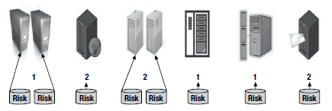

Figure 2.23 shows how risk exposure can impact company’s most valuable assets.

###### Figure 2.23 Combined Risk Impact Structure

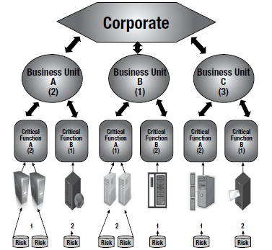

#### 2.8.2 Impact Assessment & Analysis

**BIA:** determine impact of losing availability of resource; establish *escalation of that loss over time*, identify minimum resources to recover, and prioritize recovery of processes and supporting systems. **Impact** = bottom line of risk. Determine range of severity to guide risk management activities. Determine only worst-case outcome? Minority of events ⇨ “Impact inflation” can be discounted as unrealistic and excessively pessimistic.

More effective approach: Perform set of *scenario analyses* with org. stakeholders to determine range of potential outcomes. Use range of outcomes to define *quantitative distribution of impact magnitudes* (minimum, maximum and most likely, with values and confidence level). Input these values to *quantitative analysis methods* (Monte Carlo simulations to determine probability distribution). Advantage: Closely resemble type of impact data from other business risk domains (e.g., investment, marketing, credit). Before beginning impact analysis of assets, obtain following information:

•**System mission** (objectives of processes performed by system or personnel)

•**System** (manual or technical) & **data criticality** (system’s value or importance to org)

•**System, personnel, data criticality** (impacts associated with unintended disclosure)

Obtain information from BIA or org. documentation (e.g., mission impact analysis report, asset criticality assessment report). (Mission impact assessment & analysis or BIA) prioritizes impact levels associated with compromise based on qualitative/quantitative assessment of asset criticality (HW, SW, systems, services, related technology). Documentation does not exist? Determine sensitivity based on level of protection to maintain *availability*, *integrity* and *confidentiality* of system and data. Describe *adverse impact of security event* in terms of *loss*, *degradation* or combination of *integrity*, *availability* and *confidentiality*:

•**Loss of integrity**: System & data integrity = requirement that info be protected from improper modification. Integrity lost due unauthorized/erroneous changes by intentional/accidental acts. If loss of integrity not corrected, contaminated system or corrupted data could result in broader corruption, fraud or misinformed decisions. Also, violation of integrity = first step to attack system availability/confidentiality.

•**Loss of availability**: Mission-critical IT system/process unavailable? Org. mission is affected. Loss of system functionality & operational effectiveness result in loss of productive time, impede users’ performance of their functions.

•**Loss of confidentiality**: Confidentiality refers to protection of info from unauthorized disclosure. Impact of unauthorized disclosure of confidential information range from jeopardized national security to disclosed private consumer data. Unauthorized, unanticipated or unintentional disclosure of private consumer or other regulated data result in loss of public confidence, customer base and legal action.

Tangible impacts can be measured quantitatively in lost revenue, cost of repair or effort required to correct problems. Other impacts (loss of public confidence, loss of credibility, damage to an organization’s interest) can be described qualitatively in terms of high, medium and low impacts. Advantage of qualitative impact analysis: prioritize risk, identify areas to address vulnerabilities. Disadvantage of qualitative analysis: No quantifiable measurements of magnitude of impacts (cost-benefit analysis of controls difficult). Advantage of a quantitative impact analysis: measures impacts’ magnitude (to use in cost-benefit analysis of controls). Disadvantage: depending on numerical ranges of measurement, meaning of quantitative analysis may be unclear, require interpretation in qualitative manner. Additional factors: range of errors in estimation or computations.

### 2.9 OPERATIONAL RISK MANAGEMENT

**Operational risk** = Risk of loss resulting from inadequate/failed processes, people and systems, or from external events. Incident management can be adequate to manage materialized risk and minimize significant disruption. In some cases, incidents escalate to disasters (business continuity and disaster recovery). In either event, backstop to limit risk and ensure it is managed: understanding + capability to address these issues sufficiently.

#### 2.9.1 Recovery Time Objectives (RTO)

**RTO** = Amount of time to *recover acceptable level* of normal operations. Dictated by business. Defined by **SDO**. Determined by asset’s *functional criticality*, *recovery priorities* and *inter-dependencies* offset by *costs*. Dependent upon: *cyclical need* (time of day, week, month or year) of information & organization, *inter-dependencies* among information & org. requirements, and *cost* of available options. **Org. requirements** based on customer needs, contractual obligations or SLAs, and regulatory requirements. RTO may vary with timing of month or year (financial info not as critical at beginning of month, but critical at end of month when monthly financial reports prepared and accounting period closed). Consider timing of business cycles & dependencies.

Perform **BIA** to determine RTO (BIA required to determine inter-connection of systems & dependencies, which affects order of restoration). Conduct BIA by interviewing info owners to obtain perspective on cost associated with service interruption. Two perspectives for RTO: ➊Perspective of individuals using information, ➋View of senior management, who considers costs and arbitrates among units competing for resources (asset critical to divisional supervisor but not critical to VP operations, who includes overall organizational risk in evaluation of the RTO). Both perspectives important! Factor into BCP, scope of services to be restored + priority order to recover systems. Senior management best position to arbitrate needs & requirements of components of business, regulatory requirements, and determine acceptable costs.

#### 2.9.2 Relation (RTO, BCP) and Contingency Planning

RTO and associated data essential to develop & implement BCP. Organization can identify and develop contingency strategies to meet RTOs of resources. RTOs drive order of priority to restore services and select recovery technologies (for short RTO). Balance cost and RTO (cost of recovery less if RTO long). Calculate **breakeven point time** (where impact of disruption > cost of recovery). Length of time period depends on nature of business disruption and assets involved. Consider qualitative & quantitative issues (loss of customer confidence, even if it cannot be estimated, have long-term negative impact). Most organizations can reduce RTOs, but there is an associated cost.

#### 2.9.3 Recovery Point Objectives (RPO)

**RPO** based on *acceptable data loss in case of disruption of operations*. Indicates *most recent point in time* to which it is acceptable to recover data (generally the latest backup). RPO quantifies *permissible amount of data loss in case of interruption*. Depending on volume of data, reduce time between backups to prevent situation where recovery becomes impossible because of volume of data. Time required to restore large volume of data can make it impossible to achieve RTO ⇦ Important for risk management strategy.

#### 2.9.4 Service Delivery Objectives (SDO)

**SDOs** = *minimal level of service to restore to meet business requirements until normal operations can resume*. SDOs affected by RTOs and RPOs. To consider in risk management strategy & implementation. High service levels require greater resources & current RPOs.

#### 2.9.5 Maximum Tolerable Outage (MTO)

**MTO** = *maximum time org. can operate in alternate (or recovery) mode*. Factors affect MTO (fuel to operate emergency generators, accessibility of recovery site, operational capacity of recovery site). Affect RTO, which affects RPO. Consider relationship among MTO, RTO and RPO to minimize risk of inadequate recovery to organization.

#### 2.9.6 Allowable Interruption Window (AIW)

**AIW** = *amount of time normal operations can be down before organization faces major financial difficulties that threaten its existence*. MTO be as long as AIW to minimize risk.

### 2.10 THIRD-PARTY SERVICE PROVIDERS

Be aware of location and access permissions for all information resources (all require protection). Considerations when outsourcing:

•Ensure org. has appropriate controls & processes in place to facilitate outsourcing

•Ensure information risk management clauses in outsourcing contract

•Ensure risk assessment performed for the process to be outsourced

•Ensure level of due diligence performed prior to contract signature

•Manage information risk for outsourced services on a day-to-day basis

•Ensure material changes to relationship are flagged; new risk assessments performed

•Ensure proper processes are followed when relationships are ended

Considerations when outsourcing services:

•Outsourcing/planning to outsource business-critical functions increases information risk.

•Complexity of managing information risk increased (separation of responsibility for control specification and control implementation).

•Separation of responsibility for control specification and control implementation is bridged by the outsourcing contract. Underlines contract’s importance as primary method through which organization can manage information risk.

•Outsourced function within regulated industry? Outsourcing contract explicitly address regulatory requirements.

•Complexity of information risk assessment increased, because there are 3 different areas to assess: ➊business function, ➋outsourcing provider and ➌outsourcing itself.

•Style of contract and amount of innovation contributed by provider have major impact on how information risk management requirements are specified.

•Relationship (organization and outsourcing provider) contributes more to effective information risk management than the contract.

•Information risk management within outsourcing arrangement must evolve so that it continues to be relevant to the organization’s needs.

•Exit strategy for outsourcing arrangement important. Develop at planning stage. Include in contract to facilitate continued availability of outsourced function. Exit strategy far too important to leave until the outsourcing arrangement comes to its conclusion.

Information risk management requirements for outsourced functions are greater than those for in-house functions. Once information risk analyzed and controls identified, define these controls in contract for provider to implement. Outsourcing disconnects setting the controls from implementation. Figure 2.24 views this separation of org. responsibilities vs. those of the provider. Be aware that, although information risk management can be outsourced, *responsibility cannot be outsourced*.

###### Figure 2.24 Disconnect of Responsibilities with Outsourced Providers

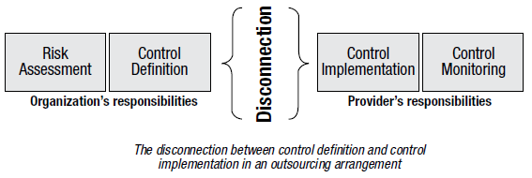

Disconnection between control definition & control implementation makes managing risk complex ⇨ Outsourcing contract essential to manage information risk. **Challenge**: how to define & implement risk management controls in different outsourced business functions? Business problem: need to define & implement risk management measures to protect business functions that were handed to 3rd party to operate. Recommendations for outsourcing initiatives:

•Timely involvement of risk management professionals to ensure risk assessment & controls definition

•Negotiation of key information risk management controls within the contract

•Mechanisms to negotiate small changes to risk management controls (can be costly)

•Avoid difficult and complicated changes to information risk management controls

•Mechanisms to get information on whether information risk is managed effectively

•Mechanisms to compensate for lack of trust in provider’s Staff

#### 2.10.1 Outsourcing Challenges

Outsourcing other challenges: vendors reluctant to share technical details on nature & extent of information protection mechanisms ⇨ Ensure adequate levels of protection included in **SLAs** and other outsourcing contracts. Specify requirements for specific audits such as **SOC 2** {*Report on Controls at a Service Organization Relevant to Security, Availability, Processing Integrity, Confidentiality or Privacy, developed by the AICPA*) or **ISO 27001:2013** certification. Analyze SOC 2 & audit reports on customer control effectiveness and policy compliance. (Note: SOC 2 report NOT sufficient on its own because criteria self-defined by organization). High-risk relationships? Rely on periodic compliance assessments conducted by sourcing organization/contracted 3rd party.

Important: (Incident management & response, BCP/DRP, testing) include all outsourced services/functions. Implement incident detection, escalation & response plan in concert with outsourcing entities. Regulated organizations (finance)? Set time frame to notify regulatory agencies regarding suspicious events on regulated information (notifications requirements established in contracts).

Other consideration: vendor financial viability (risk to operate according to contract and honor indemnity agreements). Obtain financial information from: credit reports, US Securities and Exchange Commission filings of publicly traded firms, and annual reports. Otherwise, obtain information from provider.

Some risk can be transferred by incorporating indemnity clauses in SLAs. Key clauses:

•Right to source code in event of default of provider (e.g., source code escrow)

•Require vendor remain timely with compliance to industry and regulatory requirements

•Right to audit the vendor’s books of accounts and premises

•Right to review the vendor’s processes

•Insistence on standard operating procedures (SOPs)

•Right to assess the skill sets of the vendor resources

•Advance information if the resources deployed are to be changed

Establish SLA on timeliness of response (system, human), scanning expectations, etc.

### 2.11 INTEGRATE RISK MANAGEMENT WITH LIFE CYCLE PROCESSES

Ensure (*risk identification*, *analysis*, *evaluation*, *mitigation*) integrated in **life cycle processes**. **Change management** provides approach to *implement* risk management on ongoing basis (changes introduce new vulnerabilities). Ensure **security** entrenched so changes NOT made without considering of overall security. Participate as member of change management committee. Ensure all subject to review & approval and meet policy & standards requirements. Change management: Extend *beyond* system owners & IT; include facilities management (data center) and other areas (physical access control).

Address system & facilities maintenance windows with facilities personnel (outsourced) and business continuity management. **Facilities**: Changes not documented timely. No current single-line drawings and blueprints ⇨ Computer infrastructure/ configuration management changes NOT documented/updated timely. **Business continuity**: Fall behind when updates occur in cycles. *Emergency response* & *business continuity* suffer communications lapses when current & changing processes NOT reviewed within facility infrastructure areas. [Environmental monitoring & control systems (*building management system [BMS]*/ *supervisory control and data acquisition [SCADA]*) for heating, ventilating & air conditioning (HVAC), water & electricity, physical access control systems]: program for remote computer access (*often* escapes infosec oversight).

IT systems can be compromised due to *vulnerabilities* in physical security system. Physical security & control systems: part of critical infrastructure ⇨ Protection of systems, system code & data integrated into *security classification schemes*. Review facilities service SLA/ contracts in support physical & control systems for *emergency-response clauses.*

Do NOT overlook internal/external parties managing facilities. Assessing risk related to: internal parties (operators with direct physical access to systems & facilities); external parties including servicing agents (cleaning/maintenance crew). **Possible controls**: *background screening*, *employment terms*, *annual confirmation* (via signature) of compliance to code of conducts, or *contractual terms*.

#### 2.11.1 Risk Management for IT SDLC

NIST Special Publication 800-30: *minimize negative impact on organization and need for sound basis for decision making = fundamental reasons organizations implement a risk management process for their IT systems*. Risk management be fully integrated into **system development life cycle (SDLC)** five phases (initiation, development/acquisition, implementation, operation/maintenance, and disposal). Risk management is *iterative process*; can be performed during each SDLC phase. Figure 2.25 describes characteristics of SDLC phase; indicates how risk management can support each phase.

###### Figure 2.25 Characteristics of SDLC Phases

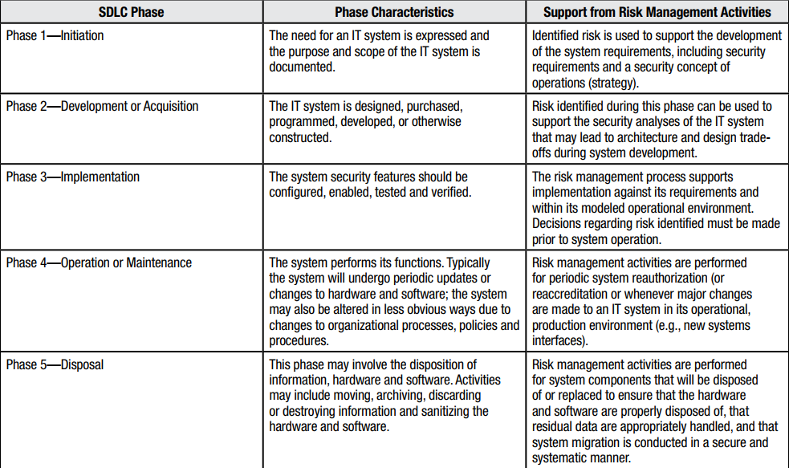

#### 2.11.2 Life Cycle-Based Risk Management Principles & Practices

Risk management is continuous process ⇨ Have life cycle: (assessment, treatment, monitoring) phases, as in figure 2.26. Life-cycle-based risk management approach integrated with change management improves costs (full risk assessment not performed periodically; updates to risk assessment & risk management processes incrementally).

###### Figure 2.26 IT Risk Management Life Cycle

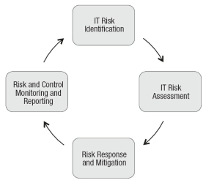

### 2.12 SECURITY CONTROL BASELINES

**Baseline** = “*Initial set of critical observations/data used for comparison or control*”. To formulate controls baselines: *Measure effectiveness & efficiency of controls*. Based on standards implemented within organization, test control *multiple times* control effectiveness & efficiency, *as required by standard*. Baseline NOT based on single test of controls; but on OVERALL capacity of controls to collectively mitigate risk. Different baselines for different security classifications (stringent security controls for higher classification levels of more critical/sensitive assets).

Benefits of security baselines: Set *minimum security requirements* throughout org.; Standardizes min. amount of security measures to employ; Provides *point of reference* to measure changes to security & identify effects on risk.

Develop controls based on: *culture*, *structure*, *risk appetite* & *tolerance*. Consider people, processes and technology. Develop *procedural* & *physical security baselines*. Consider (and tailor, incorporate into org. security baselines) specifications from vendors, security organizations, infosec professionals and systems auditors about *security configuration specifications* that represent *prudent level of due care*. Caution: commingling different technologies can introduce new risk/change secure system into one with vulnerabilities ⇨ *Tailor* risk assessment to recognize above *interactions* & *dependencies;* specific regulatory requirements for industry & regions. Adjust standard (higher/lower) commensurate with asset classification. Objective: residual risk across security domain be at consistent acceptable level ⇦ Validate by periodic risk assessments to address ever-changing nature of threats, vulnerabilities and technologies.

Example: Establish baseline for antivirus processes. Require *periodic (weekly, monthly) reports of infected systems*, *virus alerts*, *virus incidents* (to help desk), *definition file updates*, etc. Use information to evaluate control effectiveness. Use additional information (man-hours required, SW costs, latent risk) to evaluate efficiency of antivirus process. This shows how metrics can be used to monitor baselines & adjust them as necessary.

Select metrics for risk management based on best ranking of characteristics:

•**Specific**: Based on clearly understood goal; clear & concise

•**Measurable**: Able to be measured; quantifiable (objective), not subjective

•**Attainable**: Realistic; based on important goals and values

•**Relevant**: Directly related to a specific activity or goal

•**Timely**: Grounded in a specific time frame

•**Meaningful**: Understood by recipients

•**Accurate**: A reasonable degree of accuracy

•**Cost-effective**: Not too expensive to acquire or maintain

•**Repeatable**: Able to be acquired reliably over time

•**Predictive**: Indicative of outcomes

•**Actionable**: Clear to the recipient what action must be taken

### 2.13 RISK MONITORING & COMMUNICATION

Implement risk management program requires monitoring & communication. **Monitor** control *effectiveness* = ongoing effort to manage risk. Establish **communication channels** for reporting & disseminating info to manage risk & inform infosec manager about risk-related activities, changes in risk and training & awareness.

#### 2.13.1 Risk Monitoring

Important component of risk management life cycle: continuous monitoring, evaluating, assessing and reporting risk. Document & report results & status of ongoing analysis.. Figure 2.27 shows a risk report from COBIT 5 as a standard to communicate risk status.

###### Figure 2.27 Risk Report

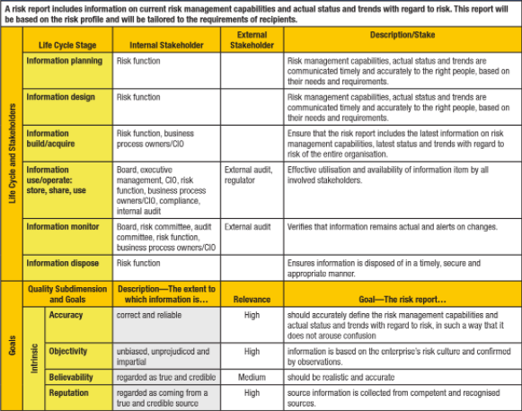

**Red-amber-green** **reports** (aka *security dashboards*), **heat charts** or **stoplight charts** are used to show assessment of security posture. Infosec responsible to manage reporting process. Ensure it takes place, results analyzed & acted on appropriately & timely. Is responsible to identify types of events (that trigger reporting required by regulatory agencies & law enforcement).

#### 2.13.2 Key Risk Indicators

Report & monitor risk with **KRIs** = *measures that indicate when enterprise subject to risk that exceeds defined risk level;* indicate *trends in factors* (known to increase risk, e.g. increased absenteeism, turnover in key employees, rising levels of security events).

KRIs provide early warnings on possible issues/areas. Based on industry benchmarks, external threat reporting services, etc. Specific to enterprise; based on parameters in internal & external environment (size & complexity of org., where it operates (regulated market), and business strategy).

Considerations to identify risk indicators:

•Risk indicators NOT focus solely on *operational* or *strategic* side of risk. Be identified for all stakeholders ⇨ Involve right stakeholders. Ensure greater buy-in and ownership.

•Balance selection of risk indicators to cover: *performance indicators* (risk after event has occurred), *lead indicators* (what capabilities in place to prevent events from occurring), trends based on (analyzing indicators over time, correlating indicators)

•Ensure selected indicators *drill down* to root cause of events (rather only on symptoms)

Additionally, determine which measures to serve as effective KRIs (differentiated by being highly relevant, possessing high probability to predict/ indicate risk). Criteria to select KRI:

•**Impact**: Indicators for risk with high potential impact

•**Effort to implement, measure, report**: Among indicators of equivalent sensitivity to changing risk, prefer the ones that are easier to measure.

•**Reliability**: Indicator be highly correlated with risk; good predictor or outcome measure.

•**Sensitivity**: Indicator be representative of risk; capable to indicate variances in risk level.

KRIs likely change over time. (KRI related to risk appetite & tolerance) ⇨ Define trigger levels to take appropriate action in a timely manner.

#### 2.13.3 Report significant changes in Risk

As changes occur, update risk assessment to ensure its continued accuracy. Report changes to management at proper time. Have periodic meetings with management to present status on org. overall risk profile (incl. changes in risk level, status of open (untreated) risk). Include a process for security breach/security event to trigger report and reassess risk & applicable controls. Define processes to evaluate security events based on impact to organization. This evaluation warrants report to inform on event, impact and steps to mitigate risk. Chapter 4 has details to establish incident response program.

### 2.14 TRAINING & AWARENESS

Appropriate training & awareness campaigns have positive contribution on managing risk. Procedural controls require operational knowledge and compliance. Technical controls must be configured and operated correctly. Ensure users are educated in procedures and understand risk management processes. Include training & awareness activities in risk management program. Target training & awareness program to different staffing & security levels (e.g., senior management, middle management/IT staff and end users). End-user infosec training should include, among other things, sessions on:

•Importance of adhering to security policies & procedures

•Respond to emergency situations

•Significance of logical access in an IT environment

•Privacy & confidentiality requirements

•Recognizing & reporting security incidents

•Recognizing & dealing with social engineering

### 2.15 DOCUMENTATION

Have documentation readily available regarding risk management policies & standard. Risk management strategy, policy & program define documentation requirements. At each stage of risk management process, documentation includes:

•Objectives •Audience •Information resources •Assumptions • Decisions

**Risk management policy** document includes:

•Objectives of policy and rationale for managing risk

•Scope & charter of information risk management

•Links between risk management policy and org. strategic & corporate business plans

•Extent & range of issues to which policy applies

•Guidance on what is considered acceptable risk levels

•Risk management responsibilities

•Support expertise available to manage risk

•Level of documentation for risk-management related activities (change management)

•Plan to review compliance with risk management policy

•Incident & event severity levels

•Risk reporting & escalation procedures, format & frequency

A *compliance & due diligence statement* can be required for managers to formally acknowledge their responsibility to comply with policies & procedures. Typical documentation for risk management (see section 2.7.13 Risk Register):

•**Risk register**: For each risk identified, register records: *Source of risk *Nature of risk *Risk owner *Risk ranking by severity *Treatment option *Existing controls *Controls (not yet implemented) and reasons why they should be implemented

•**Consequences** & **likelihood of compromise**, including: *Income loss *Unexpected expense *Legal risk (compliance & contractual) *Interdependent processes *Loss of public reputation/public confidence

•**Initial risk rating**

•**Vulnerability to external/ internal factors**

•**Inventory of information assets**, including IT & telecom assets, that lists: *Description of asset *Technical specifications *Number/quantity *Location *Special licensing req.

•**Risk mitigation** & **action plan**, providing: *Who is responsible to implement plan *Resources to utilize *Budget allocation *Timetable for implementation *Details of mechanism/control measures *Policy compliance requirements

•**Monitoring** & **audit documents**, which include: *Outcomes of audits/reviews & other monitoring procedures *Follow-up review recommendations and implementation status

All documentation be subject to *version control process* and *standard approach to marking & handling*. Label documentation with classification level, revision date and number, effective dates and document owner.

### CHAPTER 2 PRACTICE

#### Knowledge Check: Semiquantitative Analysis

You have been asked to determine the relative value for some identified risk within an organization. Using the info provided, determine the relative value of the following:

1. **Reputational risk if a product line fails**: Product development team indicated that market is ready for this particular product. But infrastructure needed to launch product is new to organization and has been rushed into production to meet desired launch date.

2. **Noncompliance with new local regulation**: Local government has passed a new law mandating businesses operating within the jurisdiction to update HVAC systems to more energy-efficient models. The cost of upgrading the existing system would be US $500,000, whereas the annual fine for noncompliance would be $10,000.

3. **Email quarantine system is outdated**: Company’s email quarantine system is outdated. Messages are not filtered as successfully as they had been in the past.

**Answers**

1. If this product fails or if its launch is hampered by technical problems, a major negative impact to the organization’s reputation could result. Using the scale on page 110, the value assigned would be Major, or 3. The likelihood of this product failing is unlikely if all goes smoothly, but the failure of the infrastructure is likely, due to the rush to market. Considering these two factors, a fair estimate would be Moderate, or value 3. Risk would then equal 9.

2. The cost for a violation annually would be US $10,000, so the impact would be Minor, or value 2. The likelihood of a violation is Likely, as it will be incurred annually, or value 4. Risk would then equal 8.

3. The impact of the email quarantine system could be considered Minor, as it would impact only the business’s email system, or value 2. Likelihood of spam or other malicious mail content getting through the system is Frequent, as it is commonly happening,

or value 5. Therefore, risk would equal 10..

#### Knowledge Check: Cost-benefit Analysis

A malware application infects 10,000 employees in a 40,000-person organization. Each infected system costs each V affected employee one hour of productivity. The average hourly wage of the employees in the organization is US $30. Anti-malware scanning software would cost the organization $20,000 per 10,000 devices as part of the organization’s desktop management system. An employee training session on email security awareness would require each employee to complete a 30-minute module on the company’s intranet.

**Questions:**

A. Determine the financial cost in employee-hours lost in this situation.

B. Determine the costs of each of the risk remediation options.

C. This is the third time this year that a significant malware infection has occurred in the organization. Based on this additional knowledge, what would be the appropriate risk remediation approach for this organization to take?

A. Anti-malware scanning software

B. Employee awareness training

C. Both options

**Answers**

1. In this situation, 10,000 employees losing one hour of productivity at US $30 per hour would equal a cost in productivity of $300,000 (10,000 x l x 30 = 300,000).

2. The cost of the anti-malware scanning software would equal US $80,000 ($20,000 per 10,000 devices times 4 for 40,000 devices). The training session would cost organization 20,000 hours of employee productivity time, or $600,000 (40,000 x 0.5 x 30 = 600,000).

3. Anti-malware software would be the least expensive option, but it would not help employees to be proactive protecting their systems from malicious software. Both options could help to eliminate potential future attacks in the event that malicious software goes undetected by the software.

#### Case Study

A major retailer was compromised, resulting in loss of about 45 million credit and debit card records. Estimates of ultimate total costs to the retailer were up to US $18 billion, including costs incurred by banks having to replace the cards and covering the resultant fraudulent charges. It also included the possible costs of lawsuits, governmental sanctions and fines levied by the major credit card organization for failure to be PCI-compliant. The retailer also suffered a 46% decrease in holiday sales when the breach was made public. Upon analysis of the incident, it was discovered that the breach was facilitated initially by a phishing email to one of the retailer’s service providers—a small HVAC company. The retailer had a service provider and Vendor portal to facilitate purchasing and billing. Once the hackers gained access to the service company, they used the retailer’s portal to gain access to the retailer’s network. Although the portal was in a segmented portion of the network, the intruders managed to bridge the segment and gain access to the internal network. From there, they gained access to the point-of-sale (POS) system where they installed malware on the POS terminals that captured credit and debit card transactions because the POS traffic was in clear text to avoid the system overhead associated with encryption. The unencrypted customer information intercepted was stored on the compromised retailer’s server and then subsequently ex-filtrated to a series of Internet service providers before finally being sent to overseas in an effort to hide the trail. To mask the exfiltration, the data were sent only during normal business hours. Analysis discovered that the exfiltration did not start until several weeks after the malware had been installed. The retailer had previously contracted with FireEye to monitor its systems for intrusions and malware. Almost immediately, FireEye sent several alerts to the retailer’s security department indicating which of the servers were compromised as per the agreement with the retailer. No immediate action was taken by the security group. No action was taken until several weeks later when the retailer received notification from a government agency that it had been compromised.

1. From a risk management standpoint, who in the organization should bear primary responsibility for this event?

A Board of directors

B. CEO

C. Information security manager

D. IT manager

2. What could have been done to ensure the most effective action was taken when the company’s security department was notified by FireEye that servers was compromised?

A. Investigate and analyze the potential impact of the compromised servers.

B. Isolate the POS devices.

C. Initiate a tested incident management plan.

D. Locate and remove the malware on the POS Devices

3. What could the information security manager suggest from a risk management standpoint to prevent a similar incident from occurring in the future?

**Answers**

**Question 1**:

**A. It is the responsibility of the board of directors to ensure that executive management adequately addresses significant risks to the organization. These and other systemic failures in various departments were the result of lacks of oversight, resources, authority or competency, or perhaps inadequate integration or communication. Whichever the case or combination of causes, the responsibility for the string of failures that led to this catastrophic event inevitably is a failure of governance and resides with the board of directors**.

B. The CEO would be responsible for aspects of the information security program and the circumstances leading up to the event; however, this incident was primarily caused by failures in governance.

C. The information security manager would be responsible for aspects of the information security program and the circumstances leading up to the event; however, this incident was primarily caused by failures in governance.

D. The IT manager is responsible for certain aspects of the retailer’s IT program; however, this incident was primarily caused by failures in governance.

**Question 2**:

A. Isolating the affected servers and implementing encryption would have prevented the POS transactions, resulting in significant revenue loss unless backup servers in a recovery facility could have been brought on line to handle the traffic.

B. Once the POS devices were compromised, there were few good options available. Taking them offline would have had a massive impact on revenues. Because the credit and debit information was being stored for several weeks before being exfiltrated, isolating

those servers while investigating and analyzing them would have thwarted the impact of the attack.

**C. If a tested incident management plan existed, it is likely the risk and impact scenario that occurred would have been considered and tested and can be assumed that some level of preventive action would have been initiated.**

D. Locating the malware on the POS devices would have been feasible, but removing it from tens of thousands of devices could pose a major problem unless it could have been automated.

**Question 3**:

A more robust training and awareness regarding potential information security risk to inform all parties, from vendors to senior management, would better position the organization to recognize and respond to potential risk events. Awareness training has a positive impact on risk management. The information security manager may also want to suggest better third-party management, including ensuring that the outsourcers adhere to the information security policies of the organization and that they are granted the appropriate level of access to systems. Compliance with PCI DSS would be another important suggestion to help prevent further incidents as it would set requirements for security to which the organization should adhere.

# III. Infosec Program Development and Management

## Section One: Overview

### DOMAIN DEFINITION

Develop and maintain an infosec program that identifies, manages and protects the organization’s assets while aligning to infosec strategy and business goals, thereby supporting an effective security posture.

#### Learning Objectives

•Understand requirements and activities to create, manage and maintain an infosec program to implement an infosec strategy.

• Define and utilize resources to achieve IT goals consistent with organizational objectives.

•Understand the people, processes and technology necessary to execute infosec strategy

### TASK STATEMENTS (10)

T3.1 Establish and/or maintain infosec program in alignment with infosec strategy.

T3.2 Align infosec program with operational objectives of other business functions (e.g., human resources [HR], accounting, procurement and IT) to ensure that the infosec program adds value to and protects the business.

T3.3 Identify, acquire and manage requirements for internal and external resources to execute the infosec program.

T3.4 Establish and maintain infosec processes and resources (people and technologies) to execute infosec program in alignment with organization’s business goals.

T3.5 Establish, communicate and maintain infosec standards, guidelines, procedures and other documentation to guide and enforce compliance with infosec policies.

T3.6 Establish, promote and maintain a program for infosec awareness and training to foster an effective security culture.

T3.7 Integrate infosec requirements into organizational processes (e.g., change control, mergers and acquisitions, system development, business continuity, disaster recovery) to maintain the organization’s security strategy.

T3.8 Integrate infosec requirements into contracts and activities of third parties (e.g., joint ventures, outsourced providers, business partners, customers) and monitor adherence to established requirements in order to maintain the organization’s security strategy.

T3.9 Establish, monitor and analyze program management and operational metrics to evaluate the effectiveness and efficiency of the infosec program.

T3.10 Compile and present reports to key stakeholders on the activities, trends and overall effectiveness of the infosec program and the underlying business processes in order to communicate security performance.

### KNOWLEDGE STATEMENTS (16)

K3.1 Know methods to align infosec program requirements with those of other functions

K3.2 Know methods to identify, acquire, manage, sefine requirements for internal and external resources

K3.3 Know current and emerging infosec technologies and underlying concepts

K3.4 Know methods to design and implement infosec controls

K3.5 Know infosec processes and resources (people, technologies) in alignment with organization’s business goals and methods to apply them

K3.6 Know methods to develop/document infosec standards, procedures, guidelines

K3.7 Know internationally recognized regulations, standards, frameworks and best practices related to infosec program development and management

K3.8 Know methods to implement and communicate infosec policies, standards, procedures and guidelines

K3.9 Know training, certifications and skill set development for infosec personnel

K3.10 Know methods to establish/maintain infosec awareness and training programs

K3.11 Know methods to integrate infosec requirements into organizational processes (e.g., access management, change management, audit processes)

K3.12 Know methods to incorporate information security requirements into contracts, agreements and third-party management processes

K3.13 Know methods to monitor and review contracts and agreements with third parties and associated change processes as required

K3.14 Know methods to design, implement and report operational infosec metrics

K3.15 Know methods for testing the effectiveness and efficiency of infosec controls

K3.16 Know techniques to communicate infosec program status to key stakeholders

## Section Two: Content

### 3.0 INTRODUCTION

**Purpose of infosec program**: execute strategy. Achieve objectives for acceptable levels of risk and business disruption. Construct based on strategy **road map** = set of high-level objectives, goals and desired outcomes with a plan to achieve them. Road map consists of step-by-step detailed plans (specific projects or initiatives). Plans include *ongoing activities* to manage, maintain and improve *cost-effectiveness* of the program.

Infosec program encompasses entire organization and all activities to protect information assets. Includes development and ongoing management of activities, processes and projects. Program exists solely to support and further business objectives; be *demonstrably* aligned with and *focused* on achieving enterprise goals.

Infosec program requires **internal and external resources**. Resources may already exist, need be acquired or outsourced. Infosec to identify optimal resource options, initiate acquisition process, implement and integrate resources into infosec program.

Develop infosec **processes** (asset classification, escalation, notification and monitoring) to provide appropriate **level of control**. Develop, maintain, modify *administrative controls* (**standards**) for all policies to ensure ongoing policy compliance. Ensures underlying **procedures** developed by operational entities are consistent with the standards. Apply *change management* to standards and procedures to maintain compliance with policies. Maintain security-related awareness and be alert to potential risk.

Assess all organization’s processes. Apply appropriate security requirements. Ensure contracts with external service providers and access to systems consistent with objectives of strategy. Monitor these entities. Periodically inspect and audit. Implement clear and tested escalation processes; authentication, authorization and network segmentation. Develop, monitor, analyze metrics (operational, tactical, strategic levels); controls; key risk indicators (KRIs) to report changing risk, internal/external environments, and compliance with policies & standards. Report on infosec program; trends to indicate improvements.

### 3.1 INFOSEC PROGRAM MANAGEMENT OVERVIEW

Primary infosec program activities: design, development and integration, as well as administration and management of **controls** (policies, processes, complex technology solutions). Infosec may be required to initiate an infosec program from inception. More often, manages, modifies and improves an existing program ⇨ Understand aspects and requirements of effective program design, implementation and management.

Infosec moves toward broader management role driven by increased desire of business to understand why security controls are required and how business benefits from them. *Senior management wants to understand the risk addressed by infosec program; why the controls are sound investment and benefit the business* ⇨ Extensive range of business knowledge and understanding must now be added to the base of infosec knowledge. In addition to security concepts and technologies, need to know budgeting, planning, business case development, recruiting and other personnel related functions.

##### Infosec Management Trends

Infosec manager = member of senior leadership (VP of security, CISO or chief security officer (CSO) (see section 1.3.5 Chief Infosec Officer). Many security functions (physical and infosec, IT security, compliance, privacy, business continuity planning/ disaster recovery (BCP/DR), security architecture) may report to independent corporate-level security organization, under senior corporate risk manager or chief risk officer (CRO). **Benefits**: All above functions inter-dependently ensure safety and preservation of organization ⇨ Best aggregate them under single corporate function.

##### Essential Elements of an Infosec Program

Three elements to ensure successful program design, implementation and management:

➊Program is execution of infosec strategy closely aligned/supporting org. objectives.

➋Program be designed with cooperation & support from management & stakeholders.

➌Effective metrics be developed for program design, implementation and management phases to provide feedback to guide program execution.

Start by **risk assessment** to develop infosec strategy. Also address the balance of important outcomes, including: strategic alignment, resource management, value delivery, assurance process integration and performance measurement. Comprehensive approach to security strategy development (see chapter 1) goes beyond **risk** by linking **infosec objectives** to **organizational objectives**. Define desired state of security, then develop comprehensive and effective strategy to achieve those objectives.

Not ready to undertake costs & efforts to implement infosec governance? “Shortcut” by using standard framework: **COBIT** or **ISO/IEC 27001:2013**, in conjunction with **capability maturity model integration (CMMI)** or **process assessment model (PAM)**. This determines **current state** of infosec program, sets specific **goals** and determines **strategy** to achieve them. Infosec must develop ***defined objectives*** for infosec program and *gain* ***management/stakeholder consensus***. **Goals** of infosec program: implement strategy and achieve defined objectives. Involve people, processes and technology. Define objectives and expected benefits of infosec program in business terms to obtain understanding and endorsement, promote feedback and participation. Examine programs and initiatives with no specific identifiable business or organizational benefits to determine whether they need justified or resources used elsewhere.

#### 3.1.1 Importance of Infosec Program

To achieve adequate levels of infosec at reasonable cost requires *good planning*, *effective strategy* and *capable management*. **Infosec program management**: ongoing requirement to protect information assets, satisfy regulatory obligations, and minimize potential legal and liability exposures.

**Security program** = process by which security systems are designed, engineered, built, deployed, modified, managed and maintained. Is infosec manager’s responsibilities to execute security program to design, implement, manage and monitor ⇨ Transform strategy into actuality. Accommodate changes in security requirements, take advantage of security expertise, tools and techniques already available. Increase likelihood that efforts are well integrated; costs of maintenance and administration are decreasing; and consistent level of security across the enterprise is provided.

Effective security program requires **planning**, **expertise** and **resources**. Effective planning enabled by **enterprise security architecture** at conceptual, logical, functional and physical levels. Models and frameworks that assist this process are detailed in section 3.9 Architecture Implementation.

#### 3.1.2 Infosec Program Management Outcomes

Infosec program management should achieve the objectives in security strategy (see chapter 1). Goals be defined in specific, objective and measurable terms. Metrics be established. Six outcomes as basis to develop objectives of effective infosec program:

➊Strategic alignment ➋Risk management ➌Value delivery ➍Resource management ➎Performance measurement ➏Assurance process integration

Develop strategy and attributes of *infosec program* are *conceptual* & *logical*. Develop *security program* by transforming these concepts and logical relationships into technologies and processes ⇨ (architectural perspective) Develop physical, functional and operational components necessary to achieve objectives ⇨ Develop full security architecture to ensure goals & desired outcomes are realized. Incorporate security architecture into existing enterprise architecture. Architecture helps define logical, physical and operational component and process relationships; clarify potential issues and provide traceability from concept to implementation and operation.

##### Strategic Alignment

Building consensus within organization involves topics:

•Organizational information risk

•Selection of appropriate control objectives and standards

•Gaining agreement on acceptable risk and risk tolerance

•Definitions of financial, operational and other constraints

Strategic alignment accomplished through **security steering committee** (business owners members and active participants). Security program supports alignment of business objectives by **implementing processes** to ensure business objectives provide ongoing input to guide security activities. **Track** and **communicate** old and new issues. **Monitor** and **report** action items related to **issue investigation**, **resolution** and **disposition** as **security performance metrics**. Regular **infosec strategy report** to executive management to provide visibility into successes and setbacks around strategic alignment (progress on projects, new risk/capabilities that may affect a line of business). **Day-to-day operational interactions** can build rapport and cooperation. Active relationships increase awareness and sense of responsibility around infosec. Participate in **strategic business planning unit** to get insight into future business directions and ensure security considerations are included in planning process ⇨ Opportunities to orient security activities to support objectives and identify potential risk. Consider security solutions good fit for business initiatives. Take into account enterprise processes as well as cost, culture, governance, existing technology and organization structure.

##### Risk Management

**Managing risk** to information assets = infosec responsibility. Provides foundation & rationale for all infosec activities. **Risk analysis** be based on business requirements and understanding of org. processes, culture and technology. Develop understanding of threats to organization, its vulnerabilities, its risk profile and level of risk determined acceptable. Evaluate potential impacts of threats. Use them to establish treatment priorities. Manage risk to level acceptable to organization. Maintain continuous process of risk management during program development, implementation and evolution.

##### Value Delivery

**Value delivery** as objective requires infosec deliver security effectively and efficiently. **Good planning** and **project management skills** are needed. Manage security investments to optimize support of business objectives and deliver clear value. Direct to achieve standard set of security practices and establish security baselines proportionate to risk. Prioritize by allocating resources to areas of greatest need and benefit. Continued delivery of value requires security solutions be institutionalized as normal and expected practices based on standards. Solutions to address logical, technical, operational and physical concerns based on end-to-end operating processes of organization. Security management cannot remain static; must strive to culture of continuous improvement.

##### Resource Management

Endeavor to utilize human, financial, technical and knowledge resources efficiently and effectively. Ensure knowledge captured and made available to those who need it. Document security processes & practices, which must be consistent with standards and policies. Resource management: project planning, technology selection, skill acquisition or development. Develop security architectures to define and use infrastructures to achieve security objectives.

##### Performance Measurement

Identify important monitoring and metrics requirements during creation, evolution and management of security program. Roll up groups of metrics to provide a more holistic picture for managing security. ISACA developed processes to provide better security management metrics (see section 3.13 Security Program Metrics and Monitoring).

To develop & implement security program requires metrics for progress and monitoring activities. Infosec program creates processes to achieve governance objectives and artifacts to measure objectives progress. **Security processes** be designed with *measurable control points* for auditors to attest. Develop monitoring processes and associated metrics to continuously report on effectiveness of processes and controls.

**Good metrics design and implementation** require understanding the needs of various constituencies. Metrics be developed at *multiple levels*: strategic, tactical and operational levels. Metrics be defined, agreed on by management and aligned with strategic objectives. Ensure metrics provide information relevant to managing security activities, help identify shortcomings and failures of security activities and provide feedback on progress made in resolving issues.

##### Assurance Process Integration

Be aware of and understand all organizational assurance functions. Develop relationships with other assurance providers. Endeavor to integrate those activities with infosec activities. This includes: physical security, risk management, privacy office, quality assurance, audit, change management, insurance, HR, business continuity and disaster recovery. As per chapter 1, seek to increase information assurance and predictability of business operations through mitigation measures to reduce information-related risk. As per chapter 2, acceptable risk at an acceptable cost is determined from recovery time objectives (RTOs) (which balances cost of restoration against acceptable outages). Alternatively, acceptable risk is determined in terms of reliability, integrity, performance levels, confidentiality, acceptable downtimes and financial impacts.

### 3.2 INFOSEC PROGRAM OBJECTIVES

**Objective of infosec program**: Implement strategy cost-effectively, while maximizing support of business functions and minimizing operational disruptions. Chapters 1 and 2 explain how governance & risk management objectives for security program are defined and incorporated into an overall strategy. The success of these initial steps determines the degree of clarity on infosec program development objectives.

Primary task: turns *high-level strategy* into *logical and physical reality* through projects and initiatives. Project elements need be modified/reconsidered during program design, development and administration due to changes in business requirements, underlying infrastructure, topology, technologies or risk level OR better solutions become available, even resistance by those affected by changes. Standard SDLC approaches useful (feasibility, requirements and design phases). Develop plans collaboratively to gain consensus and cooperation and to minimize implementation and operational problems.

#### 3.2.1 Define Objectives

Often, develop infosec program = process to compare existing program to desired infosec state. Achieve through **gap analysis** (see section 3.7.3 Gap Analysis: Basis for an Action Plan). Per chapter 1, identified objectives at high level and down to more concrete & practical level. Determine forces that drive business need for infosec program.

Primary drivers for infosec program include:

•Ever-increasing requirements for regulatory compliance

•Higher frequency and cost related to security incidents

•Concerns over reputational damage

•Commercial demands of Payment Card Industry Data Security Standard (PCI DSS)

•Business processes or objectives that may increase organizational risk

Determine drivers helps clarify program objectives/ provide basis to develop metrics. Develop processes and projects to close gap between current state and objectives. Much of basic work: identify necessary controls, implement them, develop suitable metrics and then monitor control points in support of control objectives.

Basic building blocks that need be in place to support control activity ⇨ determine management objectives for infosec, develop key goal indicators (KGIs) to reflect those objectives, and then develop ways to measure whether the program is heading in the right direction to meet those objectives.

### 3.3 INFOSEC PROGRAM CONCEPTS

**Fundamental purpose of security program**: implement security strategy and achieve defined outcomes. **Define objectives for security activities** EVEN if security governance NOT implemented and strategy NOT developed. Off-the-shelf, ready-made objectives: conform to particular set of standards or achieve defined maturity level based on CMMI model. Implementation effort to include specific control objectives (as defined in COBIT or ISO 27000). Great deal of security program consists of designing, developing and implementing controls (technical, procedural or physical). Consider also monitoring and metrics to measure control effectiveness and failure. Metrics development approaches and processes are in section 3.13 Security Program Metrics and Monitoring. Implementation consists of projects and initiatives; involves project management skills: resource utilization, budgeting, setting and meeting time lines and milestones, quality assurance, and user acceptance testing (UAT). Many projects involve complex technical elements that require detailed specification, design and engineering efforts ⇨ Engage services of consultants or contractors with subject matter expertise.

#### 3.3.1 Concepts

Key management and process concepts including:

•Architectures • Budgeting, costing, financial issues •Business case development •Business process reengineering •Communications •Compliance monitoring/enforcement •Contingency planning •Control design & development •Control implementation & testing •Control monitoring & metrics •Control objectives • Deployment & integration strategies •Documentation •Personnel issues •Problem resolution •Project management •Quality assurance •Requirements development •Risk management •SDLCs •Specification development •Training assessments & approaches •Variance & noncompliance resolution

#### 3.3.2 Technology Resources

Be qualified to make decisions with respect to technology, including viability/ applicability of solutions in terms of program’s goals and objectives. Understand where technology fits into: prevention, detection, containment, reaction, recovery framework, how it serve to implement strategic elements. Technologies related to infosec:

•Antivirus systems •Application security methodologies •Authentication & authorization (one-time passwords [OTPs], challenge-response, public key infrastructure [PKI] certificates, multifactor authentication, biometrics) •Backup & archiving redundant array of inexpensive disks (RAID) •Cryptographic techniques (PKI, Advanced Encryption Standard [AES]) •Data integrity controls (backups, data snapshots, data replication, RAID, SAN real-time replication) •Data leak prevention methodologies (removable media security, content filtering) •Digital signatures •Identity & access management systems •Firewalls • IDSs, host-based intrusion detection systems (HIDSs), network intrusion detection systems (NIDSs) •Intrusion prevention systems (IPSs) •Log collection, analysis, correlation tools (security information and event management [SIEM]) •Mobile computing •Mobile devices •Remote access methodologies (virtual private network [VPNs]) •Security features in networking devices (e.g., routers, switches) •Smart cards •Vulnerability scanning & penetration testing tools •Web security techniques •Wireless security methodologies

In addition to security-related technologies, broader aspects of information technology:

•Bring your own device (BYOD) •Cloud computing •Databases •Enterprise architectures (2/3-tier client servers, messaging) •Internet/network protocols (TCP/IP, UDP, etc.) •LAN •Network routing concepts & protocols •Operating systems •Servers Storage area networks (SANs) •Virtualization •Web-related technologies & architectures •Wide area networks (WANs) •Internet of things (IoT) •Application server •Middleware

### 3.4 SCOPE & CHARTER OF INFOSEC PROGRAM

Must determine scope, responsibilities, charter of infosec department. Gain understanding from management on expectations, responsibilities, scope, authority, budgets, reporting requirements, etc.; document these elements and obtain agreement with management. Understand where infosec function fits into organizational structure. Aware of inherent structural conflicts, discuss conflicts of interest with management, understand how they will be handled. Ability of infosec be effective internal regulatory function *precludes* reporting to those it is supposed to regulate. Infosec who reports in technology chain of command or operations tend to be limited in their ability to provide effective infosec.

Just inherit infosec department? Determine if responsibilities defined and documented. Often, prior manager took on responsibilities that were not formally defined and documented. She may be effective by being persuasive and influential rather than through defined and documented processes and structure. Prior manager available for orientation? Try gain insight into existing situation. Not available? Thoroughly investigate to determine the manager’s responsibilities and how tasks were accomplished.

The ability to be effective is impacted by *culture* and your understanding of it. Security often *politically charged.* Success may hinge more on developing relationships than on expertise. Orgs don’t operate with organizational charts, but by undocumented relationships and influence. Influence is affected by relationships to other people.

Understand current state of security functions (risk assessment & business impact analysis (BIA)). Ascertain state of governance and strategy, condition of policies and standards, compliance, etc. Reviews of recent audits, incidents also useful. **Figure 3.1** summarizes the steps to develop infosec program.

Establish **scope** of infosec program by developing a **strategy** (chapter 1), combined with **risk management responsibilities** (chapter 2). The **charter** determined by the extent of management support of strategy implementation and risk management activities. Expect resistance to changes, because security program impacts org’s established way of doing things. No infosec strategy and no formal charter? Use industry standards, e.g. ISACA’s description of mature infosec program: *Infosec is a joint responsibility of business, infosec and IT management and is integrated with corporate business objectives. Infosec requirements are clearly defined, optimized and included in a verified security plan. Security functions are integrated with applications at the design stage and end users are increasingly accountable for managing security. Infosec reporting provides early warning of changing and emerging risk, using automated active monitoring approaches for critical systems. Incidents are promptly addressed with formalized incident response procedures supported by automated tools. Periodic security assessments evaluate the effectiveness of implementation of the security plan. Information on new threats and vulnerabilities is systematically collected and analyzed, and adequate mitigating controls are promptly communicated and implemented. Intrusion testing, root cause analysis of security incidents and proactive identification of risk are the basis for continuous improvements. Security processes and technologies are integrated organization wide.* This coupled with “*COBIT 5 or ISO/IEC 27001:2013 Information technology: Security techniques: Information security management systems: Requirements*” can help define **strategy**, **scope** and **charter**.

###### Figure 3.1: Steps in Infosec Program Development

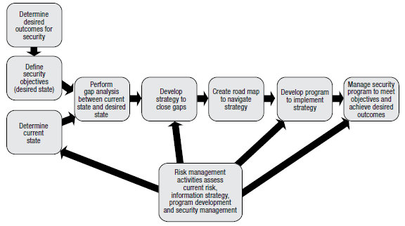

### 3.5 INFOSEC MANAGEMENT FRAMEWORK

**Infosec management framework** = conceptual representation of infosec management structure (= an *operational architecture* - section 3.9 Architecture Implementation). Define: technical, operational, managerial, administrative and educational components of program; organizational units and leadership responsible for each component; control/ management objective that each component should deliver; interfaces & information flow among components; and tangible outputs of each component. Describe *infosec management components* (e.g., roles, policies, standard operating procedures [SOPs], management procedures, security architectures) and their *interactions*.

Focus on shorter-term needs. Facilitate implementation of solutions with internal or external resources. Ensure initiatives and operations adhere to policies and standards. Craft infosec management options to deliver outcomes that are less direct (but no less important) such as demonstrate (directly and indirectly) that:

•Program adds tactical and strategic value to organization.

•Program operates efficiently and with concern to cost issues.

•Management has clear understanding of infosec drivers, activities, benefits and needs.

•Infosec knowledge and capabilities are growing as result of program.

•Program fosters cooperation and goodwill among organizational units.

•Program facilitates stakeholders to understand roles, responsibilities and expectations.

•Program includes provisions for organization’s continuity of business.

Above soft goals (directly and indirectly) demonstrate to security steering committees, senior management and boards of directors that infosec program is delivering results and infosec manager is managing program effectively.

Two internationally recognized frameworks: COBIT and ISO/IEC 27001 for developing information security program.

#### 3.5.1 COBIT 5

###### Figure 3.2: COBIT 5 Principles

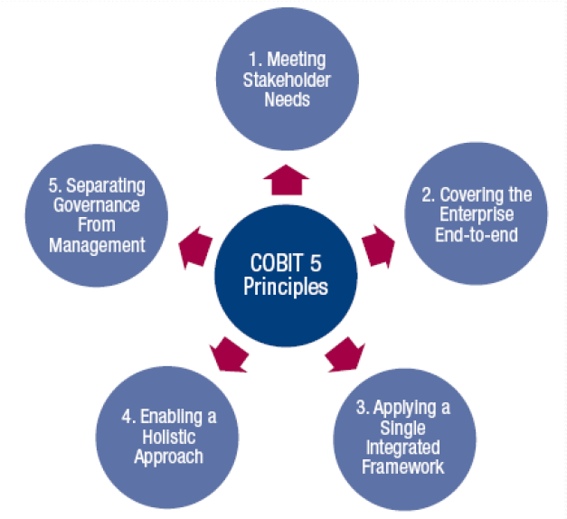

COBIT 5 focus on helping create value from IT by maintaining balance between realizing benefits and optimizing risk levels and resource use. COBIT 5 enables IT and information be governed and managed holistically by addressing business & IT functional areas of responsibility and by considering info-related interests of internal/external stakeholders.

COBIT 5 is based on 5 key principles (shown in figure 3.2) for governance and management of enterprise IT (section 1.8.3 The Desired State). ***COBIT 5 for Infosec*** leverages view of COBIT 5 while providing guidance to professionals involved in maintaining confidentiality, availability and integrity of information. Framework provides tools to help understand, use, implement and direct core infosec-related activities and make more informed decisions. Enables infosec professionals to communicate with business and IT leaders and manage risk associated with information, including risk related to compliance, continuity, security and privacy.

#### 3.5.2 ISO/IEC 27001:2013

*ISO/IEC 27001:2013: Information technology: Security techniques: Infosec management systems: Requirements* and *ISO/IEC 27002:2013: Information technology: Security techniques: Code of practice for infosec controls* provide framework and approach to infosec management. The **114 controls** in **14 domains** can be generally mapped to COBIT, (but *less business-oriented* and *comprehensive)*. Provide high-level comprehensive requirements for infosec programs (but *not complete tool sets*). Based on British Standard (BS7799), and expanded to include **14 broad control areas**:

•A.5: Infosec policies •A.6: Organization of infosec •A.7: Human resource security (before, during or after employment) •A.8: Asset management •A.9: Access control •A.10: Cryptography •A.11: Physical and environmental security •A.12: Operations security •A.13: Communications security •A.14: System acquisition, development and maintenance •A.15: Supplier relationships •A.16: Infosec incident management •A.17: Infosec aspects of business continuity management •A.18: Compliance (internal requirements, e.g. policies, and external requirements, e.g. laws)

ISO/IEC 27000 series of standards covers all aspects of security at a high level:

•ISO/IEC 27000 Info tech: Security techniques:

•Infosec management systems: Overview and Vocabulary

•Infosec management systems: Requirements

•Code of practice for infosec> controls

•Infosec management system implementation guidance

•Infosec management: Measurement

•Infosec risk management

•Requirements for bodies to audit & certify infosec management systems

•Guidelines for infosec management systems auditing

•Guidelines for auditors on infosec controls

•Infosec management for inter-sector and interorganizational communications

•Infosec management guidelines for telecom based on ISO/IEC 27002

•Guidance on the integrated implementation of ISO/IEC 27001 and ISO/IEC 20000-1

•Governance of infosec’

•Infosec management guidelines for financial services

•ISO/IEC TR 27016 Info tech: Security’ techniques: Infosec management: Org. economics

•ISO/IEC TR 27019 Info tech: Security’ techniques: Infosec management guidelines based on ISO/IEC 27002 for process control systems specific to the energy utility industry

•ISO/IEC 27031 Info tech: Security techniques: Guidelines for information and communication technology readiness for business continuity’

•ISO/IEC 27032 Info tech: Security techniques: Guidelines for cybersecurity

•ISO/IEC 27033 Parts 1 to 5 Info tech: Security techniques: Network security

•ISO/IEC 27034-1 Info tech: Security techniques: Application security: Part 1: Overview and concepts

•ISO/IEC 27035 Info tech: Security techniques: Infosec incident management

•ISO/IEC 27036-3 Info tech: Security techniques: Infosec for supplier relationships: Part 3: Guidelines for information and communication technology supply chain security

•ISO/IEC 27037 Info tech: Security techniques: Guidelines for identification, collection, acquisition and preservation of digital evidence

•ISO 27799 Health informatics: Infosec management in health using ISO/IEC 27002

### 3.6 INFOSEC FRAMEWORK COMPONENTS

(Most infosec standard frameworks): Develop infosec program by starting with *risk assessment* and *identification of control objectives* & *key controls* (COBIT and ISO/IEC 27001 -27002). Guidance is provided by these standards; but *control objectives* be based on individual *org. objectives* and *risk appetite & tolerance* (chapter 1). Components that make up management framework be broken into *functional elements* (*technical, operational, managerial, administrative* and *educational* components).

#### 3.6.1 Technical Components

Infosec involved with technical IT components: provide and maintain suitable security standards; review procedures for policy compliance; design and implement security metrics; and general oversight. Many controls in framework address risk associated with technical components, including: configuration, monitoring, maintenance and operation. IT “own” the systems, is NOT data owner but custodian with requirement to provide protection and compliance with org infosec policies by operating within applicable standards. Essential that ALL technology components have identified owner; NO “orphan systems” ⇨ Ensure responsibility & accountability to maintain systems in compliance with security policies, ownership and treatment of associated risk. Infosec function to regulate IT function and provide oversight to ensure policy compliance sufficient to achieve acceptable risk levels consistent with infosec strategy objectives.

#### 3.6.2 Operational Components

Operational components of security program = ongoing (daily/weekly) management & administrative activities, including: SOPs, business operations security practices, and maintenance and administration of security technologies. For components outside direct control of infosec (e.g., patching procedures), work with/provide oversight of org. groups such as IT, business units, etc. Examples of operational components:

•Identity management and access control administration

•Security event monitoring and analysis

•System patching procedures and configuration management

•Change control and/or release management processes

•Security metrics collection and reporting

•Maintenance of supplemental control technologies and program support technologies

•Incident response, investigation and resolution

•Retirement and sanitization of data processing equipment and media storage

For each infosec operational component, identify owner. Collaborate with owner to document key information: component ownership & execution roles, activity schedule or triggers, required info or data inputs, actual procedural steps, success criteria, failure escalation procedures, approval/review processes, processes to provide management metrics. Ensure procedures for log maintenance, issue escalation, management oversight, and periodic risk assessment and quality assurance reviews are developed and implemented. Update roles and responsibilities documentation as new tasks arise in operational component development.

#### 3.6.3 Management Components

**Management components**: strategic implementation activities (standards development/ modification, policy reviews, oversight of initiatives, program execution). Less frequent than operational (months, quarters, years). **Management objectives**, **requirements** and **policies** are key. Ensure process executed with consideration to *legal*, *regulatory*, *risk* and *resource* issues and *metrics* for decision support. Ongoing **analysis of assets, threats, risk** and **organizational impacts** = basis to modify security policies and develop/modify standards. Exercise flexibility to **adjust** standards and policy interpretation during initial stages of security program. Ongoing **communication** with business to provide feedback that provides guidance to infosec management, ensure its effectiveness, and maintain alignment with objectives of organization.

Have **management oversight** to fulfill requirements and consistency with strategic direction. Oversight in form of management reviews of program components (e.g., CIO, CEO, steering committee/executive committee perform quarterly review of security operations). Topics for review: modifications to operational or technical components, effectiveness of program components, metrics and key performance indicators (KPIs), root cause analysis of detrimental events such as outages or compromises, issues hampering component effectiveness that require management attention, and review of action items and commitments from previous review sessions.

#### 3.6.4 Administrative Components

**Business administration activities**: financial, HR, other management functions.

**Financial administration**: budgeting, time line planning, total cost of ownership (TCO) analysis/ management, return on investment (ROl) analysis/management, acquisition/ purchasing and inventory management. Require updates throughout fiscal year.

**HR management**: job description management, organizational planning, recruitment and hiring, performance management, payroll and time tracking administration, employee education and development, and termination management. Account for time and resources; Develop organizational structure with appropriate layers of management & supervisory personnel. Work with HR leadership. Establish procedures to prevent legal liabilities and other types of risk. Balance project efforts/ ongoing operational overhead with staff head count, utilization levels and external resources. Always necessary to prioritize efforts. Work with steering committee and executive management to determine priorities and establish consensus on what project items may be delayed because of resource constraints. Spikes in activity/ unexpected project efforts? consider 3rd-party resources ⇨ maintain relationships with vendors to be called on in such cases. **Spike** in operational activities (e.g., an intrusion) requires immediate attention of operational staff

Pressure to shortcut security management, quality assurance (QA), development processes, divert resources from daily operations to accelerate project efforts? Document and ensure executive management understands risk implications of moving initiative ahead without full security diligence. Utilize first available opportunity to revisit systems or initiatives that are not certified or accredited.

#### 3.6.5 Educational & Informational Components

Employee education and awareness regarding security risk integrated with employee orientation and initial training. General organizational policies and procedures (acceptable use policies and employee monitoring policies) be communicated and administered by HR. Issues & responsibilities specific to role or organization (e.g., call center authentication of customers) communicated & administered at business unit level. Interactive education techniques (online testing and role-playing) more effective than a purely informational approach. Examples: incident response and contingency plan training and exercises. Collaborate with HR and business to identify infosec education needs. **Metrics** (average employee quiz scores, average time elapsed since last employee training) be tracked and communicated to steering committee and executive management.

### 3.7 DEFINE INFOSEC PROGRAM ROAD MAP

Six goals: *strategic alignment*, *risk management*, *value delivery*, *resource management*, *assurance process integration* and *performance measurement* be defined in developing security strategy. Consider each goal in detail. Clarify while evolving road map (as project plans for various parts of road map develop, best approaches become apparent).

Most effective: develop road map **in stage**. Start with simple objectives to demonstrate program value & provide feedback on key goals achievement. Aware of management unrealistic expectations and poor outcomes if infosec concepts not well understood.

###### Figure 3.3 Infosec Management System Controls Process

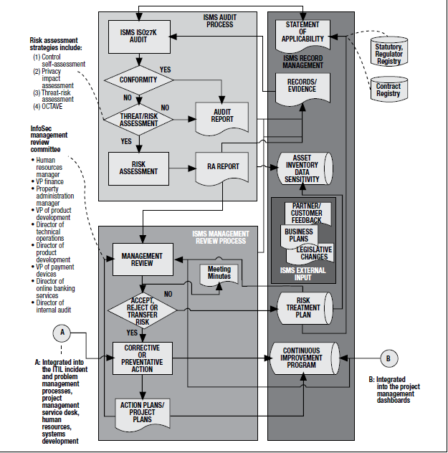

**Example**: Stage 1: Create program subcomponent to demonstrate extent of strategic alignment and approaches to improvements. Interview stakeholders (HR, legal, finance and major business units) to determine important organizational issues and concerns. Information from interviews point to ***candidates*** *for infosec steering committee members*. Stage 2: Use forum to draft basic security policies to implement infosec program for approval by management. Because infosec steering committee represents business interests, use forum to list specific business goals for security with reference to business processes (and also to systems as depicted in **Figure 3.3**). Stage 3: members of infosec steering committee hold functional roles to promote awareness of policy and conduct internal security reviews for compliance. Stage 4: Identify compliance gaps from security reviews to effect change. Develop approach to monitor org. policy compliance strategy. From that foundation, begin the work to build consensus around roles & responsibilities, processes, and procedures in support of policy.

#### 3.7.1 Elements of Road Map

Along with strategy, define *high-level road map* to achieve strategy objectives + objectives, resources and constraints. Next: transform conceptual or logical architecture/ design into physical. Plan construction of specific projects and initiatives along with budgets, timetables, personnel and other tactical project management aspects. Strategy not developed and risk management objectives not defined? Risk that elements of infosec program NOT integrated or prioritized; NO useful metrics ⇨ sub-optimal results.

Bulk of infosec program development effort: design controls that meet control objectives; then develop projects to implement, deploy and test the controls. Consider ability to absorb new security activities to address control weaknesses and meet new objectives (these activities can be disruptive to other organizational activities). See section 3.12 Controls and Countermeasures.

#### 3.7.2 Develop Infosec Program Road Map

Review security level of existing data, applications, systems, facilities and processes ⇨ Insight into specific projects to meet strategic objectives. See section 3.11.4 Security Reviews and Audits for approaches to perform security reviews & evaluate security program. **Implementation road map** = *High-level project plan(s)* or *architectural design* to define steps to achieve particular objective of program. Include *milestones* to provide KGIs, KPIs and CSFs. Provide steps and sequence of steps.

#### 3.7.3 Gap Analysis: Basis for Action Plan

Establish org. roles & responsibilities + inventory of required vs. existing technology & processes ⇨ Identify where control objectives not adequately supported by controls. Identify control points and assist in developing processes to monitor them. Concentrate on KGIs and KPIs; frequently validate that control objectives are met; and progress toward achieving infosec program goals. More important to establish procedure to monitor achievement of control objectives than get all processes right on first pass (effective monitoring provides basis for security program to evolve and mature).

### 3.8 INFOSEC INFRASTRUCTURE & ARCHITECTURE

**Infrastructure** = underlying base/foundation on which info systems deployed. Comprises: computing platforms, networks, middleware layers. Supports range of applications. Infrastructure and security infrastructure = foundation enabling security resources to deploy. Infrastructure secure if designed/implemented with policies and standards.

#### 3.8.1 Enterprise Infosec Architecture

**Enterprise infosec architecture (EISA)** designed as part of enterprise IT system design. **EISA objectives** NOT just to manage security technology but to address elements of business structure, performance management and security processes. They are:

•Provide overarching structure, coherence and cohesiveness.

•Serve as program development road map.

•Ensure strategic alignment between business and security.

•Support and enable achievement of business strategy.

•Implement security policies and strategy.

•Ensure traceability back to business strategy, business requirements and key principles.

•Provide level of abstraction independent of specific technologies and preferences.

•Establish common language for infosec within the organization.

•Allow many individual contributors to work together to achieve objectives.

Several architectural approaches (section 1.11.2 Enterprise Infosec Architecture) fall into 3 basic categories: *process approaches*, *frameworks* and *reference models*. Examples: COBIT, Zachman framework, Sherwood Applied Business Security Architecture (SABSA) and The Open Group Architecture Framework (TOGAF). *Frameworks* describe elements of architecture and how they inter-relate. *Process models* more directive in processes used for various elements. *Reference models*: small-scale representation of implementation.

**TOGAF Architecture Development Method (ADM)** phases in figure 3.4, include:

•**Preliminary phase**: Define architecture framework and architecture principles. Identify overall scope, constraints, objectives and assumptions.

•**Architecture vision**: Define vision and scope of architecture and specific segments of work to be performed.

•**Business architecture**: Describes *as-is* business architecture domain, development of the *to-be* business architecture and *gap analysis* between the two

•**Information systems architecture**: Describes *as-is* and *to-be* data, *applications domains* and conduct *gap analyses*

•**Technology architecture**: Describes *as-is* and *to-be* technology domains and conduct *gap analysis*

•**Opportunities and solutions**: Formulates high-level implementation and migration strategy to transform *as-is* architectures into *to-be* architecture

•**Migration planning**: Formulates detailed implementation and migration road map, including analysis of costs, benefits and risk

•**Implementation governance**: Ensures that implementation projects conform to defined architecture

•**Architecture change management**: Keeps *architecture* up to date. Ensures architecture responds to needs of enterprise, as changes arise

•**Requirements management**: Ensures that architecture projects are based on business requirements; and business requirements are validated against architecture

###### Figure 3.4 TOGAF Architecture Development Cycle

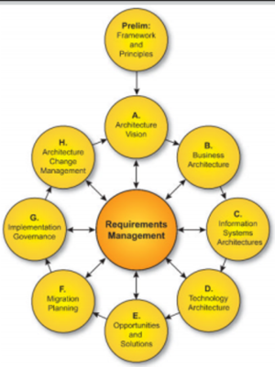

##### Enterprise Architecture Domains

Four subsets of overall enterprise architecture, as shown in figure 3.5, which TOGAF and COBIT are designed to support:

•Business (or business process) architecture defines business strategy, governance, organization and key business processes

•Data architecture describes structure of organization’s logical and physical data assets and data management resources.

•Applications architecture provides blueprint to deploy individual application systems, their interactions and relationships to core business processes of organization.

•Technology architecture describes architectural principles, component relationships, and HW/SW infrastructure to support the deployment of core, mission-critical applications.

###### Figure 3.5: Architecture Concerns of Stakeholders

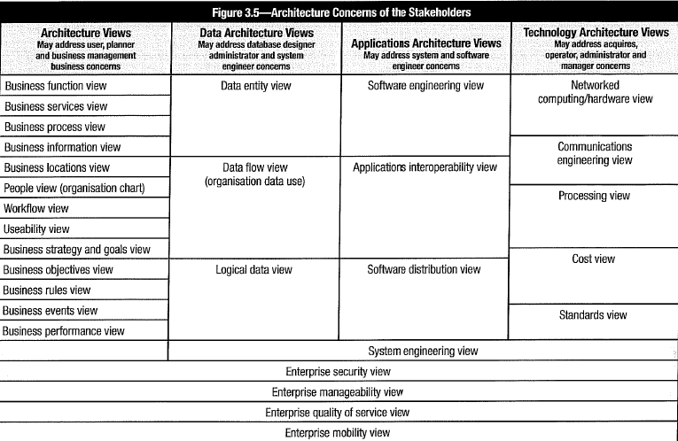

Start with **enterprise business architecture**. Subsequent designs (application, security, data architectures) = subsets to align/support business strategy and objectives. Highest or contextual level (in SABSA and Zachman frameworks): “*business*” or *utility layer*, i.e., what structure is for. *Design* or *architecture* tightly aligned with *purpose* (i.e., linked to business objective). *Contextual architecture* serves to define relationships among various business attributes: who, what, when, where, how, which drive next layer, conceptual layer, which integrates architectural design concepts with business requirements. Next layer: **logical architecture** describes same elements in terms of relationships of logical elements. Followed by **physical layer**, which identifies relationships among various security mechanisms that execute logical relationships and component architecture consisting of actual devices and interconnections. Finally, **operational architecture** describes how security service delivery is organized.

SABSA or Zachman frameworks have been found complex/ costly to develop and difficult to maintain along with rapid change and new business objectives are defined. However, when developing and implementing infosec program, some form of high-level architecture/design should be prepared.

#### 3.8.2 Objectives of Infosec Architectures

**Key function of architecture**: to provide framework to manage complexity successfully. ⇨ Designers/ design influencers need to work as a team under a single design authority ⇨ Business processes and support functions must integrate seamlessly to provide effective services and management to business, customers and partners.

##### Provide a Framework and Road Map

Architecture acts as *road map* to collect smaller projects and services that must be integrated into a single homogenous whole. Provides *framework* within which members of large design, delivery and support teams can work harmoniously and toward which tactical projects can be migrated.

##### Simplicity and Clarity through Layering and Modularization

Information systems architecture defines *rules* and *standards* to design and construct computers, communications networks and distributed business systems to deliver business services. Information systems architecture must take account of:

•Goals to achieve through systems

•Environment in which to build and use systems

•Technical capabilities of people to construct and operate systems and subsystems

##### Business Focus beyond Technical Domain

Information systems architecture concerned with ***technical factors***, as well as with **enterprise objectives** and **environmental factors** that influence those achievements. “**Enterprise**” implies an organization and all the parts that exhibit a “joined up” quality (in which org. is seen at highest level as single entity with integrated mission & purpose).

##### Architecture and Control Objectives

Where **security control objectives** are considered, systems architect can combine technologies to provide control points in system’s infrastructure. With control activities and associated procedures, these control points ensure policy compliance. Example: if a network is structured to have only one connection to Internet, then all network traffic to Internet must travel through that connection ⇨ Can deploy technology in one place to inspect all documents for authorization. Since no technology is specified by architecture ⇨ wide range of design choices for control points to inspect documents sent to Internet.

### 3.9 ARCHITECTURE IMPLEMENTATION

**Architectural decisions at policy level ⇨** Choices of technology mandated by policy to simplify implementation of security features. *Architectural policies* where damage from data exposure warrants redundant controls. Examples of architecture policy domains are:

•Database management systems (to restrict application access) •Telecommunications (to mitigate threats of phone fraud) •Web application access

**Example**: Web application access is often protected from unauthorized access via user IDs and passwords. Vulnerabilities on public networks ⇨ security architects require *transport layer security (TLS)* on web servers that hosted applications with sensitive information. Mandated by policy to ensure traffic client-server encrypted. However, this policy does not assure that client not be compromised or user password not be stolen. Require control in addition to passwords and TLS encryption ⇨ multifactor authentication.

Many approaches to architecture for components of information systems exist (e.g., architectures for data and databases, servers, technical infrastructures, identity management). However, few developed a comprehensive enterprise security architecture, management and relationship to business objectives – resulting in malfunction and untrustworthy outcome. Many architectural frameworks address this issue (section 3.8.1 Enterprise). The *framework* approaches offer flexibility in using variety of standards and methods (COBIT, 1TIL and ISO/IEC 27001:2013).

### 3.10 PROGRAM MANAGEMENT & ADMINISTRATIVE ACTIVITIES

Infosec program management includes: direct, oversee & monitor activities to support org. objectives. Achieve by bringing together human, physical & financial resources optimally with process & technology. Make best decision for org. while considering its operating environment. Includes: short/long-range planning, day-to-day administration, directing various projects & initiatives; various risk management activities; incident management & response functions; and oversight and monitoring functions. Includes aspects of governance (policy & standards development or procedural controls & general rules of use for end users. Infosec responsible to manage infosec program activities to achieve outcomes listed in section 3.1.2 Outcomes of Infosec Program Management. Senior management responsible to support objectives, provide resources & authority to ensure objectives are achieved. Define roles & responsibilities of assurance providers to prevent gaps. **Checklist for comprehensive, well-managed security program**:

•Security strategy linked with business objectives that management accepts & supports

•Security policy & supporting standards be complete and consistent with strategy

•Complete & accurate security procedures for all important operations

•Clear assignment of roles & responsibilities

•Established method to ensure continued alignment with business goals & objectives (e.g., security steering committee, information assets identified & classified by criticality and sensitivity)

•Security architecture complete & consistent with strategy; aligned to business objectives

•Effective controls well-designed, implemented and maintained

•Effective monitoring processes in place

•Tested and functional incident and emergency response capabilities

•Tested business continuity/disaster recovery plans

•Appropriate infosec involvement in change management, SDLC, project management

•Established processes to ensure risk identified, evaluated, communicated and managed

•Established security awareness training for all users

•Established activities to create and sustain corporate culture that values infosec

•Established process to maintain awareness of current/emerging regulatory/legal issues

•Effective integration with procurement & 3rd-party management processes

•Resolution of noncompliance issues & other variances in timely manner

•Processes to ensure ongoing interaction with business process owners

•Business-supported processes to assess risk & business impact, develop risk mitigation strategies, and enforce policy and regulatory compliance

•Established operational, tactical and strategic metrics to monitor utilization & effectiveness of security resources

•Established methods to capture and disseminate knowledge

•Effective communication and integration with other organizational assurance providers

##### Program Administration

Administration of security program ongoing tasks:

•Personnel performance, time tracking, other record keeping •Resource utilization •Purchasing & acquisition •Inventory management •Project monitoring & tracking •Awareness program development •Budgeting, financial management, asset control •Business case development •Financial analysis •HR admin. & personnel management •Project & program management •Operations & service delivery management •Implementation & administration of metrics & reporting • Information technology development life cycle management

Technical administrative and operational requirements:

•Cryptographic key management •Log reviews and monitoring •Change request review & oversight •Configuration, patch, other life cycle management reviews & oversight •Vulnerability scanning •Threat monitoring •Compliance monitoring •Penetration testing

Infosec manager be familiar with frameworks and international standards for IT & security management (e.g., COBIT, ISO/IEC 27001-27002). Extract relevant elements for best management approach suited to org (depending org. structure, culture, resources, business sector, etc.) Infosec responsible to help resolve competing objectives between security and performance; gain senior management support and acceptance. Take facilitative approach to work with departments to discuss infosec risk and suggest solutions that address security requirements and impact on business activities. Take consultative role to ensure that org. life cycle processes incorporate infosec; facilitate infosec program while staying informed about org. activities.

#### 3.10.1 Personnel, Roles, Skills, Culture

Allocate personnel resources based on technical & administrative skills. Staff members include: security engineers, QA & testing specialists, access administrators, project managers, compliance liaisons, security architects, awareness coordinators, auditors, and policy specialists. Develop positions in accordance with specific program needs. Merge responsibilities of multiple roles if necessary. Ensure personnel maintain appropriate skills.

For specialized skill, analyze cost, timing, intellectual capital implications of hiring/training staff vs. external service provider. Perform background checks, especially if classified, confidential, sensitive information involved. Involve HR. Have project management office (PMO) to help develop and implement projects. Use existing functions whenever possible both to max. organizational involvement in program and leverage existing capabilities.

##### Roles

**Role** = designation assigned to individual by virtue of job function. **Responsibility** = description of procedure/function related to role. **Roles** important to infosec (allow responsibilities & access rights be assigned based on individual function NOT individual people). (Fewer roles than staff members; roles change less often) ⇨ administrative costs reduced. Roles can be assigned during HR onboarding ⇨ streamlines process. Use **RACI** (responsible, accountable, consulted, informed) charts to define roles. See section 1.3 Roles and Responsibilities for more information.

##### Skills

**Skills** = training, expertise and experience in given job function. Understand proficiencies of personnel to map to competencies required for program implementation. Specific skills be acquired through training or utilizing external resources. External resources such as consultants often cost-effective choice for short time and specific projects. Establish formal employment agreements to reference responsibilities.

##### Culture

**Culture** represents org. behavior, methods to navigate and influence org. formal & informal structures to get work done, attitudes, norms, level of teamwork, existence or lack of turf issues, and geographic dispersion. Culture impacted by backgrounds, work ethics, values, past experiences, individual filters/blind spots and perceptions of life that individuals bring to workplace. Organization has culture (purposely designed or emerged over time as reflection of leadership).

Build relationships, foster teamwork and influence org. attitudes toward positive security culture rely on good interpersonal skills. Build *security-aware culture* depends individuals in their respective roles. Each person be able to articulate how infosec relates to her role ⇨ Plan communications, participate in committees & projects, provide individual attention to end users needs. Be able to answer “*What is in it for me?*” or “*Why should I care?*” Tailor communications to these answers.

**Outcomes indicative of successful security culture**: infosec department invited to projects at appropriate times; end users know how to identify/ report incidents; org. can identify security manager; people know their role in protecting information assets; and people integrate infosec into their daily practices.

#### 3.10.2 Security Awareness Training & Education

Risk inherent in computing systems NOT addressed purely through technical security mechanisms. Users *front line* to detect threats NOT detectable automatically (e.g., fraudulent activity & social engineering). Security awareness program reduces risk by addressing behavioral element of security through *education* and *consistent application of awareness techniques*. Security awareness programs to focus on common user security concerns (password selection, use of computing resources, safe email & web browsing, and social engineering). Tailor programs to specific groups.

Educate org. on *importance of infosec program*. All personnel be trained in specific responsibilities related to infosec. Pay attention to job functions requiring *unlimited* data access (e.g., people transferring data with access to data in many systems; performing tuning, who can change most operating system configurations; scheduling batch jobs with authority to run most system jobs applications; programmers with access to change application code). Elaborate monitoring controls possible, but NOT technically feasible/ financially prudent to provide oversight to ensure that data transfer jobs only transmit reports to authorized recipients.

Vary *techniques for delivery* to prevent from becoming stale or boring. Incorporate into org. training programs. **Security awareness programs** consist of: training (online); quizzes to gauge retention of training concepts; reminders (posters, newsletters, screen savers); regular schedule of refresher training. Special management-level training on infosec awareness & operations.

In addition to clear policy, applicable standards and process coordination, management in all areas must understand security requirements and assist in providing oversight. Employee awareness start from onboarding (*induction training* ⇨ before getting access to information/services) and continue regularly. All employees, 3rd-party users to receive appropriate training and regular updates on importance of security policies, standards and procedures. Includes: security requirements, legal responsibilities & business controls, training in correct use of info processing facilities (e.g., login procedures, use of software packages).

Aspects of education and awareness program:

•Who is *intended audience* (senior management, business managers, IT staff, end users)? •What is *intended message* (policies, procedures, recent events)? •What is *intended result* (policy compliance, behavioral change, better practices)? •What comm. method be used (computer-based training [CBT], all-hands meeting, intranet, newsletters, etc.)? •What is organizational structure & culture?

Mechanisms to raise infosec awareness:

•Computer-based security awareness & training programs •Email reminders & security tips •Written security policies, procedures (and updates) •Nondisclosure statements signed by employee •Use different media to promulgate security (company newsletter, web page, videos, posters, login reminders) •Visible enforcement of security rules •Simulated security incidents to improve security •Reward employees who report suspicious events •Job descriptions •Performance reviews.

#### 3.10.3 Policy for Rules of Use & Acceptable Use

Effective assistance of general users to understand security-related responsibilities? Develop **acceptable use policy:** detail users obligations & responsibilities. **Rules of use** provide **security baseline**; Include: policy & standards for access control, classification, marking/ handling of documents & information, reporting requirements, disclosure constraints; rules on email and Internet usage. Communicate use policy to all users; ensure read and understood; supplemental info to specific groups aligned with responsibilities.

#### 3.10.4 Ethics

Implement **ethics training** to provide guidance on what considered **legal & appropriate behavior**. Target individuals engaged in activities of sensitive nature: monitoring user activities, penetration testing, access to sensitive personal data. Be sensitive to *conflicts of interest*, activities perceived detrimental to organization. **Codes of ethics and conduct** be reviewed & acknowledged by each infosec employee. Archive signed acceptance of code.

#### 3.10.5 Documentation

Oversight of creation & maintenance of security-related documentation: important admin. component of infosec program. Documents pertain to infosec program:

•Policies, standards, procedures, guidelines •Technical diagrams of infrastructure & architectures, applications, data flows •Training & awareness docs •Risk analyses, recommendations •Security system designs, configuration policies, maintenance docs •Operational records (shift reports, incident tracking reports) •Operational procedures & process flows •Org. docs (org. charts, staff performance objectives and RACI models)

Assign to each document owner responsible for updating documentation (templates if operational records). Changes made under recommendations of management or security steering committee. Approve changes prior to distribution. Owner also responsible to ensure access to documentation appropriate, controlled and auditable.

###### Figure 3.6 COBIT 5 Enterprise Enablers



Ensure that **enterprise enablers** (figure 3.6) available to address creation, approval, change, maintenance, controlled distribution and retirement of documentation (services often part of *enterprise document management system* ⇨ infosec NOT required to maintain custodianship of security-related documentation). Ensure **sensitive technical and operational documents** protected by controls & practices *equal to* or *stronger than* those implemented for other sensitive corporate information assets. Security docs follow org. standards for classification and labeling. Ensure infosec *program doc. requirements* *current* with changes; *standards & procedures* consistent with change in risk, technology, business activities/baselines and published policies. Implement **version control** to ensure all parties operate from same revisions; reliable **notification/ publication process**.

Required documentation:

•Program objectives •Road maps •Business cases •Required resources •Controls •Budgets •Systems designs/architectures •Policies, standards, procedures, guidelines •Project plan milestones, time lines •KGIs, KPls, CSFs, other metrics •Training/ awareness requirements •Business impact & risk analysis •SLAs •Severity criteria •Declaration criteria

###### Document Maintenance

Implement procedures to add, modify and retire infosec policies, standards, procedures and other. Ensure **version control process** in place. Use *automated systems* with single source for doc. so that only current policies, standards and procedures are used. All doc. to have standardized markings, including effective release date, version, owner and classification. **Process for change proposals** be based on *policy reviews* or initiated as stakeholders recognize need for policy change. Track proposed changes to policies for review in appropriate forums.

**Standards** change frequently driven by changes in technology (new security capabilities), changes in risk, evolution of technical infrastructure and requirements of new business initiatives. Proposed standards be reviewed by steering committee and by departments impacted by proposed standards. Standards be reviewed periodically or as warranted by environmental changes, changing risk, request of stakeholders or audit determination of insufficiency. Changes to standards be *managed similarly to policy changes.* Include technical/ operational risk analysis of proposed change. Modifications to policies or standards trigger **procedures** to modify compliance monitoring tools & processes. Changes be periodically shared with **auditors** and **compliance** to ensure awareness & acceptance of changes prior to auditing activities. Changes in standards necessitate *review of procedures*. Other documentation (acceptable use policies, guidelines, and QA and procurement processes) may also require modification.

#### 3.10.6 Program Development & Project Management

Basis for development: **strategy** to achieve objectives: *obtain desired maturity levels, manage risk to acceptable levels while supporting business operations*. Infosec **gap analysis** (section 3.7.3 Gap Analysis: Basis for an Action Plan) identifies project needs to improve infosec program. Review section 3.11.11 Integration With IT Processes to identify projects (e.g. tech. implementations or reconfigurations to secure existing technology) that can fill gaps toward program’s visions. Each project to have time, budget and measurable result; must secure environment without causing control weaknesses in other areas. Prioritize portfolio of projects, so that projects not delay others, resources allocated, and results integrated/ transitioned from existing operations. Employ techniques: set goals, measure progress, track deadlines, assign responsibilities in controlled & repeatable manner.

#### 3.10.7 Risk Management

Program management serves *to manage risk to acceptable levels*. Because risk landscape changes continuously, change and adapt as required to ensure business capable to deal effectively with changes. Ensure that organization can respond effectively to security incidents that disrupt business operations.

###### Risk Management Responsibilities

Develop the skills to evaluate and manage risk (chapter 2). This includes:

•Know program development life cycle risk •Know program management risk •Know methods to assess vulnerabilities in technical and operational environments •Ability to analyze exposures, general threat environment and threats specific to the organization •Know risk analysis approaches including quantitative and qualitative methods •Know risk management processes including mitigation, elimination, transfer and informed acceptance •Ability to understand and assess potential impacts if risk is exploited •Know methods to track, document and communicate risk and impact issues.

#### 3.10.8 Business Case Development

Projects/initiatives benefit from **business case** (1.4.2 Infosec Roles & Responsibilities). Provide clear statement of **value proposition (or cost benefit)** based on org. needs. Identify **risks to address**; **impacts** if project not undertaken and **reduction in risk & impacts** as result of effort. Make evident the significant **returns** on investment, **feasibility** and **practicality**, and impact on **productivity**.

#### 3.10.9 Program Budgeting

Effective *preparation and defense of budget* help get staff and resources to accomplish objectives of infosec program. Self-education and advance preparation: key factors to successfully navigate this process. *Before budget cycle begins*: be familiar with **budgeting process & methods**; consider timing of stages of **budget cycle**;consider infosec strategy and related budget expenditures. Lay out elements of security strategy in **security road map**. Get consensus on strategy objectives; communicate strategy and get it approved.

##### Elements of an Infosec Program Budget

Expenses related to: personnel (salaries, training, etc.), HW and SW, subscription services; resources for short/long-term projects’ objectives (on security road map). Collaborate with PMO and SMEs to get estimate costs for projects. Project elements to consider:

•Employee time •Contractor & consultant fees •Equipment (HW, SW) costs •Space requirements (data center rack space, etc.) •Testing resources (personnel, system time, etc.) •Training costs (staff, users, etc.) •Travel •Creation of supporting documents •Ongoing maintenance •Contingencies for unexpected costs

Engage SMEs and project managers for fair estimate. Consider **unanticipated costs**, such as in area of incident response (e.g., cost external resources for events exceeding skills or bandwidth of current staff) ⇨ Use historical data of incidents and remediation costs of previous security events to estimate unbudgeted external resources. Estimate costs based on average costs over previous years as a starting point. If information not available, use industry statistics from peer organizations.

#### 3.10.10 Infosec Problem Management Practices

**Problem management** focus on ascertaining **root causes of issues**. Requires: systematic approach to understand various aspects of issue, define problem, design action program, assign responsibility and assign due dates for resolution. Implement reporting process to track results and ensure problem be resolved. Not unusual for *security controls in place* to occasionally develop problem and not work as intended ⇦ Identify the problem & assign a priority to it. Be familiar with *mitigating controls* to employ if primary security control fails. Take alternative actions to protect information resources until problem is resolved. Example: if firewall fails, disconnect system from outside until firewall problem corrected ⇨ Information resources protected from outside risk, but ability to perform business affected ⇨ Establish specific authority and limits by management.

#### 3.10.11 Vendor Management

Infosec management and administrative responsibility includes: oversight & monitoring of external providers of HW/SW, general supplies, etc. ⇨ Provide assurance that risk from acquisition processes, implementation and service delivery is managed. Other units involved in managing vendors: legal, finance, procurement, etc.

**Security service providers** often most cost-effective approach ⇨ Provide specialist skills as needed, staff augmentation while recruiting for open positions, offloading routine tasks. Special services: assessment & audit, engineering, operational support, security architecture & design, advisory services, forensics support. Free up internal resources to focus on projects or operations where *preservation of intellectual capital at premium*. Provide objective, fresh perspective on infosec program. Uses outsourced provider, their capabilities and approaches while aligning with infosec program. Use external parties creates **risk** to be managed: financial viability, quality of service, adequate staffing, adherence to org. security policies and right-to-audit.

#### 3.10.12 Program Management Evaluation

Certain situations call for infosec manager to assess current state of existing infosec program (e.g., if promoted or hired into existing CSO role). Also important to periodically reevaluate effectiveness of program relative to changes in org. demands, environment and constraints. Share results of analysis with infosec steering committee and stakeholders to review and develop program modifications. Followed are critical areas for evaluation.

##### Program Objectives

Key considerations for program’s security objectives to re-evaluate:

•Infosec strategy & development road map developed? •Criteria for acceptable risk and impact determined? •Existing complete/current policies, standards, procedures? •Program goals aligned with governance objectives? •Objectives measurable, realistic, associated with time lines? •Program objectives aligned with org. goals, initiatives, compliance & operational environment? •Consensus on program objectives? •Objectives developed collaboratively? •Metrics implemented to measure program objective success and shortfalls? •Regular management reviews of objectives and accomplishments?

##### Compliance Requirements

Evaluate management program (framework & components) against compulsory and voluntary compliance standards. Key considerations include:

•Level of compliance plus time lines & milestones determined? •Communication between compliance & infosec? •Infosec compliance requirements defined? •Compliance requirements integrated in policies, standards, procedures, operations, success metrics? •Program’s technical, operational & managerial components aligned with components required by regulatory standards? •What results of recent audit and compliance reviews of infosec program? •Program compliance deficiencies tracked, reported and addressed timely? •Are compliance management technologies used to increase efficiency of fulfilling security compliance demands?

##### Program Management

Evaluation of program management components reveals extent of management support and depth of existing program. Technical/tactically-driven security programs implement fewer management components, whereas strategic programs driven by standards, compliance and governance implement more comprehensive set of management activities. Considerations of program management components include:

•Thorough documentation of program itself? •Policies, standards, procedures reduced to accessible operating guidelines and distributed to responsible parties? •Responsible individuals understand their roles & responsibilities? •Roles & responsibilities defined for members of senior management, boards, etc.? •Organizations understand & engage in their responsibilities? •Infosec responsibilities represented in individual business managers’ objectives and part of their performance rating? •Policies & standards complete, formally approved and distributed? •Business unit managers involved in guiding & supporting infosec program activities? •Formal steering committee? •How is program positioned within organization? •To whom is program accountable? •Does this positioning impart appropriate level of authority/visibility for objectives that program must fulfill? •Administration functions implemented (budgeting, financial management, HR, knowledge management)? •Meaningful metrics to evaluate performance? •Metrics regularly collected & reported? •Forums & mechanisms for regular management oversight of program activities? •Regular management assess program effectiveness?

##### Security Operations Management

Evaluate effectiveness with which program implements security operational activities (within security org. and in other org. units). Key considerations include:

•Security requirements & processes included in security, technology and business unit standard operating procedures (SOPs)? •Security-related SOPs provide for accountability, process visibility and management oversight? •Documented SOPs for security-related activities (configuration management, access management, systems maintenance, event analysis and incident response)? •Schedule of regularly performed procedures (e.g., technical configuration review)? •Program provides records of scheduled activities? •Segregation of duties (SoD) among system implementers, security administrators and compliance personnel? •Report of operational, tactical and strategic metrics to provide information for oversight? •Other oversight mechanisms in place? •Regular review of security operations? •Forum to escalate operational issues for resolution?

##### Technical Security Management

In addition to technical environment, issues regarding management of technical security:

•Technical standards for security configuration of network, system, application and other technology components? •Standards to address architectural security issues (topology, communication protocols, compartmentalization of critical systems)? •Do standards support/enforce high-level policies & requirements? •Standards = collaborative effort among technology, operations and security staff? •Technical standards uniformly implemented? •Procedures exist to regularly evaluate/report on compliance with technical standards? •Formal process to manage exceptions? •Continuous monitoring of key controls? •Controls provide notification on failure? •Separation of development, test, production environments enforced? •Systems enforce SoD? •Reliable/comprehensive visibility (logging) into system activities, configurations, accessibility, security-related events? •Is this visibility continual or intermittent? •Proper decommissioning processes in place to prevent data leakage?

##### Resource Levels

Assess level of financial, human and technical resources. Identify areas of deficiency. Escalate to senior management and steering committee. Consider following areas:

•**Financial resources**:

-What is current funding level for program? -Is capital & operating budget maintained?

-Financial allocations aligned with program budget expectations? -Linkages between resource allocation and business objectives? -Any prioritized functions in terms of financial allocation? -Which functions will suffer from underfunding?

•**HR**:

-Program implements workload management methodology? -What current staffing level? -Resources fully utilized in terms of time & skills? -Existing resources adequately skilled for the roles? -Low-value tasks to leverage other resources? -What other resources (e.g., IT staff) does program depend on to operate effectively? -Infosec formal part of these resources’ job descriptions and activity plans?

•**Technical resources**:

-What technologies currently support infosec program objectives? -Is capacity of supporting technologies sufficient to support current demands? -Will technologies scale to meet future needs? -Does program account for maintenance, administration and eventual replacement of supporting technologies? -Other technologies that could make the program more efficient or effective?

#### 3.10.13 PLAN-DO-CHECK-ACT

Infosec program based on effective/efficient management of controls designed & implemented to treat/mitigate threats, risk, vulnerabilities and impacts ⇨ Fit with concepts & methodologies in **total quality management (TQM)** based on cycle of four (4) primary processes: **plan-do-check-act (PDCA)**, as depicted in figure 3.7.

###### Figure 3.7 PDCA Methodology

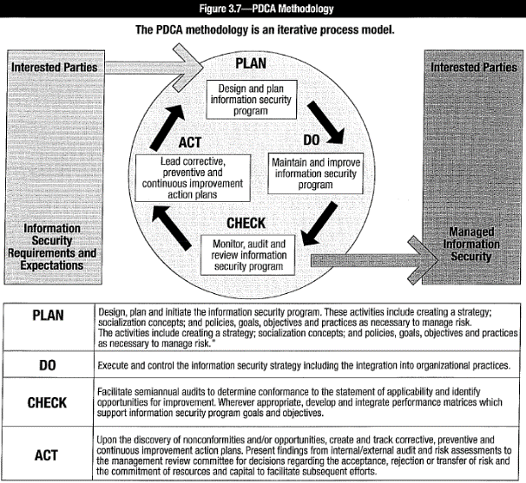

TQM combined with governance methodology to focus on program alignment with organizational goals ⇨ Tools to implement/maintain efficient program. (Chapter 1): basic elements of governance methodology include: strategic vision, objectives, KGIs, CSFs, KPIs, key actions/tactical and annual action plans. These are defined/ depicted in figure 3.8:

###### Figure 3.8 Strategic Objectives, CSFs, KPIs and Key Actions

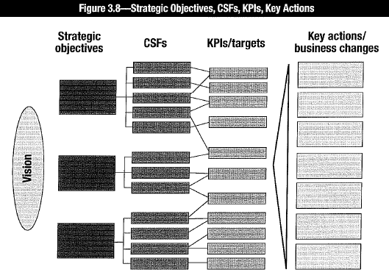

•**Vision** = broadly defined, clear and compelling statement about organization’s purpose. Include outcomes of infosec program •**Strategic objectives** = set of goals necessary & sufficient to move organization toward its vision. Goals be reflected in KGIs •**CSFs** = set of circumstances/events necessary to achieve strategic objectives •**KPIs** = metrics to ensure that CSFs achieved •**Key actions** (incl. tactical & annual action plans) = initiatives to be delivered to achieve strategic objectives and KGIs.

#### 3.10.14 Legal & Regulatory Requirements

Corporate legal departments primarily focused on contracts, securities or company stock-related matters. Often unaware of regulatory requirements ⇦ Infosec not rely on legal to identify them. Often impacted department most knowledgeable about legal & regulatory issues. However, prudent to request legal review and interpretation of legal requirements with security implications. Infosec manager may be required to support legal standards related to: privacy of information & transactions, collection & handling of audit records, email retention policies, incident investigation procedures, cooperation with legal authorities, whenever employee is investigated or monitored, or when disciplinary action taken for inappropriate behavior. Legal & regulatory requirements differ in different regions and jurisdictions ⇦ Engage HR and legal departments prior to any actions.

#### 3.10.15 Physical & Environmental Factors

Confidentiality, integrity & availability of information compromised by unauthorized physical access, damage/destruction to physical components. Security level of HW/SW, physical info assets (documents, media) depend on criticality of systems, sensitivity of information, significance of applications, cost of equipment and availability of backup equipment. Regardless who owns physical security control (security, facilities or infosec), infosec responsible for physical security policies, standards and activities.

Physical security controls: electronic locks, motion detectors, cameras, steel wire caging and radio-frequency tracking devices. Physical access control be based on sensitivity of information; be provided on *as-needed* basis. Avoid areas with unstable environments or in proximity to water pipes or other potential hazards. Computing environments to incorporate systems to monitor and control environmental factors such as temperature, humidity and electrical power quality. Ensure levels of security for personal computers in unsecure user areas. Isolate workstation with sensitive function/information. Physically secure device to prevent theft, lock chassis to prevent tampering, remove/disable external device interfaces (e.g., universal serial bus [USB], serial ports), and enforce local area network (LAN)-based storage to minimize sensitive data on workstation disks. Use disk encryption to protect sensitive information in the event of loss. Secure electronic and print media. Prevent disclosure of sensitive information on paper, microfilm, tape, CD-ROM or other physical media. Encrypt backup tapes when transported and stored offsite. Consider clean desk policy to prevent unauthorized access.

Consider geographic concerns for facilities and disaster recovery sites. Avoid regions with risk of earthquakes, hurricanes, flooding or other natural disasters; proximity to facilities that present special risk (e.g., nuclear power plants, chemical production facilities, airports). Primary processing facilities, disaster recovery sites and offsite data storage facilities be located far from one another.

#### 3.10.16 Culture & Regional Variances

Be aware of differences in perceptions, customs and appropriate behavior across different regions and cultures. Identify audience and those affected by infosec activities. Consider laws in countries that restrict sharing of personal information. Develop/implement policies, controls, procedures with respect to these differences. Work with legal and HR.

#### 3.10.17 Logistics

Address logistical issues, given amount of interaction with other business units. Logistic issues to manage:

•Cross-organizational strategic planning & execution •Project & task management •Coordination of committee meetings & activities •Development of schedules of regularly performed procedures •Resource prioritization & workload management •Coordination of security resources and activities with larger projects and operations

Corporate resources (online scheduling and resource management systems) can assist. In addition, develop logistics management skills through training, self-study or mentoring.

### 3.11 PROGRAM SERVICES & OPERATIONAL ACTIVITIES

#### 3.11.1 Infosec Liaison Responsibilities

Other organizational functions have great impact on infosec ability to implement and manage security program. Most of all, integration with IT is essential (section 3.11.11).

##### Physical/Corporate Security

Corporate security has physical security responsibilities; managed by law enforcement personnel; limited exposure to infosec. Physical security can be part of facilities management. Have close working relationship; understand physical security operation, including: policies, standards, procedures and practices.

##### IT Audit

IT internal audit provides assurance of policy compliance. No policies and standards? Auditors will base on good or acceptable practices; their findings may not agree with infosec perspective ⇨ Need complete governance documentation; develop, maintain relationship with IA; get IA support to achieve infosec objectives.

##### Information Technology

IT implements & operates information processing systems. Develop relationship with IT to foster rapport, trust, open communication, common goals ⇨ challenge: for IT, security impediments efforts. IT conflicting requirements: meet policies & standards AND performance & efficiency requirements. **Security requirements** ⇨ control mechanisms in network, systems, application PLUS technology operations. **Non-security**: functionality, accessibility, performance, capacity and scalability. IT designs, deploys, operates security systems: firewalls, identity management systems and encryption technologies (e.g., VPNs, secure sockets layer [SSL] accelerators) ⇨ Effective oversight, monitoring and good communication. Basis to **separate operational responsibilities** between infosec and IT: impact of system on production. IT operates system that directly affects production. Example: Failure of passive control such as NIDS unlikely to create systemwide outage. Failure of in-line system (firewall) brings down Internet or partner connections).

##### Business Unit Managers

Engage business unit management when develop infosec program. Develop relationships to ensure ongoing alignment with business objectives. Ensures business managers’ responsibility for front-line operations meets security requirements; business understands responsibility to identify/escalate security incidents and other risk concerns. Have infosec ***steering group*** composed of representatives from business units and other (finance, legal, IT, information and physical security, etc.) ⇨ Forum provides infosec information on: business direction, emerging risks, control effectiveness, etc. Engage in ***development process*** for business products/services. Ensure business use **baseline of standing security requirements** (e.g., authentication controls, activity logging). Help develop additional controls to safeguard against *application-specific* risk. Early involvement ensures allocate infosec resources & time. Involve **infosec security architecture** to understand effects on architecture and possible modifications.

##### Human Resources

HR *infosec responsibilities* with regard to employee *policy distribution, background checks, education* and *enforcement*. Establish with HR best means to administer employee education on computer resource usage policies and procedures. Involve HR and legal in any monitoring of employee’s actions or suspected abuse of computing resources. Establish procedures & escalation as part of **incident management procedures** so involved parties understand roles & responsibilities and prepared for immediate action. Assign senior representative of HR to *infosec steering committee*.

##### Legal Department

Infosec issues often related to legal areas: *compliance, liability, corporate responsibility*, *due diligence*; *contracts for outsourcing* & *service providers*. Be included on all security considerations. Assign legal to *security steering committee*; ensure legal ongoing aware of infosec issues; act with their consensus to protect organization from legal liability.

##### Employees

Employees: 1st line of defense in information security. Security training on policies, standards and procedures; test to confirm understanding; keep signed acknowledgment of training with personnel records. Once trained, employees responsible to follow policies, standards and procedures. Train employees to report potential threats & incidents, offer suggestions to improve infosec program, based on their day-to-day involvement.

##### Procurement

Have visibility into procurement process. Provide input into acquisition practices. Manage/ minimize vulnerabilities with new equipment acquisitions ⇨ Have equipment list approved and evaluated for policy and standards compliance.

##### Compliance

Work with compliance office (possibly independent department or part of legal) on policy, standards & procedural recognition of applicable legal and regulatory requirements.

##### Privacy

Privacy office can be part of compliance office or separate function. Coordinate with privacy on requirements in jurisdictions to avoid sanctions.

##### Training

Contact training/education for assistance with security awareness training & education.

##### Quality Assurance

Quality assurance includes acceptable levels of security-related controls. Ensure QA includes testing of security-related aspects. Ensure risk is standard part of process.

##### Insurance

Infosec-related insurance policies (business interruption coverage). Relevant to incident response, business continuity and disaster recovery. Include kinds/extent of insurance in risk analysis, management and recovery planning because this is *compensating control*.

##### Third-party Management

3rd-party management: outsourced functions & services. IDS monitoring directly controlled by infosec; others managed by other departments. Understand what external functions, services and associated risk. Manage risk to acceptable levels. Require various *preventive*, *detective* and *compensatory* controls including *oversight* and *monitoring*.

##### Project Management Office

Maintain relationship with PMOs. Be aware of all projects, particularly IT projects. Be able to review projects to provide insight into potential risk and required security measures. Get insight into which project managers have best qualifications for infosec projects.

#### 3.11.2 Cross-Organizational Responsibilities

Be aware of **SOD issues** if same manager responsible for overlapping aspects of policy, implementation and monitoring. Ensure **SOD** in security monitoring: regulatory functions (security, audit, quality control, compliance, enforcement) NOT under control of those being monitored. Provide compensating controls. Provide assurance that responsibility appropriately assigned across senior managers to avoid conflicts of interest. Figure 3.9: typical set of roles and responsibilities, with sample approach for KPIs. For KPIs to be useful, define KGIs to show extent to which goal/objective achieved. Show progress or additional efforts required to achieve goal.

###### Figure 3.9 Information Security Roles and Responsibilities

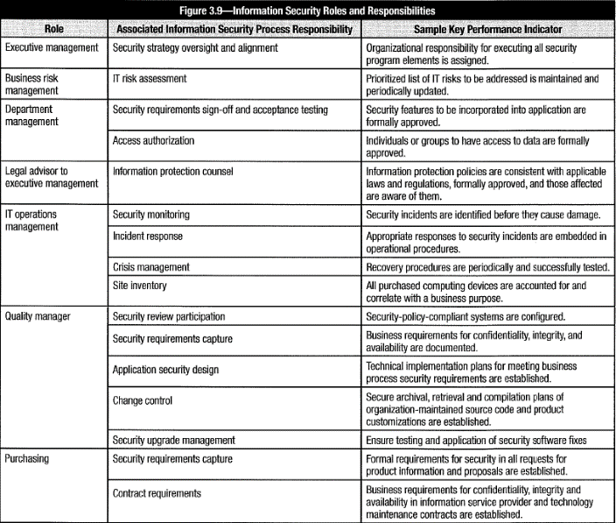

Executives, managers with risk management responsibilities be made aware of each phase of security program; understand, accept, have resources to implement their part of infosec program ⇨ Form *infosec steering committee/executive security council* (chapter 1). They often *owns infosec* strategy; *empowered* to approve changes to policy/ standards. Select members for ability to support infosec program/ represent org. interests.

Set forth in the form of **policy mandates:** documents that reflect decisions set by security strategy. Policy documents identify management intent/direction and is basis for org. standards to comply with management/regulatory objectives for data confidentiality, integrity and availability. See section 1.13 Action Plan to Implement Strategy.

Conduct **awareness** by business areas responsible to maintain processes in conformance with security policy. Can be informal training classes but should fit with org. culture and management method of communication: videos, memos, email reminders, posters, seminars and formal training classes (variety of approaches more effective). Infosec to initiate, coordinate, monitor delivery of infosec awareness materials tailored.

**Business manager** = *policy compliance owner* for her area of responsibility; monitor & oversight to ensure compliance ⇨ Establish processes to create, maintain alerts, logs and metrics on system security configuration and activity. Escalate security issues to infosec.

**Compliance** = tracks security issues, ensures resources facilitate resolution of security issues. Compliance executives establish programs to track trends in metrics; investigate anomalies and known security violations; report to executive management investigations, along with recommendations for changes. Infosec is SME/lead in this process.

#### 3.11.3 Incident Response

**Incident response** (chapter 4) infosec operational requirement; provide **1st responders**. Objective: quickly identify, contain incidents to prevent interruptions to business activities, restore affected services, determine root causes so improvements can be implemented.

#### 3.11.4 Security Reviews & Audits

Standardize approach to assess/evaluate state of infosec program ⇨ Provide trend over time, metric for improvements. Accomplish with audit-like security review process. As with audit, security reviews have: •Objective •Scope •Constraints •Approach •Result

**Review objective** = statement of what to determine in review (e.g., “*determine whether Internet banking can be exploited to gain access to internal systems*” = review objective of external penetration study to ensure that users of web services cannot exploit system vulnerabilities to gain access to hosting systems). **Scope** = mapping of objective to aspect under review. Review objective *dictates* scope (e.g., *previous review objective dictates scope to include application’s Internet access points and all underlying technology*). If scope hard to describe, clarify review objective so that result of review be defined and actionable. **Constraint** = hindrances to ability to review the scope and complete review objective (e.g., *constraint =prohibition to access application during business hours*). Evaluate ability to fulfill review objective in context of constraints. **Approach** = activities to cover scope to meet objective of review, given constraints. More alternative activities can cover scope and objective ⇨ Identify those hampered by fewest constraints (e.g., *constraint = not have credentials to create web session as authorized user ⇨ identify constraint as lack of authorization; find alternative like set up system in test environment*). **Result** = assessment whether review objective was met (answer to question: “*Is this secure?*”) Declare incomplete, if not possible to answer with assurance. **Figure 3.10** depicts common types of reviews, objective, scope, constraint and approach results.

Security reviews can gather data about *policy and process* at various levels, but also specific *control weaknesses*. This data useful to prioritize program development efforts.

###### Figure 3.10 Security Review Alternatives

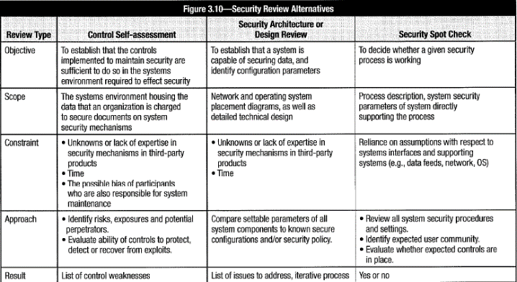

##### Audits

**Audits** have objectives, scope, constraints, approach and results. Auditors identify, evaluate, test and assess *effectiveness of controls*. **Effectiveness** judged on basis whether *controls meet set of control objectives* (e.g., compliance with policies and standards). Audit documentation called “***work papers***”: ➊maps controls to control objectives, ➋states what team did to test those controls, ➌ links test results to final assessment.

Policies & standards established? Audit to determine whether they fully implemented. Policies & standards NOT finalized? Select external standard then engage audit team to determine extent to which organization in compliance. External standard/framework (COBIT, ISO/IEC 27001-27002) provides structure for control objectives to enable audit. *Work papers* from audit often more useful than final report. Valuable if external standards closely resembles those infosec intends to put in place.

Different standards focus on different aspects of controls:

•**COBIT** lists control objectives and control practices for each control objective •The **Standard of Good Practice for Infosec** catalogs infosec management practices & lists requirements for resources and responsibilities. •**ISO/IEC 27001**-27002 list control practices in IT security, an appendix of security-related control objectives and control practices for each control objective,.

##### Auditors

Audits both essential assurance process and critical/influential ally to achieve security governance & compliance. Can be instrumental to implement security standards: feedback to senior management through audit findings; influence tone at top & create high-level support for security activities. Involve auditors in security management = powerful tool to improve organization’s security culture.

Integrate infosec program with internal/external audit activities. Some audits *compulsory* (required for compliance with regulatory standard). Others *voluntary* (attestation to compliance with industry standard). Ensure time & resources allocated for audit. Establish procedures to observe employee activities, provide configuration data from systems).

Deficiency/concerns identified by auditor? Agree with auditors on risk, mitigating factors and satisfactory control objectives. Craft potential solutions that fit org. operational, financial and technical environment. Audit findings = strong, independent feedback for steering committee and management to assess effectiveness of infosec program.

#### 3.11.5 Manage Security Technology

##### Technology Competencies

Although infosec spans technical, operational and managerial domains, implementation of infosec likely *technical*. Infosec and security considered primary sources for *technical security subject matter expertise*. Work with security steering committee, management and other security stakeholders to establish *scope and approach of technical skills delivery*. Wide spectrum in technical scope: <infosec program operates at corporate level to set security standards at high level; act as technical SMEs to provide consultative services to system administrators/technologists who implement technical controls and security systems><infosec takes ownership of infrastructure pieces, e.g., access control systems, intrusion detection/monitoring systems, and compliance & vulnerability assessment automation tools>.

Infosec technology skills vary based on her operational role, org. structure and technical scope. Technically focused infosec managers (system administration roles) need in-depth technical knowledge. Infosec at higher level (CISO) requires hands-on technical skills, but be knowledgeable about org. architectural/data flow; how/to what extent technology contributes to achieve control objectives. All IT managers to thoroughly understand security architecture, control implementation principles, and commonly implemented security processes & mechanisms. Include strengths, limitations, opportunities and risk of security controls and financial/operational implications of deployment. Consider all levels of technology to plan skills development. *Network & systems security* crucial; but so is **application security** (coding practices, functional application security mechanisms, data access control mechanisms), **database security** (data access control methods, application integration, content protection) and, elements of **physical, operational and environmental security** issues. Integrated and tightly coupled systems, e.g. ERP new challenge (consider entire system; compromise of one element can disrupt operations of entire enterprise). Plan for **potential domino effect of cascading risk.**

#### 3.11.6 Due Diligence

**Due diligence** related to “**standard of due care**” (*steps to be taken by reasonable person of similar competency in similar circumstances*) ⇨ Basic components of security program:

•Senior management support

•Comprehensive policies, standards & procedures

•Appropriate security education, training, awareness throughout organization

•Periodic risk assessments

•Effective backup & recovery processes

•Implementation of adequate security controls

•Effective monitoring & metrics of security program

•Effective compliance efforts

•Tested business continuity and disaster recovery plans

•Protection of data (in transit and at rest)

**Third party due diligence**: place security language into contracts & agreements, performance against security requirements. Collaborate with legal to ensure language provides adequate levels of protection. Periodically review infrastructure (best by independent/knowledgeable 3rd party) both internally and of service provider.

##### Manage & Control Access to Information Resources

Be aware of various standards to manage and control access to information resources. Depending on org. industry sector, specific regulatory bodies have defined standards that must be addressed. Organizations with reference materials of interest to infosec:

•American Institute of Certified Public Accountants (AICPA) •Canadian Institute of Chartered Accountants (CICA) •The Committee of Sponsoring Organizations of the Treadway Commission (COSO) •German Federal Office for Infosec (BSI) •International Organization for Standardization (ISO) •ISACA •International Information Systems Security Certification Consortium, Inc. (ISC)2 •IT Governance Institute •National Fire Protection Association (NFPA) •Organization for Economic Co-operation & Development (OECD) •US Federal Energy Regulatory Commission (FERC) •US Federal Financial Institution Examination Council (FFIEC) •US National Institute of Standards & Technology (NIST) •US Office of the Comptroller of the Currency (OCC)

##### Vulnerability Reporting Sources

Publisher of vulnerabilities: US Computer Emergency Readiness Team, MITRE’s Common Vulnerabilities and Exposures database, Security Focus’ BUGTRAQ mailing list, SANS Institute, OEMS and numerous software vendors.

#### 3.11.7 Compliance Monitoring & Enforcement

Consider **compliance enforcement processes** during program development. Compliance enforcement = activity within infosec program to ensure compliance with org. security policies, standards and procedures.

Compliance of complex controls (e.g. procedural controls): challenges to security program since not readily enforceable or difficult to monitor ⇨ little value and considerable risk.

Enforcement procedures designed to assume that control activities in place to support control objectives. These procedures = *added layer of control* to verify that procedures actually followed. Example password reset procedure: enforcement procedure = supervisor listen to randomly selected help desk calls; list help desk staff who neglect to ask for security identification code prior to resetting passwords. Enforcement procedure: use list to warn, then to discipline staff who did not follow password reset procedure.

##### Policy Compliance

**Policies** = basis for accountability w.r.t. security responsibilities. Be *comprehensive* to cover all situations, yet *flexible* to allow processes & procedures to evolve for different technologies and still be in compliance.

Designate *security roles* to establish which department head responsible to implement processes to maintain policy compliance/meet standards. **Infosec responsibility**: ensure NO *orphan* systems or systems without *policy compliance owners*; provide oversight; ensure policy compliance processes properly designed. Accomplish oversight by combining security review, metrics gathering and reporting processes.

**Policy exception process:** *justifications:* based on risk/reward decision (benefit not follow policy justifies risk); financially/technically infeasible. Consider these trade-offs when develop policy, to minimize need for exceptions. Implement **formal waiver process** to manage exceptions life cycle to ensure periodic review & closure. *Assess* exceptions for risk & impact prior to implementation; identified risk be *accepted* by management.

##### Standards Compliance

**Standards** = Boundaries within policy of options for systems, processes and actions. Standards ensure *systems of same type within same security domain* be configured & operated in similar way based on *criticality & sensitivity* of resources ⇨ Allow admin. **procedures** be developed with *standards* as reference to ensure *policy compliance*. Standards provide *economy of scale:* map configuration to policy *once* for each security domain then reuse for systems of same type. *Automate* compliance with standards to ensure system configurations NOT deviate from policy. Review **exceptions** to standards; justify deviation with *risk assessment* and *management acceptance* of risks and changes.

##### Resolution of Non-compliance Issues

Non-compliance issues result in risk. Serious risk? Resolve quickly ⇨ Implement method to ***determine criticality*** *and* ***subsequent risk-based response***. Develop ***timetable*** to document *each* noncompliance item, assigned responsibility to address and record. Regular follow-up to ensure issue and other variances addressed in a timely manner. **Mechanisms to identify** non-compliance issues and variances: •Normal monitoring •Audit reports •Security reviews •Vulnerability scans •Due diligence work

##### Compliance Enforcement

**Compliance enforcement** = Activities to *bring into compliance* policy & standards requirements. **Audits** = snapshot of compliance in time; **compliance enforcement** = ongoing process to reduce risk and ensure positive audit opinions. Enforcement responsibilities *shared* across org. units; results reported to executives, board’s audit and compliance committees. Legal and IA responsible to assess business strategies & operations. Infosec (or compliance) responsible to independently evaluate technical standards (with automated tools).

Infosec program itself target of compliance evaluation & performance. Work with IA and compliance to demonstrate compliance. Issues be defined in terms of risk, mitigating factors and control objectives. Depending on magnitude of issue, infosec addresses concern independently or collaborates with executive management and security steering committee to create acceptable solutions.

#### 3.11.8 Assess Risk & Impact

Infosec program objective: minimize disruptions to org. activities balanced against acceptable cost. See chapter 2 for tasks required to achieve this objective..

##### Vulnerability Assessment

Monitor information systems environment for development of *vulnerabilities* threatening *confidentiality, integrity* or *availability*. Search *known vulnerabilities* + detect unexpected changes to technical systems ⇨ Best use automated, network/host-based tools that deliver concise reports of immediate alerts on severe vulnerabilities. Schedule regular scanning. Ensure change management process over scheduled changes to technical environments (e.g., install new service, relocate hosts, upgrade firewall) don’t inadvertently create architectural vulnerabilities. Aware of human error/unexpected system behaviors that cause enforcement policies of technical security controls to change.

##### Threat Assessment

Technical & behavioral threats evolve as from internal/external factors (new technologies, broader network/application access to partners/customers, growing capabilities of attackers) ⇨ Periodic (*min. annual*) reassessment of **threat landscape** by evaluating changes in technical/operating environments, particularly where external entities have access; **Internal factors** (new business units, new/upgraded technologies, changes to products & services, changes in roles & responsibilities.

Identify new threats/changes in threat levels. Prioritize in terms of impact. Evaluate ability of existing controls to mitigate risk ⇨ Modify technical security architecture, deploy threat-specific countermeasure, implement compensating mechanism/process until mitigating controls developed.

**Threat sources**: technical/cyber, human, facility-based, natural/environmental, and pandemic events. Evaluate range of possible threats to determine *viability*; likelihood to materialize; potential magnitude/ impact to systems, operations, personnel or facilities.

##### Risk Assessment and Business Impact Analysis (BIA)

**Risk assessment:** identify, analyze and evaluate risk; probability of compromise; potential impact in quantitative or qualitative terms.

**BIA** determines *impact of losing availability* of org. resource; establishes *escalation of loss over time*; identifies *minimum resources* to recover; and *prioritizes recovery* of processes & systems. **Impact** (determined by BIA or other process) = **bottom line of risk** ⇨ **range of severity** guides risk management activities. Potential impact also basis for **asset classification**. Ignore high risk with little or no impact.

Develop **KGIs** to achieve control objectives. Make choices about benefits vs. costs of achieving control objectives for confidentiality, integrity and availability of info resources. Develop *risk management process* (chapter 2). Develop **business case** (section 1.4.2 Infosec Roles and Responsibilities) to map control benefits and impact against business goals for security; to develop/ implement security controls to achieve objectives. Business case to address fact that **residual risk** always remain regardless of control level; fact that risk may aggregate into unacceptable levels. Even if controls effective in managing risk to acceptable levels, *aggregate effect of types of acceptable risk* may NOT be acceptable. Disasters often NOT single calamitous occurrence BUT result of small incidents & mistakes contributing to major event. **Lesson**: *individual types of residual risk might be low, collectively they can be disastrous*.

Analyze and communicate effect on **risk posture[8]** as threats and vulnerabilities emerge. Process be *annual* or *incremental* (analyze portions of enterprise monthly/quarterly). Recognize that asset values and risk characteristics can change; require *re-analysis* of risk posture. *Asset value* can increase/decrease in terms of real monetary or strategic value. Example: initial small database contains few dozen personal information records; 5 years later may contain 10,000, representing a much higher impact if compromised.

Report periodic risk assessment results to steering committee/management to guide infosec priorities and activities. More on risk assessment in section 2.7 Risk Assessment.

##### Resource Dependency Assessment

Resources or other constraints for comprehensive BIAs? Develop **business resource dependency assessment:** less expensive alternative basis to allocate resources based on criticality of function. Review resources used to conduct business (i.e., servers, databases, etc.). Depending on criticality of business function, identify required assets & resources. Business resource dependency assessment determines required applications and infrastructure for day-to-day operations, interdependencies and other resources BUT NOT capture *financial* & *operational impact* of *potential disruptions*. NOT replace BIA.

#### 3.11.9 Outsourcing & Service Providers

Two types of infosec outsourcing: 3rd-party providers of security services + outsourced IT OR business processes to integrate into infosec program. Security requirements are similar; depend on criticality & sensitivity of assets and extent of services; BUT ownership is different (infosec is process owner). Risk posed by 3rd parties connected to internal network *substantial;* must be *carefully* considered.

Understand **TCO** of outsourcing *over contract duration*. Economic benefit may be *modest* ➊(service levels contract at specific level, BUT business may contract and require less services with NO commensurate cost reduction) OR (growth in business requires additional services, resulting in higher fees). Either event increases *cost per unit of service*, reducing/eliminating initial cost savings. ➋LONG time to negotiate increased service levels (adverse affects to org. agility). ➌Costs of repatriation at end of contract (in-source, outsourcing constrictions not acceptable or costs of new agreement too high).

Other considerations when evaluating outsourcing option:

•Loss of essential skills

•Lack of visibility into security processes

•New access and other control risk

•Viability of third-party vendor

•Complexity of incident management

•Cultural and ethical differences

•Unanticipated costs and service inadequacies

Audit adequacy of vendor’s controls. Monitor through life of contract. Ensure that security measures not marginalized over time due cost pressures. Accomplished by independent audit or onsite visits at the third-party facility.

Consider enforcement of **privacy laws** to protect company’s data. Sensitive info in one country may not be in another country). In addition to technical controls for outsourced processes, business processes need training, awareness, manual controls, monitoring to ensure 3rd-party staff treat processes, physical/electronic data to acceptable standards.

Use 3rd-party security providers in design & operation of infosec program or other IT services. Security concerns: to what extent vendors *can and will* meet security policies and standards on *ongoing, verifiable basis*. Consider *maturity* of vendor’s security program + vendor’s assurance of compliance in contracts. (Similar process when evaluate org. autonomous division or subsidiary for security services).

Common issues with outsourcing based on scope, type and risk associated with initiative:

•Isolation of external party access to resources

•Integrity & authenticity of data and transactions

•Protection against malicious code or content

•Privacy/confidentiality agreements and procedures

•Security standards for transacting systems

•Data transmission confidentiality

•Identity and access management of 3rd party

•Incident contact and escalation procedures

•Compliance enforcement of critical sole source vendors

##### Outsourcing Contracts

Contract between parties = key to establish control of org.’s **information processing facilities** (**IPFs**). Purposes of contracts: ➊Ensure parties to agreement aware of responsibilities & rights within relationship ➋Provide means to address disagreements once contract is in force. Be familiar with *provisions* for security & information protection. Work with legal to ensure security requirements are covered.

**Provision for confidentiality or nondisclosure:** Parties agree that confidential/sensitive info received as part of agreement be kept confidential through appropriate measures. Include requirement to return/destroy any proprietary/confidential info upon termination or after specified period of time. Determine specific level of destruction (e.g., document shredding, disk and tape degaussing).

Stipulation that parties must maintain **appropriate security controls** to ensure systems and info used under agreement are protected by appropriate means. Explicitly define “*appropriate*” and requirements to demonstrate effectiveness of protections. Define standards by which program be judged: 3rd-party audit report (e.g., SSAE16), compliance with industry-standard security framework (ISO/IEC 27001:2013, 27002:2013 or COBIT 5). Network connectivity between buyer & seller? Address responsibility for security of connection; specify to expected level of security (firewalls, intrusion detection/prevention, monitoring) or specific technical requirements. Contract determined (through risk assessment) to be beyond risk threshold? Include provisions for ***right-to audit*** & ***right-to-inspect*** without notice (for 3rd party that accesses, stores or processes sensitive/ business-critical information; provides mission-critical services; or connects to network infrastructure). **Right-to-audit clause** allows customer right to conduct in-depth audit of 3rd party’s security program/processes. **Right-to-inspect** without notice provides greater incentive to adhere to contractual requirements on an ongoing basis. Parameters for audit be explicit (compliance criteria, notification, scope limitations, frequency & responsibility for incurred costs). Right to inspect: few, if any, constraints.

Security breach at either party? Contract specifies roles each party in investigation & remediation process. Which party will lead investigation? notification procedures? responsibilities (including law enforcement or regulatory notifications)? Timing?

Contract to contain **indemnity clauses** (compensation for impacts caused by provider).

“**Choice of law**” provision: Litigation in jurisdictions favorable to service provider.

Infosec elements be covered in contract:

•Detailed specification of outsourced service •Specific security requirements •Restrictions on copying information & securing assets •Prohibiting access without explicit authorization •Maintaining list of individuals who have access •Right to audit and/or inspect •Indemnity clauses to mitigate impacts caused by service provider •Requirements for incident response plans (IRPs) and business continuity plans (BCPs) •Level of service quality Integrity & confidentiality of business assets •Nondisclosure agreements signed by employees/agents of 3rd parties •Protection of intellectual property •Ownership of information •Requirement applicable legal & regulatory requirements are met •Return and destruction of information/assets at end of contract •Duration for confidentiality be maintained •Employees/agents of 3rd party to comply with org. security policies •Escalation processes •Predetermined reduction or increases in costs associated with changing service levels •Response & implementation times for changing service requirements •Conditions & circumstances for contract cancelation and associated costs

##### Third-party Access

3rd party access controlled based on risk assessment. Clearly defined in **SLA**. Grant access based on principles of *least privilege*, *need-to-know* and *need-to-do*. Aware that 3rd parties have different set of ethics & business culture to consider in terms of risk. Provide access through defined *methods of access*, *access rights* and *level of functionality.* Access requires *approval* of asset owner. *Log* access usage. Review by security manager on a regular basis. Review frequency be decided on factors such as: •Criticality of info •Criticality of privileges given •Period of contract. Report anomalies immediately to asset owner. Specify *escalation conditions*. Remove access rights immediately after contract expires. Network and information access NOT granted before contract been signed. Contract to define *terms for access,* *control requirements*, *assurance* that appropriate safeguards are in place and will remain in place for duration of contract.

#### 3.11.10 Cloud Computing

NIST defines cloud computing: “*model for enabling convenient, on-demand network access to a shared pool of configurable computing resources (e.g., networks, servers, storage, applications, and services) that can be rapidly provisioned and released with minimal management effort or service provider interaction.*” 5 characteristics cloud include:

➊**On-demand self-service**: Computing capabilities provisioned w/o human interaction.

➋**Broad network access**: Available over network, accessible by diverse client platforms.

➌**Resource pooling**: Computer resources pooled to support *multitenant* model.

➍**Elasticity**: Resources scale up/down rapidly & automatically per business demands.

➎**Measured service:** Resource utilization optimized through *charge-per-use* capabilities.

Cloud model composed of **3 service models** (figure 3.11) and **4 deployment models** (figure 3.12). Risk & benefits differ per model.

###### Figure 3.11 Cloud Computing Service Models

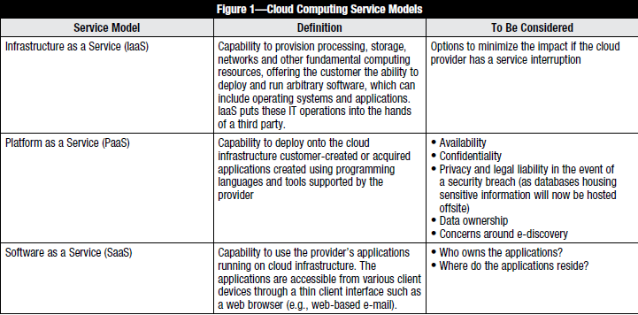

###### Figure 3.12 Cloud Computing Deployment Models

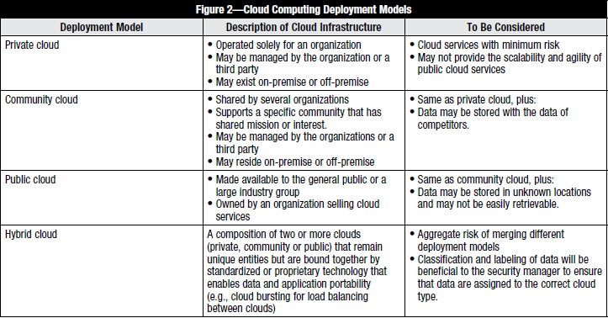

**Security as a service** (**SecaaS**) two major forms:

➊Cloud service provider (CSP) provides stand-alone managed security services (antivirus scanning, mail security to full deployment of end-point security).

➋CSP offloads appliance utilization for client. CPU/memory-intensive activities moved to cloud services. Antivirus activities on **unified threat management (UTM)** devices off-loaded to SecaaS to reduce number of chassis at client site. Advantage to clients: risk minimized when applying patches/updates (no longer directly linked to device).

**Disaster recovery as a service (DRaaS)**: CSP cloud infrastructure offered as disaster recovery (DR) solution: backup equipment & storage plus BCP services. Benefits:

•Cost for in-house DR infrastructure reduced. Because DR considered necessity, rather than business, ROI in DR services significant.

•Offsite storage means DR environment less likely to fail in case of major disaster.

**Identity as a service (IDaaS)** two interpretations:

➊Management of identities in cloud, separated from users & applications. Either managed identity services (incl. provisioning) or manage onsite & offsite services. **Single sign-on (SSO)** part of cloud service offering.

➋**Identity and access management (IAM)** solution. Often *hybrid* solution (federated model): access & roles configured by CSP/users authorized internally.

**Data storage & data analytics as a service (Big Data)**: data analysis without constraints on *volume, variety, velocity* and *veracity*. Constraints not taken away by technologies; rather, removed through *synergy* between technologies and cloud capabilities. *Limitless volume availability*/*variety* allow enterprises reuse “old” data for new purposes. Ability to find patterns in data ⇨ influences way to do business. Receive decision-making support from information from big data analysis (real-time reporting & predictive analysis).

**Information as a service (IaaS):** rather than raw data or algorithms, provides required information. Result of a query *more important* than query itself.

**Integration platform as a service (IPaaS)** aka “**cloud integrator**”: “*suite of cloud services enabling development, execution and governance of integration flows connecting any combination of on premises and cloud-based processes, services, applications and data within individual or across multiple organizations*” (Gartner IT Glossary, [link](http://www.gartner.com/tiglossary/%20information-platform-as-a-service-ipaas))

**Forensics as a service (FRaaS)** “*establishes a cloud forensic investigative process, which can be implemented within a cloud ecosystem, integrated with tolls that should ensure relevant information gathered, verified and stored in a manner that is forensically sound and legally defensible*” (Jon Rav Gagan Shende)

**Cloud access security brokers (CASBs)** either on-premises or cloud-based policy control points. Control points between consumer & service provider to enforce consumer’s policies. Include *authentication*, *authorization*, *SSO*, *tokenization*, *logging*, *notification* & *alerts*, *malware detection* & *prevention*, etc.

##### Advantages

•**Optimized resource utilization**: Enterprises typically use just 15-20% of server computing resources. Have 5 times computing capacity required. With *pay-as-you-go cloud* solution, resources available when needed/liberated when no longer needed ⇨ *near-perfect alignment with actual demand*.

•**Cost savings**: Increased server utilization + transition of computational capability from acquired/maintained to rented cloud services change *computing cost paradigm* from **capital expenditure (CAPEX)** to **operational expenditure (OPEX)**, with up-front and total cost savings. Flexible, on-demand services enable testing with no significant capital investments. Provide *transparency of usage charges* to drive *behavioral change*.

•**Better responsiveness**: On-demand, agile, scalable and flexible services provide organizations with ability to respond to changing requirements and peak periods.

•**Faster cycle of innovation**: Patch management/upgrades to new versions more flexible. (Upgrade to new version = different uniform resource locator (URL) in web browser).

•**Reduced time for implementation**: Processing power/data storage *as needed* and *at capacity needed*, in *near-real time*, not requiring weeks/months (or CAPEX).

•**Resilience**: Large, highly resilient environment reduces potential for system failure. Failure of one component less impact on service availability, reduces risk of downtime.

High reward in terms of containment of costs, agility and provisioning speed. BUT unknown & potentially high risk. **Level of abstraction** between physical infrastructure and owner of information being stored & processed ⇨ Demand for greater transparency + robust assurance approach of cloud’s security & control environment. Identify business objectives & risk of cloud implementation. Determine what types of data be trusted to cloud, which applications/services deliver greatest benefit. Prudence dictates initially entrusting only relatively low-value, noncritical services to the cloud.

##### Security Considerations

Consider loss of control over sensitive data, location of data. Store & transmit data across state or national boundaries? Consider myriad laws, regulations and compliance requirements of various jurisdictions. Requirements for handling incidents vary from one jurisdiction to another (e.g., breach notification laws). Availability of audit logs may be limited or nonexistent from cloud provider. Actual level of security may be difficult to ascertain. Relationship of cloud services and risk is shown in figure 3.13.

###### Figure 3.13 Cloud computing Risk Map

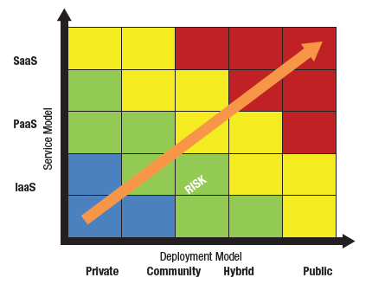

##### Evaluation of Cloud Service Providers

Conduct evaluation based on organization’s *security posture* and *risk appetite*. Consider that provided services under control of other orgs (data center provider, backbone transport and Internet service provider, etc.). Failure of any provider results in loss of critical operations. Quantify risk. Provide informed basis for decision to use services.

**Two categories of frameworks for assurance and risk identification**:

➊Existing/accepted frameworks customizable for cloud (i.e., *COBIT*, *ISO 2700x*)

➋Built for cloud (*CSA Cloud Control Matrix*, *Jericho Forum* Self-Assessment Scheme*)

###### Figure 3.14 Cloud Standards, Certifications and Frameworks.

**AICPA/CICA Trust Services (SysTrust and WebTrust)**: Provide assurance that systems controls meet *Trust Services principles & related criteria*. Areas addressed: *security*, *online privacy*, *availability*, *confidentiality* and *processing integrity*. **SysTrust** similar to **SOC 1** report (but with predefined principles and criteria). Principles may lack specificity required to be effective. IT audit and assurance professionals could insert specific risk control points. But user auditors *responsible* to determine these more detailed control points. Also, effective in 2011, *Trust Service reports* can be issued as **SOC 2** or **SOC 3**.

**AICPA Service Organization Control (SOC) Reports**: SOC report = independent, 3rd -party examination under *AICPA/Canadian Institute of Chartered Accountants (CICA) audit standards*. Released under *Statement of Standards for Attestation Engagements (SSAE) No.16* and *International Standard on Assurance Engagements (ISAE) 3402*, SOC reports replaced *Statement on Auditing Standards No. 70* (*SAS 70*) 3rd -party examination reports effective 15 June 2011. CSP engages CPA firm to perform independent examination to provide CSP clients and their internal/external auditor's assurance w.r.t. *understanding* and *reliance* on controls that support CSP client’s processes and systems. Three SOC report forms: •**SOC 1** apply to financial reporting processes; most consistent with SAS 70. •**SOC2** & **SOC 3** as AICPA Trust Services.

**Background Intelligent Transfer Service (BITS):** *BITS Shared Assessment Program* contains *Standardized Information Gathering (SIG)* questionnaire and *Agreed Upon Procedures (AUP)*. Used by financial operations to evaluate IT controls for *security*, *privacy* and *business continuity*. SIG is aligned with *ISO/IEC 27002:2005*, *Payment Card Industry Data Security Standard (PCI DSS)*, *COBIT* and *NIST* and *US Federal Financial Institutions Examination Council (FFIEC)* guidance, *AICPA/ CICA Privacy Framework,* etc. BITS covers most, but not all, security elements of cloud computing. BITS also mapped its control framework for CSPs. (In 2010, Shared Assessments published “[*Evaluating Cloud Risk for the Enterprise*](sharedassessments.org/media/pdf-EnterpriseCloud-SA.pdf)”, a risk-based guide to evaluate cloud computing for the enterprise.)

**Cloud Control Matrix**: first released by CSA in April 2010. Cloud security controls matrix specifically designed to guide cloud vendors and cloud clients in assessing security risk of a CSP. CSA’s cloud control matrix = amalgam of controls from *Health Insurance Portability and Accountability Act (HIPAA)*, *ISO/IEC 27001/27002*, *COBIT*, *PCI* and *NIST*.

**COBIT**: Developed and maintained by ISACA. COBIT 5 provides comprehensive framework for the management and governance of business-driven, IT-based projects and operations. *Appendix A* maps COBIT 5 process practices to the cloud.

**CSA STAR Certification**: Released September 2013. STAR Certification allows cloud providers to give customers an understanding of their levels of security controls. Technology-neutral certification based on 3rd-party independent security assessment. Leverages requirements of ISO/IEC 27001:2005 with CSA Cloud Control Matrix.

**Federal Risk and Authorization Management Program** **(FedRAMP)**: US government program to provide framework for security assessments to authorize cloud computing services. Designed for federal agency use, but can be used for joint authorizations and continuous security monitoring services for commercial cloud computing systems.

**Jericho Forum® Self-Assessment Scheme (SAS):** Guideline for vendors to self-assess security aspects of cloud offering; for cloud clients to include into *requests for proposal* (RFPs). Based on org. “*11 Commandments*” (released in 2006) = design principles for effective security in de-perimeterized environments. Designed to assess cloud security tools, either applications or devices.

**ISO 20000**: First international standard on IT service management, established in 2005. For organizations to certify their “*design, transition, delivery and improvement of services that fulfil service requirements and provide value for both the customer and the service provider.*” ISO certification NOT one-off exercise: Maintain certificate requires reviewing and monitoring *Infosec Management System (ISMS)* on an ongoing basis.

**ISO 2700x**: Specification against which ISMS is evaluated and by which certification is granted. Objective of standard : “*provide a model for establishing, implementing, operating, monitoring, reviewing, maintaining and improving an ISMS.*” CSA’s Cloud Security Matrix has been identified as appropriate ISO control subset for the cloud.

**NIST SP 800-53**: NIST IT security controls standards contain a controls framework for cloud security. Unspecified subset of the entire framework. Current draft of **NIST SP 800-146** contains additional guidance to use/implement various cloud deployment models.

#### 3.11.11 Integration with IT Processes

Provide defined interfaces between security-related functions and other assurance functions. Ensure clear channels of communication. Infosec risk management activities to integrate with activities of risk manager to ensure continuity and efficiency. BCP must integrate with incident response activities of infosec.

##### Integration

Infosec program interfaces with other assurance functions ⇨ Assurance integration (see chapter 1). Reduce security gaps and duplication of efforts; poor practices in one area undermine infosec efforts; or assurance providers (compliance, QA, change/ configuration management, legal, audit, physical security) working at cross-purposes.

Interfaces often *bidirectional*: assurance functions provide input, requirements and feedback to infosec, which in turn, provides metrics and evaluation data for assurance evaluation. Important that assurance units in *steering committee* to ensure awareness of security issues. Broad ongoing involvement helps prevent *silo effect*. To be effective, infosec be *pervasive*, affecting every aspect of enterprise ⇨ Range of responsibilities for effective security management is broad and exceeds direct authority of infosec ⇨ Collaborate, be good communicator, develop business case for security initiatives.

##### System Development Life Cycle Processes

Include risk and protection considerations in SDLC. Because these activities usually not infosec responsibility but with significant impact on security, develop approaches to integrate with infosec activities. Create process to inform infosec of proposed change to assess associated risk and provide appropriate treatment.

Traditional division of SDLC stages: •Initiation •Development/acquisition •Implementation •Operation/maintenance •End of life/disposition

Expanded versions of SDLC: •Establishing requirements •Feasibility •Architecture & design •Proof of concept •Full development •Integration testing •Quality & acceptance testing •Deployment •Maintenance •System end of life

##### Change Management

Security needs be integral part of change management process because vulnerabilities may be introduced from system/process changes. Identify all change management processes. Establish notification process when changes may impact security.

Implement processes to ensure security implications considered as standard practice. Accomplish by requiring that risk & impact of change assessed prior to implementation. Treat if risk exceeds acceptable level. Determine which existing controls may mitigate changes in risk. Ensure that infosec controls and countermeasures are tested regularly. As part of change management process, update/adapt/modify to address changes in risk or impact. Decentralized organizations? Understand org. structure to establish effective change management approach. Maintain accountability for policy compliance by identifying where IT changes initiated, funded and deployed. Negotiate hooks into job functions/ processes that specify, purchase and deploy new systems have policy compliance in job functions: timely notify so infosec can understand vulnerabilities in new systems/devices, identify new risk, and assist in developing policy-compliant standards (handed to release manager as pre-approved for production deployment).

##### Configuration Management

Incorrect configuration enables security breaches to information systems. Implement procedural & technical controls to ensure proper configuration *prior* to system/device activation on network. Typical underlying causes for failure: lack of clear standards/ procedures for configuration; short-handed staff failing to properly follow procedures; improper shortcuts. Ensure documentation exists on correct configuration, adequate oversight; IT staff has sufficient training. Examine workload to see if time is the issue or if some form of compliance enforcement is required to ensure correct configuration.

##### Release Management

Release management reduces chances of operational failure by ensuring adequate testing has been performed and required conditions exist for the correct operation of new software, devices or systems. Ensure that proper standards and procedures exist so that products are not deployed to production prematurely. Provide adequate monitoring and oversight to ensure procedures followed to avoid unexpected production system failure.

### 3.12 CONTROLS & COUNTERMEASURES

Include both *general* and *application-level controls* to achieve control objectives.

**General controls** = control activities support organization in centralized fashion as part of security infrastructure (“*general controls*” often describe all controls in infrastructure). Control activities to support operating system, network, facility security; user admin. policies, standards, procedures; technical elements (access controls, firewalls and IDSs).

**Application-level controls** = controls to provide security to application (non-centralized business information processing).

General controls and application-level controls managed by different groups (technical infrastructure managed by IT; financial controls managed by finance). Ensure security-related roles and responsibilities identified for these groups. Document roles and responsibilities in a matrix (see figure 1.4).

Security management = design, implement, monitor, test & maintain controls. **Controls** = *policies, procedures, practices, technologies & org. structures* to assure business objectives are achieved and undesirable events prevented, detected and corrected. Controls = regulatory process (physical, technical or procedural). Choice of controls based on many considerations (effectiveness, cost, restrictions to business activities and optimal form).

Controls for physical elements (admin. processes and procedures) are *just as critical* as technical controls. Many security failures attributed to *failures of management.* Management problems typically NOT have technical solutions. People and physical processes exist at each end of technical processes and constitute *greatest risk* to infosec.

Do NOT place excessive focus & reliance on technology. Standards/procedures too restrictive or hindrance to business objectives likely be circumvented. Objective: balance need for controls with business requirements. Have good business perspective, understand risk to information resources, interpret info security policies, implement security controls that consider all these aspects. Use least restrictive & disruptive approach that still meets criteria for acceptable risk at acceptable cost. *Trade-off between security & least impact on business activities* = fine line must strive to achieve.

Develop infosec controls for IT & non-IT-related information processes: secure marking, handling, transport & storage requirements for physical information, considerations for handling/ preventing social engineering. Consider environmental controls, so that systems not being stolen, as has occurred in some well publicized cases.

Two references for infosec: *COBIT 5* and *ISO/IEC 27001-27002*. Other sources of guidance: *US Federal Information Processing Standards (FIPS) Publication 200*, *NIST 800-53* and  *Standard of Good Practice for Infosec* published by the Infosec Forum.

#### 3.12.1 Control Categories

###### Figure 3.15 Control Types and Effect

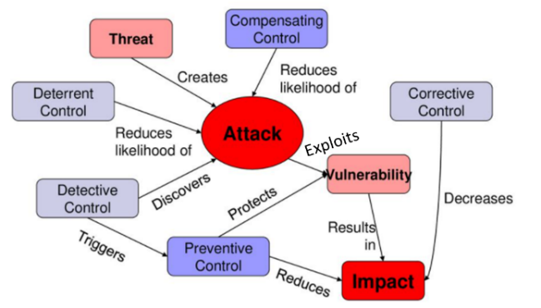

Controls and effect are shown in figure 3.15. *Compensating* and *corrective* controls are often combined because they both address impact. Control categories include:

•**Preventive** controls inhibit attempts to violate security policy (access control enforcement, encryption and authentication). Preventive controls *directly* address risk.

•**Detective** controls warn of violations or attempted violations of security policy (audit trails, intrusion detection methods and checksums).

•**Corrective** controls remediate impact. Backup restore procedures = corrective measure enable system to recover.

•**Compensating** controls are *internal* controls to reduce risk of existing/potential control weakness resulting in errors and omissions. Examples: challenge response to weak access controls can compensate for deficiency; insurance can compensate for breach losses.

•**Deterrent** controls provide warnings to deter potential compromise (warning banners on login screens; rewards for arrest of hackers).

*Corrective* + *compensating* controls address *impact*. *Deterrent* controls address *threat*.

#### 3.12.2 Control Design Considerations

Controls & countermeasures most efficiently approached based on ***top-down, risk-based*** approach, because *control objectives* essentially determined by *management’s acceptable risk levels*. **Acceptable risk levels** = objectives of controls = design goal + subsequent control metric for effectiveness (*primary control effectiveness metric = extent to which control meets the objectives*). **Defining control objectives** pertinent to *physical*, *admin.* and *technical controls*. **Achieving control objectives** requires combinations of several control types (technical control such as firewall requires: physical protection control + configuration procedural control + oversight via an administrative control).

Selection of controls based on cost-effectiveness comparisons of available options, plus other selection: •Impacts on productivity/inconvenience to users •Acquisition & implementation costs •Training costs •Operational costs •Maintenance & testing costs •User acceptance •Cultural & ethical acceptability •Legal/regulatory requirements & restrictions •Adaptability to changing risk •Scalability •Ability to monitor •Provide notification •Robustness •Resilience •Reliability •Ease of testing •Self-testing capability •Acceptable failure mode •Tamper resistance

##### Controls as Resources to implement Strategy

Strategy implementation consists of: *design, develop, test and implement controls of various types in various combinations*. Development of strategy includes *determining acceptable risk and risk tolerance* (as in chapters 1 and 2). Use *acceptable risk levels* to determine control objectives, which in turn set main requirements for controls.

Controls to affect all aspects of organization: people, technology and processes. Combine controls to achieve control objectives. **Example**: Access control = *preventive* control to prevent unauthorized access. Intrusion detection = *detective* control because it detects unauthorized access. Backup and restoration = *corrective* control to recover system. *Compensating* controls (e.g., insurance) similar to *corrective* controls: compensate for impact as result of compromise. Firewall filters network traffic to limit what protocols (or ports) can be used to enter/exit internal network; what address/ address range is allowed as source/destination ⇨ *preventive* control because prevents access to network ports, protocols or destinations. Firewall with features to examine inbound network traffic for malware and send alerts to operations center? This is *detective* control. Firewall can divert incoming traffic to a backup site upon responding to virus alert? That is *recovery*, or *corrective* control because it allows systems to resume normal operations. Proxy service that runs on firewall may be capable of displaying warning banner as *deterrent* control against unauthorized access. **Note**: deterrent, preventive, detective or corrective (or compensatory) control features of firewall are fully describable, technically, without using the word “firewall.” Recognize *security value* of technology features *independently* of label given to product by vendor.

Controls be automated so that it is technically infeasible to bypass. (See section 3.12.6 Countermeasures). Control practices to prevent users from bypassing controls:

•**Access (logical) control**: Identify, authenticate and authorize prior to access information. Access control models: **mandatory access control (MAC)** or **discretionary access control (DAC)**. **MAC** restricts access to data based on security requirements contained in data and corresponding security clearance of users. Used for military applications where secret clearance is required to access data. Also a second requirement of *need-to-know*. **DAC** restricts access to objects based on identity of subjects and groups to which they belong. Discretionary in the sense that *rules* allow subject with access permission to pass that permission on to another subject. Choice of access control mechanisms depends on organizational requirements for data protection.

•**Secure failure**: Device designed to shut down/stop processing when detects malfunction. Be carefully considered because it affects *availability;* pose *hazard* when electrically controlled physical access fails in locked condition.

•**Principle of least privilege**: Partition resource access so that those requiring fewer resources have minimum system privileges to accomplish their responsibilities.

•**Compartmentalize to minimize damage**: Contain access to subsets of system resources by requiring separate set of authorization controls. Example: restrict admin. privileges in combination with network port restrictions to deny internet users admin. functions.

•**Segregation of duties (SOD):** Restrict user from having two functions with supervisory or oversight features. Example: prevent person with ability to print checks from being able to change name of check recipient before and after it is printed.

•**Transparency**: Average layperson to understand how system security works to see effect of her activities on systems security. Users, administrators, engineers and architects be able to converse about system controls so that all can verify that they are working as expected. Transparency achieved by keeping technology design simple to avoid confusion as to system functionality.

•**Trust**: Design strategy that includes security mechanism to identity user based on relationship to trusted identity provider. Relying party has mechanism to determine authenticity of connection from identity provider and to allow identity provider to pass to it the identity of user. Example: use trusted third party in **PKI architecture** known as **certificate authority (CA)**, which attests to identity of entity by issuing a **certificate**.

•**Trust no one**: Include *oversight controls* in information system design rather than designating trusted individuals to administer the system. Typical application: use closed-circuit television (CCTV) to monitor activities.

#### 3.12.3 Control Strength

Measure *strength of controls* by **type of control** (preventive, detective, manual, automated, etc.) and **quantitative/qualitative compliance testing results**. *Automated control may be preferred to manual, detailed analysis reveal manual control is better*. **Automated control design** creates alerts & generates automatic reports BUT NO evidence of review and subsequent response up to resolution. **Manual control** more effective: handwritten notes recorded daily within IDS log reports with initials and dates/ notes contained analysis, action plans, ticket numbers and resolution. **Strength of control** )only concluded after adequate test) measured in terms of *inherent (design) strength* & *likelihood of effectiveness*. Example of inherently strong control: Balance books to account for cash & segregating accounting responsibilities among employees. Example of inherently strong control by design: Dual control to access sensitive areas or materials. **To demonstrate value & alignment with business objectives:** tie risk mitigation to business functions ⇨ Infosec & IT governance initiatives inherently followed; cost justification for treatment process available and self-explanatory.

#### 3.12.4 Control Methods

Security controls use *technical* and *nontechnical* methods: administrative, technical and physical controls (figure 3.16). **Technical controls** = safeguards incorporated into HW, SW, firmware (e.g., access control mechanisms, identification & authentication mechanisms, encryption methods, intrusion detection software). **Nontechnical controls** = **management & operational controls** (security policies, standards, operational procedures & personnel, and physical and environmental security). Controls such as two-factor authentication include technical & manual processes (e.g., smart cards + personal identification number). Physical controls essential to achieve acceptable risk levels.

###### Figure 3.16 Control Methods

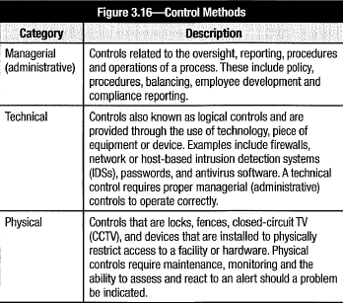

#### 3.12.5 Control Recommendations

When **evaluating control strength**, consider control elements: *preventive vs. detective*, *manual vs. automated*, *ad hoc vs. formal* (documented in procedure manuals, evidence of operation). Provide controls that *mitigate/ eliminate* identified risk. Goal of recommended controls: reduce level of risk to acceptable level. Factors when recommending controls:

•Effectiveness of recommended options

•Compatibility with other impacted systems, processes and controls

•Relevant legislation and regulation

•Organizational policy and standards

•Organizational structure and culture

•Operational impact

•Safety and reliability

Control recommendations = results of risk assessment & analysis process. Provide input to risk treatment process. During *risk treatment*: evaluate, prioritize & implement procedural & technical security controls. Conduct cost benefit analysis for proposed controls to demonstrate costs justified by reduction in level of risk/impact.

#### 3.12.6 Countermeasures

**Countermeasure** = (in addition to safeguards from standard controls) control against *specific & known* threat. Provide specific protection *more effective, but less efficient* than general safeguards; not *less cost-effective* (based on original/residual **annual loss expectancy (ALE)** associated with threat). Countermeasures may be *preventive*, *detective* or *corrective*; *nontechnical* (reward for info leading to arrest of hackers). NOT recognized in ISO/IEC 27001:2013. Can be considered a form of *targeted control*.

Countermeasures often *expensive* (operationally & financially). Can become *distraction* from core security operations. Deploy only with *clear justification,* *due caution*, only when no existing control can adequately mitigate threat. Countermeasures used just like other control. Apply as *incremental enhancements* to existing controls. Example: Threat to email infrastructure due influx of spam ⇨ Countermeasure to spam attacks = enhance virus scanner to block incoming mail from list of known spammers.

Infosec program be *flexible* to implement countermeasures with little warning. Emergency changes need to *bypass standard change control*, but must be used with caution and thoroughly documented.

#### 3.12.7 Physical & Environmental Controls

Foundation: strong physical barrier to protect physical media hosting information. Physical security provided by *facilities management*. Requirements on *building-by-building basis* enforced with combined *physical security technology measures* + *manual procedures*. ***Physical & environmental controls***: general controls on computing facilities, personnel.

**Physical controls** to *prevent/mitigate damage* to facilities due natural/tech. events (e.g., backup power to sustain operations after hurricane damages). Example: unauthorized physical access to devices allow unauthorized access to information. To prevent unauthorized access: *identification badges*, *authentication devices* (smart cards or access controls based on biometrics, security cameras, security guards, fences, lighting, locks and sensors), *intrusion sensors* (vibration sensors, motion detectors, etc.).

**Environmental controls**: air conditioning, water drainage, fire suppression, etc. to ensure facilities be designed with *physical limitations* of system operation as requirements. General & application control ineffective/useless without adequate environmental controls to prevent, detect and recover from physical damage to information systems.

Infosec validates technology choices supporting physical security processes. Ensures policies & standards developed to ensure adequate physical security. Ensures *roles & responsibilities* assigned to *physical access controls*+ *escalation path* unauthorized person prevented from physically connect to network; equipment & removable media (documents & discarded items) protected from theft. Aware that technologies have features for physical mechanisms *to override* logical controls. Ensure IT site manager be assigned at each site; all equipment inventoried & configured to policy-compliant standards. Establish this role & responsibility as *resource to interface* with local physical security organizations on behalf of infosec program.

#### 3.12.8 Control Technology Categories

When determining types of control technologies, consider *operational authority* & *types of controls available*. Because IT responsible of technical controls, consider how security be maintained. 3 categories of technical controls: *native*, *supplemental* and *support*.

##### Native Control Technologies

**Native control technologies** = out-of-the-box security features integrated with business systems. Example: web servers native controls (authentication capabilities, access logging and SSL transport encryption). Policies & standards governing their use established by infosec; native control technologies configured & operated by IT (because native controls directly impact production). Infosec with configuration rights to core production systems *violates* SOD principal + creates risk (complicating change control & system ownership).

Native technology controls on devices: •Servers •Databases •Routers •Switches

##### Supplemental Control Technologies

**Supplemental control technologies** = components add-on to information systems. Provide functions NOT available from native components (e.g., network intrusion detection) OR more appropriate to implement outside of primary application systems (for architectural/performance reasons e.g., single network firewall vs. individual host-based network filtering). Supplemental technologies more *specialized* than native control technologies. Often operated by *security specialists*. Leverage support of IT OR share responsibility particularly if technology deeply embedded in both security & business application domains (e.g., responsibilities for *federated identity & access management* shared across security and IT).

##### Management Support Technologies

**Management support technologies** *automate* security-related procedure; *provide* management information processing, *increase* management efficiency/capabilities. Examples: *security information management (SIM)*, *security event analysis systems,* *compliance monitoring scanners*. NO direct impact to production ⇨ Implemented & operated by infosec, *independent from IT*. Automate security-related procedures to increase infosec efficiency or capabilities. Common supporting technologies: •SIM[9] tools •SIEM systems •Compliance monitoring & management tools •Access management workflow systems •Vulnerability scanning tools •Security configuration monitoring tools •Policy management & distribution systems

#### 3.12.9 Technical Control Components & Architecture

Technical mechanisms previously categorized as: native control technologies, supplementary control technologies and management support technologies.

##### Analysis of Controls

Control & support technologies collectively form *technical security architecture*. Apply construct to individual business applications or enterprise as a whole to reveal how interaction of individual technical components contributes to overall enterprise/ application security. Holistic view of technical component capabilities prevents *point-solution perspective* (poor overall security). Coordinate *technical security architecture* with *reviews* & *analysis of threat + risk factors*. Ensure components of security architecture aligned with org. *risk* and *threat postures* and *business requirements* ⇨ Align *technical architecture* with *higher levels of architecture* (i.e., logical, conceptual). To analyze, use defined set of measurable criteria to enable tracking of performance metrics. Pose questions then develop methods to provide answers. Criteria to analyze technical security architecture & components and develop suitable metrics & monitoring include:

•**Control placement**

-Where are controls located?

-Are controls layered?

-Is control redundancy needed?

-Are controls on/near perimeter efficient providers of broad access protection?

-Are there uncontrolled access channels to processing services or data? (Consider: physical, network, system-level, application and message access vectors.)

•**Control effectiveness**

-Are controls reliable?

-Are controls the minimum required?

- Do controls inhibit productivity?

-Are controls automated or manual?

-Are key controls monitored? In real time?

-Are control easily circumvented?

•**Control efficiency**

-How broadly do the controls protect the environment?

-Are controls specific to one resource or asset?

-Can they and should they be more fully utilized?

-Is any one control a single point of application failure?

-Is any one control a single point of security failure?

-Is there unnecessary redundancy in controls?

•**Control policy**

-Do controls *fail secure* or *fail open*?

-Do controls implement a *restrictive policy* (denial unless explicitly permitted) or a *permissive policy* (permission unless explicitly denied)?

-Is the principle of *least-needed* functionality and access enforced?

-Does rationale for control configuration align with policy, expectations, other drivers?

**•Control implementation**

-Is each control implemented in accordance with policies and standards?

-Are controls self-protecting?

-Will controls alert security personnel if they fail or detect an error condition?

-Have controls been tested to verify that they implement the intended policy?

-Are control activities logged, monitored and reviewed?

-Do controls meet defined control objectives?

-Are control objectives mapped to organizational goals?

Details of security technologies, technical control architecture, analysis of technical control requirements + ongoing management and administration *important component* of infosec program development. Be well versed in technologies that are part of technical security architecture. Have access to technical specialists responsible for installing, configuring and maintaining these technologies.

#### 3.12.10 Control Testing & Modification

Periodic testing of controls mandatory in publicly traded organizations. Be implemented as regular practice to ensure procedural controls carried out consistently & effectively.

**Changes to technical controls** be made under *change control procedures* & *stakeholder approval*. Analyze control environment to determine if new/recurring vulnerabilities exist in design; ensure control properly designed (i.e., *self-protecting*, *contains a failure policy*, *can be monitored*). Conduct *acceptance testing* to ensure policies are enforced.

**Changes to operational procedures** to undergo *review* and *approval*. Requisite changes to process inputs, activity steps, approvals or reviews, and process results be considered; modifications be coordinated. Consider workload to ensure changes not overload resources & impact operational quality. Complete additional staff training prior to implementation. Review operational control in form of *walkthrough* shortly after implementation to ensure all elements understood and implemented. Information to develop control objectives and implement controls in *COBIT 5*, *ISO/IEC 27001-27002*.

#### 3.12.11 Baseline Controls

Define **baseline security requirements** in *standards* (*authentication functions*, *logging*, *role-based access control* and *data transmission confidentiality*) in *system documentation*. Ensure *traceability* of security requirements across different phases of life cycle. Consider org. *risk appetite*. Refer to *industry* & *regional sources* to determine baseline security functions appropriate to policies and acceptable risk levels. *Supplemental controls* warranted based on *vulnerability*, *threat-risk analysis* and included in *requirements-gathering* process. Always *trade-offs* among security requirements, performance, costs and other demands. Exercise diligence to identify & communicate *solution deficiencies*. Develop mitigating/compensating controls as required. Review *coding practices* & security logic during development to ensure adequate practices.

During **quality & acceptance** phases: coordinate testing of original functional security requirements plus system interfaces. Verify system’s security mechanisms meet *control objectives* and provide *administrative* & *feedback* functions. Functional security shortcomings, coding vulnerabilities, exploitable logic flaws? Prioritize & resolve issues. Cannot be repaired/ mitigated? Review security issues to decide if system be deployed prior to resolution of identified vulnerabilities. Deploy system with unresolved security issues? Document issues, ensure *agreed-on timetable* to resolve issues. No viable resolution? Track & periodically reassess issue & keep searching resolution.

Ensure *segregation of duties* throughout **SDLC**. *Testing* & *QA plans* subject to review to ensure security elements tested & certified. May require *code review* in addition to QA testing process. Code reviews often outsourced for independent review.

### 3.13 SECURITY PROGRAM METRICS & MONITORING

Aspects of metrics to consider. ➊Are metrics necessary to track & guide program development at project, management & strategic levels? ➋Will metrics development be needed for ongoing management of program? One essential element of controls selection: can it be effectively monitored & measured? ⇨ Consider this during design & development. Can’t monitor key control? *Unacceptable* risk ⇨ Avoid this control.

Org. security involves technical controls, policy, firewalls, passwords, intrusion detection and disaster recovery plans; processes around technical controls; and people issues ⇨ Complex system of many components. Apply *system engineering concepts* of design, planned implementation, scheduled maintenance & management to increase effectiveness & performance. One fundamental principle of systems engineering: *ability to measure & quantify*. *Measurement* enables proper design, accurate implementation to specifications, effective management (goal setting, tracking progress, benchmarking & prioritizing). *Measurement fundamental requirement for security program success*.

Distinction between managing technical IT security systems at operational level AND overall management of infosec program. *Technical metrics* useful for purely tactical operational management of technical security infrastructure (e.g., antivirus servers, intrusion detection devices, firewalls) - indicate whether infrastructure operates soundly, technical vulnerabilities identified & addressed. BUT of less value from strategic/ overall security program management standpoint (say nothing about strategic alignment with objectives or how well risk is managed; few measures of policy compliance or whether objectives are reached; no info. on program direction, velocity or objective proximity). Technical metrics incapable of providing answers to questions:

•How secure is organization?

•How much security is enough?

•How do we know when adequate security is achieved?

•What are most cost-effective solutions?

•How do we determine degree of risk?

•How well can risk be predicted?

•Are we moving in right direction?

•What impact is lack of security having on productivity?

•What impact would a catastrophic security breach have?

•What impact will proposed security solutions have on productivity?

#### 3.13.1 Metrics Development

Infosec governance process (in section 1.1 Infosec Governance Overview) produces set of *goals* for infosec program. As in section 3.3.1 Concepts, these goals generate *control objectives* + *planning activity* to achieve objectives. Security management metrics be developed from foundation of governance, which sets goals & creates points of reference. *Measurements without reference in form of objectives* or *goals without metrics* not useful in program guidance. Many considerations when developing metrics. Purpose of metrics = decision support ⇨ Essential to know what decisions made at which org. level ⇨ Roles & responsibilities be defined to know what information is required by whom.

**Primary parameter of metrics design**:

•Who needs to know? •What do they need to know? •When do they need to know it?

Metrics need provide info at 3 levels: •Strategic •Management •Operational

##### Strategic

**Strategic metrics** = compilation of other management metrics to indicate program *on track*, *on target* and *on budget*. Info essentially *navigational* (determine whether security program headed in right direction to achieve objectives leading to desired outcomes).

##### Management

**Management (or tactical) metrics** to manage program at level of *policy & standards compliance*, *incident management* & *response effectiveness*, and *manpower* & *resource utilization*. At security management level: info on compliance, emerging risk, resource utilization, alignment with business goals and other topics. Infosec manager also requires summary of *technical metrics* to ensure machinery is operating properly in acceptable ranges (driver wants to know fuel level in tank, oil pressure and water temperature). These metrics may NOT ensure car in right direction BUT can warn destination not reached.

##### Operational

**Operational metrics** = common technical & procedural metrics (open vulnerabilities & patch management status). Purely technical metrics primarily useful for IT security managers and system administrators: malware mitigation measures, firewall configuration data, syslog reviews and other operational matters. Considerations for developing metrics:

•**Manageable**: Data readily collected, condensed, sorted, stored, correlated, reviewed and understood.

•**Meaningful**: Data should be understandable to recipient and relevant to objectives and provide basis for management decisions.

•**Actionable**: Makes clear to pilot which direction to head/stay on course. Info that merely invites further investigation may just be clutter.

•**Unambiguous**: Info not clear not useful.

• **Reliable**: Must be able to rely on feedback mechanisms; on consistency to provide same result for same conditions each time they are measured.

•**Accurate**: Degree of accuracy depends on how critical measure is. *Qualitative* metrics may be approximations. *Quantitative* metrics need be accurate.

•**Timely**: To be useful, feedback must occur when needed.

•**Predictive**: To the extent possible, leading indicators are very valuable.

•**Genuine**: Metrics subject to manipulation not reliable and inaccurate.

Above attributes can be ***meta-metrics*** (measure of metrics themselves), serve to rank metrics and determine which are useful. Any metric failing to meet these criteria is suspect. Even well-rated metrics can fail ⇨ Prudent to create *system of metrics that cross-reference each other for the purpose of validation* (accomplished by measuring 2 separate aspects of same thing and ensuring agreement between them). Investigate *discrepancies* between internal measures of compliance and results of audit.

**Monitor** to ensure compliance with laws & regulations. Monitoring of all metrics is required to ensure they are operating & information is properly distributed & handled. Understand how to monitor security programs and controls. Some monitoring *technical* and *quantitative* while others are *imprecise* and *qualitative*.

Use **quantitative metrics** with elements such as *number* or *percentage of*: •Un-remediated vulnerabilities •Open/ closed audit items •User accounts in compliance with standards •Perimeter penetrations •Unresolved security variances

**Qualitative metrics** to monitor to determine trends: •CMMI levels at periodic intervals •KGIs •KPIs •KRIs •Business balanced scorecard (BSC) •Six Sigma quality indicators •ISO 9001:2015 quality indicators •COBIT 5 PAM

Other relevant measures: •cost-effectiveness of controls •extent of control failures.

#### 3.13.2 Monitoring Approaches

Develop consistent/reliable method to determine *overall effectiveness* of program & *trends* in technical security. Regularly conduct risk assessments & track improvements over time. Use external & internal scanning plus penetration testing to determine system vulnerabilities (only a facet of program). Steady improvement = hallmark of effective program, but of limited value without info about *viable threats* and *potential impacts*. Feed *change management* activities into monitoring. Deal with adverse trends timely. Review metrics regularly and report unusual activities. Develop action plan to *react* plus proactive plan (*in anticipation*) to address trends leading to security breach/failure.

##### Monitor Security Activities in Infrastructure & Business Applications

Continuous monitoring = prudent business practice (and regulatory requirement). **Technical monitoring**: performed by IT. Define *operating standards* along with *severity criteria* & *escalation processes*. Monitor **IDS** and firewalls for real-time info on attempts to breach perimeter defenses. Train help desk to escalate reports that signal breach/attack.

##### Determine Success of Infosec Investments

Have processes to determine *effectiveness* of security investments & *extent to which* objectives met. Obtain ***ROI****,* ***justify costs***. Ensure **KPIs** defined & agreed to. Implement mechanism to measure progress against these indicators. *Actual costs* need be accurate to determine *cost-effectiveness*. Use ***TCO*** to evaluate components of program. In addition to initial procurement and implementation costs, include:

•Costs to administer controls •Training costs •Maintenance costs •Monitoring costs •Update fees •Consultant/ help desk fees •Fees associated with inter-related systems that may need modified.

#### 3.13.3 Measure Infosec Management Performance

Implement processes & mechanisms to assess program success & shortcomings. **Measure success** = define measurable objectives, track appropriate metrics, analyze results to determine areas of success and improvement opportunities. Program objectives be *conceptually* & *chronologically* aligned with business goals. Common objectives:

•Achieve acceptable levels of risk & loss related to infosec issues.

•Support achievement of overall organizational objectives.

•Support organizational achievement of compliance.

•Maximize program’s operational productivity.

•Maximize security cost-effectiveness.

•Establish & maintain organizational security awareness.

•Facilitate effective logical, technical, operational security architectures.

•Maximize effectiveness of program framework & resources.

•Measure & manage operational performance.

#### 3.13.4 Measure Infosec Risk & Loss

Determine whether security program is functioning at suitable level: *balance operational efficiency against adequate safety*. Approaches to periodically measure program’s success against risk management & loss prevention objectives:

•**Technical vulnerability management** related questions:

-How many technical or operational vulnerabilities exist?

-How many have been resolved?

-What is average time to resolve them?

-How many recurred?

-How many systems (critical or otherwise) are impacted by them?

-How many have potential for external exploit?

-How many have potential for gross compromise (e.g., remote privileged code execution, unauthorized administrative access, bulk exposure of sensitive printed information)?

•**Risk management** related questions:

-How many high/ medium/ low-risk issues unresolved? What aggregate ALE?

-How many resolved? What aggregate ALE that has been eliminated?

-[Completely eliminated] vs. [partially mitigated] vs. [transferred]?

-How many accepted risks due no tenable mitigation/compensation?

-How many opened risks due inaction/ lack of cooperation?

•**Loss prevention** related questions:

-Any loss event in period? What aggregate loss (incl. investigation, recovery, data reconstruction, customer relationship management)?

-How many preventable events (risk/vulnerability identified prior to loss event)?

-Average time to identify loss incidents? To initiate incident response procedures? To isolate incidents from other systems? To contain event losses?

**Qualitative measures** to monitor risk management:

•Do risk management activities occur as scheduled?

•Have IRPs and BCPs been tested?

•Are asset inventories, custodianships, valuations and risk analyses up to date?

•Consensus among infosec stakeholders on acceptable levels of risk?

•Do executive management oversight and review activities occur as planned?

#### 3.13.5 Measure Support of Org. Objectives

Measure organizational objectives is *subjective.* Org. objectives change rapidly due evolving operational pressures & market conditions. Related qualitative measures:

•Any documented *correlation* between org. milestones & infosec program objectives?

•How many infosec objectives completed in support of organizational goals?

•Any organizational goals not fulfilled because infosec objectives were not met?

•How strong is consensus that program objectives are complete and appropriate?

Value of successful measure in analyzing why objective met/not met ⇨ Qualitative measures on support of org. objectives; analyze missed objectives (why not accomplished)

#### 3.13.6 Measure Compliance

Compliance = essential in security management: most security failures result from failure to follow procedures compliant with standards. Know *criticality* & *sensitivity* (mandate level of compliance to achieve to manage risk). Anything less than 100% compliance is *unacceptable*. Activity NOT life/org. threatening? Weigh cost & level of compliance efforts against benefits & potential impacts. Measure compliance with *technical standards* often straightforward & can be automated; compliance with *procedural/process standards* more difficult. {Direct continuous monitoring: access controlled by guards & sign-in procedures. Detective controls logging and checklists}.

Compliance requirements may be *statutory*, *contractual* or *internal*. Align program goals with compliance of *compulsory* or *voluntary* standards. Implemented policies, procedures and technologies must fulfill requirements of adopted standards.

Measurements of compliance achievement tied to results of internal/external audits. Implement automated/manual compliance monitoring with higher frequency & broader scope than (incremental) audits. Measure *effectiveness* *of resolved compliance issues* in addition to *actual point-in-time compliance*.

#### 3.13.7 Measure Operational Productivity

Maximize operational productivity. Use automation technologies, outsource low-value operational tasks and leverage activities of other organizational units. Automation of security management = workforce multipliers/ increase accomplishment of operational tasks many times over. Example: Vulnerability scanning tools (manual vulnerability assessment in hours instead of weeks). Personnel cost savings justifies expense of tools.

Productivity measures useful in *time-based comparison analysis* (show productivity before/ after productivity-boosting technology) to demonstrate *returns on security investments*. **Productivity** = measure of work product per tech./personnel resource (e.g., network packets processed per IDS node). Example: work product = analyzed event log entries; resource = analyst; productivity measure = event log entries analyzed per analyst.

Set periodic goals to increase productivity of infosec program through specific initiatives. Review goals to determine achieved productivity gains. Analyze data (hourly employee cost and effort expended per task) to demonstrate financial value of productivity improvement initiatives to senior management.

#### 3.13.8 Measure Security Cost-Effectiveness

Infosec program needs be *financially sustainable* because *financial constraints* common reason for security lapses, failure to plan for ongoing maintenance. Maximize value of each security investment to control expenses & ensure sustainable achievement of objectives. Begin with **cost forecasting & budgeting** (by monitoring **budget utilization** vs. **original projections**) to identify issues with *security cost planning*. In addition to *budgeting effectiveness*, measure ongoing **cost-effectiveness** of security components (by tracking **cost-result ratios**). Establish **cost-efficiency goals** for new technologies + **improvement goals** for existing technologies by measuring total cost to generate specific result. Costs include: *maintenance*, *operations*, *administration costs* for period (e.g., month, quarter, year). Use **ratios of result-units per currency-unit** (e.g., 7,400 network packets analyzed per USD annually) or **vice versa** (0.04 euros per ,000 emails scanned annually) to demonstrate cost-efficiency and cost of results. Other examples include:

•Costs of vulnerability assessment per application

•Costs for workstation security controls per user

•Costs for email spam and virus protection per mailbox

Technology purchase & deployment efforts only a *fraction* of full life cycle costs. Consider total costs to maintain, operate and administer technical security components + personnel costs associated with operational and management activities. Share analyses with security steering committee to identify areas of opportunity to improve cost-effectiveness and forecast future resource needs.

#### 3.13.9 Measure Organizational Awareness

Threats from personnel actions mitigated only through education & awareness. Track ongoing effectiveness of awareness programs. Achieved at employee level. Work with HR to implement metrics to track org. awareness success. Metrics for training program: records of initial training, acceptance of policies, usage agreements, ongoing awareness updates (help identify individuals in need of training; org. units not fully engaged in security awareness program). Measure of awareness program effectiveness: employee testing ⇨ Develop tools (short online/paper examinations following training; conduct additional quiz on random sampling of employees months after training to determine long-term effectiveness of awareness training and other efforts (e.g., infosec newsletters).

#### 3.13.10 Measure Effectiveness of Technical Security Architecture

Technical security architecture most tangible manifestations of infosec program. Quantitative measures of effectiveness of technical control environment:

•Probe & attack attempts repelled by network access control devices; qualify by asset or resource targeted, source geography, attack type

•Probe & attack attempts detected by IDSs on internal networks; qualify by internal vs. external source, resource targeted, attack type

•Number & type of actual compromises; qualify by attack severity, attack type, impact severity, source of attack

•Statistics on viruses, worms, other malware identified/neutralized; qualify by impact potential, severity of larger Internet outbreaks, malware vector

•Amount of downtime attributable to security flaws & unpatched systems

•Number messages processed, sessions examined, kilobytes (KB) data examined by IDS

Qualitative measures that apply to technical control environment:

•Technical mechanisms tested to verify control objectives & policy enforcement.

•Security architecture constructed of appropriate controls in layered fashion.

•Control mechanisms configured & monitored in real time, self-protection implemented, infosec personnel alerted to faults.

•Critical systems stream events to infosec personnel/to event analysis automation tools for real-time threat detection.

Most above measures & metrics little meaning/interest to senior management ⇨ Provide composite summary on security progress according to expectations.

#### 3.13.11 Measure Effectiveness of Management Framework & Resources

Efficient infosec max. results by implemented components & processes ⇨ Mechanisms to capture process feedback, identify issues & opportunities, track consistency of implementation, and communicate changes & knowledge. Methods to track success:

•Track frequency of issue recurrence

•Monitor level of operational knowledge capture & dissemination

•Degree to which process implementations standardized

•Clarity & completeness of documented infosec roles & responsibilities

•Incorporate infosec requirements into every project plan

•Efforts & results to make program more productive & cost-effective

•Overall security resource utilization & trends

•Ongoing alignment with/support of organizational objectives

Implement mechanisms to extract *latent[10] value* from framework, procedures & resources.

#### 3.13.12 Measure Operational Performance

Measures of security operational performance include:

•Time to detect, escalate, isolate, contain incidents

•Time between vulnerability detection & resolution

•Quantity, frequency, severity of incidents discovered after occurrence

•Average time between vendor release of vulnerability patches & application

•Percentage of systems audited within certain period

•Number of changes released without full change control approval

Determine appropriate metrics to track security operations within org. units. Compile, analyze & distribute metrics to stakeholders. Analyze performance issues for root cause by security steering committee and improvement solutions implemented.

#### 3.13.13 Monitoring & Communication

New/modified controls, design considerations, require methods to determine if operating as intended. Monitoring **technical controls**: review logs & alerts (IDS or firewalls) for security vulnerabilities or emerging threats. **Procedural & process controls** more difficult to implement. **Technical monitoring of physical processes** most efficient & effective. Most promising control points to monitor: personnel interface with info systems. Monitor early in processes, watch for suitable outcomes ⇨ Early warning of impending problems. Develop *central monitoring environment* to provide *visibility* into information resources. Determine which events most pertinent to affect resource and event type. Commonly monitored event types:

•Failed access attempts to resources

•Processing faults that may indicate system tampering

•Outages, race conditions, faults related to design or other issues

•Changes to system configurations, particularly security controls

•Privileged system access & activities

•Technical security component fault detection

Develop procedures to analyze events and take responsive action. Train monitoring analysts on these procedures. Monitoring supervisors to have response procedures to address anomalies. **Response procedures**: analyze events & system states, capture additional event-related info, investigate suspicious activity, or escalate issue to analysts/ management. Test *escalation path* for security events & incident initiation.

In addition to real-time monitoring, periodically conduct analysis of trends in events (attempted attack types/ frequently targeted resources) ⇨ Reveal threat & risk patterns. Monitor key controls in real time. *Detective controls* (log reviews) useful *only* to determine how something that already happened might unfold. IDS alerts are *reactive*; (depending on tuning, IDS is effective as means to trigger rapid response).

*Roll up results* of ongoing monitoring to provide assurance that security provides appropriate levels of operational assurances and control objectives are being met.

### 3.14 COMMON INFOSEC PROGRAM CHALLENGES

Surprising array of unexpected impediments to infosec program:

•Org. resistance due to changes in areas of responsibility introduced by program

•Perception that increased security will reduce access required for job functions

•Overreliance on subjective metrics

•Failure of strategy

•Assumptions of procedural compliance without confirming oversight

•Ineffective project management, delaying security initiatives

•Previously undetected, broken or buggy security software

Always cultural & organizational challenges. Path not cleared simply by virtue of gaining senior management support. Require cooperation of others in organization. Figure 3.17 identifies constraints inherent in road map development for 3 organizations. Be aware of type of constraints inherent in organization.

###### Figure 3.17 Constraints in developing infosec Road Map

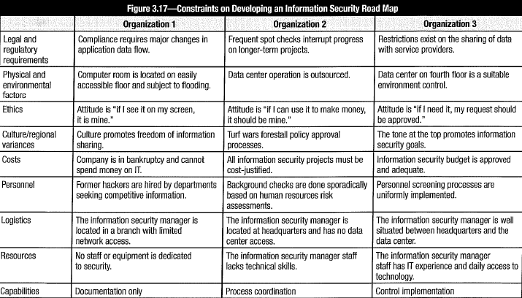

Last line in figure 3.17 shows *infosec program capabilities* resulting from constraints. Organization 1 most resource-constrained w.r.t. implementing infosec program. Organization 3 has abundant resources, strong management and technical support- all conducive to develop effective program. These examples demonstrate that infosec capability to produce effective program dependent on environment.

Many view infosec as low-level, technology-based cost center, forgoing security governance & strategic infosec management. While recognized as necessary, infosec viewed as *obstructionist* and *impediment* to get job done. Manifestations of challenges: lack of management support, poor infosec resource levels, shortsighted approach to strategy and poor cooperation from business. In addition, requirements & demands rapidly changing, driven by technical & regulatory pressures.

Regardless of organizational circumstances, *persuasive* infosec with clear vision of infosec role can improve overall security posture with campaign to educate stakeholders in infosec role & relevance: define & seek agreement on info risk control objectives, determine org. risk appetite, and identify mission-critical information assets. Align infosec activities with to support business objectives. Develop meaningful KPIs and metrics; appropriate breadth & depth to provide info for management. Implement consistent reporting to promote awareness of infosec role in achieving org. objectives.

##### Management Support

Lack of management support most common in small org. or those not in security-intensive industries. No compulsory requirement to address infosec. View it as marginal issue that adds cost with little value. Reflect misunderstanding of org. dependence on info systems, threat & risk environment, or impact org. unknowingly experiencing.

Use resources: industry statistics, org. impact & dependency analyses, and reviews of common threats to specific information processing systems. Management may require guidance in what is expected of them and approaches taken by industry peers. Ongoing education be conducted to develop awareness of security needs.

##### Funding

Inadequate funding for infosec initiatives most frustrating and challenging issues. Symptom of underlying lack of management support. Other funding-related issues:

•Management not recognize value of security investments

•Security viewed as low-value cost center

•Management not understanding where existing money is going

•Org. need for a security investment not understood

•Need for more awareness of industry trends in security Investment

If additional funding to close financial gaps not available, exercise strategies to minimize impact of financial shortfall on org. info risk posture:

•Leverage budgets of other organizational units (e.g., product development, internal audit, information systems) to implement needed security program components

•Improve efficiency of existing infosec program components

•Work with infosec steering committee to reprioritize security resource assignments

•Provide senior management with analysis of what security components will become under resourced and associated risk implications.

Pay attention to funding issues. Work on them on ongoing basis. Understand financing infosec program is difficult. If program successful, management not see where money is going/ may wonder why they are spending. If program not successful, management not understand why they budget significant amounts of money for systems that are still compromised. Find ways to show that security important, functional & business-related.

##### Staffing

Obstacles to obtain effective staffing levels might include:

•Poor understanding of what activities new resources will do

•Question need or benefit of new resource activities

•Lack of awareness of existing staff utilization levels or activities

•Belief that existing staff are underutilized

•Desire to examine outsourcing alternatives

Utilize workload management procedures to generate personnel workload analyses, utilization reports and other metrics to demonstrate current level of effort; charts to associate specific infosec roles/teams with protection they provide. Demonstrate high/ growing levels of productivity to demonstrate resources usage effective & efficient. If unable to allocate additional human resources, consider following strategies to minimize impact of understaffing on infosec program effectiveness:

•Collaborate with other business units to determine if they can assume more infosec responsibilities; delegate appropriate tasks with oversight.

•Analyze outsourcing possibilities, especially for high-volume operational activities. Demonstrate how freed resources can be redeployed to higher-value activities.

•Work with infosec steering committee to re-prioritize security personnel assignments; provide senior management with analysis of what security activities will not be addressed with current staff & communicate risk implications.

### CHAPTER 3 PRACTICE

#### In Practice

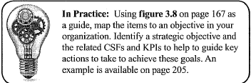

**Answers**

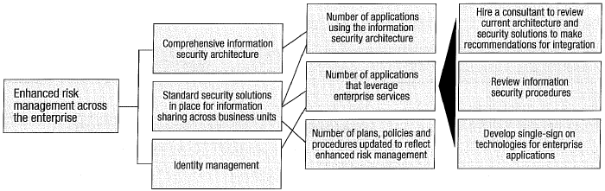

#### Knowledge Check: Outsourcing Contracts & Cloud Computing

1. What is main purpose to develop contract with 3rd -party service provider?

2. List 5 key points a contract with 3rd party vendor should include

3. What additional security considerations need be considered for cloud service?

4. To address concerns in question 3, what provisions should be included in a contract with the cloud service provider?

**Answers**

**Question 1:** To ensure both parties (the outsourcer and the service provider) are aware of their responsibilities and rights within the relationship and provide the means to address disagreements once the contract is in force.

**Question 2**: Considerations include:

•Detailed specification of outsourced service

•Specific security requirements

•Restrictions on copying information and securing assets

•Prohibit access without explicit authorization & maintain list of individuals with access

•Right to audit and/or inspect

•Indemnity clauses to mitigate impacts caused by service provider

•Requirements for IRPs and business continuity plans (BCPs)

•Level of service quality

•Integrity and confidentiality of business assets

•Nondisclosure agreements to be signed by the employees/agents of third parties

•Protection of intellectual property

•Ownership of information

•Requirement that applicable legal and regulatory requirements are met

•Return and/or destruction of information/assets at the end of the contract

•Duration up to which the confidentiality shall be maintained

•Employees/agents of 3rd party required to comply with security policies of organization

•Escalation processes

•Predetermined reduction or increases in costs associated with changing service levels

•Response and implementation times for changing service requirements

•Conditions and circumstances for contract cancelation and associated costs

**Question 3**: Loss of control of sensitive data, location of data, laws, regulations and compliance requirements, processes for handling incidents between jurisdictions, availability of audit logs

**Question 4**: Considerations include:

•Specific security requirements

•Right to audit and/or inspect

•Indemnity clauses to mitigate impacts caused by the service provider

•Requirements for IRPs and BCPs

•Integrity and confidentiality of business assets

•Nondisclosure agreements to be signed by the employees/agents of third parties

•Protection of intellectual property

•Ownership of information

•Requirement that applicable legal and regulatory requirements are met

•Return and/or destruction of information/assets at the end of the contract

•Duration up to which the confidentiality shall be maintained

•Employees/agents of 3rd party required to comply with security policies of organization

•Escalation processes

#### Knowledge Check: Control Categories

Sort the controls listed below into the appropriate control category:

•Audit trail •Business interruption insurance •Data backup •Data leak prevention •Employee awareness training •Error correction •Segregation of duties •Intrusion detection system •Restricted Access sign •User policy

**Answers**

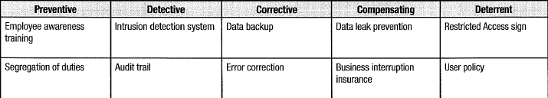

#### Case Study

At the start of a multinational corporation’s new financial year, a new information security manager was hired to oversee the firm’s information security program. The information security manager requested and obtained policies and procedures, prior year internal audits, and results from the most recent external audits.

Upon reviewing information provided by internal audit, the information security manager focused on the change management component of the overall information security program. In assessing the control design effectiveness for the change management process, it was noted through interviews with key IT personnel that the firm uses a proprietary change control system (dubbed “GLASS”) to enter change requests and then track them through the change management process—taking into account approvals and plans for both rolling out and backing out changes. GLASS also keeps a record of all changes made to the billing system, along with the associated date, using unique identifiers for each change and audit logs that capture other billing system activities.

To determine operational effectiveness for the control process, the information security manager conducted interviews with technology owners for the billing system and the firm’s audit personnel, then used a random sample of changes taken from the proprietary change control system. The sampling methodology used concurred with the finn’s internal audit policies. The resulting control assessment involved in the audit was also conducted, along the parameters required by the firms’ policies and procedures. The change control system passed and no exceptions were found. However, during the firm’s external audit, it was determined that there were changes to the system that did not have the required approvals. Reviewing the policies and procedures, the information security manager could not find any obvious reason why the changes were missed during the internal audit. Through subsequent investigation with the audit team and personnel responsible for migrating changes into one of the production systems, the information security manager determined that GLASS was not the sole point of entry for change requests, but instead could be bypassed.

The firm was then tasked to develop a monitoring solution that looked at all billing system and database system activity, then compared it against approved functionality (called “VIEW”). This tool would then alert IT security of any actions that did not reflect those permitted by change management policies and procedures, such as a change that did not have approvals being migrated into production. 1. When evaluating control design effectiveness, reviewing the audit program and making inquiries with staff, what are some of the mistakes the information security manager made?

2. What type of control does the implementation of the VIEW tool represent?

A. Compensating B. Corrective C. Detective D. Preventive

**Answers**

**Question 1**: When evaluate control design effectiveness, review audit program & make inquiries with staff, what are some of the mistakes infosec made?

Infosec’s review and sampling methods were flawed. ➊Infosec not primarily involved in audit function; however, he could consult the audit reports to gather additional information. ➋Interviews should be supported with additional research because interviews can be unreliable; employees may omit information or not be forthcoming with information for a variety of reasons. ➌Interviews did not uncover the more significant issues of changes occurring that bypassed the system. When inquiring about a process that has a built-in version control and monitoring system, it is important to note all possible entry points, or completeness. Since it is the supplemental control technology, GLASS, that recorded activity, it was important to note whether or not there was a way around this system. The closer to the native control technology of a system the infosec manager can get, the closer he/she will be to accessing core functionality. The infosec manager missed this part of the investigation.

**Question 2**: What type of control does the implementation of the VIEW tool represent?

A. Compensating B. Corrective C. Detective D. Preventive

A. A compensating control is an internal control that reduces the risk of an existing or potential control weakness, resulting in errors and omissions. The VIEW reacts to attempted violations and logs the information but does not react based upon the actions of other controls and correct errors; therefore, it is detective.

B. A corrective control would have the power to remediate impact. In the case of the VIEW tool, it is a monitor against activity and sends out alerts when a breach of acceptable activity occurs.

C. **A detective control warns of violations or attempted violations of security policy: in this case, logging of system activity and comparing it against authorized actions. The VIEW tool can react only once an action has occurred; therefore, it is detective**.

D. The VIEW reacts based on the activity already implemented within the targeted systems; therefore, it cannot be a preventive tool. For it to be preventive, the tool would have to be empowered with preventing users from completing an action that was not authorized.

# IV. InfoSec Incident Management

## Section One: Overview

### DOMAIN DEFINITION

Plan, establish and manage the capability to detect, investigate, respond to and recover from infosec incidents to minimize business impact.

#### Learning Objectives

•Identify, analyze, manage, respond effectively to unexpected events that may adversely affect the organization’s information assets and its ability to operate.

•Identify the components of an incident response plan.

•Evaluate the effectiveness of an incident response plan.

•Understand the relationship among an incident response plan, a disaster recovery plan and a business continuity plan.

### TASK STATEMENTS (10)

T4.1 Establish and maintain *organizational definition* and *severity hierarchy* for incidents to allow accurate classification and categorization of and response to incidents.

T4.2 Establish and maintain an *incident response plan* to ensure an effective and timely response to infosec incidents.

T4.3 Develop and implement *processes* to ensure the *timely identification* of infosec incidents that could impact the business.

T4.4 Establish and maintain *processes* to *investigate and document* infosec incidents in order to determine the appropriate response and cause while adhering to legal, regulatory and organizational requirements.

T4.5 Establish and maintain *incident notification and escalation processes* to ensure that the appropriate stakeholders are involved in incident response management.

T4.6 *Organize, train and equip incident response teams* to respond to infosec incidents in an effective and timely manner.

T4.7 *Test, review and revise* (as applicable) the *incident response plan* periodically to ensure an effective response to infosec incidents and improve response capabilities.

T4.8 Establish and maintain *communication plans and processes* to manage communication with internal and external entities.

T4.9 Conduct *post-incident reviews* to determine the root cause of infosec incidents, develop corrective actions, reassess risk, evaluate response effectiveness and take appropriate remedial actions.

T4.10 Establish and maintain *integration among the incident response plan, business continuity plan and disaster recovery plan*.

### KNOWLEDGE STATEMENTS (18)

K4.1 Knowledge of incident management concepts and practices

K4.2 Knowledge of the components of an incident response plan

K4.3 Knowledge of business continuity planning (BCP) and disaster recovery planning (DRP) and their relationship to the incident response plan

K4.4 Knowledge of incident classification/categorization methods

K4.5 Knowledge of incident containment methods to minimize adverse operational impact

K4.6 Knowledge of notification and escalation processes

K4.7 Knowledge of roles and responsibilities in identifying and managing infosec incidents

K4.8 Knowledge of the types and sources of training, tools and equipment required to adequately equip incident response teams

K4.9 Knowledge of forensic requirements and capabilities to collect, preserve and present evidence (e.g., admissibility, quality and completeness of evidence, chain of custody)

K4.10 Knowledge of internal and external incident reporting requirements and procedures

K4.11 Knowledge of post-incident review practices and investigative methods to identify root causes and determine corrective actions

K4.12 Knowledge of techniques to quantify damages, costs and other business impacts arising from infosec incidents

K4.13 Knowledge of tech./processes to detect, log, analyze, document infosec events

K4.14 Knowledge of internal and external resources to investigate infosec incidents

K4.15 Knowledge of methods to identify the potential impact of changes made to the operating environment during the incident response process

K4.16 Knowledge of techniques to test the incident response plan

K4.17 Knowledge of applicable regulatory, legal and organization requirements

K4.18 Knowledge of key indicators/metrics to eval effectiveness of incident response plan

## Section Two: Content

### 4.0 INTRODUCTION

**Incident management** = capability to effectively manage unexpected disruption to minimize impacts and maintain or restore normal operations within defined time limits.

**Incident response** = operational capability of incident management to *identify*, *prepare for* and *respond to* incidents to control and limit damage; provide *forensic and investigative capabilities*; and *maintain*, *recover* and *restore* normal operations as defined in **service level agreements (SLAs).**

**Infosec responsibility:** Require technical expertise and infosec competence. Develop and test incident management and response plans; ensure it correlates with business continuity and disaster recovery plans. Need definition of incident and subsequent categorization levels (based on severity level or impact pervasiveness) ⇨ Can prioritize incidents and enable response from incident management resources.

**Incident response plan (IRP)** must maintained multiple objectives, such as:

•Demonstrate that incident response efforts have senior management support

•Ensure IRP is communicable form for organizational distribution, review and revision based on incident-handling experience and organizational changes

•Outline goals to consistently and systematically address and remediate incidents in a timely manner that is consistent with business objectives.

**Timely identification of infosec incidents** refers to overall effectiveness of incident identification process. **Effectiveness** refers to both **timeliness** and **accuracy** with which incidents are identified. **Timeliness** = time between incident identification and acceptance as a valid incident. Must be kept within determined acceptable tolerances (if excessive time passes, impact of incident may spread, making initial classification incorrect and remediation efforts more difficult).

Identified incidents must be investigated and documented. A response commensurate with incident severity is determined. **Effective documentation** during **incident discovery process** helps participants understand the incident so they can respond appropriately. In addition, documentation includes data to help **forensics examiners** (such as a legal investigation). When incident investigations involve individuals, ensure *compliance with legal and regulatory requirements* ⇨ involve legal and HR.

Once incident identified and classified, the next step: notify **incident response team (IRT)** and support teams, IT and business owners. **Operational agreements** be set up, including specifications on timeliness of notifications. **Distribution lists** of stakeholders be available and up to date. **Escalation procedures** be set up to include alternates if stakeholders cannot be reached or remediation effort encounters complications.

Ensure **dedicated resources** specialized in incident response (trained and equipped).

**Test and revise IRP** because changes and new risks mis-align IRP with business.

**Communication plans** be documented and resource listings maintained. Involve internal and external resources such as a public relations (PR) representative, audit and legal counsel. Equip incident handlers with methodology to determine communication to various stakeholders and at which point that contact should be established.

**Post-incident review**: to address root causes, form lessons learned and maintain an accurate archive of incident events. Allows organization to review all events, identify trends and pervasive causes, and support management buy-in for constructive solutions and policy changes as needed.

**Incident** = unplanned interruption of business activities. Impact of incident may result in declaration of a disaster that triggers **business continuity plan (BCP)** and **disaster recovery plan (DRP)**.

### 4.1 INCIDENT MANAGEMENT OVERVIEW

###### Figure 4.1: Incident Management Life Cycle Phases

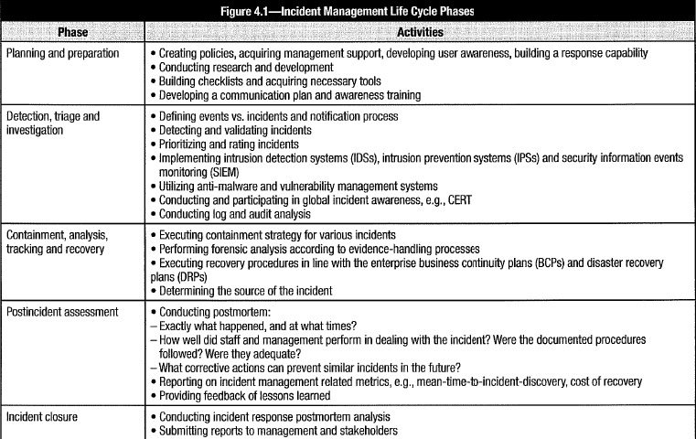

**Incident management & response** = emergency operations component of risk management. Included: activities that result from unanticipated attacks, losses, theft, accidents or any other unexpected adverse events that occur as a result of the failure or lack of controls. No single best approach. Approach depends on variety of factors:

•Constituency to be served •Mission, goals and objectives •Services provided •Organizational model & relationship with parent organization or customer base •Funding for start-up costs and ongoing operations • Resources needed by **computer security incident response team (CSIRT)**

Incident management involves actions taken *prior to* (including testing and planning), *during and after* an infosec incident occurs. Goals:

•Provide effective means to address situation to minimize impact •Provide management with information to decide courses of action •Maintain/restore continuity of services • Provide defense against subsequent attacks •Provide additional deterrence through use of technology, investigation and prosecution.

Incident management and response objectives:

•Detect incidents quickly •Diagnose incidents accurately •Contain and minimize damage •Restore affected services •Determine root causes •Implement improvements to prevent recurrence •Document and report.

See **Figure 4.1** for steps in Incident Management.

### 4.2 INCIDENT RESPONSE PROCEDURES

#### 4.2.1 Importance of Incident Management

Factors that compound the necessity of effective incident management include:

•Trend of increased occurrences and escalating losses resulting from infosec incidents

•Increase of vulnerabilities in software or systems affecting large parts of an organization’s infrastructure and impact operations

•Failure of security controls to prevent incidents

•Legal and regulatory mandates require development of incident management capability

•Growing sophistication and capabilities of profit-oriented and nation-state attackers

•Advanced persistent threats (APT)

•Increasing zero-day attacks

#### 4.2.2 Outcomes of Incident Management

Outcomes of good incident management and response:

•Deal effectively with unanticipated events that might threaten to disrupt the business.

•Sufficient detection and monitoring capabilities to ensure incidents detected timely.

•Defined severity and declaration criteria, escalation and notification processes.

•Personnel trained to recognize incidents, apply severity criteria, report, escalate

•Capabilities to support business strategy by being responsive to criticality & sensitivity of protected resources

•Proactively manage risk of incidents cost-effectively; integration of security-related organizational functions to maximize effectiveness.

•Provide monitoring and metrics to gauge performance of incident management and response capabilities

•Periodically test capabilities. Ensure information and plans updated regularly, current and accessible when needed.

Outcomes of monitoring and metrics activities:

•Information assets adequately protected. Risk level within acceptable limits.

•Trained and equipped incident management and response teams in place.

•Effective IRPs in place and understood by stakeholders (management, IT, end users).

•Incidents quickly identified, categorized and contained. Root cause addressed to allow recovery within an **acceptable interruption window (AIW)**.

•Communication flows to stakeholders and external parties controlled, as documented in communication plan.

•Lessons learned documented and shared with stakeholders to increase level of security awareness and serve as a basis for improvement.

•Assurance to internal and external stakeholders that control is adequate and business survivability ensured in the long term.

#### 4.2.3 Role of Infosec in Incident Management

Infosec manager has, at a minimum, responsibility as *first responder* to information-security-related incidents, regardless of the causes ⇨ Need conceptual and practical understanding of what is required to address those responsibilities; good understanding of the BC and DR processes (for incident management & response plans and activities to integrate with BCP and DRP in the event that an incident escalates to a disaster).

#### 4.2.4 Incident Response Concepts

(Key terms related to incident response as defined by CMU SEI)

**Incident handling**: processes/tasks to handle events and incidents. Multiple functions:

•**Detection and reporting**: Receive & review event information, incident reports, alerts

•**Triage**: Categorize, prioritize, assign events/incidents to max. effectiveness of resources

•**Analysis**: Determine what happened, impact & threat, resulting damage, following recovery or mitigation steps

•**Incident response**: Resolve or mitigate incident, coordinate and disseminate information, implement follow-up strategies to prevent recurring incidents

**Incident management** ensures incidents detected, recorded, managed to limit impacts. **Record incidents** so incident response activities can be tracked, information be provided for planning and no aspect of an incident is inadvertently overlooked; to include forensics data for disciplinary or legal options. **Classify incidents** for prioritization and routing to correct resources. Incident management includes **initial support processes** for new incidents to be checked against known errors and problems (to identify known workarounds). Incident management **structure** to *investigate*, *diagnose*, *resolve* and then *close* incidents; ensures that incidents are *owned*, *tracked* and *monitored* throughout life cycle. Major incidents may require a response beyond normal incident process that require activating **BC/DR capabilities**. Incident management often includes: **vulnerability management,** **security awareness training**, proactive activities to help prevent incidents.

**Incident response** (last step in incident-handling process) encompasses: *planning*, *coordination* and *execution* of *mitigation*, *containment*, and *recovery strategies* and *actions*. Plan for *nontechnical incidents*: social engineering, lost or stolen backup tapes or laptop computers, physical theft of sensitive materials, and natural disasters.

#### 4.2.5 Incident Management Systems

Incident management systems ability: track incident during its life cycle. Tracking ensures incidents not overlooked but receive attention based on criticality. Provides information and receives status updates along the event life cycle until it is closed.

**Distributed incident management system**: contains multiple **incident detection capabilities** (e.g., **network intrusion detection systems** [**NIDSs**], **host-based intrusion detection systems** [**HIDSs**], server/appliance logs, etc.).

**Centralized incident management system** = **security information and event manager (SIEM)**: automated log reader that *combines* critical events/logs from systems & devices and *correlates* them into meaningful incident information. *Normalize* data from system and device logs in single database; *data-mine* using correlation and inference tools; *notifications* and *alerts*; identify *policy violations*; *prioritize* incidents based on severity or business impacts; perform specific *notifications escalations* based on impact ratings.

SIEM can: •Consolidate & correlate inputs from multiple systems •Identify incidents or potential incidents •Notify staff •Prioritize incidents based on business impact •Track incidents until closure •Provide status tracking and notifications •Integrate with major IT management systems •Implement good practices guidelines

**Considerations**:

•**Operating costs:** No automated and centralized incident management system? Costs for training and maintaining staff. Higher probability of human error.

•**Recovery costs**: Automated system can detect and escalate incidents faster than with a manual process. Control and prevent further damage when recovery activated earlier.

### 4.3 INCIDENT MANAGEMENT ORGANIZATION

Incident management = *operational* and *reactive* element of risk management (if risk management insufficient to prevent a threat, incident management & response to limit the damage and restore operations.

Activities in response & recovery program: meet with *emergency management officials* (e.g., federal, state/provincial, municipal/local) to understand what governmental capabilities are available.

*Emergency management activities:* immediately after incident, during/after a physical disaster, fire, electrical failure or security-related incident. May require action to recover operational status (restoration of hardware, software and/or data files). Include measures to assure safety of personnel (evacuation plans, creation of command center from which emergency procedures can be executed). Information about incident be communicated on *need-to-know basis* to control exposure of sensitive information.

#### 4.3.1 Responsibilities

Infosec responsibilities in incident management:

•Develop infosec incident management and response plans

•Handle and coordinate infosec incident response activities effectively and efficiently

•Validate, verify, report protective/countermeasure solutions (technical & administrative)

•Plan, budget, develop program for infosec incident management and response.

Goals of incident response:

•Maintain incident response readiness

•Contain, minimize effects of incident so damage/losses not out of control

•Notify appropriate people for the purpose of recovery or infor

•Recover quickly and efficiently from security incidents

•Respond systematically and decrease likelihood of recurrence

•Balance operational and security processes

•Deal with legal and law-enforcement-related issues

Security-related incidents include:

•Malicious code attacks

•Unauthorized access to IT or information resources

•Unauthorized use of services

•Unauthorized changes to systems, network devices or information

•DoS/DDoS attacks

•Misuse

•Surveillance and espionage

•Hoaxes/social engineering

Many incidents (initially appear to be malicious) result from human error. Typically, incidents due to human error double those caused by external security breaches.

#### 4.3.2 Senior Management Commitment

Senior management commitment: **business case** to show effective incident management & response less costly than attempting to implement controls for all possible conditions. **Incident management and response** allows greater business opportunities (allow higher levels of acceptable risk based on demonstrated capacity to handle security incidents). **Adequate incident response combined with effective infosec**: most cost-effective risk management approach + most prudent resource management decision.

### 4.4 INCIDENT MANAGEMENT RESOURCES

**Internal and external resources** to develop incident management & response plan:

•IT department •Internal audit •HR department •Legal department •Physical security •Risk management •Insurance department •PR department • Sales and marketing •Senior management •Compliance office •Privacy officer

Develop clear **scope**, **objectives** and **implementation strategy**. The strategy must consider how to move from current state of incident management to the desired state. This will clarify what resources are required and how they must be deployed.

#### 4.4.1 Policies & Standards

Policies, standards and procedures:

•Ensure that incident management activities are aligned with the IMT mission

•Set correct expectations

•Provide guidance for operational needs

•Maintain consistency and reliability of services

•Clearly understand roles and responsibilities

•Set requirements to identify alternate personnel for all important functions

#### 4.4.2 Incident Response Technology Concepts

•**Security principles**:

-Confidentiality -Availability -Authentication -Integrity -Access control -Privacy -Non-repudiation -Compliance

• **Security vulnerabilities/weaknesses** and associated attacks:

-Physical security issues

-Phishing resulting from lack of user awareness

-Protocol design flaws (e.g., man-in-the-middle attacks, spoofing)

-Malicious code (e.g., viruses, worms, Trojan horses)

-Implementation flaws (e.g., buffer overflow, timing windows/ race conditions)

-Configuration weaknesses

-User errors or lack of awareness

•**The Internet**: Security issues in underlying protocols and services used on Internet. To be addressed in incident response program (IRP):

-**Network protocols**: Common (or core) network protocols: Internet Protocol (IPv4 vs IPv6), Transmission Control Protocol (TCP), User Datagram Protocol ( UDP), Internet Control Message Protocol (ICMP), Address Resolution Protocol (ARP) and Reverse Address Resolution Protocol (RARP); how they are used; common types of threats/ attacks against protocol; strategies to mitigate or eliminate such attacks; and Internet technologies

-**Network applications and services**: Domain name system (DNS), network file system (NFS) and secure shell (SSH); how they work; common usage; secure configurations; common types of threats/attacks against application or service; mitigation strategies

-**Network security issues**: Vulnerable points in network configurations. Basic perimeter security, network firewalls (design, packet filtering, proxy systems, demilitarized zone [DMZ], bastion hosts, etc.); router security (potential for information disclosure of data traveling across network (e.g., packet monitoring or “sniffers”) or threats relating to accepting untrustworthy information.

•**Operating systems**: Know operating systems (UNIX, Windows, MAC, Linux, Android, etc.)

-Configure (harden) the system

-Review configuration files for security weaknesses

-Identify common attack methods

-Determine whether a compromise attempt occurred

-Determine whether an attempted system compromise was successful

-Review log files for anomalies

-Analyze the results of attacks

-Manage system privileges

-Recover from a compromise

•**Malicious code (viruses, worms, Trojan horse, APT)**: Different types of payloads causing DoS attack or web defacement. Understand how malicious code propagated (e.g., CDs, universal serial bus [USB] drives, email, programs, malicious web sites) through other means such as macros, multipurpose Internet mail extension (MIME), peer-to-peer file sharing, or viruses that affect operating systems running on PC and Macintosh platforms

•**Programming skills**: Range of programming languages used in operating systems, concepts and techniques for secure programming, how vulnerabilities can be introduced into code (e.g., through poor programming and design practices, lack of input validation, susceptibility to structured query language [SQL] injection, cross-site scripting, broken authentication, unvalidated redirects).

#### 4.4.3 Personnel

An IMT consists of an infosec manager, steering committee or advisory board, permanent or dedicated team members, and virtual or temporary team members. Above the infosec manager, senior management executives in a group, e.g., *security steering group (SSG)*, *security advisory board* or *executive committee*. The SSG function is responsible for approving the *charter* and serves as an *escalation point* for the IMT. The SSG also approves *deviations and exceptions* to normal practice. Permanent/dedicated team members have full-time work inside the IMT. They perform the primary tasks in the IMT/IRT. As information systems are broad and complex, it is inefficient and expensive to have all individuals covering all disciplines in performing IMT/IRT. Virtual/temporary team members may have specialized skills and are recruited when necessary to fill gaps within the internal skills portfolio.

##### Incident Response Team Organization

Incident handlers analyze incident data, determine impact of incident and act to limit the damage to the organization and restore normal services. Often, the team will depend on the participation and cooperation of complementary groups and of general users.

**IRT models**:

•**Central IRT**: Single IRT handles all incidents (small or centrally located organization).

•**Distributed IRT**: Teams responsible for a logical or physical segment of infrastructure ( large or geographically dispersed organization).

•**Coordinating IRT**: Central team provides guidance to distributed IRTs, develops policies and standards, provides training, conducts exercises, coordinates or supports response to specific incidents. Distributed teams manage and implement incident response.

•**Outsourced IRT**: may be fully or partially outsourced.

*Permanent team* members: incident handlers, investigators and forensics experts, and IT and physical security specialists. *Virtual team* members: business representatives (e.g., middle management), legal staff, communications staff (e.g., PR), HR staff, other security groups (e.g., physical security), risk management and IT specialists.

Composition of incident response staff depends on a number of factors such as:

•Type (i.e., centralized/decentralized) and size of the organization •Mission and goals of the incident response program •Nature and range of services offered •Available staff expertise •Constituency size and technology base •Anticipated incident load •Severity or complexity of incident reports •Funding

#### 4.4.4 Roles & Responsibilities

###### Figure 4.2 Common roles and responsibilities of IRT personnel.

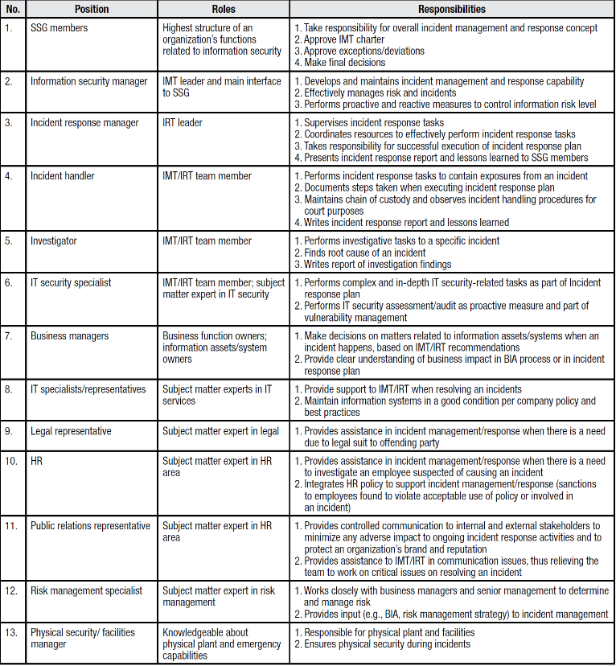

**Note:** each position has an alternate in case designee is incapacitated or unavailable.

#### 4.4.5 Skills

**Personal skills**

•**Communication:**

-Communicate with: •Team members •IT staff •Application owners •Users of systems •Technical experts •Management and other admin. Staff •Human resources • Law enforcement •Media/public relations staff •Vendors

-Communication forms: •Email responses concerning incidents •Documentation of event or incident reports, vulnerabilities, other technical information •Notifications and/or guidelines to constituency •Internal development policies and procedures •Other external communications to staff, management or other relevant parties

•**Leadership skills**: Directing and get support of other members of the organization.

•**Presentation skills**: Technical presentations, management or sponsor briefings, panel discussion at a conference, other form of public speaking engagement, expert testimony in legal or other proceedings on behalf of the team or users.

•**Ability to follow policies and procedures**.

•**Team skills**: Work in team environment, as productive and cordial team players; be aware of responsibilities; contribute to goals of team; and work together to share information, workload and experiences. Be flexible and willing to adapt to change.

•**Integrity**: Be trustworthy, discreet and able to handle information in confidence.

•**Self-understanding**: Recognize their limitations and actively seek support from their team members, other experts or management.

•**Coping with stress**: Recognize when becoming stressed, willing to make team aware of the situation, and take the necessary steps to control and maintain their composure.

•**Problem solving**: Include ability to think outside the box or look at issues from multiple perspectives to identify relevant information or data. This includes knowing who else to contact or approach for additional information, creative ideas or added technical insight.

•**Time management**: Multitude of tasks: analyzing, coordinating and responding to incidents; duties such as prioritizing their workload, attending and/or preparing for meetings, completing time sheets, collecting statistics, conducting research, giving briefings and presentations, traveling to conferences, providing onsite technical support, and prioritizing tasks. Team members must be able to balance efforts between completing the tasks and recognizing when to seek help or guidance.

**Technical skills** Two types:

•**Technical foundation skills**: require basic understanding of underlying technologies.

•**Incident-handling skills**: require understanding of techniques, decision points and supporting tools (software or applications) required in daily activities.

#### 4.4.6 Awareness & Education

Lack of user awareness causes security breaches. Ensure ongoing awareness campaign to reduce risk of a security breach (e.g., phishing attacks, malicious web sites). Assess skills to determine whether required expertise available. Relevant training or education. Develop relationships with experts in the field to provide necessary skills.

#### 4.4.7 Audits

Internal and external audits verify compliance with policies, standards and procedures. Internal audits usually intended to support compliance requirements or improve risk and incident management. External audits part of mandatory requirements. Both types of audits can be useful in reviewing incident management and response plans and capabilities. Periodic audits of the processes and procedures provide validation that security will not be compromised in the event of an incident and policy compliance and legal requirements are addressed appropriately. Audits also provide an objective view of the overall completeness and functionality of incident management & response plans. Provide assurance that major gaps in the processes do not exist.

#### 4.4.8 Outsourced Security Providers

Outsourcing incident management capability can be a cost-effective option (see 3.11.9 Outsourcing and Service Providers). May benefit from close integration if outsourced to same vendor. Still require IRP overseen by IRT. Understand outsourcer’s capabilities, response times. Develop SLAs with appropriate indemnity clauses. **Considerations**:

•**Match organization’s incident reference numbers with vendor’s for each incident**: Ensure common understanding of incident details. Helps identify actual recovery time. (e.g. vendor reports service restored at 4:00 p.m.; however, organization notice incident ended at 6:00 p.m. ⇨ Organization took an additional 2 hours to recover internally.

•**Integrate organization’s change management functions with vendor’s:** Link change management functions via leaders on change advisory board. Or have a platform where the security group can view vendor’s changes and follow-up with key points of contact.

•**Require vendor to periodically review incidents that occur regularly (e.g., monthly**, **annually**): Operational leadership from organization and vendor attend these meetings to review incidents/events. Follow-up items to help prevent incidents from recurring.

### 4.5 INCIDENT MANAGEMENT OBJECTIVES

Incident management serves as *next-to-last safety net* after controls failed. Its purpose: respond to/ contain security incidents or restore normal. Failing to do so results in the declaration of a disaster. Recovery operations will move to an alternate site to restore operations according to a BCP/DRP. **Objectives of incident management**:

•Handle incidents so exposure can be contained or eradicated to enable recovery within **recovery time objectives (RTOs)**

•Restore systems to normal operations

•Prevent incidents from recurring by documenting and learning from past incidents

•Deploy proactive countermeasures to prevent/minimize probability of incidents

Incident management & response needs have *monitoring capabilities for key controls*. Personnel should be trained in *assessing the situation*, *providing triage*, and *managing effective responses* that maximize operational continuity and minimize impacts. *Capture relevant information*. Apply previously *learned lessons*. Be prepared for a disaster through criteria, experience, knowledge, and authority to invoke the *disaster recovery processes*.

#### 4.5.1 Strategic Alignment

Components for alignment:

•**Constituency**: To whom does the IMT provide services? Know the stakeholders. Identify their expectations and information needs. Meet performance and reporting requirements.

•**Mission**: Defines purpose of team, primary objectives and goals. Example of IMT mission: “*The mission of the incident management team is to develop, maintain and deliver incident management capabilities and services to safeguard the organization’s information assets against computer incidents. We strive to provide assurance to our stakeholders that risk and cyber- or IT-related incidents are dealt with in an efficient and effective manner and that we will prevent/minimize losses resulting from such incidents*.”

•**Services**: Services be clearly defined to manage stakeholder expectations. Services correlate with the size of the organization and the extent of senior management buy-in.

•**Organizational structure**: The structure of IMT should support organization’s structure. For multinational companies: geography-based structure. For organizations with multiple subsidiaries: one IMT for each major subsidiary. Best structure provides maximum availability of IMT services on the most cost-effective basis.

•**Resources**: Sufficient staffing can be solved by establishing virtual team members and/or complement the team with external resources.

•**Funding**: for highly specialized members and equipment.

•**Management buy-in**: Lack of buy-in results in suboptimal IMT performance because there may be significant limitation in budgets or the availability of suitable personnel.

#### 4.5.2 Risk Management

Successful outcomes of risk management include: effective incident management and response capabilities. Any risk that is not prevented by internal controls constitutes an incident that must be managed and responded to so not escalated into a disaster.

#### 4.5.3 Assurance Process Integration

Ensure incident management & recovery plans incorporate and integrate functions (physical security, HR and legal) where required. Set of plans to define which departments are involved in which incident management and response activities. Linkages be tested under realistic conditions.

#### 4.5.4 Value Delivery

To deliver value, incident management should:

•Integrate with business processes and structures as seamlessly as possible

•Improve capability of businesses to manage risk and provide assurance to stakeholders

•Integrate with BCP

•Be part of org. strategy & effort to protect, secure critical business function and assets

•Provide backstop. Optimize risk management efforts

#### 4.5.5 Resource Management

Resource management (time, people, budget, etc.) to achieve objectives efficiently under given resource constraints. Manage resources for incident management & response activities by: **oversight**, **monitoring** and **regular reporting**. Address the most important priorities first ⇨ **triage capabilities** ensure limited resources are applied most effectively to contain and limit damage. Identify assets: too compromised to address quickly, unaffected and can wait, can be restored with available resources.

### 4.6 IM METRICS AND INDICATORS

**Incident management metrics**, **measures** & **indicators**: criteria to measure effectiveness and efficiency of incident management function. Metrics based on **key performance indicators (KPIs)** and **program goals (KGIs)** are presented to senior management as a *basis of justification* for *continuous support and funding*. Enables senior management to understand the *incident management capability* and *areas of risk* to be addressed.

**KPIs** = quantifiable activity measure (e.g., number of incidents per year resolved within 2 minutes of occurrence). **KGIs** = quantitative or qualitative, to show progress toward predefined goal. Example: Business goal for the year: 1,000 incidents resolved within 2 minutes of incident occurrence. Current KPI = 100 incidents resolved in target time frame ⇨ current KGI = 10% (100 incidents resolved out of 1,000 target incidents).

**Common criteria for incident management metrics**:

•Total # reported incidents •Total # detected incidents •# days without incident •Average time to respond to incident relative to RTO •Average time to resolve incident •Total # incidents successfully resolved •Incidents not resolved successfully •Proactive & preventive measures taken •Total # employees receiving security awareness training •Total damage from reported & detected incidents if incident response not effective or performed •Total savings from potential damages from incidents resolved •Total labor responding to incidents •Detection and notification times

#### 4.6.1 Performance Measurement

Performance measurements for incident management & response: focus on achieving objectives and optimizing cost-effectiveness. KGIs and KPIs be defined and agreed on by stakeholders and ratified by senior management. Typical range of KGIs encompasses successful handling of incidents whether by live testing or under actual conditions. Key performance measures can be identified by successfully handling incidents that threaten business operations within the RTOs.

### 4.7 INCIDENT MANAGEMENT PROCEDURES

There is no single, fixed, one-size-fits-all set of incident management procedures for every organization. However, there are a number of good practices that most organizations adopt and customize to meet their own specific needs. Commonly adopted approaches are available from CMU SEI and the SANS Institute, among others.

#### 4.7.1 IM Detailed Plan of Action

**Incident management action plan** aka IRR.

###### Figure 4.3 CMU/SEI’s Incident Management Processes

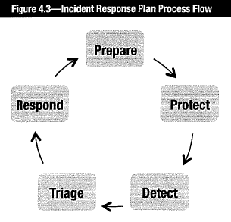

•**Prepare/improve/sustain (prepare)**: Preparation work to complete prior any capability to respond to incidents. Contains subprocesses to evaluate incident-handling capability and postmortem review of incidents for improvements:

-**Coordinate planning and design**:

•Identify incident management requirements •Establish vision and mission •Obtain funding and sponsorship •Develop implementation plan.

-**Coordinate implementation**:

•Develop policies, processes and plans •Establish incident-handling criteria Implement defined resources •Evaluate incident management capability •Conduct postmortem review •Determine incident management process changes •Implement incident management process changes.

•**Protect infrastructure (protect)**: Aims to protect & secure critical data, computing infrastructure and its constituency. Also proposes improvement on a predetermined schedule, while considering security context. Subprocesses include:

-**Implement changes** to infrastructure to mitigate ongoing or potential incident.

-**Implement infrastructure protection improvements** from postmortem reviews.

-**Evaluate computing infrastructure** with proactive security assessment & evaluation.

-**Provide input to detect** incidents/potential incidents.

•**Detect events (detect)**: Identifies unusual/suspicious activity that might compromise business functions or infrastructure. Subprocesses include:

-**Proactive detection**: Conduct detection regularly. Monitor info from online/periodic vulnerability scanning, network monitoring, antivirus & personal firewall alerts, commercial vulnerability alert services, risk analysis, and security audit/assessment.

-**Reactive detection**: Conduct detection upon reports from users or other orgs.

Users may notice unusual or suspicious activity. Other organizations may advise when their system received malicious activity from you. Set up multiple communication channels from end users to the IMT: phone calls, faxes, email messages, webform reporting and automated intrusion detection systems (IDSs).

•**Triage events (triage)**: Sort, categorize, correlate, prioritize and assign incoming reports/events into 3 categories: ➊problems cannot be readily resolved ➋those can wait and ➌those can be efficiently addressed ⇨ Ensure maximum effectiveness of limited resources. Can serve as a single point of entry for IMT communication & information.

- Triage prioritization at 2 levels:

•**Tactical**: Based on a set of criteria

•**Strategic**: Based on the impact of business

-Subprocesses include:

•**Categorization**: Use predetermined criteria to classify all incoming reports/events. Example: (*NIST Special Publication 800-61 Revision 2 Computer Security Incident Handling Guide*): -DoS -Malicious code -Unauthorized access -Inappropriate usage

-Multiple components

•**Correlation**: Correlates report/event with other information. Higher correlation provides more information useful for appropriate response.

•**Prioritization**: Incidents prioritized based on potential impact. Remediation efforts start with highest priority and then move down to lowest priority.

•**Assignment**: Assignment may be based on: -Workload -Experience with similar incidents -Category or priority of the event -Relevant business unit

•**Respond**: Steps to address, resolve or mitigate. CMU SEI’s 3 types of response activities:

➊**Technical response**: Technical response forms include the following:

•Collect data for further analysis •Analyze incident-supporting information such as log files •Research corresponding technical mitigation strategies & recovery options •Consult telephone or email technical assistance •Secure onsite assistance •Analyze logs •Develop and deploy patches and workarounds

➋**Management response**: Activities require supervisory or management intervention, notification, interaction, escalation or approval. Executed by business managers, senior management and members of the affected business units.

➌**Legal response**: Associated with activity related to investigation, prosecution, liability, copyright and privacy issues, laws, regulations, and nondisclosure agreements. Usually referred to the corporate legal team.

###### Figure 4.4. Detailed flow diagram of the incident management process.

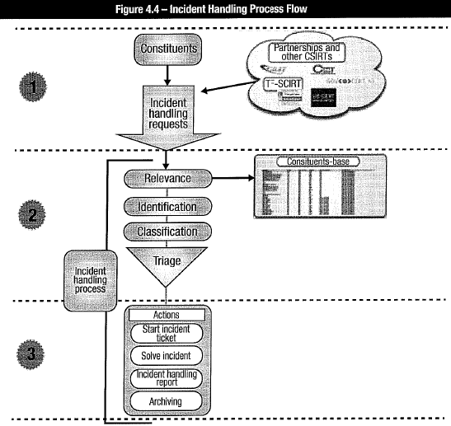

### 4.8 CURRENT STATE OF IR CAPABILITY

Identify what is already in place to understand the current state. Approaches:

•**Survey senior management, business managers and IT representatives:** Employ surveys and focus groups to gather information on past performance and perception.

•**Self-assessment:** Conducted by IMT against set of criteria. Easiest method but provide a limited view on current capability and aspects that stakeholders may consider important.

**•External assessment or audit:** Most comprehensive option. Combines interviews, surveys, simulation and other assessment techniques. Normally used for organization with adequate incident management capability but is improving or reengineering processes.

#### 4.8.1 History of Incidents

Past incidents (both internal and external) can provide valuable information on trends, types of events and business impacts. This information is used as an input to the assessment of the types of incidents that must be planned for and considered. A sample of historical information maintained associated with an incident is shown in figure 4.5.

#### 4.8.2 Threats

•**Environmental**: Include natural disasters. May occur for prolonged periods or annually. Some rare enough and impractical to address effectively so are disregarded (e.g., comet strike) or addressed with business interruption insurance.

•**Technical**: Include: fire; electrical failure; heating, ventilating and air conditioning (HVAC) failure; information system and software issues; telecommunication failure; and gas/water leakage. Most can be managed adequately. Exceptions: APTs and zero-day attacks.

•**Man-made**: Include damage by disgruntled employees, corporate sabotage/espionage, political instability. Some easy to identify; some (espionage, embezzlement) more difficult.

#### 4.8.3 Vulnerabilities

**Vulnerability** = weakness in system, technology, process, people or control that can be exploited and result in compromise. Can be exploited by **threats** results in **risk**. *Risk management* manages vulnerabilities to maintain risk within acceptable limits as determined by risk appetite and tolerance. **Vulnerability management**: part of incident management capability - proactive identification, monitoring and repair weaknesses.

###### Figure 4.5 Sample historical information on security incidents

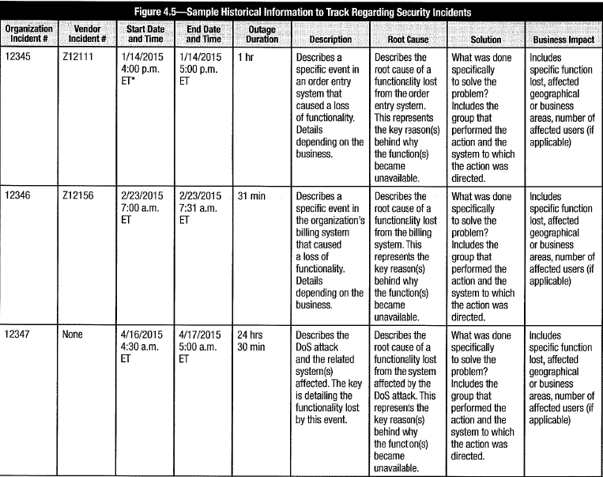

### 4.9 DEVELOP INCIDENT RESPONSE PLAN (IRP)

IRP = operational component of incident management. Details actions, personnel and activities if adverse events result in loss of information systems or processes. Include formation, management and maintenance of the IRT.

#### 4.9.1 Elements of Incident Response Plan

Six-phase model of incident response: preparation, identification, containment, eradication, restoration and follow up:

➊**Preparation**: Prepares to develop an IRP. Activities in this phase include:

-Establish approach to handle incidents

-Establish policy and warning banners to deter intruders and allow info collection

-Establish communication plan to stakeholders

-Develop criteria on when to report an incident to authorities

-Develop process to activate the IMT

-Establish secure location to execute the IRP

-Ensure equipment needed is available

➋**Identification**: Verily if incident happened. Find out more details about it. Reports on incidents may come from information systems, end users or other organizations. Not all reports are valid incidents (may be false alarms or not qualify as incident). Activities:

-Assign ownership of incident/potential incident to incident handler

-Verify that reports or events qualify as an incident

-Establish chain of custody during identification when handling potential evidence

-Determine severity of an incident and escalating it as necessary

➌**Containment**: After incident identified and confirmed, activate IMT, and share information. Conduct detailed assessment. Contact system owner or business manager of affected info systems/assets to coordinate. Action: limit the exposure. Activities:

-Activate IMT/IRT to contain the incident

-Notify appropriate stakeholders affected by the incident

-Reach agreement on actions (may affect service availability/ risk containment process)

-Involve IT and virtual team members to implement containment procedures

-Obtain and preserve evidence

-Document and take backups of actions from this phase onward

-Control and manage communication to the public by the PR team

➍**Eradication**: Once containment measures deployed, determine root cause of incident and eradicate. Eradication by: restoring backups to achieve clean state of system, removing root cause, improving defenses, performing vulnerability analysis to find further potential damage from the same root cause. Activities:

-Determine signs and cause of incidents

-Locate most recent version of backups or alternative solutions

-Remove root cause. Worm or virus? Deploy patches/ updated antivirus software.

-Improve defenses by implementing protection techniques

-Perform vulnerability analysis to find new vulnerabilities from root cause

➎**Recovery**: Ensure systems/ services restored to condition specified in **service delivery objectives (SDO)** or **BCP**. **RTO** documents time constraint. Activities:

-Restore operations as defined in the SDO

-Validate actions taken on restored systems were successful

-Get involvement of system owners to test the system

-Facilitate system owners to declare normal operation

➏**Lessons learned**: At the end of incident response process, develop report to share what has happened, what measures were taken and results of executed plan. Contain lessons learned of what could have been done better. Develop lessons into plan to enhance incident management capability and IRP documentation. Activities:

-Write incident report

-Analyze issues encountered during incident response efforts

-Propose improvement based on issues encountered

-Present report to relevant stakeholders

#### 4.9.2 Gap Analysis Basis for IR Plan

**Gap analysis** provides information on gap between current and desired level of incident response capabilities. Identify improvements in capabilities, skills and technology:

•**Processe**s that need to be improved to be more efficient and effective

•**Resources** needed to achieve the objectives for the incident response capability

Gap analysis report can be used for planning: determine steps to resolve gap. Determine strategy to achieve objectives and prioritize efforts. Priorities be based on areas of greatest potential impact and best cost benefit.

#### 4.9.3 Business Impact Analysis (BIA)

Next step in incident response (after identifying possible events): consider potential impact of each incident type (cannot plan or prioritize response if no idea of likely impacts of incident scenarios). Analyze potential incidents and business impacts by conducting **BIA**: *systematic activity to assess impact of disruption or total loss of support of critical information resource (system, network device, application, personnel and/or data)*.

BIA outcomes:

•Determine loss to organization resulting from function being unavailable

•Establish escalation of that loss over time

•Identify minimum resources needed for recovery

•Prioritize recovery of processes and supporting systems

BIA purposes: create report to help stakeholders understand what impact an incident could have on business. Impact may be in the form of *qualitative (rating)* or *quantitative (monetary)* value. Must understand: structure and culture of organization, key business processes, acceptable risk and risk tolerance, and critical IT and physical resources. Requires: business process owners, senior management, IT, physical security, end users.

BIAs three primary goals:

➊**Criticality prioritization**: Identify and prioritize every critical business unit process. Evaluate incident impact: the higher the impact, the higher the priority.

➋**Downtime estimation**: Estimate **maximum tolerable downtime (MTD)** or **maximum tolerable outage (MTO)** or **allowable interruption window** (**AIW**) = longest period of unavailability of critical processes before company ceases to operate.,

➌**Resource requirement**: Identify resource requirements for critical processes. Most time sensitive and highest-impact processes: highest priority for resource allocation.

Assessment activities:

•**Gather assessment material**: Initial BIA step: identify which business units are critical. Drill down to critical tasks to be performed and resources for business survival.

•**Analyze information compiled**: Several activities: document required processes and resources, identify interdependencies, and determine acceptable period of interruption. Tasks in this phase include:

-**Identify interdependencies** among critical or high-impact functions/departments

-**Discover possible disruptions** that could affect departments‘ functions.

-**Identify, document potential threats** that disrupt interdepartmental communication.

-**Gather quantitative and qualitative information** pertaining to those threats.

-**Provide alternative methods of restoring** functionality and communication.

-**Provide brief statement of rationale for each threat** and corresponding info.

•**Document result and present recommendations**: Document assessment results from previous activities. Create a report for business units and senior management.

Alternative view of BIA: Exercise to identify most important resources and impact resulting from disruption or availability loss. Result in understanding of organization process flows to optimize recovery priorities based on system dependencies and interdependencies. Facilitates understanding of potential loss (and other unwanted effects) that could occur from certain types of events. **Potential loss** includes *direct financial loss* and intangible types of loss (reputational damage, failure to achieve regulatory compliance).

Common problem: failure to update BIAs when systems/ business functions are added or changed. *BIA part of and related to risk assessment* (qualitative and quantitative risk assessment): degree of risk exposure correlates to potential for event that causes an impact. BIA also used to determine consequences of compromise, whereas the risk determination calculates the probability of compromise.

##### Elements of a Business Impact Analysis

•Describe the business mission of each particular business/cost center

•Identify the functions that characterize each business function

•Determine dependencies such as required inputs from other operations

•Determine subsequent operations dependent on the function

•Identify critical processing cycles (in terms of time intervals) for each function

•Estimate the impact of each type of incident on business operations

•Determine **required recovery time (i.e., RTO)**

•Identify resources and activities required to restore an acceptable level of operation

•Determine amount of data that can be lost and must be re-created to determine **RPOs**

•Determine work-around possibilities (manual/PC-based operation, workload shifting)

•Estimate time to recover from each type of incident (and required dependencies) in relation to RTO. If estimated time > RTO, additional resources may be needed.

Information from the organization’s functional units in BIA:

•**Function description**: What is the function of the business unit?

•**Dependencies**: What is dependent upon this function? What has to happen or needs to be available before the function can be performed?

•**Impact profile**: Any specific time, day, week or month that the function would be more vulnerable to risk/exposure? Or impact to business greater if function not performed?

•**Operational impacts**: When operational impact be realized if function not performed?

•**Financial impacts**: When financial impact be realized if function not performed?

•**Work backlog**: At what point will the backlog of work start to impact the business?

•**Recovery resources**: What resources needed to support the function? How many are needed? How soon are they needed after a disruption (e.g., phones, desks, PCs)?

•**Technology resources**: What software and applications are needed?

•**Stand-alone PCs or workstations**: Does function require stand-alone PC/ workstation?

•**Local area networks (LANs)**: Does function require access to the LAN?

•**Workaround procedures:** Any manual workaround procedures if IT unavailable? If so, how long could these workarounds be used to continue the function?

•**Work-at-home**: Can the function be performed from home?

•**Workload shifting**: Can shift workloads to another part of the business?

•**Business records:** Any required business records? Are they backed up? How? Frequency?

•**Regulatory reporting**: Are regulatory documents created as a result of the function?

•**Work inflows:** What input (internal or external) is needed to perform the function?

•**Work outflows:** Where does output go after it leaves functional area? Who would be impacted if the function were not performed?

•**Business disruption experience:** Any past disruption of the function? (If so, describe)

•**Competitive analysis:** Any competitive impact if the function were not performed? If so, when would the impact occur and when would a potential loss of the customer occur?

•**Other issues and concerns:** Other issues/concerns relevant to success of function?

##### Benefits of Conducting a Business Impact Analysis

•Increase understanding of potential loss and other undesirable effects.

•Prioritize restoration activities and understanding recovery options

•Understand dependencies of various functions and their interdependencies

•Raise level of awareness for response management within an organization

#### 4.9.4 IM Escalation Process

**Escalation process** establishes events to manage. Routine events can be related to security compromise and constitute *incident*. Is part of *emergency management* and *incident management policies & procedures*. Describe escalation process, who can authorize recovery actions or disaster declaration. For each event: list actions in the sequence to be performed; identity corresponding responsible person and alternates; estimated time for execution. Document “***end of emergency***” (when all actions completed successfully). Any action cannot be executed? Estimated time is reached? continue next action. If the accumulated elapsed time (caused by unsuccessful actions) reaches predetermined limit, change emergency status to alert condition (i.e., low, medium, high ). **Alert situation** prompts notification to: •Senior management •Response & recovery teams •HR •Insurance • Backup facilities •Vendors •Customers.

Once emergency resolved or last alert has occurred, emergency team meets to *evaluate damages and mitigation alternatives*, *decide whether to declare disaster* or *launch response and recovery plan*, and *determine the appropriate strategy*. Infosec develops a **communication plan** in consultation with PR, legal counsel and senior management to ensure appropriateness of any information disclosures.

After the escalation process: notify personnel, activate backup facilities, contain security threats to info resources, make transportation arrangements and carry them out, retrieve and unload data, and test. Total elapsed time be in accordance with RTO (see chapter 2).

**Escalation process** includes: prioritize event information and decision process to determine when to alert various groups (senior management, public, shareholders, stakeholders, legal counsel, HR staff, vendors, and customers). Infosec develops escalation processes and decision authority through consultation with PR, legal counsel and senior management. This process should also include vendors and utility services.

**Level of events** can be based on severity, number of affected organizations, and their specific need to be notified.

Infosec to have **mechanisms to communicate crisis** or event information: email, cellular phones, fax machines, electronic pagers, web sites or an emergency telephone number at which a message can be placed. Some types of communication (e.g., emails) are by default in cleartext, making them subject to potential interception. Infosec to develop methods to encrypt email and other communications to ensure that information is released only as prudent or according to plans.

#### 4.9.5 Service Desk Processes to Identify Security Incidents

Processes be defined for help/service desk personnel to distinguish a typical request from a possible security incident. Help/service desk likely to receive first reports of security-related problem. *Prompt recognition* of incident in progress and *quick referral* to appropriate parties critical to minimize damage. Define *appropriate criteria* and improve awareness of help/service desk personnel. Proper training also helps to reduce the risk that help/service desk is targeted in a social engineering attack. In addition to identifying a possible security incident, help/service desk personnel should be aware of proper procedures to report and escalate a potential issue.

#### 4.9.6 Incident Management & Response Teams

Key decision-making, technical and end-user personnel to lead teams need be designated and trained. Develop matrix to indicate correlations among functions of different teams. Examples of the kinds of teams usually needed include:

•**Emergency action team**: First responders to deal with fires/other emergency scenarios

•**Damage assessment team**: Qualified individuals to assess extent of damage. Make initial determination regarding what is complete loss/ what is restorable or salvageable

•**Emergency management team**: Responsible for coordinating activities of all recovery teams and handling key decision making

•**Relocation team**: Responsible for coordinating the process of moving from the affected location to an alternate site or to the restored original location

•**Security team**: aka **computer security incident response team (CSIRT)** responsible for monitoring security of systems & communication links; containing ongoing security threats, resolving security issues that impede expeditious recovery of the system(s), and assuring proper installation and functioning of every security software package.

Key decisions in planning, implementation & evaluation of response & recovery plan:

•Goals/requirements/products for each phase •KGIs and KPIs •Reporting criteria •Critical success factors & critical path aspects of implementation •Alternate facilities •Critical information resources to deploy (e.g., data and systems) •Decision authority & persons responsible for completion •Available resources (financial, personnel and technical) to aid in deployment •Scheduling of activities with established priorities

#### 4.9.7 Organize, Train, Equip Response Staff

Develop event scenarios. Test response and recovery plans to ensure teams familiar with tasks and responsibilities. Teams also identify resources for response & recovery. Detect and modify ambiguous procedures. Determine recovery resources that may not be adequate or effective. Training program:

•**Induction to IMT**: Provide essential information to be an effective IMT member.

•**Mentoring team members** regarding roles, responsibilities and procedures. Use buddy system to pair new members with experienced members.

•**On-the-job training**: Provide an understanding of company policies, standards, procedures, available tools and applications, acceptable code of conduct, etc.

•**Formal training**: To attain adequate level of competence necessary to support the overall incident management capability.

#### 4.9.8 Incident Notification Process

Notification mechanisms that enable an automated detection system or monitor to send email or phone messages should be used whenever possible.

Functions that be informed on incident occurrence: •Risk management •HR (when security compromise involve insiders) •Legal •PR •Network operations •Physical and infosec •Business process owners •Senior management

Notification activities effective only if knowledgeable personnel understand their responsibilities and perform them in an efficient and timely manner. Infosec needs to define responsibilities and communicate them to key personnel. Work with HR to determine how these responsibilities can be documented in employees’ job descriptions.

#### 4.9.9 Challenges with Developing IM Plan

Challenges in developing and maintaining an incident management plan:

•**Lack of management buy-in and organizational consensus**: When incident occurs, management response may not be provided as expected. This happens when senior management and other stakeholders/ constituents not involved in incident management planning and implementation. Challenges also caused by lack of regular meetings between IMT and constituents. Sense of ownership among constituents in incident management helps ensure sufficient resources and support are available.

•**Mismatch to organizational goals and structure**: Incident management may not be able to cope with speed or nature of changes within organization.

•**IMT member turnover**: The champion of incident management, who is normally either a member of senior management or the infosec manager, may leave unexpectedly, causing any planning or development efforts to come to a halt. The lack of a champion is likely to reduce the focus and resources devoted to implementing the plan.

•**Lack of communication process**: Ineffective communication processes may result either in under communication or overcommunication. Under communication: relevant stakeholders not receive information they need ⇨ different understandings about need for incident management planning; benefits that can be obtained; or role in developing, implementing and maintaining an incident management capability. Overcommunication: turn stakeholders against incident management because they may feel that the plan is too much to handle or it competes with priorities they have established.

•**Complex and broad plan**: Proposed plan may be good and cover many issues, but too complex, too broad. Constituents not prepared to participate and commit to plans.

### 4.10 BC & DR PROCEDURES

Considerations when develop response & recovery plans: available resources; expected services; types, kinds & severity of threats, state of monitoring &detection capabilities, level of risk willing (section 1.2.2 Determining Risk Capacity and Acceptable Risk). Effective strategy for recovery plans = cost-effective balance among risk management, incident management & response, and business continuity/disaster recovery planning.

**Business continuity** (COBIT 5): “*prevent, mitigate and recover from disruption. The terms ‘business resumption planning,’ ‘disaster recovery planning’ and ‘contingency planning’ also may be used in this context; they focus on recovery aspects of continuity*.”

Relationship (BC, DR): DRP subset of BCR. **BCP** goals include *incident prevention* & *mitigation*. **DRP** focus on restore operations after incident already taken place. **BCP** = *continuous process actively implemented in business-as-usual scenarios*. **DRP** = reactive and implemented only upon specific set of conditions (i.e., incident).

#### 4.10.1 Recovery Plan & Business Recovery Processes

**Disaster recovery** = Recovery of IT systems after disruptive events that cause major system failures, such as hurricanes and floods resulting in inaccessibility or prolonged power or communication outages. **Business recovery** = Recovery of all critical business processes to continue/ resume operations. Business recovery includes disaster recovery and all other required operational aspects. **Planning** includes documenting requirements for declaring a disaster. Not all events, incidents or disruptions are security incidents.

Main phases of planning processes:

•Conduct risk assessment and BIA

•Define response and recovery strategy

•Document response and recovery plans

•Training that covers response and recovery procedures

•Update response and recovery plans

•Test response and recovery plans

•Audit response and recovery plans

Prior to detailed BCP, perform BIAs to determine *incremental daily cost* of losing systems. This is basis for appropriate RTOs and associated costs. This in turn, affects location, cost of offsite recovery facilities and composition & mission of response & recovery teams.

#### 4.10.2 Recovery Operations

**Monitor restoration progress at primary site**: Once *recovery mode* is up (from disaster recovery site). Assess when safe to return. Evaluate whether primary data center and facilities accessible, operational, and capable of functioning at normal capacities/ load.

**Relocating teams:** On complete restoration of primary facility, update business continuity leader, who will then declare normalcy in consultation with the crisis management team and migrate operations back to the primary site.

Primary site completely destroyed or severely damaged? Strategic decision: transform alternate recovery site to primary operations site or identify, acquire, set up another site.

**BCP to address**: processes, roles & responsibilities to identify incident, declare disaster, manage operations in disaster mode, restore operations at primary site, announce return to normalcy. During *strategy phase*, identify *cold site* to be upgraded to primary operating facility in the event that the incident renders the primary facility useless.

**Infosec** is incorporated into all response and recovery plans (information resources must still be protected). Ensure that plan execution does not compromise infosec standards and requirements or mitigation options be explored.

Disaster recovery site be **restored to** state of readiness after operations reinstated at primary facility. Lessons learned and gaps identified be recorded and recommendations be implemented to enhance plan effectiveness of the plan. Plan to cover all aspects of reestablishing operations at primary site: people, facilities and technology areas.

#### 4.10.3 Recovery Strategies

**Total cost of a recovery capability** = Cost to prepare for possible disruptions (e.g., purchase, maintain and regularly test redundant computers, maintain alternate network routing, training & personnel costs) 🞦 Cost to put these into effect in event of incident.

**Mitigate impacts of disruptions** with business interruption insurance.

**Development** of incident management & response plan difficult, expensive, takes time, may require several alternative strategies, may need outsourcing and associated cost.

#### 4.10.4 Addressing Threats

Strategies to address threats as part of incident management:

•**Eliminate or Neutralize threat**: Unrealistic when threat external. Possible if threat internal and specific.

•**Minimize likelihood of threat’s occurrence:** Reduce or eliminate vulnerabilities or exposure. Implement appropriate set of physical, environmental and/or security controls. Example: firewalls, IDSs, Authentication. Reduce exposure by compartmentalization, such as network segmentation.

•**Minimize effects of threat**: Effective incident management and response, insurance, redundant systems with automatic failover, or other compensating or corrective controls.

**Restore operations in the event of disruption**. Alternative strategies (incident management & response capability and disaster recovery perspective): Redundant and mirrored systems to ensure high degree of system or process resilience and robustness.

#### 4.10.5 Recovery Sites

Basis: probability of major outages occurring, nature and extent of impact on ability to continue operations, and overall cost. Types of offsite backup facilities to consider:

•**Hot sites**: Configured fully and ready to operate within *several hours*. Equipment, network and systems software *compatible* with primary installation. Additional needs are staff, programs, data files and documentation.

•**Warm sites**: Complete infrastructures, but partially configured in terms of IT (network connections + essential peripheral equipment such as disk drives, tape drives and controllers. Sometimes equipped with less powerful central processing unit (CPU).

•**Cold sites**: Viable when can afford relatively long downtime. Only basic environment (electrical wiring, air conditioning, flooring, etc.) to operate **information processing facility (IPF)**. Ready to receive equipment but no component at the site in advance. Activation takes several weeks. Options for equipping a cold site:

-**Vendor or third party**: Hardware vendors usually best source for replacement equipment. Involve waiting period. Used best when plan to move from hot site to warm or cold site. Advance planning is critical.

-**Off-the-shelf**: Conditions: •Avoid unusual and hard-to-get equipment •Regularly update equipment to keep current •Maintain SW compatibility on newer equipment

•**Mobile sites**: Specially designed trailers to be quickly transported to alternate site to provide ready-conditioned IPF. Can be attached to form larger work areas. Can be preconfigured with servers, desktop computers, communications equipment, and microwave and satellite data links. Useful when no recovery facilities in immediate geographic area; widespread disaster; cost-effective alternative for duplicate IPFs.

•**Duplicate sites**: Dedicated recovery sites. Functionally similar/identical to primary site. Standby hot site or facilities available through reciprocal agreement. Large organizations with multiple data facilities can develop failover capabilities among own geographically dispersed data centers provided:

-Chosen site not subject to same disaster event.

-Coordination of HW/SW strategies. Degree of HW/SW compatibility must exist.

-Resource availability assured. Workloads monitored for sufficient availability.

-Agreement on priority to add workloads until recovery resources fully used.

-Regular testing.

•**Mirror sites**: If require continuous uptime and availability. Mirror site similar or identical to primary site. Operational in concert with primary site on load-sharing basis. Applications launched by automatic scheduler that balances loads between sites. Applications seamlessly switched between sites without interruption.

•**Reciprocal agreements**: (now seldom used.) Participants promise to provide computing time and network operations to each other when an emergency arises. Essential that similar equipment and applications are available. However: IT resources generally approaches maximum capacity (cannot support recovery operations). Consider cost of personnel at alternate facility, extra expenses to integrate external personnel into operations, additional threats to physical security.

-Additionally: difficult to create contract with adequate protection; cost of dealing with changes over time. Contractual provisions to cover: configuration of 3rd party HW/SW, speed of availability, reliability, duration of usage, nature of inter-site communications, and period of usage.

Part of the recovery of IT facilities involves telecommunications:

•Alternative routing •Diverse routing •Long-haul network diversity •Protection of local resources •Voice recovery •Availability of appropriate circuits & adequate bandwidth •Availability of out-of-band communications when failure of primary communication.

Strategies for entire period of recovery until all facilities are restored:

•Doing nothing until recovery facilities are ready

•Using manual procedures

•Focus on most important customers, suppliers, products, systems, etc.

•Use PC-based systems to capture data for later processing. Perform local processing

#### 4.10.6 Basis for Recovery Site Selections

Considerations to select type of sites:

•**AIW (allowable interruption window)**: Total time normal operations can wait from point of failure to services restoration. After this, cumulative losses may threaten existence of organization.

•**MTO (maximum tolerable outage)** or **MAD (maximum allowable downtime)**: Total downtime in recovery site without causing significant harm to the organization's mission. Various factors including increasing backlogs of deferred processing. Affected by SDO.

•**RTO (recovery time objective)**: Length of time from interruption to time process to function at service level sufficient to limit financial and operational impacts (from point of failure to technical recovery, or point of disaster declaration to full operations).

•**RPO (recovery point objective)**: Age of data to restore (i.e., data amount can be lost to be recreated). Point of last known good data. Start point for operations at recovery site. Infrequent full backups may result RTO not met (take too much time to re-create).

•**SDO (service delivery objective)**: Level of services (functionalities) during alternate process mode until normal situation restored. Directly related to business needs.

•**Proximity factors**: Distance from hazards (e.g., flooding risk from nearby waterways, hazardous material manufacturing or storage) posing risk to operation of recovery site

•**Location**: Sufficient distance to min. likelihood of both primary and recovery facilities being subject to same occurrence of an environmental event.

•**Nature of probable disruptions**: To consider in terms of MTO. MTO in area subject to disruption must be greater than probable duration of such event.

**Relationships**: **RTO <= MTO <= AIW**

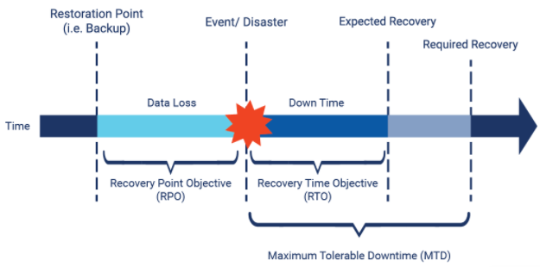

#### 4.10.7 Implement Response & Recovery Strategy

Factors to consider while developing response & recovery plan:

•Pre-incident readiness •Evacuation procedures •Flow to declare a disaster •Transition steps to disaster recovery if incident response fails •Identification of business processes & IT resources to recover •Identification of individuals with authority & responsibilities of the plan •Identification of people (and alternates) responsible for each function in plan •Identification of contact information •Step-by-step explanation of recovery options •Identification of various resources required for recovery and continued operations •Consideration for other logistics (personnel relocation, temporary housing)

Document response & recovery plan in simple language. Identify teams of personnel responsible for specific tasks in case of incidents or disasters. Create BCPs as set of procedures to accommodate system, user and network recovery strategies. Keep copies of plan offsite (at recovery facility, media storage facility and homes of key decision-makers).

#### 4.10.8 Response & Recovery Plan

Elements of Issue Response & Recovery Plan (IRP):

•Mission •Strategies & goals •Senior management approval •Organizational approach to incident response •Key decision-making personnel & responsibilities •Communication within and without organization •Metrics to measure incident response capability and its effectiveness •Road map to mature incident response capability •How the program fits into the overall organization

#### 4.10.9 Integrate IR with Business Continuity

Effective integration of incident response and business continuity/ disaster recovery planning = Φ (relationships RTO, RPO, SDO, MTO). Business continuity planning, disaster recovery and incident response do not need be combined into a single plan; but, must be consistent with each other and integrated for effective transition to disaster mode.

##### Risk Acceptance and Tolerance

**Risk tolerance** = acceptable *degree of variance to acceptable risk.* Be determined by management. Ensure that incident or disaster not result in security compromise.

##### Business Impact Analysis

Basis and priorities for response & recovery plans plan be founded on impacts determined from BIA. Response & recovery strategies be identified, validated and approved by senior management. Once strategies approved, oversee development of response & recovery plans. Identify response & recovery teams. Mobilize team members. Plans to provide teams guidance on steps to be taken to recover business processes.

##### Recovery Time Objectives

RTO = amount of time allowed for recovery of business function or resource to predefined operational level after a disaster occurs. Exceeding this time threatens organization survival or losses would exceed acceptable levels. RTOs determined by management deciding level of acceptable impact caused by unavailability of information resources.

##### Recovery Point Objectives

RPO = measurement of point prior to outage to which data must be restore. Last point of known good data. RTO and RPO closely linked to facilitate incident management & response. Short RTO adversely impacted by RPO if large data amount must be re-created.

##### Service Delivery Objectives

SDO = level of acceptable service to achieved within RTO. Acceptable level may be substantially less than normal operations, less costly and easier to achieve. SDO determined by; business requirements, SLAs, costs & sustainability over likely duration of operation in an alternate facility.

##### Maximum Tolerable Outage

MTO = total time operations can be sustained at alternate site. Must be related to types of events that require operations to move to alternate site; their probable duration. If threats such as major earthquake results in long-term damage, MTO measured in months.

#### 4.10.10 Notification Requirements

Notification responsibilities & requirements. Directory of key decision-makers, IRT members, information systems owners, end users, and others required to initiate and carry out response efforts. Include multiple communication methods (telephone, cellular phone, texting, email, etc.) in event of any communication channel failure. Include individuals:

•Representatives of equipment and software vendors •Contacts within companies to provide supplies and equipment or services •Contacts at recovery facilities (hot site representatives, network communications rerouting services) •Contacts at offsite media storage facilities •Contacts authorized to retrieve media from offsite facility •Insurance company agents •Contact information for regulatory bodies •Contacts at HR and/or contract personnel services •Law enforcement contacts

Senior management decides to bring in law enforcement during such an incident. Infosec NOT make direct contact external organizations.

#### 4.10.11 Supplies

Provisions for supplies necessary to continue normal business activities during recovery: detailed, up-to-date hard-copy procedures for staff and contract personnel; regular staff unavailable to implement plan; supply of special forms (check stock, invoice forms and order forms), specialized electronic data interchange (EDI) equipment and programs, etc.

#### 4.10.12 Communication Networks

Details of telecommunication networks. Procedures for continuous telecom. capabilities.

**Telecommunication unique disruptive events**: central switching office disasters, cable cuts, communication software glitches and errors, security breaches from hacking (phone hackers aka “phreakers”), human errors.

**Back up own telecommunication facilities** (local exchange carrier NOT responsible for backup services: telephone voice circuits, wide area networks (WANs) (connections to distributed data centers), LANs and 3rd-party EDI providers. Satellite and microwave links, wireless links or single sideband radiotelephone communications.

**Critical capacity requirements** for various thresholds of outage (2 hours, 8 hours or 24 hours for each telecommunications capability). **Uninterruptable power supplies (UPSs)** sufficient to backup telecommunications and computer equipment.

#### 4.10.13 Methods to Provide Network Services Continuity

•**Redundancy**: Solutions:

-Provide extra capacity with plan to use surplus capacity if primary transmission capability not available. For LAN: install second cable through alternate route.

-Provide multiple paths between routers

-Use *special dynamic routing protocols*: **Open Shortest Path First (OSPF)** and **External Gateway Routing Protocol (EGRP)**

-Provide failover devices to avoid single points of failure in routers, switches, firewalls...

-Save configuration files to recover network devices (routers and switches)

•**Alternative routing** = Routing information via alternate medium such as copper cable or fiber optics. Use different networks, circuits or end points, if normal network unavailable. Example: **counter-rotating fiber-optic rings** (rings of fiber-optic cables to transmit in 2 different directions, in separate cable sheaths for increased protection. Rings connect through central switching office or second central office); **dial-up circuits** as alternative to dedicated circuits; **cellular phone and microwave communications** as alternatives to land circuits, and **couriers** as an alternative to electronic transmissions.

•**Diverse routing**: Method of routing traffic through split cable facilities or duplicate cable facilities. Accomplished with different and/or duplicate cable sheaths. *Different cable sheaths* (cable in same conduit, therefore subject to same interruptions as cable it is backing up). Can subscribe to duplicate facilities through alternate routes (entrance to and from customer’s premises may be in same conduit). Can subscribe to diverse routing and alternate routing including dual entrance facilities. Most services transmitted over terrestrial media: facilities located in ground or basement of buildings that house computer equipment ⇨ Risk due aging infrastructures in cities. Cable-based facilities share space with mechanical/electrical systems: risk due human error disastrous events.

•**Long-haul network diversity**: Use high-speed data circuits among major long-distance carriers. Ensures long-distance access if any single carrier experiences network failure. Several major carriers now installed automatic rerouting SW and redundant lines to provide instantaneous recovery. Infosec manager to confirm recovery capabilities.

•**Last-mile circuit protection**: Redundant combination of local carrier high-speed data circuits, microwave and coaxial cable access to local communications loop. Alternate local carrier routing also used.

•**Voice recovery**: Redundant cabling and alternative routing for voice communication lines as well as data communication lines.

#### 4.10.14 High-Availability Considerations

Plans to include operational failover methods to prevent servers from going offline. Include server recovery. Techniques for failover or fault-tolerant capabilities include UPSs and use of failover systems to prevent power failures.

**Direct attached storage (DAS)** = Storage device (e.g., disk drive) directly attached to server or client. Users need direct access to server. Server or client needs be taken offline so additional drives can be installed, which affects availability.

**Network attached storage (NAS)** has its own operating system (e.g., LINUX); storage and user interface connected to server through Ethernet. No downtime to add storage to NAS (connection to network not server).

**Storage area network (SAN)** = High-speed, special-purpose network for mass storage using remote interconnected devices (disk arrays, tape libraries or optical jukeboxes) with associated data servers. SANs part of network of computing resources, can serve as remote resources for backup and archival storage. Support disk mirroring, backup and restore functions, data migration between storage devices, and sharing of data.

**Redundant array of inexpensive (or independent) disks (RAID):** compatible with DAS, NAS and SAN storage solutions. Provides performance improvements and fault-tolerant capabilities via HW/SW solutions. Break up data and write them to series of multiple disks to improve performance and save large files simultaneously. Potential for cost-effective continuous data availability onsite or offsite.

###### Figure 4.6. Techniques implemented in relation to RTOs and RPOs

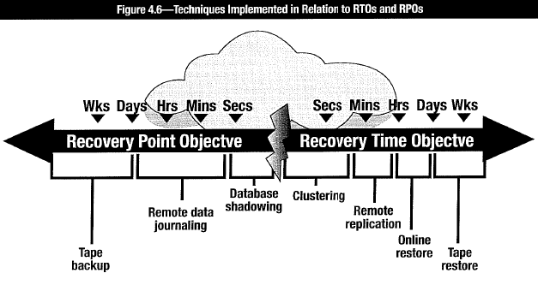

###### Figure 4.7. Relationship RTOs, RPOs, High Availability and Fault Tolerance

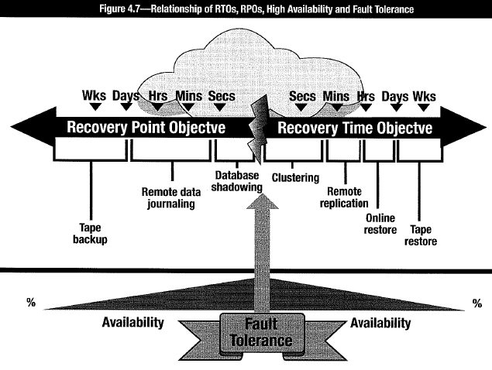

Strategies to ensure data availability and re-creation in event of incident are dependent on RPOs and RTOs (see 4.10.9 Integrating Incident Response With Business Continuity).

**Fault-tolerant storage solution** required for instantaneous RTO and stringent RPO (users to experience NO downtime) ⇨ **Fail-safe redundancy** through **mirrored images** of the primary server ⇨ “**load balancing**” or “**clustering**” (all servers take part in processing. Intelligent cluster unit provides for load balancing). High cost. Difficult.

**High-availability storage solution** required for more flexible RTO and RPO (business tolerates limited amount of downtime). Example: Set of servers with fail-over relationship. When an application is running and the primary server fails, the application is restarted in the failover server. Most current work in progress may be lost; however, the application could be up and running within seconds. High availability solutions are less costly to implement than those designed for 100% fault tolerance.

#### 4.10.15 Insurance

IRP includes information regarding insurance plans (general coverage, cyber insurance or IT-related insurance). Include elements of coverage (business interruption policy). Insurance policies for current information systems processing = *multi-peril* policy; constructed modularly to adapt to insured’s particular IT environment. **Cannot insure against failure to comply with legal and regulatory requirements or any other breach of the law**. Number of other exclusions and deductibles.

Available types of coverage:

•**IT equipment and facilities**: Coverage of physical damage to IPF and owned equipment. Insure leased equipment if responsible for hazard coverage. Review wording such that insurers obligated to replace damaged or destroyed equipment with “*like kind and quality*,” not necessarily the identical brand and model.

•**Media (software) reconstruction**: Covers damage to computer-related media owned by insured and for which insured may be liable. Insurance available for on-premises, off-premises or in-transit disasters. Covers actual reproduction cost of property. Consider programming costs to reproduce damaged media; backup expenses; and physical replacement of media devices such as tapes, cartridges and disks.

•**Cybersecurity**: Covers cyberattacks of various kinds, including malware, DoS and DDoS, and breach losses

•**Professional and commercial liability**: Protects from 3rd party claims for losses and damages caused by the insured

•**Extra expense**: Covers extra costs of continuing operations following damage or destruction at the IPF. Amount of insurance needed is based on availability and cost of backup facilities and operations. Extra expense can cover *loss of net profits* caused by computer media damage (reimbursement for monetary losses resulting from suspension of operations due to physical loss of equipment or media).

•**Business interruption**: Covers loss of profit due to disruption of activity caused by any covered IT malfunction or security-related event (attacker or malicious code causes loss of availability of computing resources)

•**Valuable papers & records**: Covers cash value of papers & records (not media) on insured’s premises against unauthorized disclosure, direct physical loss/ damage

•**Errors & omissions**: Legal liability protection when professional practitioner commits act, error or omission that results in financial loss to a client. (Originally designed for service bureaus, but now available to protect against actions of systems analysts, software designers, programmers, consultants and other information systems personnel)

•**Fidelity coverage**: Takes form of banker’s blanket bonds, excess fidelity insurance and commercial blanket bonds. Covers loss from dishonest or fraudulent acts by employees. Prevalent in financial institutions operating their own IPF.

•**Media transportation**: Coverage for potential loss or damage to media in transit to off-premises IPFs. Transit coverage wording usually specifies that all documents must be filmed or otherwise copied. Management to obtain from insurance carrier a letter that specifically describes carrier’s position and coverage in event data are destroyed.

#### 4.10.16 Update Recovery Plans

Establish process to update recovery plans as changes occur. Assess response and recovery plan requirements during change management process. Plans and strategies for response & recovery be reviewed and updated according to schedule to reflect continuing recognition of changing requirements.

Factors impacting requirements and need to update the plan:

•Strategy inadequate as needs of an organization change.

•New applications developed or acquired.

•Changes in business strategy alter/add significance of critical applications.

•Changes in HW/SW make current provisions obsolete or inappropriate.

•Changing physical and environmental circumstances.

Specific plan maintenance activities:

•Develop schedule for periodic review and maintenance of the plan

•Advise personnel of their roles and deadline for receiving revisions and comments

•Call for revisions when significant changes have occurred

•Review revisions & comments. Update plan within reasonable period (e.g., 30 days) after review date

•Arrange, coordinate scheduled/unscheduled tests of the plan to evaluate its adequacy

•Participate in scheduled plan tests (to perform at least once each year). For scheduled and unscheduled tests: coordinator to write evaluations; integrate changes to resolve unsuccessful test results into response plan within reasonable period (e.g., 30 days)

•Develop schedule for training personnel in emergency and recovery procedures.

•Schedule training dates within reasonable period (e.g., 30 days) after each plan revision and scheduled plan test.

•Maintain records of plan maintenance activities, such as testing, training and reviews

•Update, at least quarterly, the notification directory to include all personnel changes, such as changes to phone numbers and responsibilities or status within the company.

### 4.11 TESTING INCIDENT RESPONSE, BUSINESS CONTINUITY, DISASTER RECOVERY PLANS

Test objective: Successful recovery of infrastructure and critical business processes. **Focus**:

•Identify gaps •Verify assumptions •Test timelines •Determine effectiveness of strategies •Evaluate performance of personnel •Determine accuracy & currency of plan information

Prior to test, ensure that:

•Risk & impact of disruption from testing minimized •Business understands & accepts risk inherent in testing. •Fallback exist to restore operations at any point during test

Document with *pretest, test and posttest reports*. Test documentation be retained for audit review and reference. Ensure that infosec also tested and not compromised during testing.

#### 4.11.1 Testing Response & Recovery Plans

Test up to disaster declaration: Structure & scope of incident management responsibilities, escalation, involvement/handover to disaster management and recovery operation. **Testing activities** includes:

•Develop test objectives •Execute test •Evaluate test •Develop recommendations to improve testing processes and response & recovery plans •Implement follow-up process to ensure recommendations are implemented

Ensure independent 3rd party to monitor and evaluate test. Result of evaluation: list of recommendations. Implement tracking process to ensure recommendations implemented in a timely fashion. Personnel should be tasked with making any necessary changes.

#### 4.11.2 Test I/F & Business Applications

Testing recovery & response plans must include both infrastructure and critical applications, although not necessarily at the same time.

#### 4.11.3 Types of Tests

•**Checklist review**: Preliminary step. Distribute recovery checklists to members of recovery team to review and ensure that checklist is current.

•**Structured walkthrough**: Team members implement plans on paper. Review each step to assess effectiveness, identify enhancements, constraints and deficiencies.

•**Simulation test**: Role-play disaster scenario without activating recovery site.

•**Parallel test**: Recovery site brought to operational readiness, but operations at primary site continue normally.

•**Full interruption test**: Shut down primary site. Operations shifted to recovery. Expensive and potentially disruptive.

Start testing simply. Increase gradually. Stretch objectives and success criteria of previous tests to build confidence and minimize risk. “Fall-interruption” tests be performed annually after individual plans tested separately with satisfactory results.

Progressively more challenging tests:

•Table-top walkthrough of plans

•Table-top walkthrough with mock disaster scenarios

•Test infrastructure and communication components of recovery plan

•Test infrastructure and recovery of critical applications

•Test infrastructure, critical applications and involvement of end users

•Full restoration and recovery tests with personnel unfamiliar with systems

•Surprise tests

Three main recovery testing categories:

•**Paper tests**: On-paper walkthrough of plan with major players. Walk through entire plan or just a portion. Paper test usually precedes preparedness tests.

•**Preparedness tests**: Localized versions of full test. Actual resources simulating system crash. Performed regularly on different aspects of plan. Cost effective way to gradually obtain evidence about plan. Help improve plan in increments.

•**Full operational tests**: One step away from actual service disruption. Test plan well on paper and locally before complete shut down. For BCP testing, full operational testing scenario is the disaster.

Maintain detailed documentation of observations, problems and resolutions. Each team has diary with specific steps and information recorded. Documentation serves as historical information to facilitate actual recovery; aids detailed analysis of strengths & weaknesses of plan. Performing full or partial testing because business continuity test needs to determine how well plan works or which portions of plan need improvement. Surprise tests advantageous (similar to real-life incident response situations), can be disruptive to production and operations. Schedule potentially disruptive testing during time that minimizes impact on normal operations (Weekends). All key recovery team members be involved. Address all critical components. Simulate prime-time processing conditions, even the test conducted during off-hours.

#### 4.11.4 Test Results

**Recovery test tasks**:

•Verily completeness and precision of response & recovery plan.

•Evaluate performance of personnel involved in exercise.

•Appraise level of training & awareness of individuals outside recovery/response team.

•Evaluate coordination among team members and external vendors/suppliers.

•Measure ability & capacity of backup site to perform prescribed processing.

•Assess vital records retrieval capability.

•Evaluate state & quantity of equipment/supplies at recovery site.

•Measure overall performance of operational and information systems processing.

**Phases to perform preparedness or operational recovery testing**:

•**Pretest**: Set stage for actual test. Outside realm of real emergency.

•**Test**: Actual activities to test specific objectives of plan. Data entry; telephone calls; information systems processing; handling orders; movement of personnel, equipment and suppliers. Evaluators review staff members. Actual test of preparedness to emergency.

•**Posttest**: Cleanup group activities. Return resources to their proper place, disconnect equipment, return personnel to normal locations, delete company data from 3rd-party systems. Formally evaluate plan and implement improvements.

#### 4.11.5 Recovery Test Metrics

**Types of metrics**:

•**Time**: Elapsed time to complete prescribed tasks, deliver equipment, assemble personnel and arrival at predetermined site.

•**Amount**: Amount of work performed at backup site by clerical personnel + Amount of information systems processing operations

•**Percentage and/or number**: (Successfully carried/required) number records to backup site + (requested/actually received) number of supplies and equipment + number of critical systems successfully recovered vs. number of transactions processed.

•**Accuracy**: Accuracy of data entry at recovery site vs. normal accuracy (as a percentage). Determine accuracy of actual processing cycles by comparing output results with those for the same period processed under normal conditions.

### 4.12 EXECUTE RESPONSE & RECOVERY PLANS

#### 4.12.1 Ensure Execution as Required

Plans need facilitator/director to direct tasks within plans, oversee execution, liaise with senior management and make decisions. Infosec may not be appropriate person.

Appoint independent observer to record progress, document exceptions. Infosec and recovery personnel review observations and make adjustments during post review.

### 4.13 POSTINCIDENT ACTIVITIES & INVESTIGATION

Adopt consistent methodology so when problem found, action plan developed to reduce/mitigate it. Then steps taken to implement the solution.

Follow-up process in incident response most valuable part of effort. Lessons learned during incident handling improves security practice and incident response process.

Calculate cost of incident = cost of loss/damage + cost of labor, HW, SW. Cost provides useful metric to justify existence of response team, and as evidence in court case.

#### 4.13.1 Identify Causes & Corrective Actions

Determine answers to questions:

•Who is involved? •What has happened? •Where did attack originate? •When (what time frame)? •Why did it happen? •How was the system vulnerable •How did the attack occur? •What was reason for attack (i.e., the perpetrator’s motivation)?

#### 4.13.2 Document Events

Develop clear record of events. Events can be investigated and provided to forensics team or authorities. Assign individuals to document incident and preserve evidence.

#### 4.13.3 Establish Procedures

Good legal framework can help pursue civil or criminal legal action against perpetrators. Develop data preservation procedures with advice and assistance of legal counsel, managers and law enforcement officials to handle security events to preserve evidence, ensure legally sufficient chain of custody and appropriate to meet business objectives.

Basic actions: do nothing that could change, modify or contaminate potential or actual evidence. Specially trained staff, 3rd-party specialists, security IRT or law enforcement officials perform computer forensics, gather and handle information and physical objects in a systematic manner to be used as evidence in a court of law.

Initial response by the system administrator:

•Retrieve information needed to confirm an incident

•Identify scope & size of affected environment (e.g., networks, systems, applications)

•Determine degree of loss, modification or damage (if any)

•Identify possible path or means of attack

#### 4.13.4 Requirements for Evidence

Contamination of evidence prevents prosecuting perpetrator and limits options. Modified data inhibit computer forensic activity. Prevent determining how attack occurred, how security program be changed and enhanced to reduce risk of similar attack.

General recommendation for compromised computer: disconnect power to maximize preservation of evidence on hard disk. Reduced risk of evidence compromised as result of system swap files overwriting evidence or intruder or malware erasing evidence of compromise. Risk of contaminating evidence.

But disconnecting power causes data in memory be lost. Sudden power loss may result in corruption of critical information on hard disk. Because some malware is only memory-resident, cause of incident and avenue of attack may be difficult to establish.

Trained personnel use forensic tools to create *bit-by-bit copy* (or *disk image*) of evidence that may exist on hard drives and other media to ensure legal admissibility. To avoid potential for alteration or destruction of incident-related data, any testing or data analysis be conducted using this copy. Give original to designated evidence custodian who must store it in a safe location. Original media must remain unchanged. Chain of custody must be maintained for the evidence to be admissible in court.

When taking copy of hard drive, take a bit-level image of all data on drive. Use cable with write-protect diode to prevent writing anything back onto source drive. Hash values of both source and destination drive be calculated to ensure that copied drive is exact image of the original.

#### 4.13.5 Legal Aspects of Forensic Evidence

Documentation to maintain legally admissible evidence:

•Chain of custody forms that include:

- Name and contact information of custodians

- When, why and by whom an evidence item was acquired or moved

- Detailed identification of the evidence (serial numbers, model information, etc.)

- Where it is stored (physically or logically)

- When/if it was returned

•Checklists for acquiring technicians (incl. details of legally acceptable forensic practices)

•Detailed activity log templates for acquiring technicians

•Signed nondisclosure/confidentiality forms for those involved in recovering evidence

•Up-to-date case log that outlines:

- Dates when requests were received

- Dates investigations were assigned to investigators

- Name and contact information of the investigator and requestor

- Identifying case number

- Basic notes about the case and its requirements and completed procedures

- Date when completed

•Investigation report templates that include:

- Name and contact information of investigators

- Date of investigation and an identifying case number

- Details of interviews/communications with management/staff regarding investigation

- Details of devices/data (serial numbers, models, physical/logical locations)

- Details of SW/HW tools for acquisition or analysis (recognized forensically sound tools)

- Details of findings incl. samples/copies of data and references to storage location

- Final signatures of investigator in charge

Procedures to initiate forensics investigation need be agreed to, documented, followed carefully and understood by everyone in the enterprise. Infosec manager works with management and HR (and other stakeholders) to establish a process that ensures that all investigations are fair, unbiased and well documented. Be aware that legal requirements vary in different jurisdictions. As a result, informed legal advice for appropriate processes that meet judicial standards will be required.

### CHAPTER 4 PRACTICE

#### Knowledge Check: Gap Analysis

A small organization has an IT team of four people, including the manager. Currently, there is no documented IRP. The current plan consists of the IT team reporting suspicious events to the manager, who briefly confirms the finding and then reports the event to the chief operating officer (COO),typically by email. The COO then decides whether or not to take an action. The COO has requested that all activity that potentially could be an incident be reported to him, as senior leadership varies in what they consider an incident. The typical time it takes the COO to respond to these reports can be anywhere between two and six hours, depending on his schedule, which means it can take up to six hours before the IT team can respond to an event. Comparable benchmarks among similar organizations show that typical response time is two hours. Good practice also recommends several guidelines for what constitutes an incident. The IT manager would like for his team to be able to follow these guidelines to help them to be more nimble in their response to events and reduce the time to respond.

**Questions:**

1. Briefly describe the current state of incident response for this IT team.

2. Briefly describe the desired state of incident response for this IT team.

3. List gaps between the current and desired states of incident response for this IT team.

4. List some potential ways the organization can close the gaps between the current and desired states of incident response for this IT team.

**Answers**

**Question 1**: No formal incident response plan is in place. The IT team has the skills to identify potential events, but it is not empowered to make timely decisions to respond to events and better contain an incident before it becomes a larger issue.

**Question 2**: A documented incident response plan that includes an organizationally approved definition for an incident should be determined. This response plan would include levels of severity and an escalation plan that would empower the IT team to make better, timelier decisions to match the response time of similar organizations.

**Question 3**: There is no agreed-upon definition from the organization as far as what constitutes an incident. Senior leadership may be unsure what “incident” means or levels of severity for incidents. No formal, documented incident response plan is in place. There is no set system for alerting the COO that an incident has been identified. There is no escalation plan in place.

**Question 4**: Define what constitutes an incident. Develop an incident response plan to include severity/escalation criteria, roles and responsibilities, and metrics for effectiveness, including time to response.

#### Knowledge Check: Incident Response Parameters

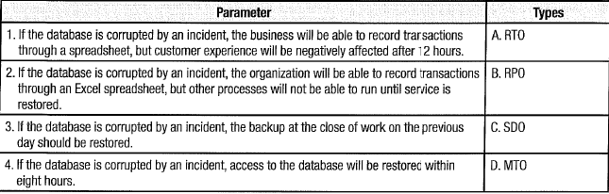

**Answers**

1 . D

2. C

3. B

4. A

#### Case Study1

A vendor-supplied, business-critical service provisioning system for internal organizational functions (i.e., not customer-facing) has peak usage between the hours of 7:00 a.m. through 7:00 p.m. on weekdays. On Monday at 6:00 a.m., the system became unresponsive. The network operations center worked with the IMT and opened a conference bridge at 6:30 a.m. At 11:00 a.m., the application owner on the user-organization side was notified of the incident by a user group manager. The application was back online by 1:00 p.m.

Three weeks following the first incident, another application service interruption occurred. On a Wednesday at 2:00 p.m., the system became unresponsive for a portion of the user base (i.e., Some areas were unaffected, including the office location of the system operations owner for the user organization). The network operations center opened a conference bridge at 2:40 p.m. At 3:00 p.m., the application owner on the user-organization side was notified of the incident by the vendor. The application was back online for the complete user community by 4:00 p.m. Going forward, the application experienced a service interruption on average once a month for the next three months. The impact of the service interruptions varied I and included partial availability loss for certain functions, as well as a full service provisioning loss. Following the lapse in notification from the first incident and the inconsistency brought about by notification from the second incident, the organization began to revamp its internal processes. Internal process revisions occurred through the creation of an incident communication procedure, which was distributed to all IT personnel charged with operating the application. The procedures designated communication goals as well I as the creation of post-incident reviews identifying clear root causes for the incidents no later than a week after resolution.

For a longer-term response, the organization enacted several business decisions that resulted in remaining with the current service provisioning system and a reduction in service interruptions following the three month period. These included cataloguing the incident history and meeting with the vendor to establish operational level agreements and a comprehensive service improvement plan, including the monitoring of operational results.

**1. Considering the first incident, when should the business owner have been notified about the incident?**

A. Within incident reporting operational level agreements

B. No later than 6:15 a.m.

C. Within the vendor’s incident reporting service level agreements

D. No later than 6:30 a.m.

**2. In a process-mature organization, how should the initial notification for the second incident have been delivered to the business owner?**

A. Through separate notifications upon incident discovery to stakeholders

B. By the security information and event management tool

C. By the application vendor

D. By the network operations center

**3. When cataloguing incidents in preparation for meeting with the vendor, which of the following is the BEST choice for the initial set of actions to be taken by the infosec manager?**

A. Create a post-incident review for each incident involved.

B. Perform a business impact analysis.

C. Update the incident response and recovery plans.

D. Perform a risk assessment.

**Answers**

**Question 1:**

**A. The timeframe for incident response should be determined by internal user-organization operational level agreements (OLAs).**

B. The timeframe for incident response should be determined by internal OLAs. These should be determined based on incident categorizations as applied by the IMT.

C. Tire user-organization’s OLAs take precedence over the vendor’s internal SLAs. If the vendor’s SLAs are insufficient, then the vendor and the organization should work to develop an improved solution to bring those SLAs to a level accepted by the user-organization. The vendor can provide notification of a service disruption; however, the organization should have internal monitoring systems in place.

D. The timeframe for incident response should be determined by internal OLAs. These should be determined based on incident categorizations as applied by the IMT. 6:30 a.m. represents the time that the conference bridge was opened; however, that may or may not be commensurate with the user-organization’s incident reporting OLAs.

**Question 2:**

A. Depending on the way an organization’s security information and event management (SIEM) tool is set up, it is possible for the same incident to be reported multiple times through numerous sources. However, if reporting comes at multiple times to the business owner, then it stops being an “initial” notification. In fact, all notification subsequent to the first become ancillary notifications, and therefore not what the question is asking for (which is the initial notification).

**B. The SIEM tool should have notified the application business owner of the incident**.

C. The application vendor could have notified the user-organization’s business owner of the incident (as stated in the case); however, this should not have been the first (or initial) notification. The initial notification should have come from the SIEM tool. If the alert first came from the vendor, then the incident is either something of an extreme outlier that the SIEM tool did not catch or the organization lacks the process maturity that is presupposed in this question.

D. The user-organization’s network operations center could have sent out the initial alert, if that was integrated with the SIEM tool; however, there is not enough information either within the case study or this question to conclude that as a certainty.

**Question 3:**

A. A post-incident review was already created for incidents that have occurred over the previous three months, based on the updated documentation that was created following the first incident.

**B. Conducting a business impact analysis is the first step in the incident response management process. In this scenario, the incidents have already occurred and were responded to; however, the combined business impact of the combined incident activity needs to be taken into account prior to discussions with the vendor. The vendor needs to understand the damage that system downtime has caused the business because this, along with the consistency of incidents, will be the basis from which a response strategy can be determined.**

C. Updating the incident response and recovery plans can be performed in tandem with preparation for a vendor meeting. However, the response and recovery plans are to help matters going forward, while the vendor meeting is to address the impact of incidents as they occurred and to form a consolidated response to the pervasiveness in the lack of consistent system availability.

D. The incidents have already occurred; therefore, an impact assessment, not a risk assessment, needs to be performed.

#### Case Study 2

In a major US financial institution, low-level personnel monitoring the network operation center (NOC) noticed unusual network activity on a Sunday evening when the bank was closed. Uncertain of what they were seeing, they decided to watch the event rather than risk disturbing management on a weekend. No severity criteria, notification requirements or escalation processes had been developed by the organization. By 3 a.m. on Monday, traffic continued to increase at the main facility and then suddenly began to grow dramatically at the mirror site, hundreds of miles away. The NOC staff remained unconcerned and felt they could still handle the increase in traffic.

By 7 a.m. on Monday, the NOC personnel were sufficiently concerned to notify the IT managers that there was a problem and the monitors showed the network was becoming saturated. An hour later when the external C1RT arrived, the network was totally inoperative and the team determined that the network had been compromised by the Slammer worm. The CIRT team manager informed the IT manager that the Slammer worm was memory-resident and restarting the entire network and mirror facility would resolve the issue. The manager stated that he did not have the authority to shut down the system and the CIO would need to approve the action The CIO could not be located, and current emergency phone and pager numbers were kept only in a new emergency paging system that required network access. When asked about the DRP and what it had to say regarding declaration criteria, three different plans were produced that had been prepared by teams in different parts of the organization, unbeknownst to each other. None contained declaration criteria or specified roles, responsibilities or authority. The final resolution ultimately required the CEO, who was traveling overseas and not immediately available, to filially issue instructions the next morning (Tuesday) to shut down the nonfunctioning network. The institution was inoperative for a full day and a half, with over 30,000 employees unable to perform their work. The final direct costs were estimated by the post-incident team to exceed US $50 million.

**1. Which of the following could have aided the NOC employees in identifying the severity of the incident?**

A. Updated security policies

B. Meaningful security metrics

C. Additional security training

D. Increased decision-making autonomy

**2. Which is an example of a metric that would be MOST meaningful to the NOC in this scenario?**

A. Amount of traffic during a typical downtime

B. Number of transactions per hour

C. Duration of increased traffic prior to contacting management

D. The number of systems showing traffic

**3. Which of the following BEST could have aided the network manager in containing the incident in a more timely manner?**

A A single, approved disaster recovery plan

B. Earlier notification from the NOC

C. Better organizational governance structure

D. Additional security training for staff

**4. Who ultimately should be responsible for ensuring that a single DRP is in place for the organization?**

**5. Who should be accountable for the lack of an effective DRP?**

**Answers**

**Question 1:**

A. Updated security policies would have helped to establish reporting and escalation procedures; however, meaningful security metrics would better help network operation center (NOC) employees recognize that an incident was occurring, which would have helped them to react in a more effective way.

**B. For those monitoring the NOC, metrics indicated a problem, but they were not sufficiently meaningful to the employees for them to make any active decisions, much less the correct ones. Either better metrics or greater proficiency of the personnel could have resolved the issue quickly in the initial stages of the incident before it became a problem**.

C. Additional security training would help employees know what to do should an incident occur; however, meaningful metrics should be established in order to make training as impactful as possible so incidents can be recognized and handled in a timely manner.

D. Increased decision-making autonomy is helpful when there are meaningful metrics in place to help employees recognize incidents are occurring. Based on that information, they can make informed decisions on how to best contain and respond to incidents.

**Question 2:**

**A. Knowing the normal traffic occurring at that time of night would have made it clear that the situation was not normal and a serious problem existed.**

B. Without a reference point, the number of transactions would not have been particularly meaningful.

C. The duration of traffic without a point of reference would not have been meaningful.

D. The number of systems without a point of reference would not be helpful.

**Question 3:**

A.A single disaster recovery plan could have been useful but without clear authority it would not by itself have helped.

B. Earlier notification would have been helpful but only if authority to act was clear.

**C. Better governance would have vested adequate authority in the network manager to take the appropriate action.**

D. Training of staff would have been useful in recognizing the event but authority to act was essential.

**Question 4:**

A disaster recovery plan (DRP) for the overall organization is a governance issue; therefore, it is the responsibility of the board of directors to ensure that a DRP is in place.

**Question 5:**

Better governance would have ensured that risk management was in place; however, those involved in governance direct the program. The C1SO or CIO: whomever the infosec manager reports to: would be accountable for the ineffective DRP. The infosec manager and the IRT would be responsible for periodically reviewing and testing the DRP to make sure it was working as expected.

1. **VAR**: maximum probable loss in defined period (day, week, year) with confidence level of 95% or 99%
2. **ROSI**: return on investment based on reduction in losses compared to cost of the control.
3. **ALE**: Likely annualized loss based on probable frequency and magnitude of security compromise.
4. **Dangerous data:** info potentially used to detriment of org. (e.g., damaging evidence in litigation).
5. SOX (Sarbanes-Oxley requires that for organizations publicly traded in the US, all financial controls must be tested for effectiveness within 90 days of reporting. The results of testing must be signed by the CEO and CFO and must be attested to by the organization’s auditors. The results must then be included in the organization’s public filings to the SEC
6. **Risk Management** aims to achieve optimal balance between realizing opportunities and minimize vulnerabilities & loss. **Business Impact Analysis** (BIA) determines impact to lose resources availability.
7. **ROSI**: return on investment (reduction in losses compared to cost of control).
8. **Cyber risk posture**: the **status** of overall cybersecurity program implemented by an organization to protect itself from breaches and safeguard its data. **Assess**: vulnerabilities, threats, exposure, impact, mitigating controls
9. **Security information management (SIM)** = practice of collecting, monitoring and analyzing security-related data from computer logs. **Security event management (SEM)** looks closely at specific types of events (e.g., "superuser event" requires detection of suspicious authentications, account logons or high-level management access at specific times of the day or night. **Security information event management (SIEM)** combines SIM with SEM.
10. Not directly observable